# ITM 440/540 - Data Networks

# Midterm Part II Review

# 10/30/2015

### *Note: This exam, scheduled for Tuesday, November 3 from 10:00 AM to 11:15 AM, in LS Room 111, will allow you to show your knowledge of IPv4 addresses and the networks and subnetworks on which they are located. It will not cover other topics that we have studied since the October midterm. Those topics, such as error control and the different header fields of the IP datagram, will be covered on the final exam.*

#### I. IP Addressing

### 1. Know the structure of IPv4 addresses. Know that the addresses are 32 bits long, which means they are 4 bytes long. Know both the dotted decimal and the bit representation of an IPv4 address.

2. Know thatan organization is given a **block** of addresses from the entire set of all the IPv4 addresses. Know that the total number of IPv4 addresses that can be created is 232.

* The blocks of addresses are given to Internet Service Providers (ISP)
* ICANN - the Internet Corporation for Assigned Names and Addresses – provides blocks of IP addresses to Internet Service Providers

3. Know how to identify the Net ID and the Host ID portions of an IPv4 PDU (Protocol data unit), also called the Prefix and the suffix.

* This hierarchical arrangement of addresses is used by routers to make decisions as to which ‘next hop’ to send the IP datagram to.
* Net ID - the set of high-order bits unique to the network on which the IP address is located
* Host ID - the set of low-order bits unique to the host device on the given network

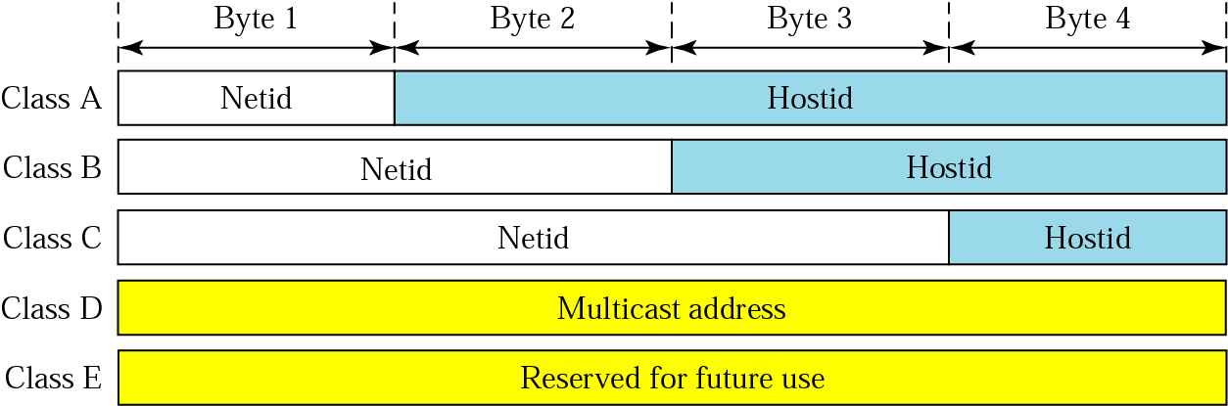

4. Know how the Net ID and Host ID portions are used to identify the network and the hosts on the IP network.

5. Know how to identify the First Address and the Last Address on an IP network. Be able to write these two special addresses down on paper. Even though we do not assign these addresses to computers, they still have the format of full IP addresses.

* ***Network Address*** also called the ***First Address*** is, by convention, the address of the ***network***, but ***not*** the address of any device on the network



* ***Network Broadcast Address*** also called the ***Last Address***, is also not the address of any device on the network.



6. Know the special meaning associated with the First Address and the Last Address of an IP network. The First Address identifies the network. The Last Address identifies the broadcast address that must be read by all IP devices on the network. Neither of these special addresses is the address of an actual computing device.

**II. Networks with Classful and Classless addressing schemes and their Network Masks**

1. Know the how to identify the class of an IP network that uses classful addressing.

* Classful addressing assigns classes to blocks of IP addresses based on the value of the high-order byte

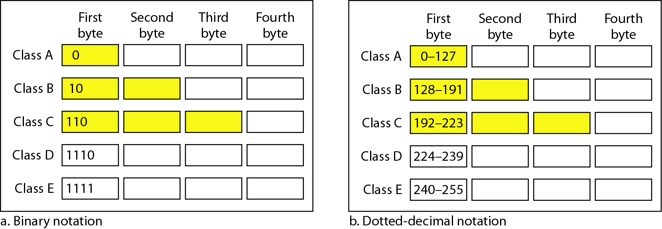



1. Know how to use the “/n” notation of CIDR(**Classless Interdomain Routing**) addresses. (Classless addresses)

* **/n** tells how many contiguous 1’s there are in the network mask

### Know how to write the network mask of an IP network whether it uses classful or classless addresses.

Network Mask - a pattern of 32 bits whose format is a set of contiguous 1’s followed by a set of contiguous 0’s used by a router to determine the address of the network on which an IP address is located

* Class A addresses have network mask 11111111 00000000 00000000 00000000
* Class B addresses have network mask 11111111 11111111 00000000 00000000
* Class C addresses have network mask 11111111 11111111 11111111 00000000
* For the address xxx.xxx.xxx.xxx/11, the network mask is 11111111 11100000 00000000 00000000

1. Remember that the network mask has the **format** of an IP address – it is 32 bits long – but that it is **not** an IP address. It is a filter that is put over an actual IP address in order to calculate the address of the network on which that actual IP address is located.
2. Know how to write the first address and last address of a given network, whether it is classful or classless. Know the use of the first address and the last address.
3. Given any IP address, be able to identify the first address and last address of the network on which it is located.

**III. Subnetworks**

1. Understand that we create subnetworks for administrative purposes. *Subnetworks do not give us more IP addresses. In fact they give us less IP addresses since we give up the first and last addresses on each subnet for the special purposes of identifying the subnetworks and of providing the subnetwork broadcast address.*
2. Be able to create sub-networks on class-full and class-less networks. *To do this we break up the host bits into two groups: One group is used to identify the subnetworks and the other group is used to assign IP addresses to the hosts on the subnetworks.*
3. Be able to write the first and last address on a sub-network. Remember that these are 32-bit (4-byte) addresses.
4. Know the use of the first and last address on a sub-network. The first identifies the subnetwork, by making all the host bits on that subnetwork equal to zero. The last identifies the subnetwork broadcast address, by making all the host bits on that subnetwork equal to 1.
5. Given the request to create N subnetworks, be able to decide how many host bits you need to use to identify the subnetworks. *Remember that you need to find the smallest power of two whose value is larger than N. So, if I asked you to create 5 subnetworks you would say, what is the next largest number to 5 that is a power of 2? The answer is 8. 8 is 2 to the third power. So you need to use 3 host bits to identify 8 subnetworks. If you do not need all 8 of them, you will keep them in reserve.*
6. Given any IP address, together with the subnet mask of the network on which that IP address is located, be able to identify which sub-network that IP address is located on, by applying the subnet mask to the host’s IP address.



0 0 0

0 0 1

0 1 0

0 1 1

1 0 0

1 0 1

1 1 0

1 1 1