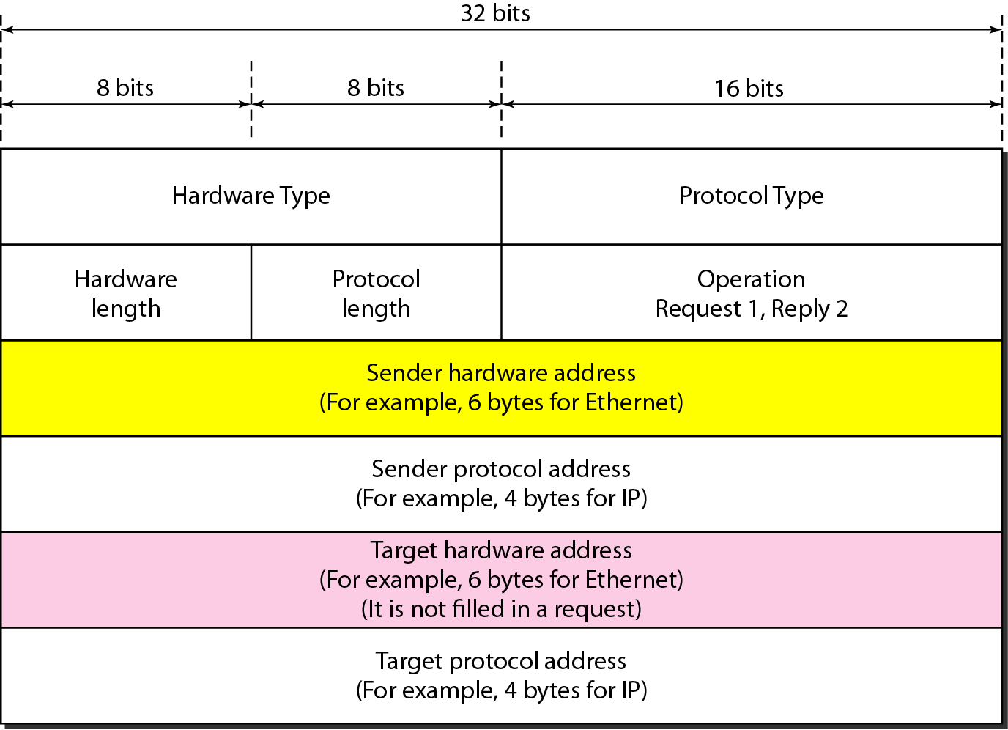



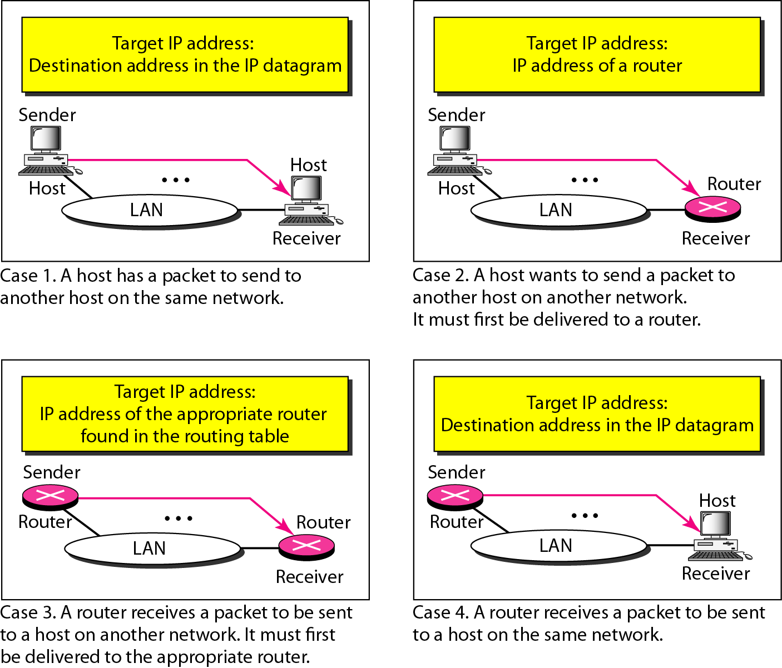

**Wireshark trace of an ARP message**

Frame 5 (60 bytes on wire, 60 bytes captured)

Arrival Time: Sep 22, 2004 20:49:13.838227000

Time delta from previous packet: 0.704565000 seconds

Time since reference or first frame: 1.557922000 seconds

Frame Number: 5

Packet Length: 60 bytes

Capture Length: 60 bytes

Ethernet II, Src: 00:0b:46:cc:61:e1, Dst: ff:ff:ff:ff:ff:ff

Destination: ff:ff:ff:ff:ff:ff (Broadcast)

Source: 00:0b:46:cc:61:e1

Type: ARP (0x0806)

Padding: 00000000000000000000000000000000...

Address Resolution Protocol (request)

Hardware type: Ethernet (0x0001)

Protocol type: IP (0x0800)

Hardware size: 6

Protocol size: 4

Opcode: request (0x0001)

Sender MAC address: 00:0b:46:cc:61:e1

Sender IP address: 216.47.140.2

Target MAC address: 00:00:00:00:00:00 (Means it is being requested. (fill in the blanks))

Target IP address: 216.47.140.97

