**CH1 Introduction**

1. Identify the five components of a data communications system.

***sender***, **receiver**, ***transmission medium***, ***message***, and ***protocol***.

2. What are the advantages of distributed processing?

The advantages are ***security***, ***access to distributed databases***, collaborative processing, and faster problem solving.

3. What are the three criteria necessary for an effective and efficient network?

***performance***, ***reliability***, and ***security***

4. What are the advantages of a multipoint connection over a point-to-point connection?

Advantages include ***ease of installation*** and ***low cost***.

5. What are the two types of line configuration?

***point-to-point*** and ***multipoint***

6. Categorize the four basic topologies in terms of line configuration.

We can divide line configuration in two broad categories:

***a. Point-to-point: mesh, star, and ring.***

*b. Multipoint: bus*

7. What is the difference between half-duplex and full-duplex transmission modes?

In ***half-duplex transmission***, only one entity can send at a time;

In a ***full-duplex transmission***, both entities can send at the same time.

8. Name the four basic network topologies, and cite an advantage of each type.

We give an advantage for each of four network topologies:

a. ***Mesh***: secure

b. ***Bus***: easy installation

c. ***Star***: robust

d. ***Ring***: easy fault isolation

9. For n devices in a network, what is the number of cable links required for a mesh, ring, bus, and star topology?

The number of cables for each type of network is:

a. ***Mesh***: *n* (*n* – 1) / 2

b. ***Star***: *n*

c. ***Ring***: *n* – 1

d. ***Bus***: one backbone and n drop lines

10. What are some of the factors that determine whether a communication system is a LAN or WAN?

The general factors are ***size***, ***distances*** (covered by the network), ***structure***, and *ownership.*

1I. What is an internet? What is the Internet?

An ***internet*** is an interconnection of networks.

The ***Internet*** is the name of a specific worldwide network

12. Why are protocols needed?

A ***protocol*** defines ***what*** is communicated, in ***what way*** and ***when***. This provides accurate and timely transfer of information between different devices on a network.

13. Why are standards needed?

***Standards*** are needed to create and maintain an open and competitive market for manufacturers, to coordinate protocol rules, and thus guarantee compatibility of data communication technologies.

14. What is the maximum number of characters or symbols that can be represented by Unicode?

***Unicode*** uses **32** bits to represent a symbol or a character. We can define **232** different symbols or characters.

15. A color image uses 16 bits to represent a pixel. What is the maximum number of different colors that can be represented?

With **16** bits, we can represent up to **216** different colors.

16. Assume six devices are arranged in a mesh topology. How many cables are needed?

How many ports are needed for each device?

Cables: 6(6-1)/2=15

Ports: 6-1=5

17. For each of the following four networks, discuss the consequences if a connection fails.

a. Five devices arranged in a mesh topology

***Mesh topology***: If one connection fails, the other connections will still be working.

b. Five devices arranged in a star topology (not counting the hub)

**Star topology**: The other devices will still be able to send data through the hub; there will be no access to the device which has the failed connection to the hub.

c. Five devices arranged in a bus topology

**Bus Topology**: All transmission stops if the failure is in the bus. If the drop-line fails, only the corresponding device cannot operate.

d. Five devices arranged in a ring topology

***Ring Topology***: The failed connection may disable the whole network unless it is a dual ring or there is a by-pass mechanism.

18. You have two computers connected by an Ethernet hub at home. Is this a LAN, a MAN, or a WAN? Explain your reason.

This is a ***LAN***. The Ethernet hub creates a LAN as we will see in Chapter 13

19. In the ring topology in Figure 1.8, what happens if one of the stations is unplugged?

Theoretically, in a ***ring topology***, unplugging one station, interrupts the ring. However, most ring networks use a mechanism that bypasses the station; the ring can continue its operation.

20. In the bus topology in Figure 1.7, what happens if one of the stations is unplugged?

In a ***bus topology***, no station is in the path of the signal. Unplugging a station has no effect on the operation of the rest of the network.

22. Draw a hybrid topology with a ring backbone and two bus networks.

21. Draw a hybrid topology with a star backbone and three ring networks.

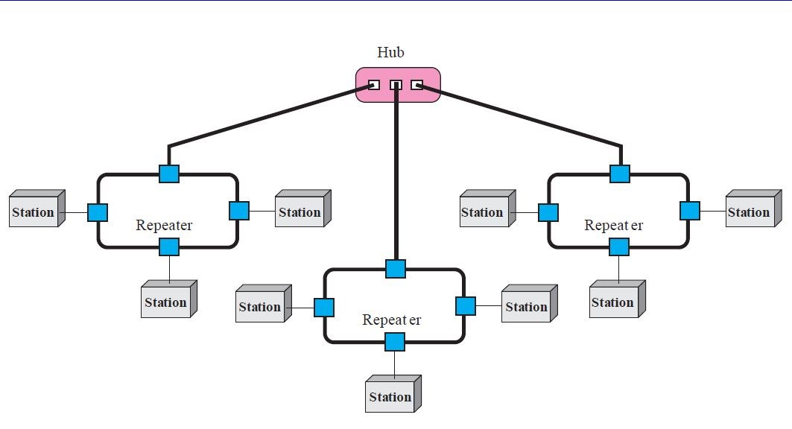

23. Performance is inversely related to delay. When you use the Internet, which of the following applications are more sensitive to delay?

a. Sending an e-mail

E-mail is not an interactive application. Even if it is delivered immediately, it may stay in the mail-box of the receiver for a while. It is not sensitive to delay.

b. Copying a file

We normally do not expect a file to be copied immediately. It is not very sensitive to delay.

c. Surfing the Internet

Surfing the Internet is the an application very sensitive to delay. We except to get access to the site we are searching.

24. When a party makes a local telephone call to another party, is this a point-to-point or multipoint connection? Explain your answer.

In this case, the communication is only between a caller and the callee. A dedicated line is established between them. The connection is ***point-to-point.***

25. Compare the telephone network and the Internet. What are the similarities? What are the differences?

The telephone network was originally designed for voice communication; the Internet was originally designed for data communication. The two networks are similar in the fact that both are made of interconnections of small networks. The telephone network, as we will see in future chapters, is mostly a circuit-switched network; the Internet is mostly a packet-switched network.

**CH 2 Network Models**

1. List the layers of the Internet model.

The Internet model includes ***physical***, ***data link***, ***network***, ***transport***, and ***application*** layers.

2. Which layers in the Internet model are the network support layers?

The network support layers are the ***physical***, ***data link***, and ***network*** layers.

3. Which layer in the Internet model is the user support layer?

The ***application*** layer supports the user.

4. What is the difference between network layer delivery and transport layer delivery?

5. What is a peer-to-peer process?

***Peer-to-peer processes*** are processes on two or more devices communicating at a same layer

6. How does information get passed from one layer to the next in the Internet model?

Each layer calls upon the ***services*** of the layer just below it using interfaces between each pair of adjacent layers.

7. What are headers and trailers, and how do they get added and removed?

***Headers*** and ***trailers*** are control data added at the beginning and the end of each data unit at each layer of the sender and removed at the corresponding layers of the receiver. They provide source and destination addresses, synchronization points, information for error detection, etc.

8. What are the concerns of the physical layer in the Internet model?

The *physical layer* is responsible for transmitting a bit stream over a physical medium. It is concerned with

a. ***physical characteristics of the media***

b. ***representation of bits***

c. ***type of encoding***

d. ***synchronization of bits***

e. ***transmission rate and mode***

f. ***the way devices are connected with each other and to the links***

9. What are the responsibilities of the data link layer in the Internet model?

The *data link layer* is responsible for

a. ***framing data bits***

b. ***providing the physical addresses of the sender/receiver***

c. ***data rate control***

d. ***detection and correction of damaged and lost frames***

10. What are the responsibilities of the network layer in the Internet model?

The *network layer* is concerned with delivery of a packet across multiple networks; therefore its responsibilities include

a. ***providing host-to-host addressing***

b. ***routing***

11. What are the responsibilities of the transport layer in the Internet model?

The *transport layer* oversees the process-to-process delivery of the entire message.

It is responsible for

a. ***dividing the message into manageable segments***

b. ***reassembling it at the destination***

c. ***flow and error control***

12. What is the difference between a port address, a logical address, and a physical address?

The *physical address* is the local address of a node; it is used by the data link layer to deliver data from one node to another within the same network. The ***logical address*** defines the sender and receiver at the network layer and is used to deliver messages across multiple networks. The port address (service-point) identifies the application process on the station.

13. Name some services provided by the application layer in the Internet model.

The *application layer services* include ***file transfer***, ***remote access***, ***shared database management***, and ***mail services***.

14. How do the layers of the Internet model correlate to the layers of the OSI model?

The ***application***, ***presentation***, and ***session*** layers of the OSI model are represented by the *application* layer in the Internet model. The lowest four layers of OSI correspond to the Internet model layers.

15. How are OSI and ISO related to each other?

The ***International Standards Organization***, or the ***International Organization of Standards***, (**ISO**) is a multinational body dedicated to worldwide agreement on international standards. An ISO standard that covers all aspects of network communications is the ***Open Systems Interconnection*** (**OSI**) model.

16. Match the following to one or more layers of the OSI model:

a. Route determination

b. Flow control

c. Interface to transmission media

d. Provides access for the end user

17. Match the following to one or more layers of the OSI model:

a. Reliable process-to-process message delivery

b. Route selection

c. Defines frames

d. Provides user services such as e-mail and file transfer

e. Transmission of bit stream across physical medium

a. Reliable process-to-process delivery: **transport** layer

b. Route selection: ***network*** layer

c. Defining frames: ***data link*** layer

d. Providing user services: ***application*** layer

e. Transmission of bits across the medium: ***physical*** layer

18. Match the following to one or more layers of the OSl model:

a. Communicates directly with user's application program

b. Error correction and retransmission

c. Mechanical, electrical, and functional interface

d. Responsibility for carrying frames between adjacent nodes

19. Match the following to one or more layers of the OSI model:

a. Format and code conversion services

b. Establishes, manages, and terminates sessions

c. Ensures reliable transmission of data

d. Log-in and log-out procedures

e. Provides independence from differences in data representation

a. Format and code conversion services: ***presentation*** layer

b. Establishing, managing, and terminating sessions: ***session*** layer

c. Ensuring reliable transmission of data: ***data link*** and ***transport*** layers

d. Log-in and log-out procedures: ***session*** layer

e. Providing independence from different data representation: ***presentation*** layer

20. In Figure 2.22, computer A sends a message to computer D via LANl, router Rl, and LAN2. Show the contents of the packets and frames at the network and data link layer for each hop interface.

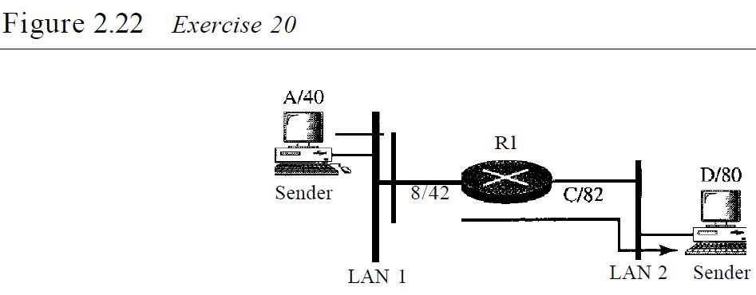

21. In Figure 2.22, assume that the communication is between a process running at computer A with port address i and a process running at computer D with port address j. Show the contents of packets and frames at the network, data link, and transport layer for each hop.

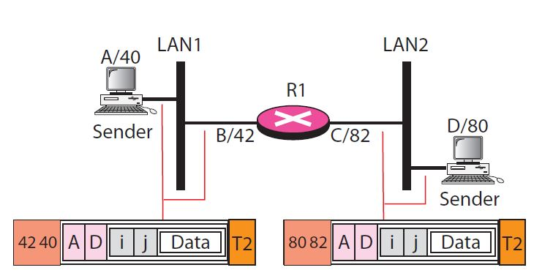

22. Suppose a computer sends a frame to another computer on a bus topology LAN. The physical destination address of the frame is corrupted during the transmission. What happens to the frame? How can the sender be informed about the situation?

23. Suppose a computer sends a packet at the network layer to another computer somewhere in the Internet. The logical destination address of the packet is corrupted. What happens to the packet? How can the source computer be informed of the situation?

Before using the destination address in an intermediate or the destination node, the packet goes through error checking that may help the node find the corruption (with a high probability) and discard the packet. Normally the upper layer protocol will inform the source to resend the packet.

24. Suppose a computer sends a packet at the transport layer to another computer somewhere in the Internet. There is no process with the destination port address running at the destination computer. What will happen?

25. If the data link layer can detect errors between hops, why do you think we need another checking mechanism at the transport layer?

The errors ***between*** the nodes can be detected by the data link layer control, but the error ***at*** the node (between input port and output port) of the node cannot be detected by the data link layer.