ITM 440/540 - Data Networks

Final Review

Part 4 - The Network Layer

I. IP datagram headers
- Know how to read and interpret the layer-3 information in a protocol trace.
IP header = 20 bytes and 四句话

- Know the functions of network layer: to link physical networks together.
  - Fragmentation – understand how this works. Break up the IP datagram into fragments and then add an IP header to each fragment. Know how the values in the header field are used to implement fragmentation.
Max Frame length = 1518 bytes; the body of length <= 1500 bytes
All fragments of a datagram have the same Identification value.
Flags: First bit is unused.
Second bit is the DF bit - Don’t Fragment.
Third bit is the MF bit - More Fragments
If the ‘more fragments’ bit is sent, the datagram must be reassembled before being sent up to layer 4.
Fragment Offset (13 bit field ): Tells the receiving host where in the datagram this fragment belongs (if fragment offset = 0 which means this is the first fragment. 这个值的设定由这个fragment的第一个byte除以8得到. 例如: 这个fragment的第一个byte 是1400, 则fragment offset = 1400/8 = 175.)
  - Routing – see review details below.
  - Addressing – see review details below.
  - Checksum for header – know how to set up the calculation of the checksum. You do not have to do the calculation. Know that the sender calculates the checksum by inserting a 0 into the checksum field and then performing the ones’ complement addition; takes the one’s complement of the sum and inserts that value into the checksum field and finally sends the datagram. Then the receiver performs the ones’ complement sum; takes the one’s complement of the result; and should get a result of 0. If it does, it concludes that the header had no errors and it continues to process the IP datagram.
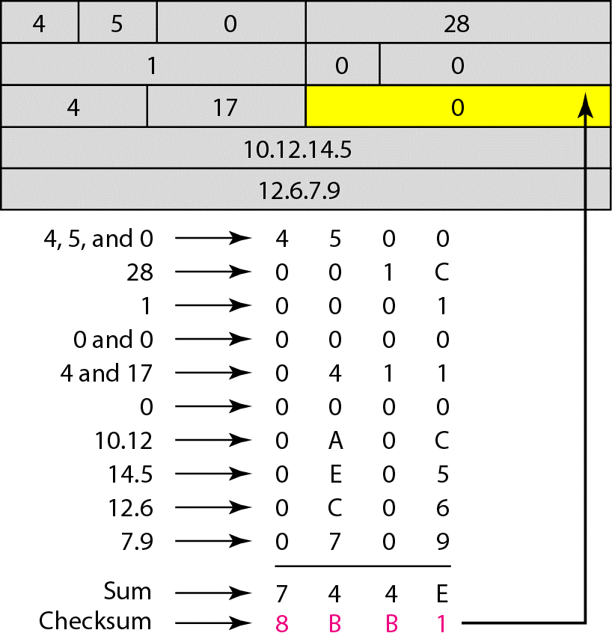

II. ICMP (Internet control Message Protocol)

1. ICMP is considered to be a Layer 3 protocol, even though ICMP messages are encapsulated inside an IP header
ICMP carry inside IP header 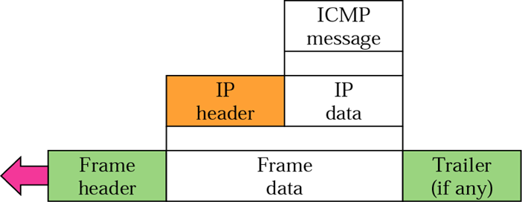
IP header : TOS = 0; Protocol = ICMP = 1
ICMP header = 8 bytes
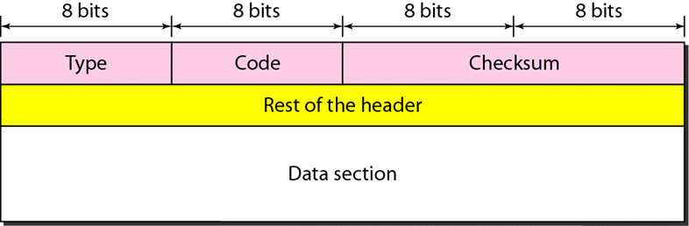

2. There are two kinds of ICMP message – error messages and control (diagnostic) messages

3. The most commonly used ICMP control messages are the ECHO request and ECHO response. Most operating systems provide you with a means to generate these messages. That means is called ‘ping.’
Type 0 = Echo Reply (ping reply)
Type 8 = Echo Request (ping)
- Used to identify the source of problems on the network
- Tests for continuity between source and destination
- If you receive a reply to an echo request, you know that the IP layer at the destination is operational and that the routers in the path between source and destination are functional
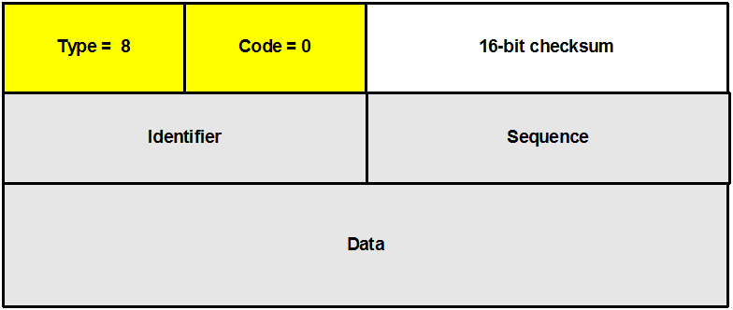
- Identifier - match echo requests to the associated reply. It may be set to zero.
- Sequence number - match echo requests to the associated reply. It may be set to zero.
- Data field - is of variable length and depends on the implementation
Identifier and sequence number are used by the sender to match requests to replies. The sender uses the same Identifier and changes only the sequence number.

4. Be able to identify an ICMP message and to classify it as either an error message or a control message.

5. Be able to identify the body of an ICMP error message
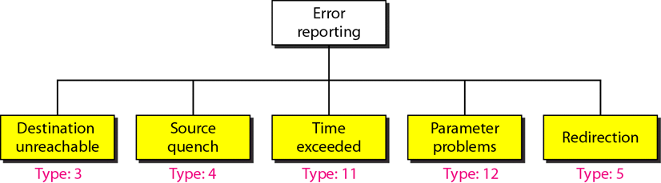

6. Be able to identify the body of an ICMP control message
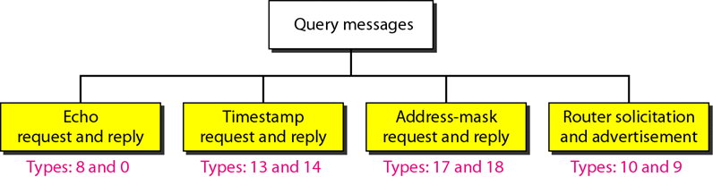

7. Understand how the utility called Trace Route use the ICMP control message (ECHO) to determine the route that a datagram will probably take to get between your computer and a remote computer.
- Ping is a basic troubleshooting tool
- Verifies that machine is active
- Verifies that machine is reachable
Command line: ping ip_address
Results: Statistics gave a max, min and average time.

III. IP Addressing
1. Be able to create sub-networks on class-full and class-less networks

2. Identify the first and last address on a sub-network
First identifies the subnetwork, 00000; the last identifies the subnetwork broadcast address, 111111.

3. Understand the use of the first and last address on a sub-network

4. Understand why we create sub-networks
Sub-networks allow you to subdivide your network into administrative units

5. Understand that when we create a sub-network we actually reduce the number of hosts that we can have on our over-all network
- Understand how to create subnetworks, by breaking up the host portion of your IP address into two parts – a subnetwork part and a host part
- Understand that you need to choose how many subnetworks you want, then you need to use that number to determine how of the host bits you will use to create your sub-net IDs
- Understand that you can learn which sub-network a host is on by applying the sub-net mask to the host’s IP address. The result is the subnetwork ID

6. Understand how we use Network Address Translation (NAT) to give ourselves more IP addresses that we receive from ICANN
- The Internet Assigned Numbers Authority (IANA) has reserved the following three blocks of the IP address space for private use.

7. Review the private address spaces that are available using NAT
- Be able to recognize a private IP address
Addresses for private use:
10.0.0.0 - 10.255.255.255 (class A)
172.16.0.0 - 172.31.255.255 (class B)
192.168.0.0 - 192.168.255.255 (class C)
- Understand that NAT allows you to add more host computers to your network than you have public IP addresses.
- Network Address Translation is a method for giving you or your enterprise a number or private addresses – addresses that are not routable on the public Internet
- NAT provides the translation service and doorway between your large private address space and the Internet
- The translation is done using a table look-up.
- Different types of look-up can be used:
Single IP address method;
Pool of IP address method;
Map IP and port method.
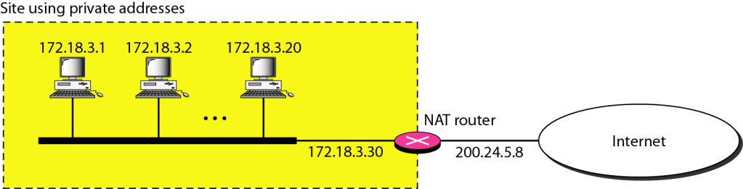

IV. IP Routing:
1. Understand how to use the routing table to determine the next hop and interface that a router will use to forward an incoming IP datagram towards its destination.
- Apply the network mask of the first line of your routing table to the incoming packet’s destination address
- Compare the result to the destination in the routing table
- If no match, go to the next line in your routing table and continue.

2. Be able to distinguish between the three different routing protocols that we studied. Know which protocol operates by exchanging Distance Vectors (RIP) and which uses the Link State routing method (OSPF). Know which method has a routing table that includes the entire route and which methods have routing tables that give only the next hop (BGF).

Routing Protocols
1. Unicast Routing - definitions - including the metric or cost of a route
Unicast routing is the process of forwarding unicasted traffic from a source to a destination on an internetwork. Unicasted traffic is destined for a unique address.
Destination address; next hop address; interface

2. RIP:
- Metric is hop count
- What information is contained in RIP messages? To update their routing tables.
- Be able to use RIP distance vectors to update a RIP routing table

3. OSPF
- Metric is a number that may be assigned in various ways and is not specified in the standard itself.
- The information in the OSPF protocol message provides the state of the links on the network
- Each router creates a routing database using the information in the LSA’s that it receives from its neighboring routers. Then each router uses the Dijkstra Algorithm to CALCULATE its own routing table.
- Be able to use the OSPF Link State Advertisement to update an OSPF routing table by applying the Dijkstra Algoritihm. Remember that the routing database is represented by the diagram that you are given when asked to solve the problem.

4. BGP
- Information contained in BGP messages – the path to the destination – called a path vector
- Understand that the information in the BGP routing table is a list of nodes. Each node in the path vector represents an autonomous system, thus, for example, in a two column routing table, the destination is in the first column, and an ordered set of AS’es is in the path column. That ordered set might look like AS4, AS3, AS1 for example

Forouzan Part 5 - Transport Layer: Process-to-process delivery
UDP and TCP
- Know what is a port number and how it is used
A Port is a point at which data from the application enters and leaves the transport layer.
- Layer 4 addresses are called Port Numbers (16 bits)
- ephemeral ports (be assigned dynamically)
- well-known ports (default)
Ports are bound to (associated with) processes within computing devices.
  - The devices are identified by their IP Address.
  - The processes are identified by their port numbers.
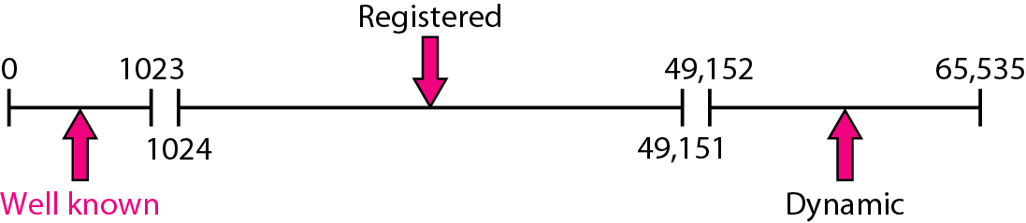

- Know what is a socket and how it is used
A Socket is the combination of an IP address and a port number.

- Understand connection-oriented vs. connectionless communications
UDP →a connectionless protocol
- Connectionless service
  - The datagrams sent by the same process to the same destination process are not related to each other

TCP →connection-oriented.
- Connection-oriented service
  - The datagrams sent by the same process to the same destination process are related to each other
  - The relationship is maintained at the cost of memory allocated in participating nodes AND processing cycles in participating nodes
  - Memory must be allocated in which the connection parameters are stored
  - Connection parameters such as connection id, sequence number, timers, encryption keys, must be stored in memory
  - Processing time must be used to read and use these connection parameters

- Checksum and the Pseudo-header
  - How is the checksum for UDP and TCP calculated?
- The checksum is over the UDP header and payload as well as over 12 bytes of the IP header (Pseudo header).
  - UDP header
  - UDP body
  - UDP pseudo header

  - What parts of the IP datagram that carries the UDP or TCP message are included in the UDP and TCP checksum? UDP and TCP use the same.
  - UDP pseudo header (12 additional bytes of the IP header - bytes that are not changed by routers.) , as follows:
    - Source IP Address
    - Destination IP Address
    - Protocol value (PT)
    - UDP length (total length minus header length)

  - Understand why the pseudo-header is used.
- The Pseudo-header includes a set of IP Parameters that are recorded by UDP.
- UDP uses the pseudo-header in the checksum to ensure that segments reach the right destination.

- UDP
  - UDP header length 8bytes
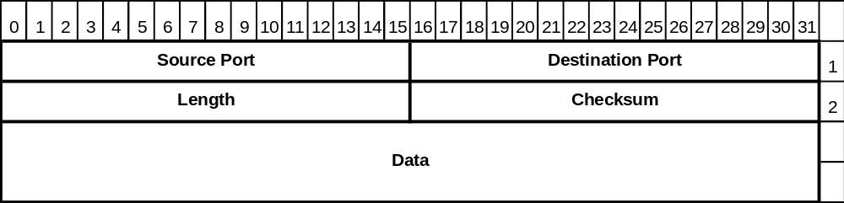

  - UDP header fields - what functions do they support
Don’t offer flow control and only Errol control but this error control mechanism does not prevent lost packets or duplicate packets

  - Examples of applications that use UDP as their transport layer
  - DNS
  - BOOTP
  - DHCP
  - TFTP
  - VoIP protocols: SIP, MGCP, RTP

- TCP
  - TCP header length 20bytes +options
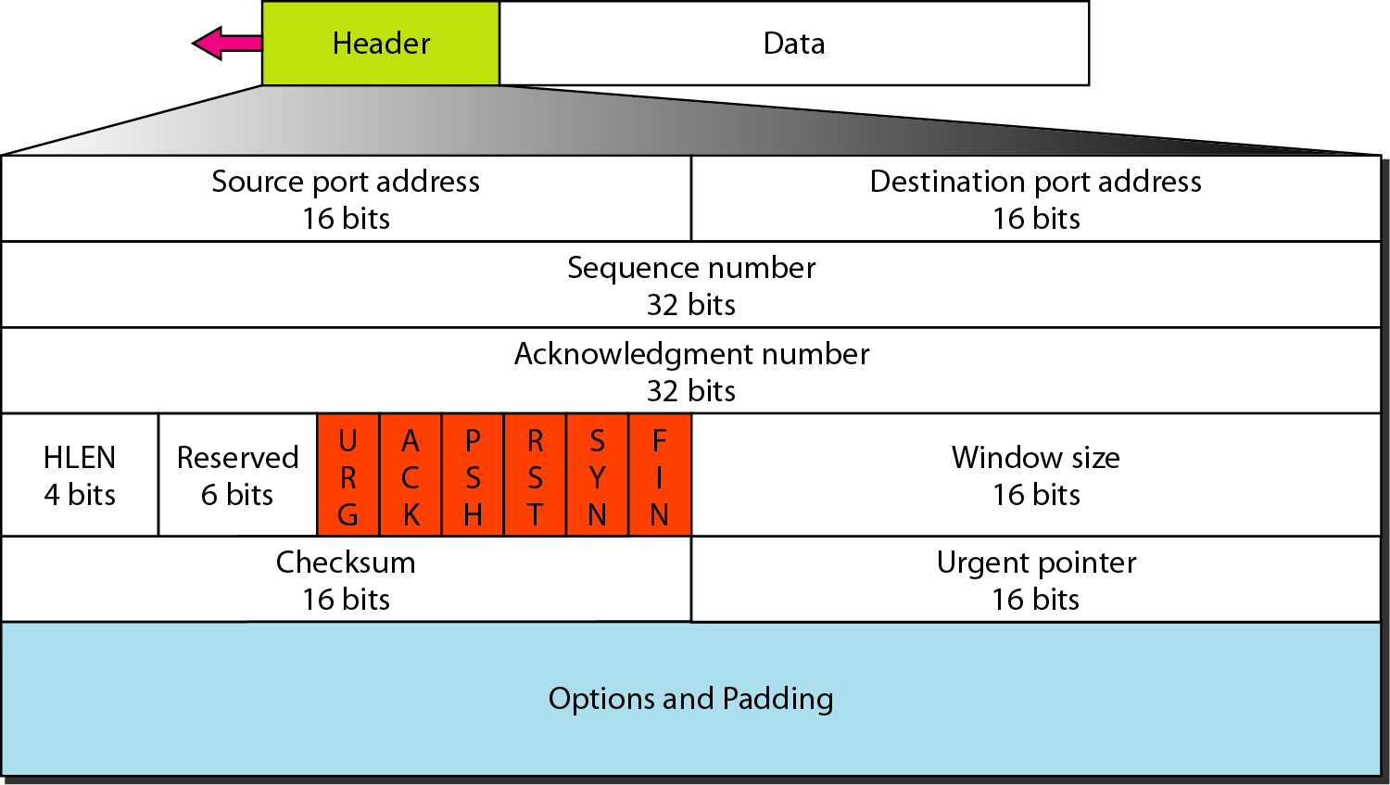

  - TCP header fields - what functions do they support Errol and flow control
- HLEN – (Data Offset Number) == Header Length indicates where the data begins.
- Reserved Field == Set to 0

  - TCP flags - what functions do they support
- The flags provide information about the data in the packet.

  - TCP options - MSS - Maximum Segment Size - when and why is this sent
  - Option 0 End of Option List
  - Option 1 No-Operation (NOOP).
  - Option 2 Maximum Segment Size
    - This is a TLV type of option (Type-Length-Value).
    - Type = 1 byte with a value of 2
    - Length = 1 byte with a value of 4
    - Value = 2 bytes that identify the maximum segment size
    - Only sent in the initial connection request - that is, in segments with the SYN flag is set.
  - Option SACK
- Maximum Segment Size indicates the maximum amount of data that the receiving system can accept.

  - Examples of applications that use TCP as their transport layer
    - E-mail
    - File transfer
    - Web browsing

- TCP segments – TCP numbers bytes
  - Sequence number is the number of the first byte being sent
  - Acknowledgement number is the number of the next byte expected to be received

- Understand the use of the TCP flags:
  - Push Data – tells TCP to over-ride the normal algorithms it uses to decide when to deliver the TCP body to the application and to deliver everything in its receive buffer right away

  - Urgent Data – tells TCP to put this data at the head of the line – take it out of sequence

  - Understand when TCP would need to read the value in the Urgent Pointer field
- The value of the urgent pointer tells TCP where the urgent information ends.
- This field is only read in a segment whose URG flag is set.

  - Understand the three “signaling flags” – SYN, ACK and FIN
- Three of these flags are used to create and delete connections under normal conditions.
- These are the ones we use in the TCP Three-Way Handshake
- ACK – This flag is set to 1 in all but the first segment during the process of establishing a connection.
- SYN – This flag is set to 1 in the initial messages when setting up a data transfer.
- FIN – This flag is set to 1 to close a session gracefully.

  - Understand what the RST flag is used for
- RST - This flag is set to 1 to indicate that the connection needs to be reset.
- Reset destroys the current connection, flushing the buffers and resetting all parameters to their null or default values

- Understand how the three-way handshake is used to create TCP connections
Establishing a TCP Connection:
Server tell TCP ready to receive requests→passive open
Step 1:
Application’s client side:
- The Client’s application sends data to TCP.
- TCP buffers the data.
- TCP constructs a segment.
The TCP segment includes:
    - source and destination port numbers
    - initial sequence number (chosen at random)
    - a window size
    - an optional maximum segment length.
TCP sets the SYN flag to 1.
TCP sends the segment.
Step 2:
- The TCP on the application's server side, responds to the SYN with a TCP message of its own.
- The TCP on the server side sets the SYN and the ACK flags to 1 in this segment.
- The server side's TCP segment includes :
  - window size
  - maximum segment size
  - its own sequence number – (also chosen at random)
  - an ACK number 1 greater than the value of the sequence number it received.
Step 3:
- The TCP process on the client side issues another segment.
  - Its sequence number is the old sequence number plus 1.
  - Its ACK number is the received sequence number plus 1.
  - It sets the ACK flag and sends this segment.
- This completes the three-way handshake.
- Now the TCP connection is open and both ends are ready to exchange data.

- 1) A --> B SYN my sequence number is X
- 2) A <-- B ACK your sequence number is X
- 3) A <-- B SYN my sequence number is Y
- 4) A --> B ACK your sequence number is Y
- Because steps 2 and 3 can be combined in a single message this is called the three way (or three message) handshake. .”

- Understand why a four-way handshake is needed to disconnect a TCP connection
- FIN – This flag is set to 1 to close a session gracefully.
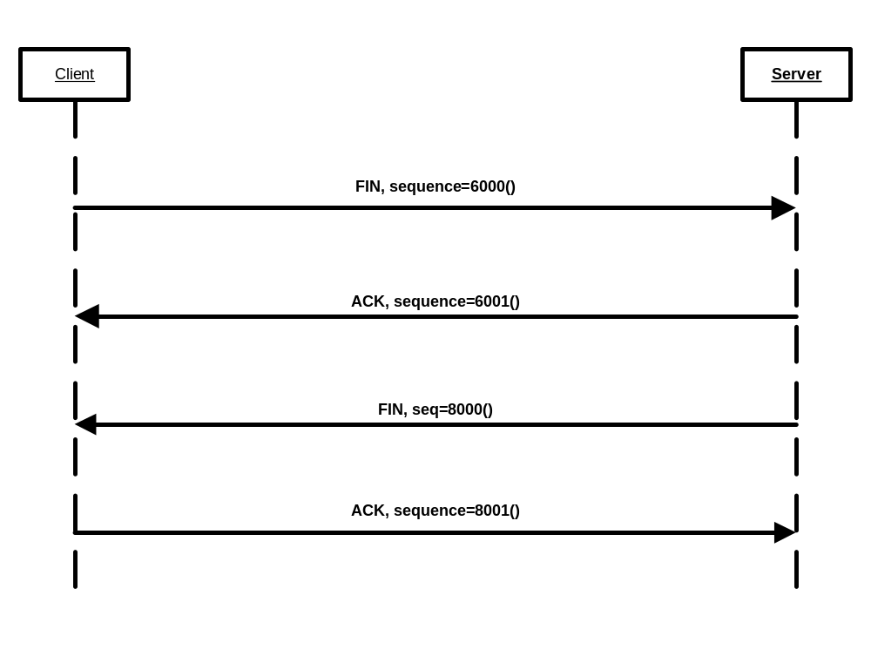
- The entity that wants to close the connections sends a segment with the FIN flag set.
- The far end sends a segment whose ACK flag is set.
- The far end sends a segment whose FIN flag is set.
- The first entity sends a segment whose ACK flag is set.
- At this point the connection is closed.

- Flow control and the sliding window protocol
- The far end's sending TCP process then knows that it may send “window” number of bytes starting with byte “ack."

  - We used the “byte-ruler” method to do simple calculations that let us determine the number of the highest byte that we are allowed to send.
  - We put the left edge of the byte-ruler down so as to cover the byte whose number is the same as the ACK value in the datagram we just received. \
  - Then we count to the right the number of bytes that is listed in the WINDOW field of the datagram we just received.
  - The byte that is covered by the right edge of the ruler is the last byte that we are allowed to send until we receive permission from the far end.
  - That permission will come in the form of a new TCP datagram whose ACK and WINDOW allow us to move the right edge of the ruler so as to cover a higher numbered byte.

- Understand what is meant by the State of the TCP connection and how to use the State Transition Diagram.
  - Remember that the state diagram shows the different states as ovals.
  - It has lines connecting one state to another.
  - On each line there will be two pieces of information:
    - One tells you what the triggering event is that drives you to change state;
    - The other tells you what message you emit or what other action you take as you transition to the next state.

