ITMO 440/540 - Data Networks

Forwarding and Routing

Assigned 11/10/2015 – Due 11/17/2015

Name: _______________________________________________________

Student ID: __________________________________________________

Purpose: Practice concepts related to Forwarding and Routing.

FORWARDING 1:
Refer to Figure 22.7 below find the answers to the following questions.

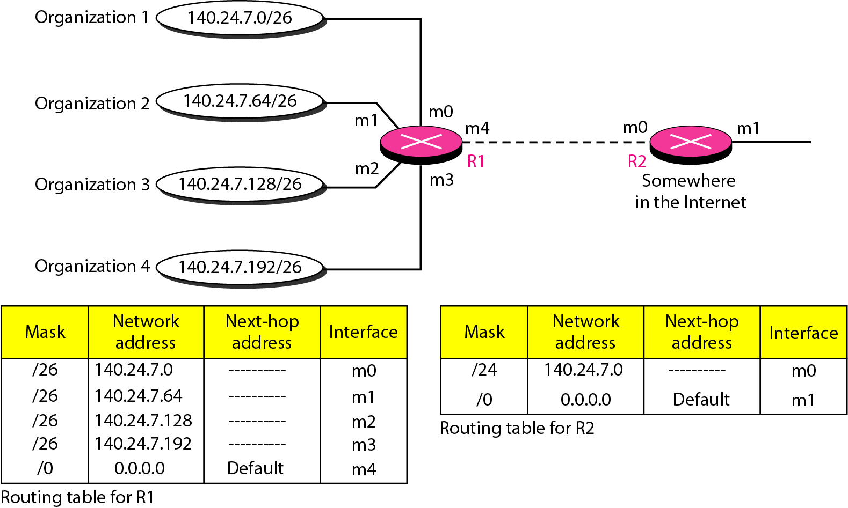
Figure 22.7

1. An IP datagram arrives at the m1 interface of R1. It has a destination IP address of 240.100.5.9. What interface does R1 send that datagram to?

11111111 11111111 11111111 11000000
240 100 5 9

The result of anding this destination IP address with a /26 mask is 240.100.5.0. Since this does not correspond to any network address in the routing table, the router sends the datagram to m4.
______________________________________

2. An IP datagram arrives at the m4 interface of R1. It has destination IP address of 140.24.7.75. What interface does R1 send that datagram to?

11111111 11111111 11111111 11000000
140 24 7 01001011

140.24.135.64 is the result of applying the /26 mask
So this datagram is sent to interface m1.

________________________________________

3. An IP datagram arrives on the m3 interface of R1. Its destination IP address is 140.24.7.132. What interface is it sent to?

11111111 11111111 11111111 11000000
140 24 7 10000100

The result of anding the mask with the destination address is 140.24.7.128. So the datagram is routed to m2.

___________________________________

FORWARDING 2:
Refer to Figure 22.8 below find the answers to the following questions.

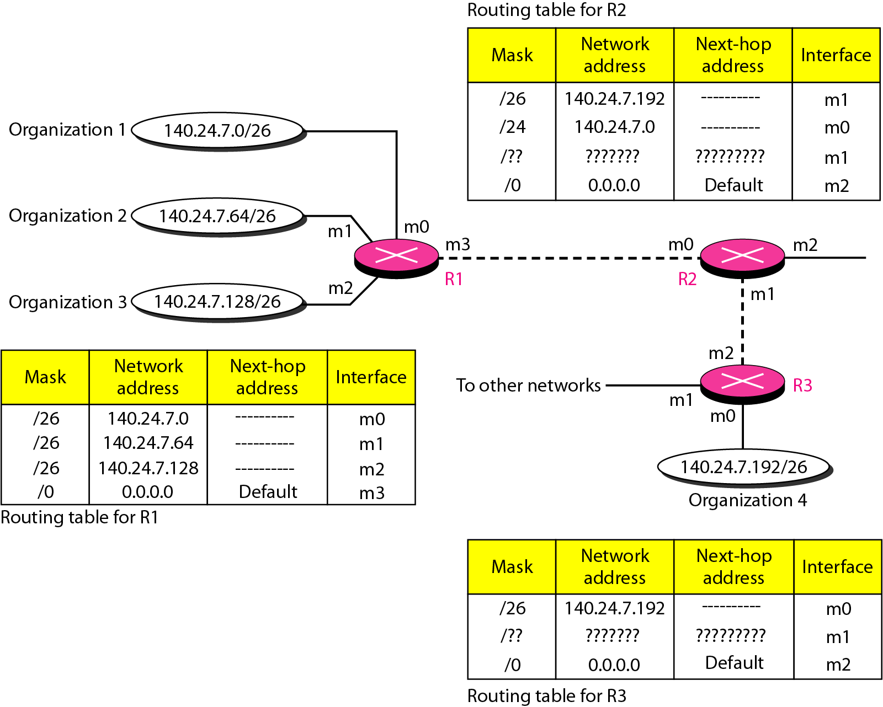
Figure 22.8

4. An IP Datagram arrives at the m2 interface of R2. Its destination address is 140.24.7.200.

a. To which interface of R2 is it sent?

/26 mask is 11111111 11111111 11111111 11000000
Apply to 140 24 7 200

Result is 140.24.7.192

So it is sent to the m1 interface.

________________________________

b. Which interface would it have been routed to if the routing table for R2 had listed the rows with the /24 in a row above the /26, so that the first two rows of the routing table looked like this:

/24 140.24.7.0 m0
/26 140.24.7.192 m1

Apply the mask /24 to the destination address:

11111111 11111111 11111111 00000000
140.24.7.200

The result is 140.24.7.0, so you would choose m0.

_____________________________________

5. An IP datagram arrives at the m1 interface of R3. It has a destination IP address of 140.24.7.220. What interface is it sent to?

Apply /26 to 140.24.7.220

11111111 11111111 11111111 11000000
140 24 7 11011100

140.24.7.192

This result matches the destination address in the first row, so the datagram is sent to interface m0.

_______________________________________

6. An IP datagram arrives at the m3 interface of R1. It has a destination IP address of 140.24.7.91. What interface is it sent to?

Apply /26 to the destination address
11111111 11111111 11111111 11000000
140 24 7 01011011

140.24.7.64

This result does not match the destination address in the first row.
It does match the destination address in the second row.
So the datagram is sent to m1.

_________________________________________

ROUTING 1:
1. What type of routing is used in the RIP routing protocol? distance vector _______________

2. What is the metric that is used to determine the best route in the RIP protocol? hop count ____________________________________

Find the answers to the following questions in Trace 1 below.

3. What is the transport protocol that is carrying the RIP protocol message? UDP __________________________________________________

4. What is the IP address from which this RIP message is sent? 10.0.1.10 ______

5. Is this a public or a private address? Private ___________________________

6. What is the hop count between this address and 10.0.2.0? 2 _______________

7. What is the hop count between this address and 10.4.2.0? 1 ________________

8. Is the destination MAC address a multicast address or a unicast address? multicast ____________________________________________________________________

9. Is the destination IP address a multicast address or a unicast address (it is classful)? multicast _____________________________________________________________________

Trace 1
Frame 1: 86 bytes on wire (688 bits), 86 bytes captured (688 bits)
Ethernet II, Src: Cisco_c6:64:00 (00:0c:30:c6:64:00), Dst: IPv4mcast_00:00:09 (01:00:5e:00:00:09)
Internet Protocol Version 4, Src: 10.0.1.10 (10.0.1.10), Dst: 224.0.0.9 (224.0.0.9)
User Datagram Protocol, Src Port: router (520), Dst Port: router (520)
Routing Information Protocol
Command: Response (2)
Version: RIPv2 (2)
IP Address: 10.0.2.0, Metric: 2
IP Address: 10.4.2.0, Metric: 1

ROUTING 2: RIP Routing Table Practice

1. Solve the following problem and show your work:

Router X has the following RIP routing table:

Destination Network | hop count | next hop
N2 | 1 | A
N4 | 3 | A
N5 | 4 | C
N7 | 2 | C
N9 | 2 | B
N10 | 5 | A

What will the contents of the routing table be after the router receives and processes the following RIP message from Router C?

Destination Network | hop count
N1 | 3
N2 | 2
N3 | 2
N4 | 4
N7 | 3
N9 | 3

Solution work sheet: add this column!
Destination Network | New hop count | Next Hop
N1 | 4 | C
N2 | 3 | C
N3 | 3 | C
N4 | 5 | C
N7 | 4 | C
N9 | 4 | C

New Routing Table:
Destination Network | hop count | next hop
N1 | 4 | C
N2 | 1 | A
N3 | 3 | C
N4 | 3 | A
N5 | 4 | C
N6 no need to add this line
N7 | 4 | C
N8 no need to add this line
N9 | 2 | B
N10 | 5 | A

2. Solve the following problem and show your work:

Router X has the following RIP routing table:

Destination Network | hop count | net hop router
N1 | 2 | A
N2 | 3 | C
N6 | 1 | F
N8 | 3 | E
N9 | 7 | F
N10 | 2 | E

What will the contents of the routing table be after the router receives and processes the following RIP message from Router E?

Destination Network | hop count (from E)
N1 | 3
N2 | 3
N3 | 4
N4 | 2
N6 | 2
N8 | 4
N9 | 3
N10 | 3

Solution:
Work sheet add add
Destination Network | hop count (from E) | hop count + 1 | next hop
N1 | 3 | 4 | E
N2 | 3 | 4 | E
N3 | 4 | 5 | E
N4 | 2 | 3 | E
N5 | 2 | 3 | E
N8 | 4 | 5 | E
N9 | 3 | 4 | E
N10 | 3 | 4 | E

New Routing Table
Destination Network | hop count | net hop router
N1 | 2 | A
N2 | 3 | C
N3 | 5 | E
N4 | 3 | E
N5 | 3 | E
N6 | - | -
N7 | - | -
N8 | 5 | E
N9 | 4 | E
N10 | 4 | E

