ITMO 440/540 - Data Networks

Forwarding and Routing

Assigned 11/10/2015 – Due 11/17/2015

Name: ____________Hong Zhang_________________________

Student ID: _______A20340043_____________________________

Purpose: Practice concepts related to Forwarding and Routing.

FORWARDING 1:
Refer to Figure 22.7 below find the answers to the following questions.

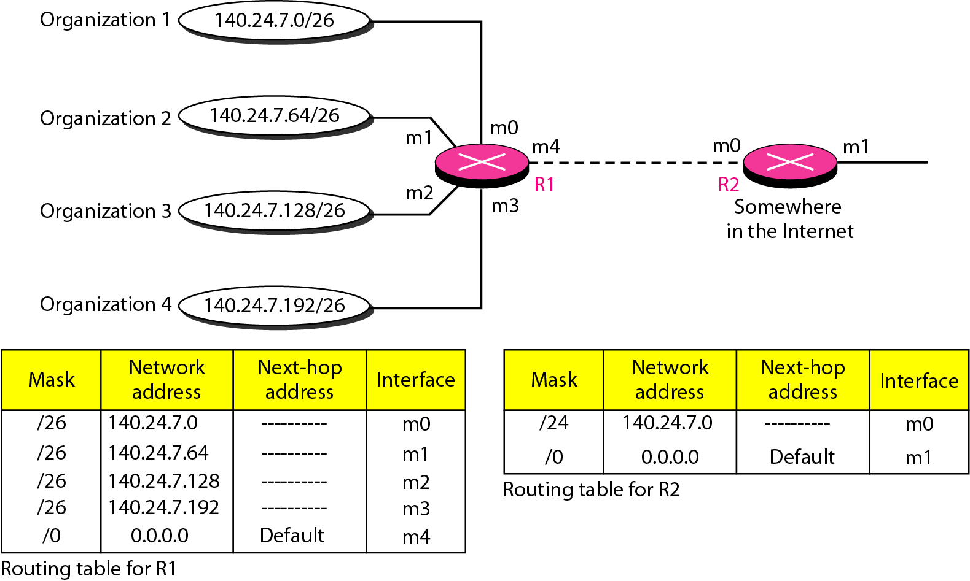
Figure 22.7

1. An IP datagram arrives at the m1 interface of R1. It has a destination IP address of 240.100.5.9. What interface does R1 send that datagram to?

______ m4 interface of R1_____________

2. An IP datagram arrives at the m4 interface of R1. It has destination IP address of 140.24.7.75. What interface does R1 send that datagram to?

______ m1 interface of R1_____________

3. An IP datagram arrives on the m3 interface of R1. Its destination IP address is 140.24.7.132. What interface is it sent to?

______ m2 interface of R1_______________

FORWARDING 2:
Refer to Figure 22.8 below find the answers to the following questions.

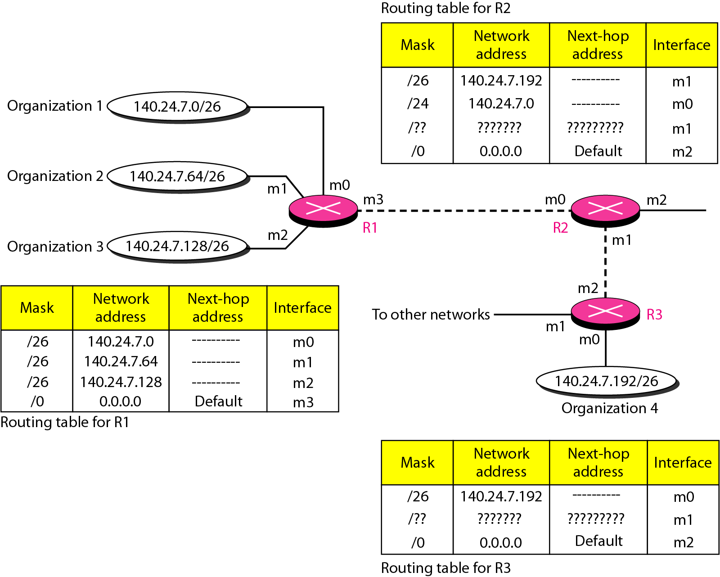
Figure 22.8

4. An IP Datagram arrives at the m2 interface of R2. Its destination address is 140.24.7.200.

a. To which interface of R2 is it sent?

_____ m1 interface of R2_____________

b. Which interface would it have been routed to if the routing table for R2 had listed the rows with the /24 in a row above the /26, so that the first two rows of the routing table looked like this:

/24 140.24.7.0 m0
/26 140.24.7.192 m1

______ m0 interface of R2___________

5. An IP datagram arrives at the m1 interface of R3. It has a destination IP address of 140.24.7.220. What interface is it sent to?

________ m0 interface of R3________________

6. An IP datagram arrives at the m3 interface of R1. It has a destination IP address of 140.24.7.91. What interface is it sent to?

________ m1 interface of R1__________________

ROUTING 1:
1. What type of routing is used in the RIP routing protocol?
_____ Distance Vector routing __________

2. What is the metric that is used to determine the best route in the RIP protocol?
______ hop count ____________

Find the answers to the following questions in Trace 1 below.

3. What is the transport protocol that is carrying the RIP protocol message?
_______ User Datagram Protocol (UDP)______________________________

4. What is the IP address from which this RIP message is sent? __10.0.1.10 ____

5. Is this a public or a private address? _____ a private address ___________

6. What is the hop count between this address and 10.0.2.0? _____2________

7. What is the hop count between this address and 10.4.2.0? ______1_______

8. Is the destination MAC address a multicast address or a unicast address?
_____ a multicast address _______________________________________________

9. Is the destination IP address a multicast address or a unicast address?
_____ a multicast address ___________________________________________

Trace 1
Frame 1: 86 bytes on wire (688 bits), 86 bytes captured (688 bits)
Ethernet II, Src: Cisco_c6:64:00 (00:0c:30:c6:64:00), Dst: IPv4mcast_00:00:09 (01:00:5e:00:00:09)
Internet Protocol Version 4, Src: 10.0.1.10 (10.0.1.10), Dst: 224.0.0.9 (224.0.0.9)
User Datagram Protocol, Src Port: router (520), Dst Port: router (520)
Routing Information Protocol
Command: Response (2)
Version: RIPv2 (2)
IP Address: 10.0.2.0, Metric: 2
IP Address: 10.4.2.0, Metric: 1

ROUTING 2: RIP Routing Table Practice

1. Solve the following problem and show your work:

Router X has the following RIP routing table:

Destination Network | hop count | next hop
N2 | 1 | A
N4 | 3 | A
N5 | 4 | C
N7 | 2 | C
N9 | 2 | B
N10 | 5 | A

What will the contents of the routing table be after the router receives and processes the following RIP message from Router C?

Destination Network | hop count
N1 | 3
N2 | 2
N3 | 2
N4 | 4
N7 | 3
N9 | 3

Work Sheet: Modified Message – adds one column and changes the hop count
Destination Network | New hop count | Next Hop
N1 | 4 | C
N2 | 3 | C
N3 | 3 | C
N4 | 5 | C
N7 | 4 | C
N9 | 4 | C

New Routing Table:
Destination Network | hop count | next hop
N1 | 4 | C
N2 | 1 | A
N3 | 3 | C
N4 | 3 | A
N5 | 4 | C
N7 | 4 | C
N9 | 2 | B
N10 | 5 | A

2. Solve the following problem and show your work:

Router X has the following RIP routing table:

Destination Network | hop count | net hop router
N1 | 2 | A
N2 | 3 | C
N6 | 1 | F
N8 | 3 | E
N9 | 7 | F
N10 | 2 | E

What will the contents of the routing table be after the router receives and processes the following RIP message from Router E?

Destination Network | hop count (from E)
N1 | 3
N2 | 3
N3 | 4
N4 | 2
N6 | 2
N8 | 4
N9 | 3
N10 | 3

Solution:
Work sheet add add
Destination Network | hop count (from E) | hop count + 1 | next hop
N1 | 3 | 4 | E
N2 | 3 | 4 | E
N3 | 4 | 5 | E
N4 | 2 | 3 | E
N6 | 2 | 3 | E
N8 | 4 | 5 | E
N9 | 3 | 4 | E
N10 | 3 | 4 | E

New Routing Table
Destination Network | hop count | next hop
N1 | 2 | A
N2 | 3 | C
N3 | 5 | E
N4 | 3 | E
N6 | 1 | F
N8 | 5 | E
N9 | 4 | E
N10 | 4 | E

