ITM 440/540 - Data Networks

Homework 12

Assigned: 11/17/2015 - Due: 11/24/2015

Name: ANSWERS

Purpose I: Apply the OSPF routing method (Dijkstra’s Algorithm.)

You are Router B and below is a graphical representation of your Autonomous System. You drew this graph using the information that was contained in the LSAs you have received from each of the routers in the Autonomous System. The information you received in the LSAs is also shown in the form of a table on the next page. Take this information as input. It is your routing DATA BASE . You need to operate on this routing data base using the Dijkstra Algorithm in order to create your ROUTING TABLE. There are two parts to this assignment. 1. Work the algorithm 2. Fill in the routing table entries. Forms are provided for each part.

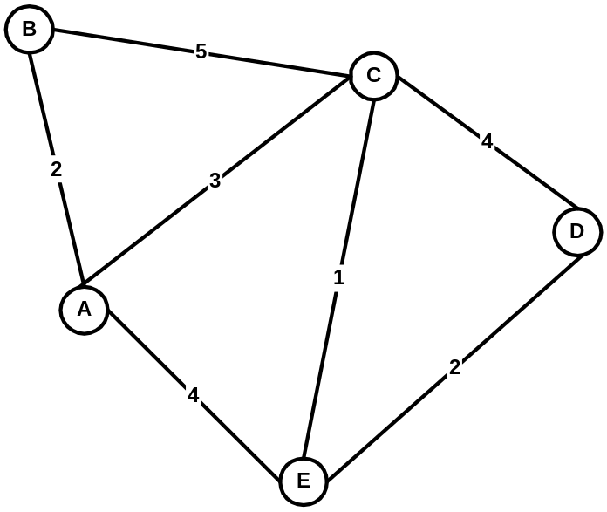

Autonomous System

Below is the information contained in the complete set of LSPs that have flooded this Autonomous System.

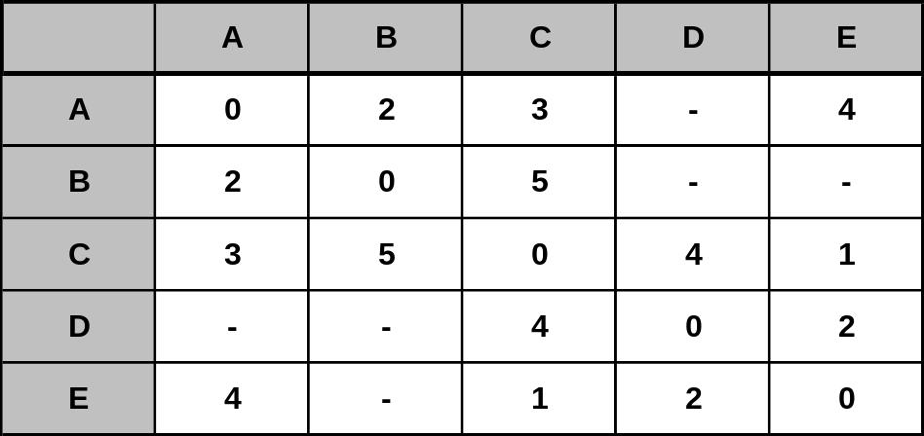

Set of all LSPs from the AS - organized into a database

Explanation of this routing database:

Read Row C as follows:
- It costs C 3 to get to A
- It costs C 5 to bet to B
- It costs C 0 to get to C
- It costs C 4 to get to D
- It costs C 1 to get to E.

You are Router B, and you need to calculate your routing table. You do so by applying the Dijkstra algorithm to the data base above, which is represented graphically on page 1.

To work the algorithm, you make a table that has two columns. One column contains Confirmed entries and the other contains Tentative entries. Entries are of the form (Destination, Cost, NextHop) , where NextHop means the next router that I need to jump to in order to get to the Desination.

Below is a blank table for you to use as you work the algorithm. (I recommend using another sheet of paper to calculate the candidate entries before entering them in the tentative column.) (I also recommend that as soon as you move a destination into the confirmed column you cross out all the other tentative entries for that destination.)

CONFIRMED | TENTATIVE
( B, 0, - ) | ( C, 5, C ) ( A, 2, A )
( A, 2, A ) | ( C, 5, A ) ( E, 6, A )
( C, 5, C ) | ( D, 9, C ) (E, 6, C ) ** SEE NOTE
( E, 6, A ) | ( D, 8, A )
( D, 8, A )
** You could have chosen (C, 5,A) as well. The next hops would be different but the costs would be the same. I apply a rule that I always take the first lowest number that I found. So, when grading this check the costs first and then observe that you could have C,5,A , (D,9,A) and (E,6,A) in that row. But all the other answers would be the same.

Fill in the Routing Table using the entries you recorded above.

DESTINATION | NEXT-HOP ROUTER | COST
A | A | 2
B | - | 0
C | C (or A) | 5
D | A | 8
E | A | 6

Problem 2.

You are the Router F and you have received the following routing database – shown below in graphical form.

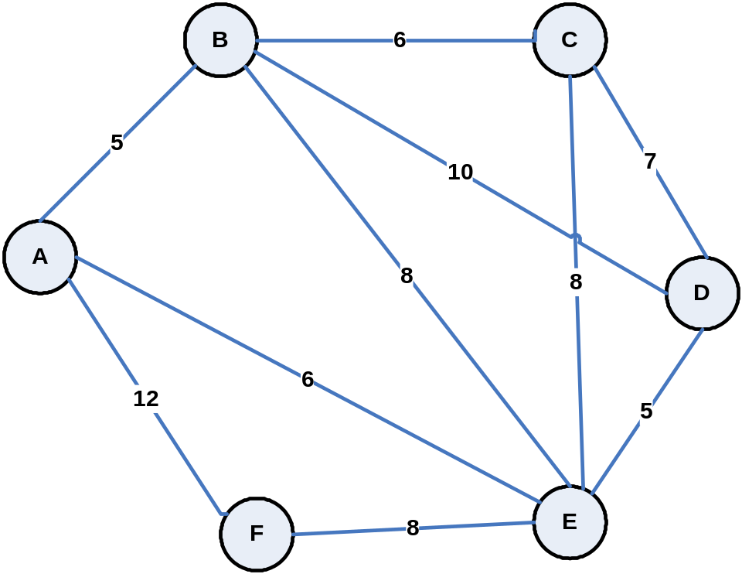

Operate on this routing database using the Dijkstra algorithm and filling in the form below. Then, create your routing table using the form below algorithm form.

Dijkstra Algorithm Form
CONFIRMED | TENTATIVE
( F, 0, - ) | ( A, 12, A ) ( E, 8, E )
( E, 8, E ) | ( A, 14, E ) ( B, 16, B ) ( C, 16, E ) ( D, 13, E )
( A, 12, A ) | ( B, 17, A )
( D, 13, E ) | ( B, 23, E ) ( C, 20, E )
( B, 16, E ) | ( C, 22, E )
( C, 16, E )

Fill in the Routing Table using the entries you recorded above.

DESTINATION | NEXT-HOP ROUTER | COST
A | A | 12
B | E | 16
C | E | 16
D | E | 13
E | E | 8
F | - | 0

Problem 3.

You are the Router C and you have received the following routing database – shown below in graphical form.

Operate on this routing database using the Dijkstra algorithm and filling in the form below. Then, create your routing table using the form below the algorithm form.

Dijkstra Algorithm Form
CONFIRMED | TENTATIVE
( C, 0, - ) | ( B, 6, B ) ( D, 7, D ) ( E, 8, E )
( B, 6, B ) | ( D, 16, B ) ( E, 14, B ) ( A, 11, B )
( D, 7, D ) | ( F, 16, E ) ( A, 14, E )
( A, 11, B ) | ( F, 23, B )
( F, 16, E )

Fill in the Routing Table using the entries you recorded above.

DESTINATION | NEXT-HOP ROUTER | COST
A | B | 11
B | B | 6
C | - | 0
D | D | 7
E | E | 8
F | E | 16

