ITM 440/540 - Data Networks
HW 14 – TCP Flow Control and Call States

Purpose 1: To practice TCP Flow Control Concepts

Answer the following questions about the trace, ‘trace-2-browsing-to-web-site.’

1. In Frame 7, which application layer protocol is requesting a TCP connection to be created? HTTP ________

2. In Frame 7, is there an ACK flag raised? No___________

3. In Frame 7, what is the relative sequence number of this TCP segment? 0_____

4. In Frame 7, what is the window size that the sender of this TCP datagram is advertising? 8192 ________

5. In Frame 7 what is the largest segment that the sender of this TCP datagram is willing to receive? 1460 bytes ___________

6. In Frame 8, which two flags are raised? ___ ACK and SYN _____.

7. In Frame 8, what window size does the sender of this TCP datagram advertise? 1460 _______

8. In Frame 8, what is the largest segment that the sender of this TCP datagram is willing to receive? 1380 _______________

9. In Frame 8, what is the value of the next SEQ number that the sender of this TCP datagram expects to receive from the distant end? 1 ________

10. In Frame 9, what is the window size now being advertised? 16560 ______

11. In Frame 10, how large in bytes is the body of the TCP message? 1230 bytes in the total frame; 14 layer 2 header; 20 layer 3 header; 20 layer 4 header =54 bytes of headers, so 1230 – 54 = 1176 bytes of body. Note that this information is also made available by Wireshark in the top line of the display. ___________________

12. In Frame 10, what is the window size advertised in the TCP message? 16560 ____

13. In Frame 10, what is the next SEQ value that the sender of this TCP message expects to receive from the far end? 1 ____________

14. In Frame 11, what is the next SEQ value that the sender of this TCP message expects to receive from the far end? 1177 _______________

15. In Frame 11, what value convinces you that TCP has successfully received all the bytes that it received from Frame 10? The SEQ value is 1177. This means that TCP is ready to receive byte 1177, and the last byte that was sent is 1176. _____

16. In Frame 52, which two flags are raised? FIN and ACK _______

17. In Frame 52, what window size is advertised by the TCP that is sending this message? 12928 _____________

18. In Frame 52, is it the client or the server that is sending this message? Server ____

19. In Frame 52, what is the next SEQ value that the sender of this TCP message expects to receive? 3281 ____________

20. In Frame 53, what is the sequence number of this TCP segment? 3281 _____

The diagram below represents the ‘send’ buffer of a TCP process. Use it to answer the following questions:

The TCP process that owns this ‘send’ buffer receives a TCP message whose ACK value is 12 and whose window value is 7.

21. What is the number of the last byte that this TCP process may send before it receives more instructions from the far end? 18____

The TCP process that owns this ‘send’ buffer has already sent a 3-byte long segment whose sequence number was 12.

22. What is the number of the next byte that the sender is ready to send? 15 __________

23. What is the maximum number of bytes that this TCP process is allowed to send before it receives more instructions from the far end? 4 (bytes 15,16,17 and 18) _____

Purpose 2: To practice using the concept of connection state

Use the diagrams below to answer these questions about the connection state of the client and the server.

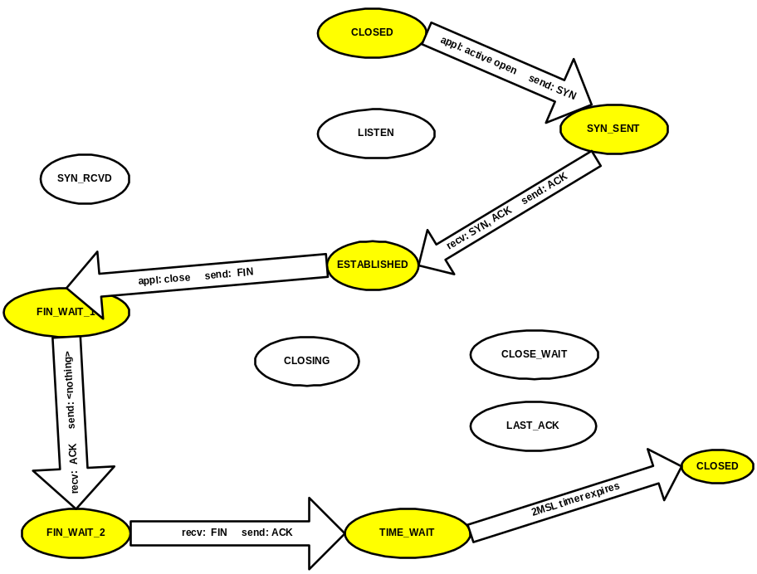
Client: Normal state transitions

- What triggering event causes the client TCP to transition from the CLOSED state to the SYN_SENT state? The application requests TCP to open a connection _________
- While the client TCP is making the transition from the CLOSED state to the SYN_SENT state, what message does it send to the server? SYN _______
- What triggering event causes the client TCP to transition from the SYN_SENT state to the ESTABLISHED state? It receives a SYN/ACK from the server TCP _________________
- While the client TCP is making the transition from the SYN_SENT state to the ESTABLISHED state, what message does it send to the server? ACK _______
- When the client application is done with the TCP connection, it sends a close request to the client TCP causing the client TCP to transition from the ESTABLISHED state to the FIN_WAIT_1 state. What message does the client TCP send while making this transition? FIN ___________
- What triggering event causes the client TCP to transition from the FIN_WAIT_1 state to the FIN_WAIT_2 state? It receives an ACK from the TCP server______
- While the client TCP is making the transition from the FIN_WAIT_1 state to the FIN_WAIT_2 state, what message does it send to the server? It does not send any message to the server _________

