ITM 440/540 - Data Networks

Homework 14

Assigned: 11/24/2015 - Due: 12/03/2015

Name: _______Hong Zhang___________________________________

Purpose 1: To practice TCP Flow Control and Call States

Answer the following questions about Trace-HW2 ‘trace-2-browsing-to-web-site.’

1. In Frame 7, which application layer protocol is requesting a TCP connection to be created? ___ HTTP _____

2. In Frame 7, is there an ACK flag raised? __No. Flags: 0x002 (SYN) _________

3. In Frame 7, what is the relative sequence number of this TCP segment?
_ Sequence number: 0 (relative sequence number) ___

4. In Frame 7, what is the window size that the sender of this TCP datagram is advertising? __ Window size value: 8192 ______

5. In Frame 7 what is the largest segment that the sender of this TCP datagram is willing to receive? __ Maximum segment size: 1460 bytes_________

6. In Frame 8, which two flags are raised? _SYN_ and __ACK___.
_ (Flags: 0x012 (SYN, ACK) )__

7. In Frame 8, what window size does the sender of this TCP datagram advertise?
__ Window size value: 1460_____

8. In Frame 8, what is the largest segment that the sender of this TCP datagram is willing to receive? ___ Maximum segment size: 1380 bytes____________

9. In Frame 8, what is the value of the next SEQ number that the sender of this TCP datagram expects to receive from the distant end?
__ Acknowledgment number: 1 (relative ack number)______

10. In Frame 9, what is the window size now being advertised?
__ Window size value: 4140____

11. In Frame 10, how large in bytes is the body of the TCP message?
____ 1176 bytes (Len: 1176)_______________

12. In Frame 10, what is the window size advertised in the TCP message?
_Window size value: 4140___

13. In Frame 10, what is the next SEQ value that the sender of this TCP message expects to receive from the far end?
___Acknowledgment number: 1 (relative ack number)_________

14. In Frame 11, what is the next SEQ value that the sender of this TCP message expects to receive from the far end?
____Acknowledgment number: 1177 (relative ack number)___________

15. In Frame 11, what value convinces you that TCP has successfully received all the bytes that it received from Frame 10?
__Acknowledgment number: 1177 (relative ack number) which is equal with Next sequence number: 1177 (relative sequence number) in Frame 10.___

16. In Frame 52, which two flags are raised? __(Flags: 0x011 (FIN, ACK)) ____
___FIN _and _ ACK ______

17. In Frame 52, what window size is advertised by the TCP that is sending this message? ___Window size value: 101__________

18. In Frame 52, is it the client or the server that is sending this message? __The Sever _

19. In Frame 52, what is the next SEQ value that the sender of this TCP message expects to receive? __Acknowledgment number: 3281 (relative ack number)__________

20. In Frame 53, what is the sequence number of this TCP segment?
__Sequence number: 3281 (relative sequence number)___

The diagram below represents the ‘send’ buffer of a TCP process. Use it to answer the following questions:

The TCP process that owns this ‘send’ buffer receives a TCP message whose ACK value is 12 and whose window value is 7.

21. What is the number of the last byte that this TCP process may send before it receives more instructions from the far end? 18____

The TCP process that owns this ‘send’ buffer has already sent a 3-byte long segment whose sequence number was 12.

22. What is the number of the next byte that the sender is ready to send? 15 __________

23. What is the maximum number of bytes that this TCP process is allowed to send before it receives more instructions from the far end? 4 (bytes 15,16,17 and 18) _____

Purpose 2: To practice using the concept of connection states

Use the diagrams below to answer these questions about the connection state of the client and the server.

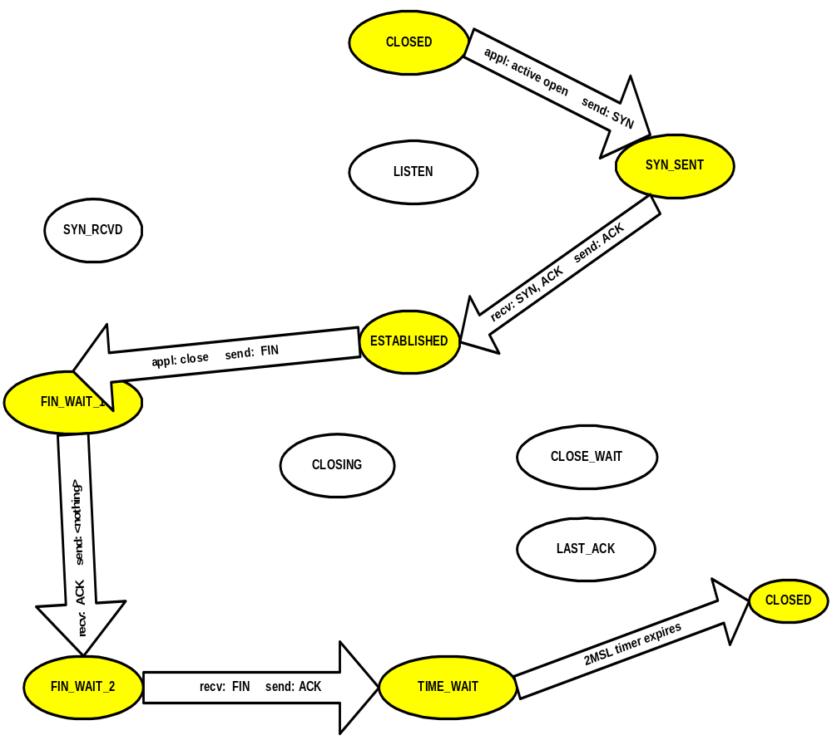
Client: Normal state transitions
- What triggering event causes the client TCP to transition from the CLOSED state to the SYN_SENT state? _Receiving a message from the application________

- While the client TCP is making the transition from the CLOSED state to the SYN_SENT state, what message does it send to the server?
__Sending a SYN_____

- What triggering event causes the client TCP to transition from the SYN_SENT state to the ESTABLISHED state? ____TCP receives a SYN/ACK ______

- While the client TCP is making the transition from the SYN_SENT state to the ESTABLISHED state, what message does it send to the server?
__Sending an ACK_____

- When the client application is done with the TCP connection, it sends a close request to the client TCP causing the client TCP to transition from the ESTABLISHED state to the FIN_WAIT_1 state. What message does the client TCP send while making this transition? ___Sending a FIN ________

- What triggering event causes the client TCP to transition from the FIN_WAIT_1 state to the FIN_WAIT_2 state? __TCP receives an ACK____

- While the client TCP is making the transition from the FIN_WAIT_1 state to the FIN_WAIT_2 state, what message does it send to the server?
__It sends nothing_______

