ITMO 440/540 - Data Networks

Assignment 4

Assigned: 09/15/2015 Due: 09/22/2015

Name: ___Hong Zhang_____________________________________________

CWID: ___A20340043_____________________________________________

Purpose: Practice using different line codes to encode data bits for transmission. The codebooks for all the line codes used in this homework are located at the end of this homework assignment.

Use the code books at the end of this homework to encode the following 16 bits in the data to be sent:

1 1 0 0 1 0 1 0 1 1 1 1 0 0 0 0

Example:
Question: Encode the bit stream above using the Unipolar line code indicated in the code book.

Answer: + + 0 0 + 0 + 0 + + + + 0 0 0 0

Questions:
- Encode the bit stream above using the ‘Polar NRZ-L’ line code:

____ - - + + - + - + - - - - + + + + ______________________

- Encode the bit stream above using the ‘Polar NRZ-I’ line code. The last signal on the link had positive polarity.

___ - + + + - - + + - + - + + + + + _______________________

- Encode the bit stream above using the ‘Manchester’ line code. The code book shows the entries L/H (1) and H/L (0) to represent the center transitions from Low to high or from high to low. An example of how to write your answer is H/L, L/H, L/H, H/L, ...

__L/H, L/H, H/L, H/L, L/H, H/L, L/H, H/L, L/H, L/H, L/H, L/H, H/L, H/L, H/L, H/L_

- Draw the signal represented in question 3 above. Use the template below. You may draw it by hand and then take a screen shot or photo of it.
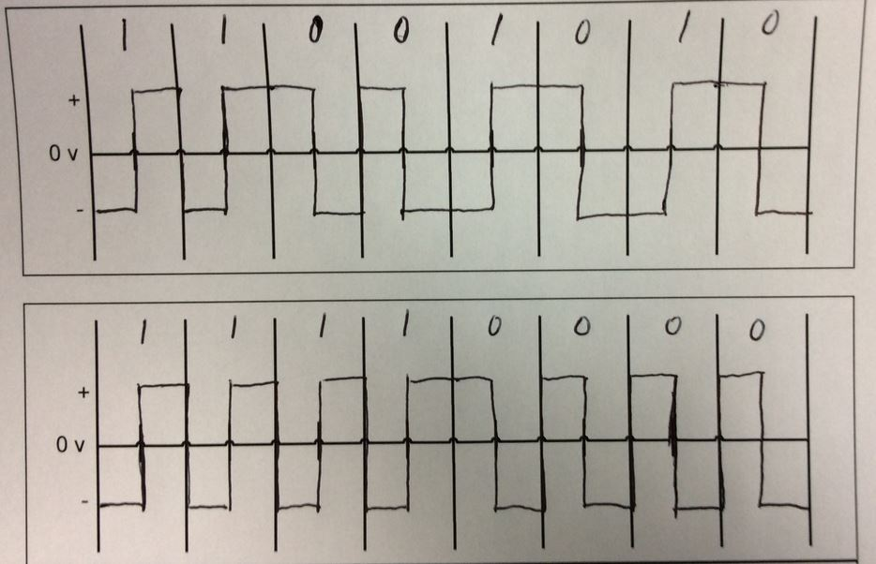
Figure 1: Signal created in question 3.

- Encode the bit stream above using the Differential Manchester line code. Assume that the last signal on the link had a positive polarity.

__H/L, L/H, L/H, L/H, H/L, H/L, L/H, L/H, H/L, L/H, H/L, L/H, L/H, L/H, L/H, L/H___

- Draw the signal represented in question 5 above. Use the template below.
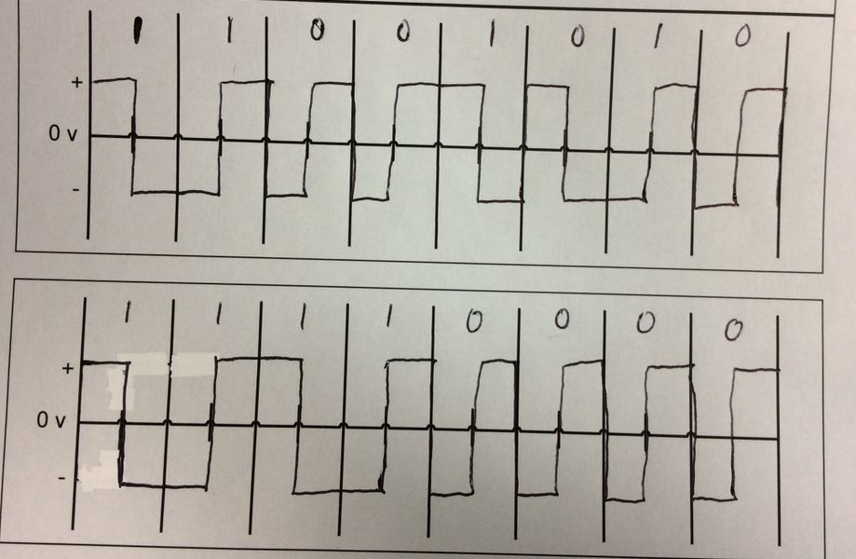
Figure 2: Signal created in question 5.

- Use the NRZ-L code book, to encode the following string of bits: 1 1 1 1 1 1 1 1

___ - - - - - - - - _________________________________
- Use the NRZ-I code book, to encode the same string of bits: 1 1 1 1 1 1 1 1 . Assume that the polarity on the link is positive before you begin to send the signals.

___ - + - + - + - + _________________________________

- Does the signal created in question 7 provide self-synchronization? __No___________

- Does the signal created in question 7 build up a charge on the line? __Yes___________

- Does the signal created in question 8 provide self-synchronization? __Yes___________

- Does the signal created in question 8 build up a charge on the line? ___No__________

- In both the Manchester code and the Differential Manchester code, there is always a transition from one polarity to the other. Where does that transition take place?

___ (a) __________________________________________________________
a) In the middle of the bit interval b) at the left edge of the bit interval

- In the Differential Manchester code the transition in the middle of the bit interval is used for which purpose below?
___ (a) ________________________________________________________
a) synchronization b) identifying whether the signal represents a ‘0’ bit or a ‘1’ bit

- Use the Manchester code book to encode the bit stream 11111111. Assume that the last signal on the link had a positive polarity.

_L/H, L/H, L/H, L/H, L/H, L/H, L/H, L/H ___________________________________

- Draw the signal represented in question 15 above. Use the template below.
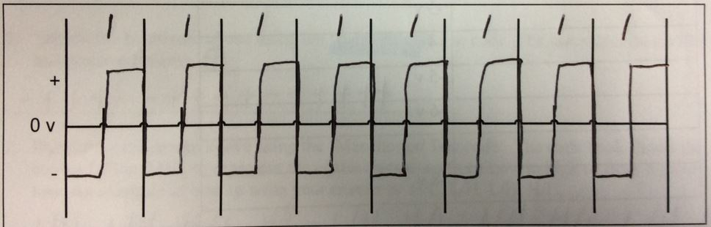
Figure 3: Signal created in question 15.

- Does the signal created in question 15 provide self-synchronization? ___Yes_________

- Does the signal created in question 15 build up a charge on the line? ____No_________

Suppose we can create 16 different signal levels as shown in the code book below.

- How many bits can you associate with each Signal level? ____4_____________

- Fill in one possible way to write the code book for the eight levels, assigning a distinct bit pattern to each level. You need to associate a unique bit pattern to each row in the column labeled ‘Bit Pattern.’

Bit Pattern | Signal level
0000 | +8 v
0001 | +7 v
0010 | +6v
0100 | +5 v
1000 | +4 v
0011 | +3 v
0110 | +2 v
1100 | +1 v
0101 | -1 v
1010 | -2 v
1001 | -3 v
0111 | -4 v
1011 | -5 v
1101 | -6 v
1110 | -7 v
1111 | -8 v

Code Books

Unipolar
The signal has no polarity if the bit to be sent is ‘0’.
The signal has positive polarity if the bit to be sent is ‘1’.
Bit | Signal Polarity
0 | 0
1 | +

Polar : NRZ-L

The signal’s polarity is dictated by the bit value.

The rule is:

If the bit is ‘0’ the polarity of the signal is positive.

If the bit is ‘1’ the polarity of the signal is negative.
Bit | Signal Polarity
0 | +
1 | -

Polar : NRZ-I

The signal’s polarity is determined by two things: the value of the bit to be sent, and the polarity of the previous signal.

The rule is:

Do not invert at the left edge if the bit value is ‘0’.

Invert at the left edge if the bit value is ‘1’.
Bit | Polarity of last signal in the channel |  | Signal Polarity
0 | - |  | -
0 | + |  | +
1 | - |  | +
1 | + |  | -
For the problems in this homework, assume that the last signal on the channel had positive polarity.

Manchester (The transition in the center of the bit interval defines the bit value)
The signal transitions from high to low or from low to high in the middle of the bit interval depending upon whether the bit to be sent is a ‘0’ or a ‘1.’

Notice that the codebook does not tell you what to do at the left edge. That is completely determined once you know whether you have to go from high to low in the center or from low to high in the center.

Bit |  | Center transition direction
0 |  | High to low (H/L)
1 |  | Low to high (L/H)

Differential Manchester

Transition at left edge of the bit interval determines the bit value. If the bit to be sent is a ‘0’ then there is a transition at the left edge. If the bit to be sent is a ‘1’ then there is no transition at the left edge. In both cases there is a transition in the middle of the bit interval.

Bit |  | Transition at left edge
0 |  | TL
1 |  | NTL (No transition left)
For the problems in this homework, assume that the last signal on the channel had positive polarity.

