ITM 440/540 - Data Networks

Assignment 6

Assigned: 10/01/2015 Due: 10/08/2015

Name: _______________________________________________________

Student ID: __________________________________________________

Purpose: Practice concepts related to the MAC address and LAN connecting devices.
MAC Addresses:

1. If an Ethernet Destination Address is 39:7N:6C:DE:10:00, what is the type of the address (unicast, multicast or broadcast)? multicast ______________________

2. If an Ethernet destination address is 04:01:02:04:05:07, what is the type of the address (unicast, multicast or broadcast) ? unicast ____________________________

3. If an Ethernet Destination Address is ff:ff:ff:ff:ff:ff, what is the type of the address (unicast, multicast or broadcast)? broadcast ______________________

4. A networked computer receives a frame with the Source Address 49:7N:6C:DE:10:00.
The computer discards the frame. Why?

The address is a multicast address and a multicast address cannot be the source of a frame. _____________________________________________________________

5. What is the access control method that is used on Ethernet II and IEEE 802.3 LANs?

CSMA/CD or Carrier Sensed Multiple Access with Collision Detection ___________

6. What is the access control method that is used on WiFi IEEE 802.11 LANs?

CSMA/CA or Carrier Sensed Multiple Access with Collision Avoidance___________

7. The minimum length of an IEEE 802.3 frame is 64 ___________ bytes.

8. The minimum length of an Ethernet II frame is 64 ___________ bytes.

9. The minimum length of the body of an Ethernet II frame is 46 ____________ bytes.

10. The minimum length of the body of an IEEE 802.3 frame is 38 ___________ bytes.

11. The Ethernet II process receives 28 bytes of data from a Layer 3 process. How many bytes of padding must it add to the data before it hands it to layer 1 to be put onto the channel?________________________________________________ 18 bytes

12. What is the maximum length that an Ethernet II Frame can have? ____ 1518 bytes

a. How many of those bytes are in the header? 14 bytes ___________________

b. How many of those bytes are in the trailer? 4 bytes _____________________

13.If the Ethernet II process receives 1520 bytes of data from a Layer 3 Process, will the Ethernet II process create a Frame to send? Explain your answer. _____
No. The maximum total frame length of an Ethernet II LAN is 1518 bytes.

14. How many more bytes are there in the IEEE 802.3 Frame header than there are in the Ethernet II header? (Include both the number and also the metric, Bytes) 8 __________________________________

15. The third field in the Frame header for IEEE 802.3 provides what information about the Frame? How many bytes follow the header. ____________________________

Use Figure 1 below (Figure 15.5 in the textbook) to answer the questions that follow. There are two drawing in Figure 1. Use the one on the bottom and the Bridge Table to answer the questions. The diagram at the top is what I have called a ‘sandwich diagram.’ It is designed to remind you that the bridge operates at layers 1 and 2 only. Higher layers of the protocol stack ‘flow’ right over the bridge. The bridge does not read the information in layer 3 or above.

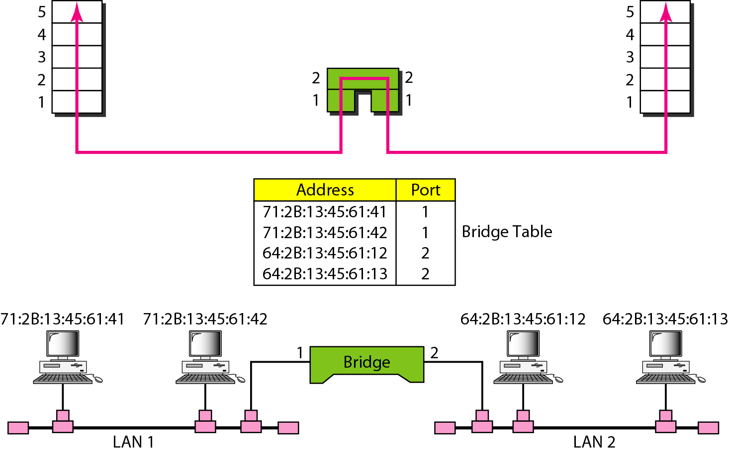

Figure 1.

16. A frame with the Destination Address 71:2B:13:45:61:41 arrives at Port 1 of the bridge. Does the bridge forward this frame or filter it?

It filters the frame because it sees that the destination address is on LAN 1 which is connected to port 1. _________________________________________________

17. A frame with the Destination Address 64:2B:13:45:61:12 arrives at Port 1 of the bridge. Does the bridge forward this frame or filter it?

It forwards the frame because it sees that the destination address is on LAN 2 which is connected to port 2. ___________________________________________________

18. What layer of the IP Data Communication Model does a Hub operate at?

Layer 1 ________________________________________________

19. What layer of the IP Data Communication Model does a Bridge operate at?

Layer 2 ________________________________________________

20. What layer of the IP Data Communication Model does a switch operate at?

Layer 2 ________________________________________________

21. Which device forwards frames using a forwarding table that shows the port at which the destination MAC address is connected? B ___________________________
a) Hub b) Switch c) Router

22. Which device forwards datagrams using a routing table that shows the interface through which the datagram must travel to reach the destination IP address? C ___________________________________________________________________
a) Hub b) Switch c) Router

23. Which device is a collision domain which does not forward frames or datagrams?
A ________________________________________________________________
a) Hub b) Switch c) Router

24.The Spanning Tree Protocol Messages that are exchanged between the switches on a managed network are designed to prevent what problem?

Forwarding Loops ___________________________________________________

25. What is the name of the database on the Switch into which the configuration parameters – including STP parameters – are stored?

Managed Information Base – abbreviated MIB ______________________________

