ITM 440/540 - Data Networks

Assignment 6

Assigned: 10/01/2015 Due: 10/08/2015

Name: __________Hong Zhang___________________________________________

Student ID: _____A20340043_____________________________________________

Purpose: Practice concepts related to the MAC address and LAN connecting devices.
MAC Addresses:

1. If an Ethernet Destination Address is 39:7N:6C:DE:10:00, what is the type of the address (unicast, multicast or broadcast)? _multicast_____________________

2. If an Ethernet destination address is 04:01:02:04:05:07, what is the type of the address (unicast, multicast or broadcast) ? __unicast__________________________

3. If an Ethernet Destination Address is ff:ff:ff:ff:ff:ff, what is the type of the address (unicast, multicast or broadcast)? ___ broadcast ___________________

4. A networked computer receives a frame with the Source Address 49:7N:6C:DE:10:00.
The computer discards the frame. Why?

___It is a multicast address and the computer uses it to configure the group. It cannot be the source of a frame. ______________

5. What is the access control method that is used on Ethernet II and IEEE 802.3 LANs?

___ CSMA/CD (Carrier Sensed Multiple Access with Collision Detection) ________

6. What is the access control method that is used on WiFi IEEE 802.11 LANs?

___ CSMA/CA (Carrier Sensed Multiple Access with Collision Avoidance) _______

7. The minimum length of an IEEE 802.3 frame is ___64________ bytes.

8. The minimum length of an Ethernet II frame is ____64_______ bytes.

9. The minimum length of the body of an Ethernet II frame is ____46________ bytes.

10. The minimum length of the body of an IEEE 802.3 frame is ___38________ bytes.

11. The Ethernet II process receives 28 bytes of data from a Layer 3 process. How many bytes of padding must it add to the data before it hands it to layer 1 to be put onto the channel? __18 bytes____________________________________________________

12. What is the maximum length that an Ethernet II Frame can have? __1518 bytes__

a. How many of those bytes are in the header? ____14 bytes_______________

b. How many of those bytes are in the trailer? _____4 bytes_______________

13.If the Ethernet II process receives 1520 bytes of data from a Layer 3 Process, will the Ethernet II process create a Frame to send? Explain your answer.
_____No. The maximum frame length of an Ethernet II Frame is 1518 bytes. _________

14. How many more bytes are there in the IEEE 802.3 Frame header than there are in the Ethernet II header? (Include both the number and also the metric, Bytes) ___8 bytes___

15. The third field in the Frame header for IEEE 802.3 provides what information about the Frame?
__ 2-byte length field tells how many bytes follow - not including the CRC field (trailer)

Use Figure 1 below (Figure 15.5 in the textbook,, edition 4) to answer the questions that follow. There are two drawing in Figure 1. Use the one on the bottom and the Bridge Table to answer the questions. The diagram at the top is what I have called a ‘sandwich diagram.’ It is designed to remind you that the bridge operates at layers 1 and 2 only. Higher layers of the protocol stack ‘flow’ right over the bridge. The bridge does not read the information in layer 3 or above.

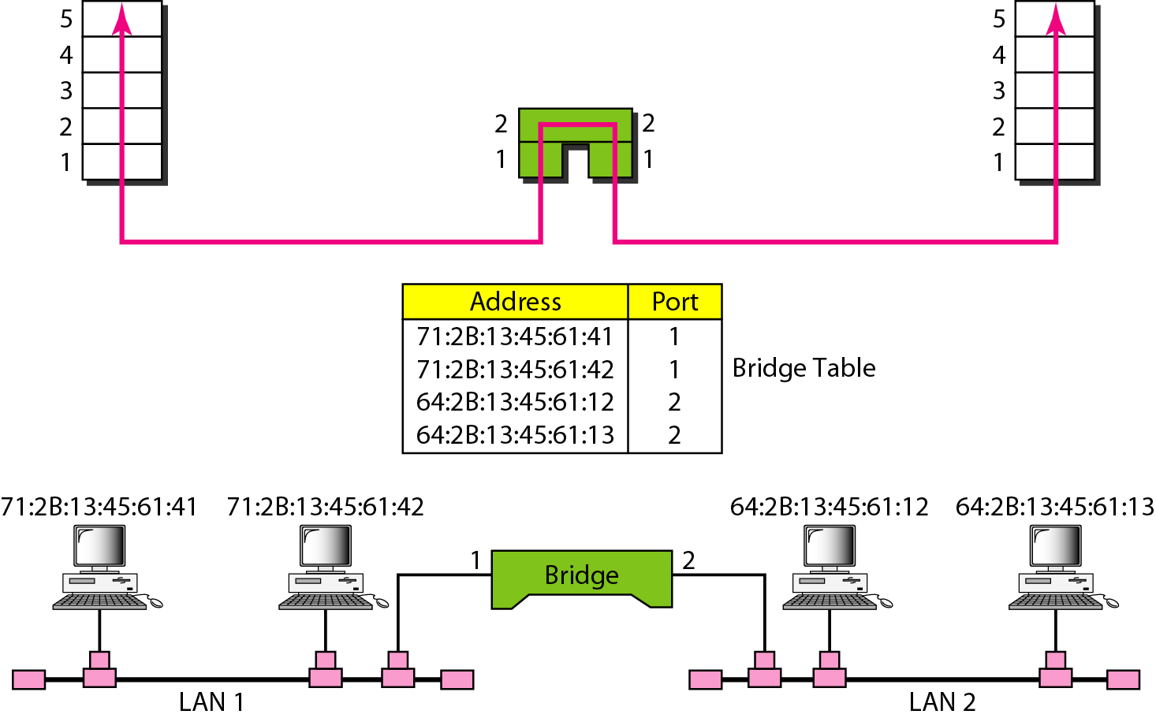
Figure 1.

16. A frame with the Destination Address 71:2B:13:45:61:41 arrives at Port 1 of the bridge. Does the bridge forward this frame or filter it?

_Filter because the frame just passed away the destination address. _______________

17. A frame with the Destination Address 64:2B:13:45:61:12 arrives at Port 1 of the bridge. Does the bridge forward this frame or filter it?

_Forward because the destination address is on LAN2 which is connected to port 2. ___

18. What layer of the IP Data Communication Model does a Hub operate at?

____layer 1____________________________________________

19. What layer of the IP Data Communication Model does a Bridge operate at?

____layer 2____________________________________________

20. What layer of the IP Data Communication Model does a switch operate at?

____layer 2____________________________________________

21. Which device forwards frames using a forwarding table that shows the port at which the destination MAC address is connected? ___ b) Switch _____________________
a) Hub b) Switch c) Router

22. Which device forwards datagrams using a routing table that shows the interface through which the datagram must travel to reach the destination IP address?
____c) Router___________________________________________
a) Hub b) Switch c) Router

23. Which device is a collision domain which does not forward frames or datagrams?
________ a) Hub _______________________________________________
a) Hub b) Switch c) Router

24.The Spanning Tree Protocol Messages that are exchanged between the switches on a managed network are designed to prevent what problem?

__ To prevent loops _________________________________________________

25. What is the name of the database on the Switch into which the configuration parameters – including STP parameters – are stored?

____ Managed Information Base (MIB) ___________________________________

