ITM 440/540 - Data Networks

Assignment 8b

Assigned: 11/11/2015 Due: 11/19/2015

Name: _______________________________________________________

Student ID: __________________________________________________

Purpose: Practice concepts related to IPv4 Header Fields and their uses.

Download the trace named frag-hw that is posted to the blackboard documents page under the heading “traces”. Open this trace using Wireshark and answer the following questions.

CHECKSUM Questions:
In Frame 2, click on the + sign next to the Internet Protocol line in the mid-section of the display to show all the header fields in the IP datagram.

1. Copy the value of the checksum as it appears in hexadecimal notation. 16 c5

2. Write the calculation that the sending IP process will use to calculate the checksum: Click on the Internet Protocol line in the mid-section of the display. This will high-light the top line in the mid section of the display and also cause the hexadecimal representation of the header to be highlighted in the bottom third of the display. Use this hex representation to set up the calculation of the check sum, following the illustration in Figure 20.13 of your text book. Do not do the addition, just set up the addition problem by writing a sum as shown in your text book and in your class notes.

45 00
03 50
0A 45
00 A0
80 01
00 00
0A 00
01 03
0A 00
01 01

3. Now write down the calculation that the receiving IP process will use to check the checksum.

45 00
03 50
0A 45
00 A0
80 01
16 c5
0A 00
01 03
0A 00
01 01

FRAGMENTATION, HLEN and TOTAL LENGTH Questions

Continue to use the trace frag-hw to answer the following questions. You will determine the length of the original payload, illustrated in Figure 1. Use the drawing below to help you answer the questions.

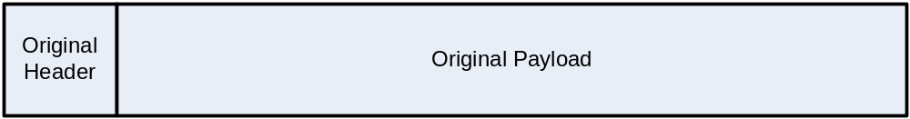
Figure 1 This is the “unknown.” You do not see this original payload that was handed down to the IP process. The IP process has fragmented it into the fragments in your trace. Your job is to figure out what the original payload looked like before it was fragmented by the IP process.

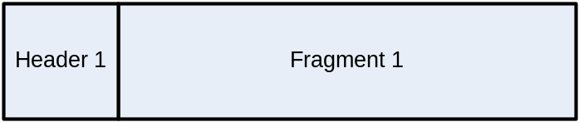
Figure 2 – Header length and total length available in trace

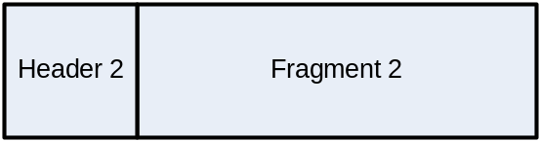
Figure 3 – Header length and total length available in trace

In Frame 1:
4. What is the IP header length? 20

5. What is the total length of the IP datagram? 1300

6. What is the length of the payload of the IP datagram? 1280

7. What is the name of the protocol in the payload of the IP datagram? ICMP

8. Is this IP datagram fragmented? What flag tells you this? Yes. The more fragments flag is set.

9. What is the fragment offset? 0

In Frame 2:
10. What is the IP header length? 20

11. What is the total length of the IP datagram? 848

12. What is the length of the payload of the IP datagram? 828

13. Are there more fragments? What flag tells you this? No. The more fragments flag is not set.

14. What is the fragment offset given by Wireshark? 1280

15. What is the ID of this IP datagram? 0x0a45 (2629)

16. Is this ID the same as the ID of the datagram carried in frame 1? Yes

17. How long was the payload in the original IP datagram before it was fragmented?
2108 bytes

