Midterm Review

Chapter 1 and Class notes - Overview
- Half duplex - both stations can transmit - but not at the same time
- Full duplex - both stations can transmit at the same time
- Point to point - Provides a dedicated link between two devices
- Multipoint - More than two devices share a single link
- Physical topologies:
  - Mesh - Every device has a point to point link to every other device (that is, the link carries traffic only between those two devices.)
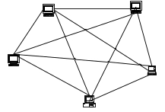
physical channels: n*(n-1)/2
ports per device: n-1
  - Star - Each device has a dedicated point-to-point link only to a central controller.
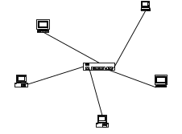
Links: n
Hub:1
  - Bus - A single cable acts as a backbone that links all the devices on the network. Multipoint
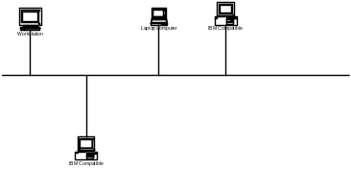
  - Ring - Each device has a dedicated point to point link only to the two devices on either side of it.
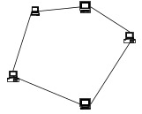

- Categories of networks
  - LAN - Local Area Network
  - MAN - Metropolitan Area Network
  - WAN - Wide Area Network
- The Internet
  - A network of networks
  - Networks on the internet are organized into hierarchies – International Service providers, national service providers, regional service providers, local service providers
- Standards bodies
  - Why do we have open standards? - Open Standards allow computing devices and intermediate devices manufactured by different vendors to interoperate.
  - IETF - Internet Engineering Task Force
Creates the open standards for the Internet
  - ITU-T - International Telecommunications Union - Telecom
  - IEEE - Institute of Electrical and Electronics Engineers
Creates layer 1 and layer 2 standards

Chapter 2 and Class notes – Overview
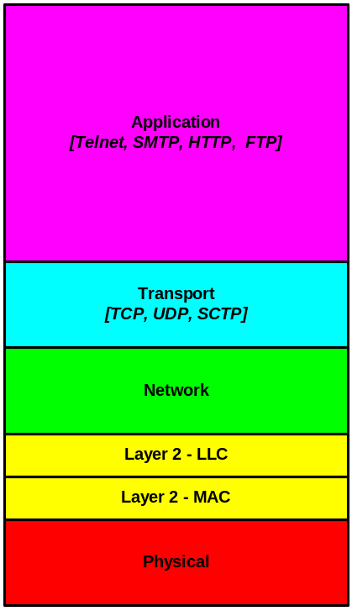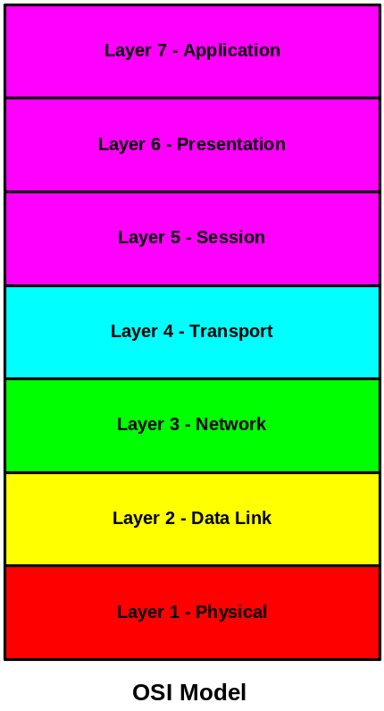 IP Model
- Layered models of data networks
  - The layers represent distinct types of functions that developers group together. This allows development to go on in parallel on different types of functions.
  - The Open Systems Interconnection Model (OSI) model identifies 7 distinct layers.
  - The Internet Model identifies 5 distinct layers. This model is sometimes also called the TCP/IP protocol suite. This terminology is confusing because TCP and IP are also two distinct layers of the Internet model. TCP is a layer 4 protocol. IP is a layer 3 protocol.
  - Know the data networking functions provided at each layer of the Internet Model and the OSI Model
OSI Model:
- Layer 1 - Physical Layer - defines the physical characteristics of 1’s and 0’s, how to distinguish them from noise.
- Layer 2 - Data Link Layer - defines how to put bits into frames and create an error-free connection between two devices on the same medium
- Layer 3 - Network Layer - defines how to perform routing, congestion control, and create a logical network on top of the links created at layer 2.
- Layer 4 - Transport Layer - Enables process-to-process communication between devices on remote networks.
- Layer 5 - Session Layer - Controls the dialog between applications in the end-systems.
- Layer 6 - Presentation Layer - Resolves differences in format and data presentation.
- Layer 7 - Application Layer - Provides a user interface and supports distributed applications
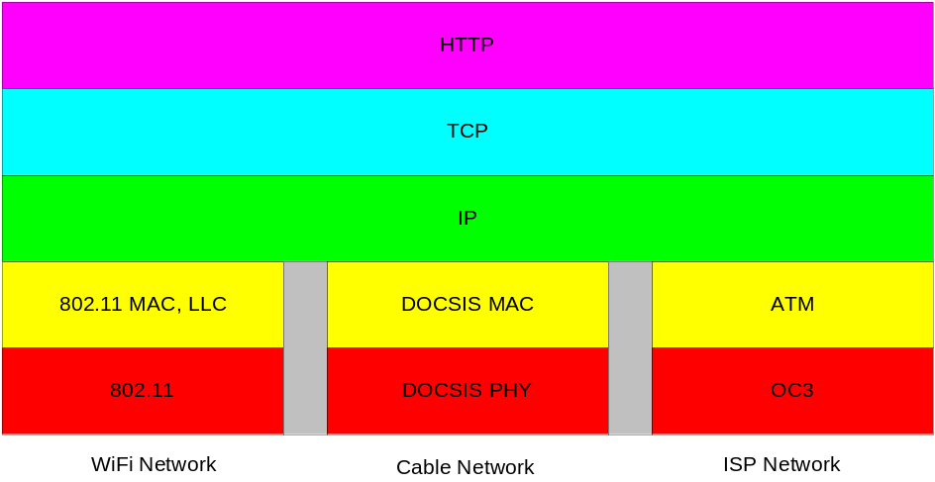
IP Model:
- Layer 1 - Physical:
  - Physical characteristics of interfaces and media
physical link:
  - Unshielded Twisted Pair (UTP)
  - Coaxial Cable
  - Fiber Optic
  - Wireless - radio waves
  - Microwaves
physical connector:
  - RJ45 - 8 conductors - twisted pair
  - BNC - T-Connection to coaxial cable
  - SC (Subscriber Channel ) Connector - for connecting fiber to cable TV
  - ST (Straight Tip) Connector - for connecting fiber to network devices
  - How to represent bits - Coding and modulation schemes that are used to represent the 1s and 0s that make up the data
  - Can use pulses of electrical energy
  - Can use variations in an electromagnetic wave
  - Data rate - The number of bits per second
  - Synchronization of bits - allows the receiver to coordinate with the sender
- Layer 2 – Data link:
  - Framing - Layer 2 divides the raw bit stream created at layer 1 into groups of bits called frames.
  - Physical addressing - Identifies the device on the link
  - Flow Control - allows you to regulate the rate at which the sender sends data
  - Error control - can include both error detection and error correction
  - Access control - which device can put signals onto the line at a given time
  - The Internet model divides layer 2 into two sub-layers: The MAC layer, (medium access control) sub-layer, and the LLC (logical link control) sub-layer.
- Layer 3 - Network:
  - Source to destination delivery of a packet
  - Logical addressing - network addresses
  - Routing - concerned with sending a packet of data to a node that is either its final destination - or the “next hop” along a path to its final destination.
  - Segmentation and reassembly of parts of the data-gram over individual hops
entities
    - Data Terminal Equipment
    - Data Circuit terminating Equipment
  - At layer 3 – think hop-by-hop
- Layer 4 – Transport
  - Process to process delivery of messages
  - Port addressing – the port represents the input/output address of a process running on a host at the given IP Address
  - Message segmentation and reassembly (as distinct from data-gram segmentation and reassembly which we have at layer 3.)
  - End to end flow control
  - End to end error control
  - At layer 4 – think end-to-end.
- Layer 5 – Application
  - User interface – whether the user is human or software
    - FTP - File Transfer Protocol
    - SMTP - Simple Mail Transfer Protocol
    - TELNET - Remote terminal capability
    - HTTP -Web browsing
  - Services such as email, remote file access, file transfer, web browsing, Voice over IP
  - The OSI model divides layer 5 into 3 layers. The OSI model’s layer 5 is called the Session layer, The OSI model’s layer 6 is called the Presentation layer; The OSI model’s layer 7 is called the Application layer. In this course we are concerned with the IP model.
- Encapsulation – what it means and how it operates
When messages are sent across the network using a layered protocol, the higher layers are carried as the payload of the lower layers.
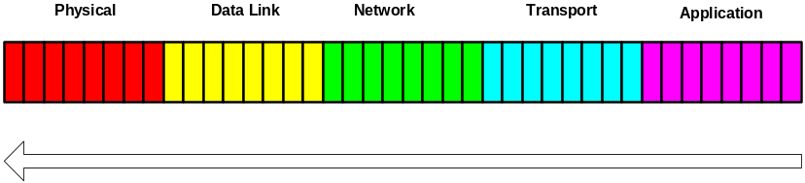

Chapter 3 and Class notes - Physical-Layer-1

Sections 3.1 and 3.2 and 3.3
- Understand the distinction between analog signals and digital signals
- Understand what are the three parameters that completely describe a sine wave – frequency, amplitude and phase
- Understand that any analog signal can be analyzed into a weighted sum of sine waves
- Understand that when we impose digital signals onto a medium we cause electromagnetic analog signals to propagate across that medium and that the analog signals we create behave like a sum of sine waves with different amplitudes.
- Distinguish between a logical bit and the physical signal that represents a bit
- Square waves – a stream of pulses – can be used to represent of bits on a physical medium
- Bit rate
- Bit interval
- Throughput is measured in bits per second
- Propagation speed measures the distance a signal can travel in a period of time
- Distortion: Different physical mediums allow signals to travel at different speeds – this can cause distortion of the bits since different frequencies that are used to create the square pulse arrive at different times
- Attenuation: Units, and how to calculate
- Signal to Noise Ratio: Units, how to calculate
- Understand the uses of the Nyquist Formula and the Shannon Formula. Understand the relationships between the analog bandwidth and the digital bit rate that is implied in these formulas and when to use each formula.

Chapter 4 and Class notes - Physical-Layer-2

Section 4.1 AND Section 4.4 and Class notes - Physical Layer -2
- Line codes
- Data Level vs. Signal level – Bit Rate vs. Baud Rate
  - Data value – can be ‘0’ or ‘1’
  - Signal level (signal value) – varies according to the line code you have chosen to use to represent your data
  - Signal rate (baud rate) vs. data rate: Pulse rate vs. bit rate
  - We put signals or symbols onto the physical medium
  - These signals or symbols are arranged and combined to represent data (bits)
- Synchronization
  - Self-synchronizing digital signals – include timing information right in the data being sent. The pulse edge can be used to synchronize the clocks in two distant computing devices.

- Understand how to use the “code books” to draw the signal that different line codes produce. Practice drawing the signals! It is not enough to be able to copy information in the code book. Use the illustrations in the text book and in your class notes

- Polarity
  - Unipolar – one non-zero and the other zero
  - Polar – two non-zero voltage levels
  - Bipolar – returns to zero; uses zero to represent logical zero; alternates the polarity of the signals used to represent logical 1’s.
- Four types of Polar encoding:
  - NRZ = Non Return to Zero
  - RZ = Return to Zero – signal change within each bits – enables good synchronization at the cost of more bandwidth – more symbol changes to create a single bit
  - Manchester = Uses a symbol inversion in the middle of each bit to represent 1’s and 0’s. Transition from low to high represents a 1; Transition form high to low represents a 0. Enables good synchronization and yet uses less bandwidth that RZ encoding.
  - Differential Manchester = Presence of a transition at the beginning of a bit interval means 0; absence of a transition at the beginning of a bit interval means 1.

- Parallel transmission – fast but over short distances
- Serial transmission – slower but over longer distances
  - Asynchronous transmission – uses start and stop bits to tell the receiver when a byte is being sent - bytes are sent asynchronously, but the receiver and sender need to synch up at the bit level – good example is the connection between the keyboard and the computer
  - Synchronous transmission – uses idle codes when no real data is being sent – since bytes are always arriving – like an infinitely long train – faster than asynchronous data – bytes need to be synchronized

Part 3 and Chapter 13 & 15 and Class notes – Data link Layer Functions and Services
- Functions of the data link layer:
  - Framing (packetization)
  - Addresses
  - Error control
  - Flow control
  - Access method
- Three types of data link service
  - Unacknowledged, connectionless – for example Ethernet II
  - Acknowledged, connectionless
  - Acknowledged, connection-oriented
- Frame consists of header, body and trailer
- CRC code (Cyclic Redundancy Check) sent in trailer; used to detect errors
- Know difference between the Ethernet II frame and the IEEE 802.3 Frame
- Know frame format of Ethernet II and IEEE 802.3
- Preamble allows the receiver’s clock to synchronize with the sender’s clock. These clocks must remain synchronized for the rest of the frame.
- Length of Ethernet II header is 14 bytes.
- Length of IEEE 802.3 header is 22 bytes (8 more bytes: 3 are the LLC, 5 are the SubNetwork Access Protocol)
- Ethernet addresses – also called Physical Addresses – also called MAC addresses – also called the hardware address – 6 bytes – each byte is written as 2 hexadecimal characters.
- Remember that there are other data link layer protocols that will use different layer 2 addresses
- Remember that the Network Interface Card (NIC) in a computing device that uses the Ethernet II or IEEE 802.3 protocol has a physical address burned into it at the point of manufacture.
- Broadcast MAC addresses consist of all 1’s: hexadecimal notation is ff:ff:ff:ff:ff:ff
- Understand the need for multiple access to a shared medium
- Understand what Carrier Sensed Multiple Access with Collision Detection (CSMA/CD) means
- Understand why there is a minimum length specified for the body of an Ethernet II or an IEEE 802.3 frame. To enable retransmission in the case of collisions.
- Know how to read a protocol trace showing layer 2 information
- Understand the functions of a hub, a switch and a router.
- Understand what is a collision domain.

Chapter 13 Wired LANS – Ethernet
- IEEE Standards
- Standard Ethernet

Chapter 15 Connecting Devices
- Understand the roles of the hub, switch (bridge) and router
- Know at which layer of the protocol stack the hub, switch and router operate
- Understand how the average data rate of a sending device is affected by whether it is connected to a hub or a bridge/switch.
- Understand how the switch (bridge) learns and thus how it builds its forwarding table
- Know how to use the forwarding table
- Distinguish between the three things the bridge can do with a Frame – Flood, forward and filter
- Understand what is meant by a loop in the switching architecture.
- Understand the trade-off between the “single point of failure” and the possibility of developing a loop
- Understand why the Spanning Tree algorithm and the Spanning Tree Protocol are used – and how they can prevent loops
- Know when you need to add a router to a network or internetwork
- Understand what a Virtual LAN (VLAN) is and why it is useful
- Understand that if you provision a switch to have several VLANs then you will need to connect the two VLANs by means of a routing function.

