Use these exercises to test your knowledge of creating disk partitions, and working with filesystems.

Provide Screen shots of each steps output:

Before I do this lab, I will add a new hard disk in my virtual box and mount it.

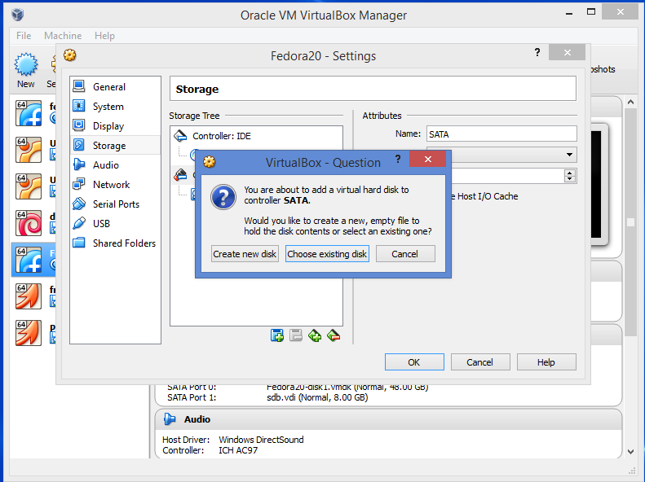

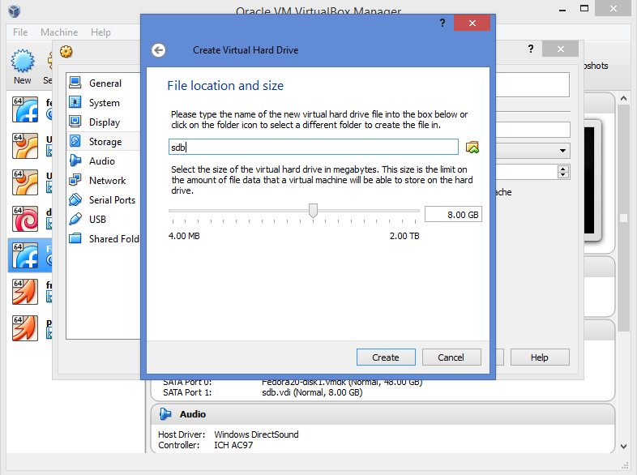

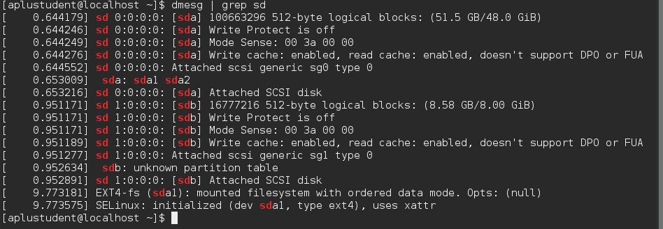

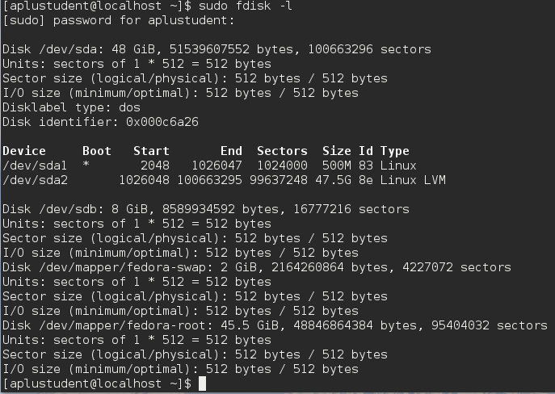

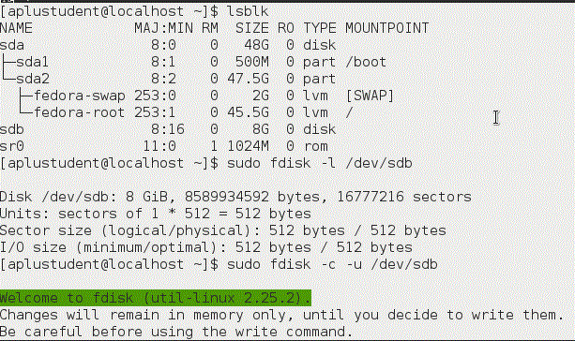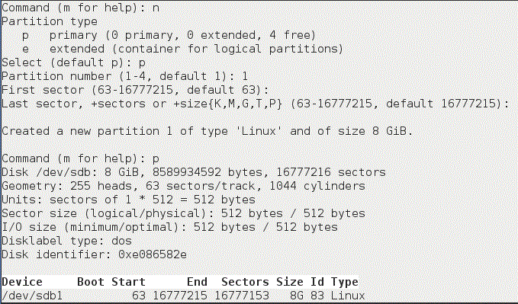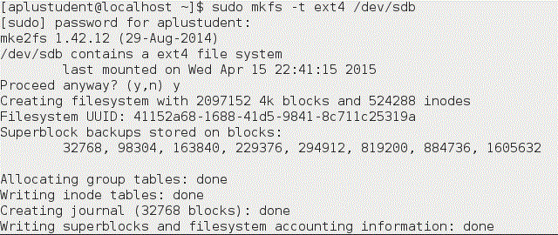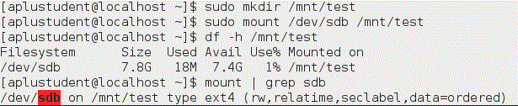C:\Users\JJ\Desktop\Capture.GIF

1. Run a command as root to watch the **/var/log/messages** or **dmesg** file. Determine the device name of the new drive (it might be sdb or sdc as you add more drives)

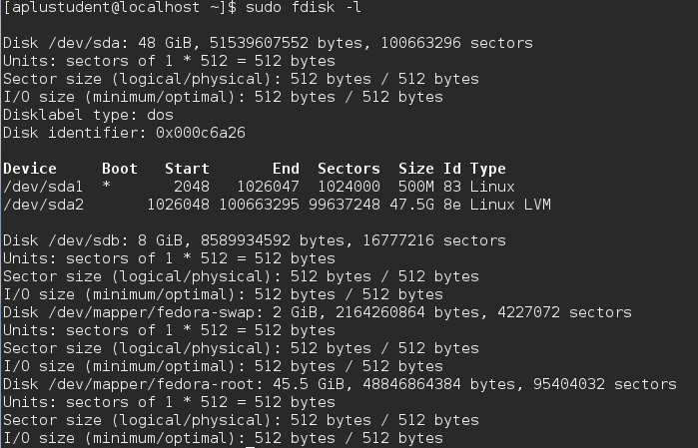

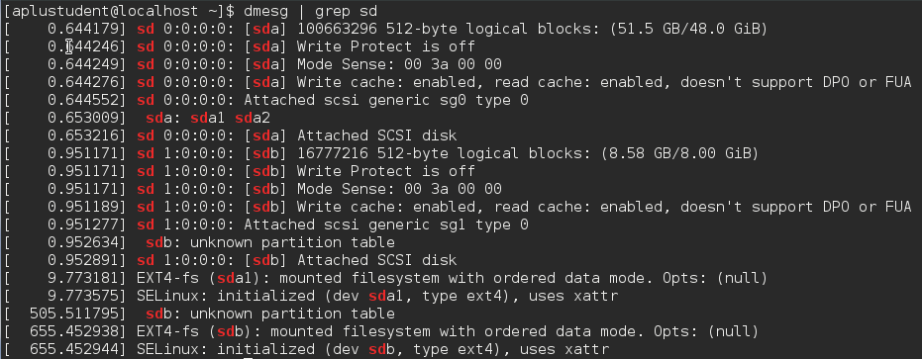

2. Run a command to list the partition table for the New Drive.

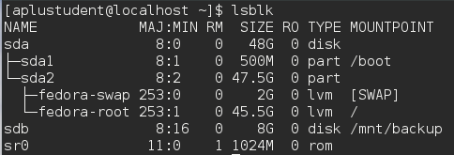

3. Delete any existing partitions on your new drive, save the changes, and make sure that the changes were made both on the disk's partition table and in the Linux kernel.

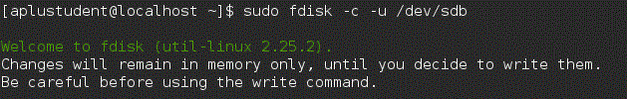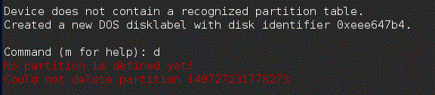

4. Add two partitions to the drive: 100MB Linux partition, 200MB Swap partition. Save the changes.

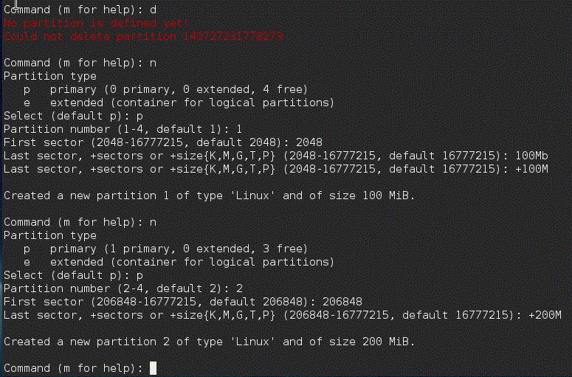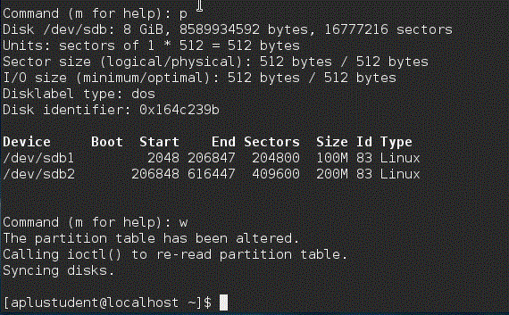**C:\Users\JJ\Desktop\Capture.GIF**

5. Put an **ext4** filesystem on the Linux partition.

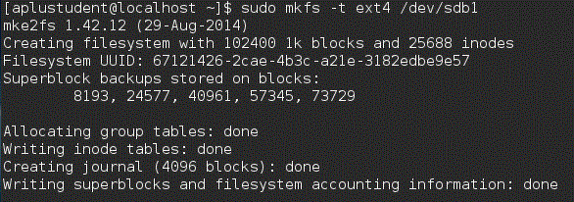

6. Create a mount point called **/mnt/mypart** and mount the Linux partition on it.

**C:\Users\JJ\Desktop\Capture.GIF**

7. Unmount the drive

**C:\Users\JJ\Desktop\Capture.GIF**8.  Add an entry to your **/etc/fstab** to automount the partition on everyboot.  Reboot to see if it works

