Upon completion of this lab the user will understand using the OpenSSH suite for secure transfer and administration of remote Linux Systems and for configuring Apache Webservers.

Use Screenshots of the commands and their results  (make use of the clear command as well if needed)

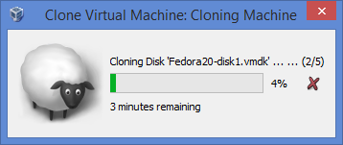

You will need two virtual machine instances (assuming both are Fedora based)

1. In order to change from NAT to Bridged network you neet to modify your Virtual Box network settings (note this won't work on the campus network because of registration issues - need to do it at home where you have a private network or in the lab today)  Use ipconfig to find your ipaddress or ip addr show

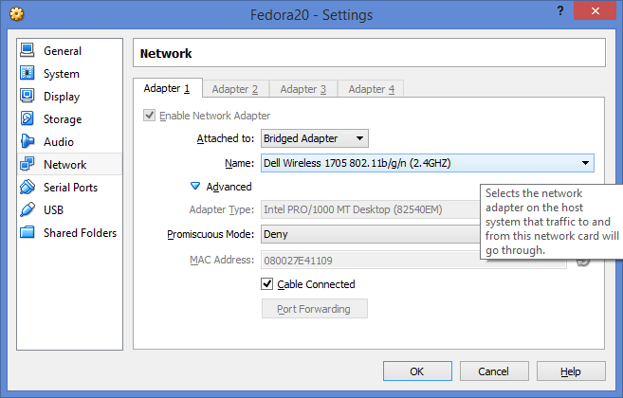

1.  Use the hostnamectl tool to change the hostname of the client to "client"  - hostnamectl set-hostname client (no sudo needed - just close your terminal and reopen it.)

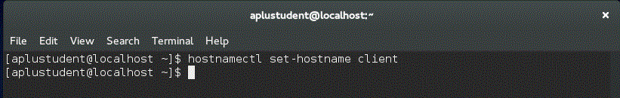



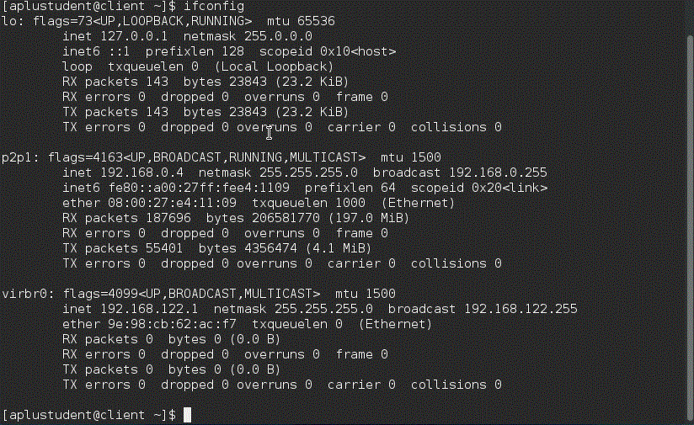

2.  Install OpenSSH server on the system marked as your server

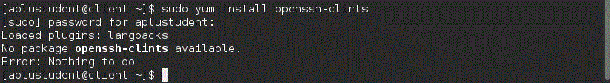

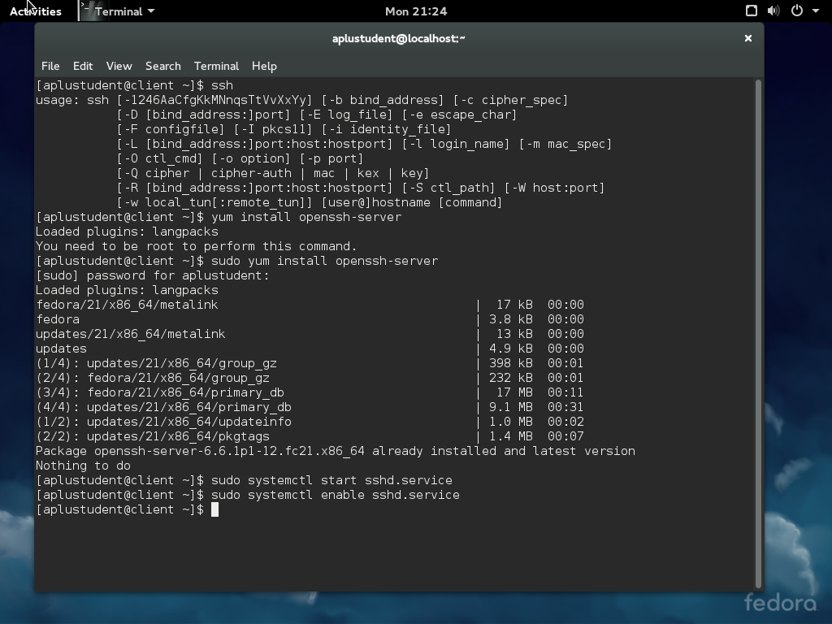

3.  Remotely connect to your server via ssh

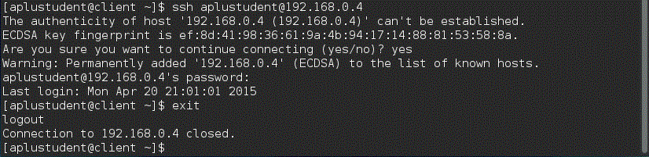

4.  Repeat step 1 on the server using the same command but server instead of client

C:\Users\hzhan121\Desktop\Capture.PNGC:\Users\hzhan121\Desktop\Capture.PNG

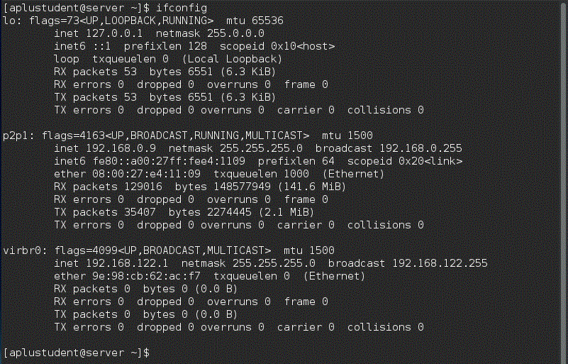

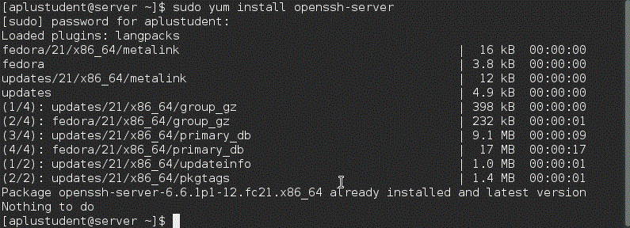

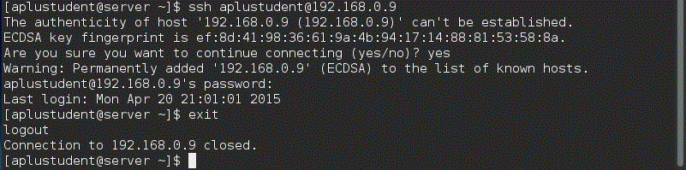

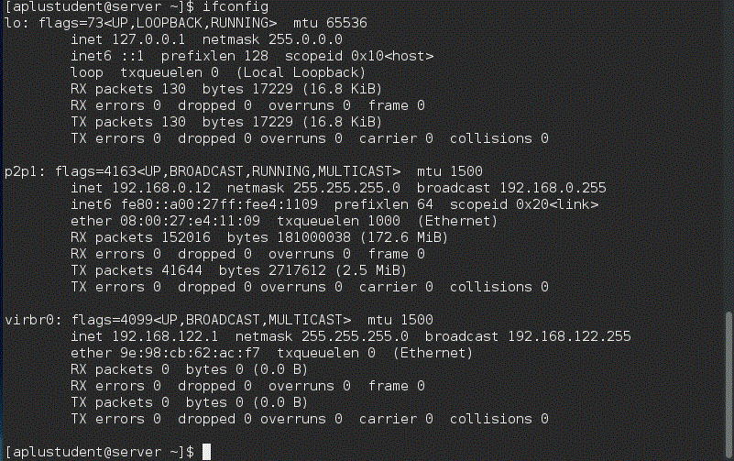

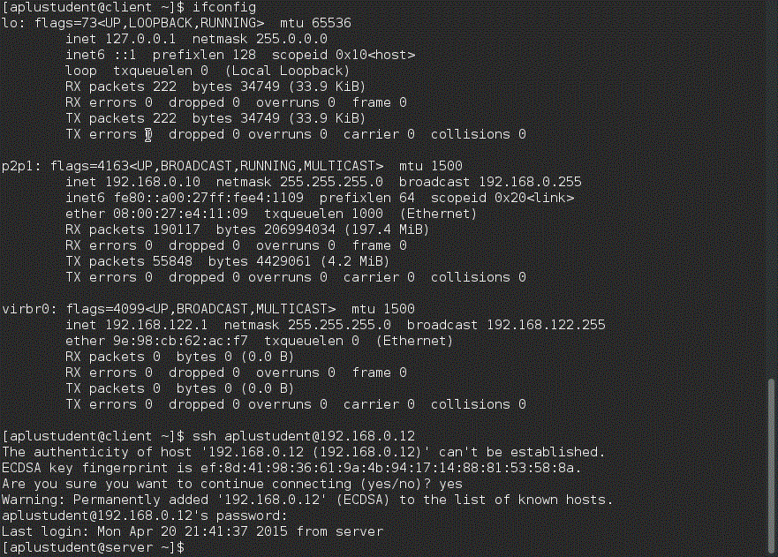

5. Install httpd and php (apache webserver on one virtual machine) (if already installed type the install command and the system will report back "nothing to do" )

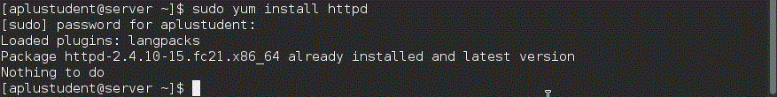

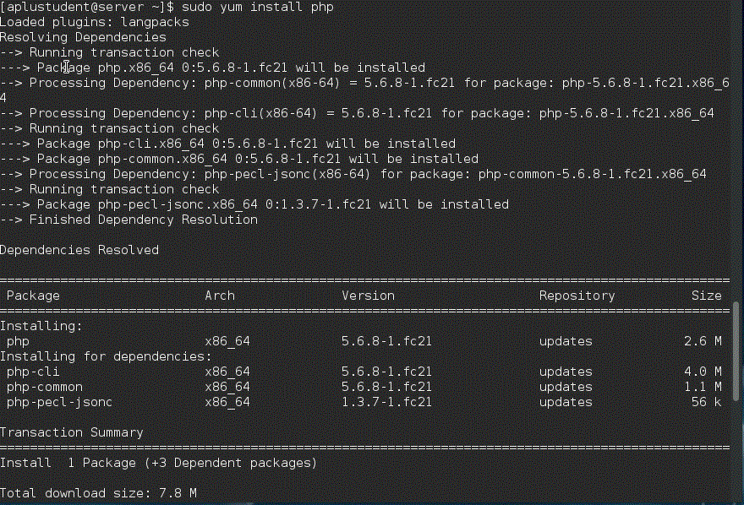

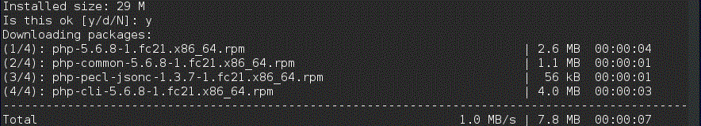

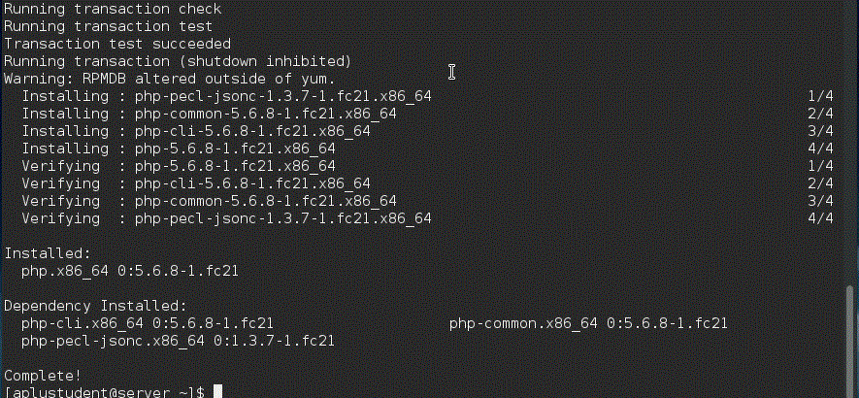

6.  Issue the command to start the webserver service and enable it at boot

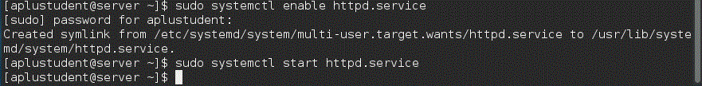

7.  Create an html file named lab13.html (code is attached - you need to also add your name to that code and add a line that will display the alligator picture I supply (download it from Blackboard to the client system)

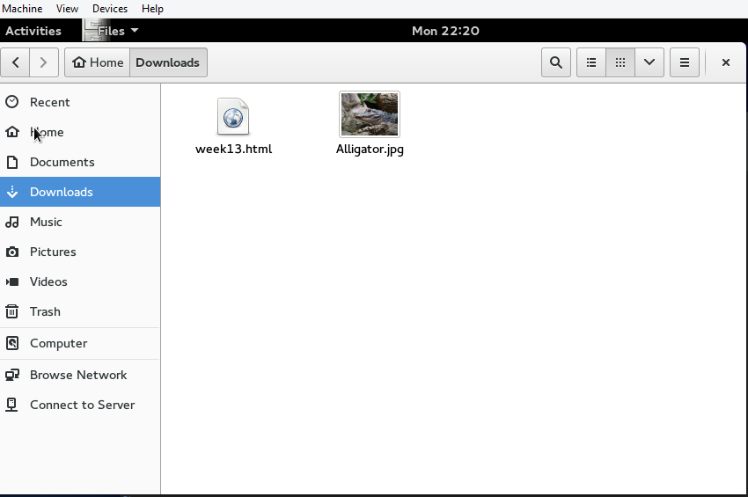

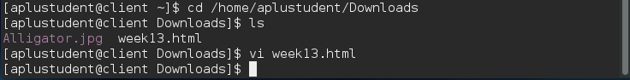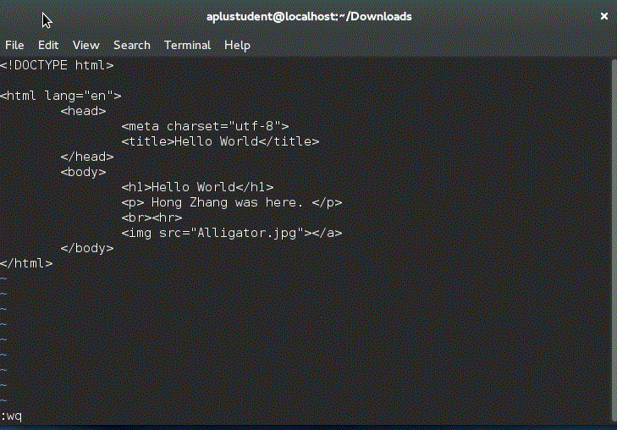8. Use scp to copy the alligator picture to the remote server

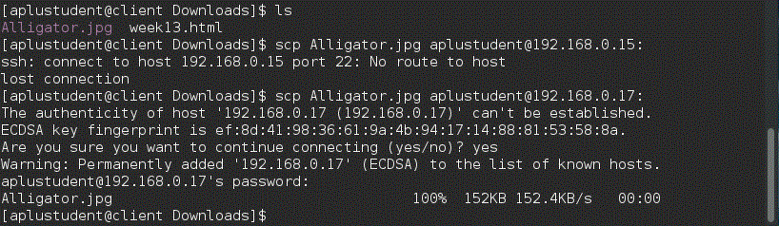



9.  Connect via SSH to the remote server and using sudo vi create a file called test.php in the root web directory (code is in the lecture) (snapshot the directory contents after the file is created)

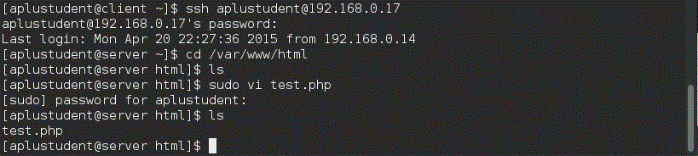

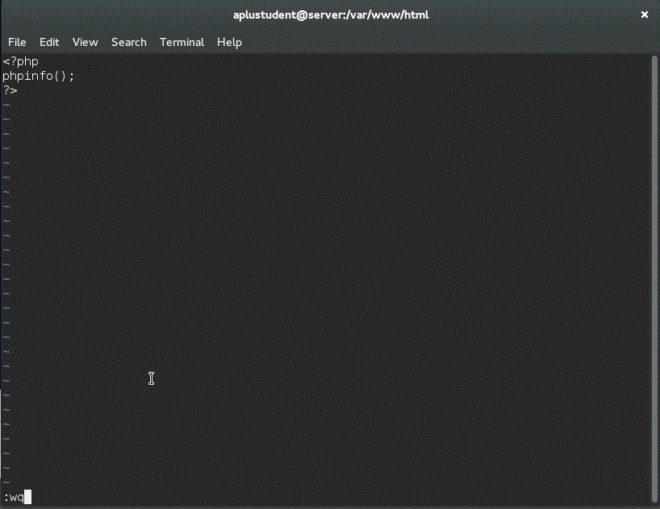

10.  On the client system connect to the two webpages you made through a web browser snapshot both rendered images

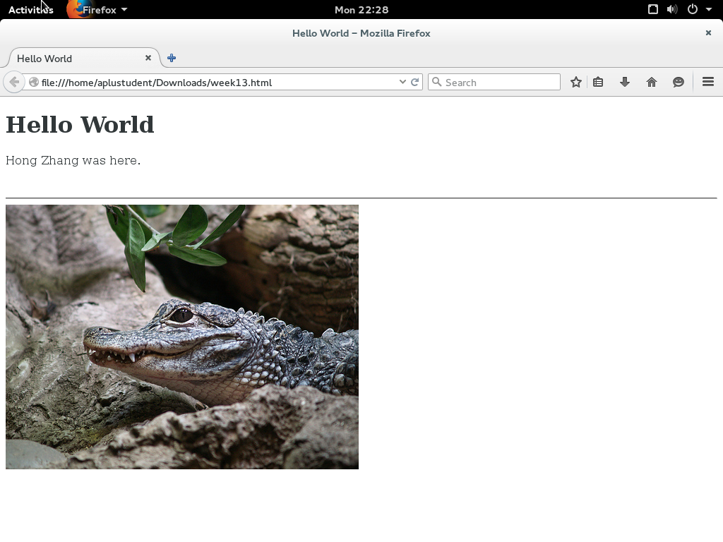

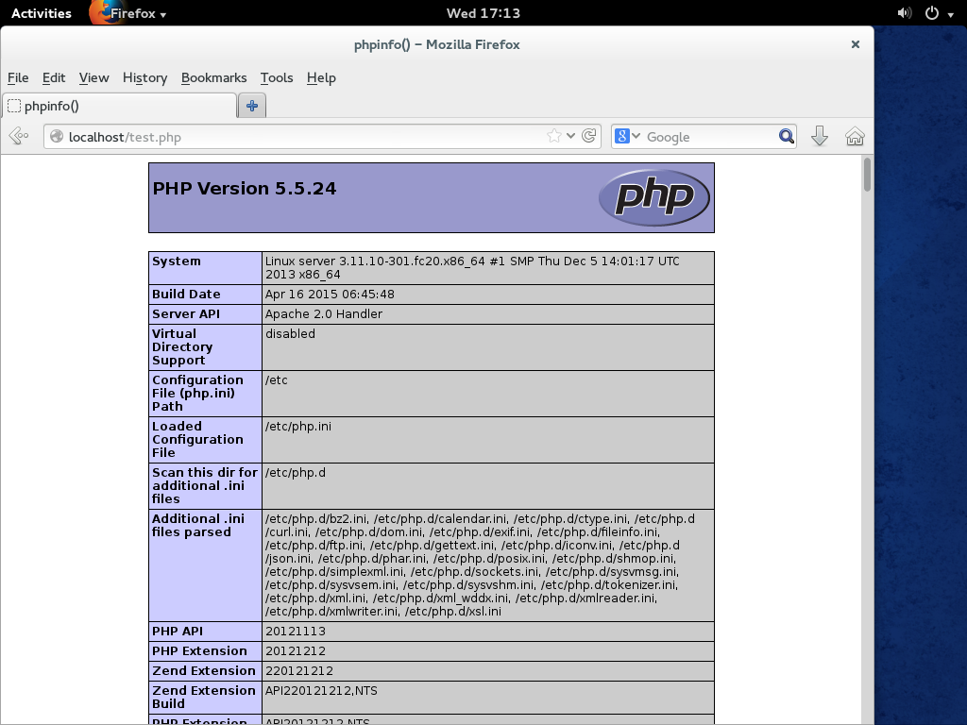

11.  Use the ssh-keygen command to create RSA keys

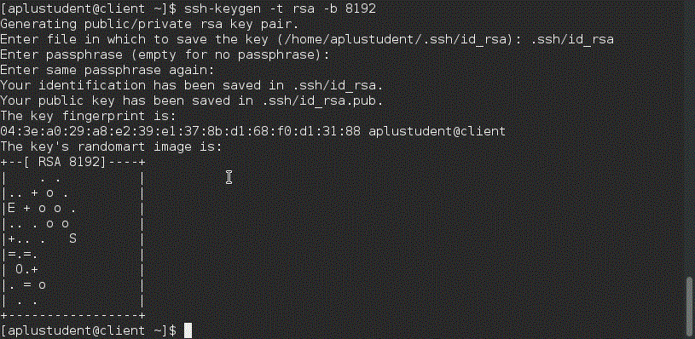

12. Use ssh-copy-id command to copy your identity to the remote server

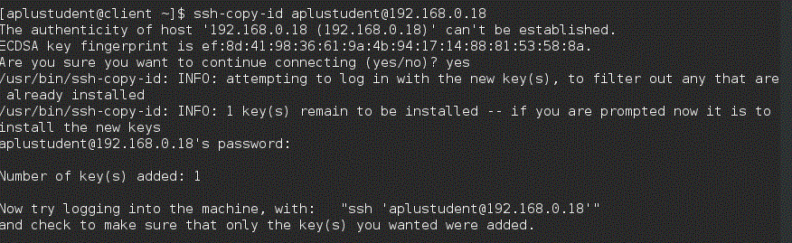

13.  Exit that session then connect to the remote server via ssh key based login - screen shot the login sequence

