Key words: Breach, intruder, vulnerability, mitigate, compromised,

Chapter 1 Security and Information Technology
Why Database Security?
- A secure data environment
例子: 邮件—1. 用户培训; 2. 过滤邮件附件; 3. 防火墙阻断
Multiple layers of security:
- Database security – database-level access control;
database-level authentication;
data storage encryption.
- Computer security -- operating system-level access control;
operating system-level authentication;
application security;
hardware and software monitors and logs.
- Network security

- Database security objectives (confidentiality, integrity, and availability)
- Confidentiality: 保密,外面的人看不到 (关键: access control and authentication)
- Integrity: 保持数据的完整性
- Availability: 确保高度的灵活可用

Who Are We Securing Ourselves Against?
危险多来自内部而不是外部 (network)
不让人用数据库是最没效率也不可行的方法
- Hackers
Hacker: 入侵网络却不造成伤害
Cracker: 入侵网络引起伤害
White hat: 相当于hacker; 主要是测试网络安全, 不引起伤害
Grey hat: 介于hacker和cracker之间, 有时做好事, 有时做坏事
Black hat: 相当于cracker; 做坏事
Hactivist (Hacktivist): 骇客主义
Script kiddie: 业余爱好者用骇客的编码进行入侵网络行为
- Social engineers: 通过操纵别人拿到密码进入系统未授权区域
- Computer users (主要泄密源)
- Network and database administrators (通常错误: 不移除没用的用户)
- The internet
- Hijacking: 网页上的code引得用户去到攻击者的网站
- Malware: 恶意软件
- Spoofing: 钓鱼网站, 具有欺炸性, 骗取用户个人信息
- SQL injection: 粘在database-directed URL后面, 可以套取数据库里的信息
- DNS poisoning: 骇客获得DNS服务器的控制权
The difference between DNS hijacking and DNS poisoning is who the responder of the DNS request is.
危险网站特征: 道德底线不高(遇到hacking 事件不会报告); 社交网站(太多没有经验用户); 新闻网站和技术论坛(用户太相信这里的链接).
- Misleading applications
- E-mails (Attachments, phishing, HTML code attacks)
- Instant messages
- Tweets

Malware
- Computer viruses: 扩散和传播(会self-encryption, 隐藏, 变化, 不需要激活, 因此很难察觉)
- Logic bombs; 2. Time bombs; 3. Spyware; 4. Adware.
- Boot sector viruses; b. macro viruses; c. file-infected viruses; d. multipartite viruses.
- Worms: 自我复制, 通过网络传播, 会伤害.
- E-mail worm;
- Instant messaging worm;
- Internet worm; IRC (internet relay chat) worm;
- File-sharing network worm.
- Trojans: 化妆藏在软件更新, 游戏和电影中. 可以获取敏感信息, 摧毁文件等.
- Remote access and administration Trojan (RAT);
- Data-sending Trojan;
- Destructive Trojan;
- Proxy Trojan;
- File transfer protocol (FTP) Trojan.
- Bots (software robots): 摇控指挥

Security Architecture: A Never-Ending Cycle
- Phase 1: Assessment and Analysis (确定需要, 安全审计, 估计损失,
列出评估步骤: 列出数据库环境下的设备和资源;
确认他们的弱点和易被攻击点;
定义可能的价值和损失;
制定安全策略;
排出安全策略的先后次序)
- Phase 2: Design and Modeling (应包括整个组织,
设计步骤: 定义需要的政策和程序;
确定须变化的软件和硬件;
制定执行计划;
确定底线;
制定用户培训和防护意识的计划)
- Phase 3: Deployment (testing
执行步骤: 如果需要调整用户培训;
测试新加的软件和硬件;
根据实际需要进行调整)
- Phase 4: Management and Support (monitor,
管理和支持步骤: 监控表现和培训进度;
如有需要进行微调;
确认如有需要则进行新一轮的安全周期)

Global Policies for the Database Environment
- Security Policies
- Change management
- Update (要时时) and upgrade (须等新版本稳定后) Management
- Disaster recovery Plan

Lesson 1 Key Terms
- adware A general term for software that uses typical malware intrusion techniques to obtain marketing data or advertise a product or service.
- availability The efforts taken through policy, procedures, and design in order to create and maintain the accessibility of resources within a database environment.
- back door A method created during the programming of a worm in which access is gained into a system by avoiding normal security, which gives the creator of the worm undetected access into the system.
- backup An intentional copy of data, program files, and system configurations that is used to archive and store information in the event of network failure or malware attacks.
- backup management plan A process developed to ensure the safety of the data on a network.
- black hat Someone who breaks into computer networks without authorization and with malicious intent.
- boot sector An area of the hard disk that contains records necessary to the boot process of a computer.
- boot sector virus Malware that infiltrates a system by loading itself onto the boot sector of a hard disk via an infected floppy disk left in a floppy disk drive.
- bot (software robot) A form of malware that has the ability to perform a large array of automated tasks for an intruder at a remote location, ranging in severity from spamming a system to initiating DoS attacks on systems.
- botmaster An individual who controls a network of bots and who accumulates a number of bots and then rents these botnets to other intruders and cybercriminals for the purpose of spamming, phishing, and other more serious types of cybercrime.
- botnet A network of bots.
- cold site A facility that provides the basic necessities for rebuilding a network. A contract that involves a cold site would promise the use of a facility that provides water, power, air conditioning, or heat.
- computer security A set of established procedures, standards, policies, and tools that are used to protect a computer from theft, misuse, and unwanted intrusions, activities, and attacks.
- computer virus A form of malware intended to spread from one computer to another without detection.
- confidentiality The efforts taken through policy, procedure, and design in order to create and maintain the privacy and discretion of information and systems.
- cracker An individual who breaks into our networks without authorization with hopes to destroy and/or steal information.
- database security A set of established procedures, standards, policies, and tools that are used to protect data from theft, misuse, and unwanted intrusions, activities, and attacks.
- data sending Trojan Malware that obtains sensitive data from your computer and transmits it back to a cracker.
- denial of service (DoS) attack A concerted effort made by malware to keep system resources, such as Internet sites, from functioning correctly.
- destructive Trojan Malware that is installed on a computer with the intent to destroy a system as a whole by randomly deleting files and folders and corrupting the registry.
- differential backup An intentional copy of data, program files, and system configurations that only saves the data that has changed since the last backup was complete.
- disaster plan A plan developed to ensure the quick reinstatement of a network that has fallen victim to a human or naturally caused disaster.
- DNS poisoning An intrusion where a cracker gains control over the DNS server and changes the domain name’s respective IP address, redirecting requests to sites that the cracker has built and maintains.
- encryption The transformation of data by using sophisticated algorithms in an attempt to make the data unrecognizable.
- file-infected virus A form of malware that will attach itself to an executable file that requires a user to run before it can propagate and corrupt the system.
- file transfer protocol (FTP) Trojan Malware that allows the attacker to use someone else’s computer as an FTP server.
- full backup An intentional copy of data, program files, and system configurations that stores all information, regardless of its critical nature, age, and prior backup activity.
- grey hat An individual or groups of individuals who waver between the classification of a hacker and a cracker, and who either act in goodwill or in malice.
- hacker Someone who has mastered the hardware and software of modern computer systems and enjoys the exploration and analysis of network security with no intent to intrude or cause harm.
- hactivist Hackers and crackers who use their extensive experience and skill to use networks to share their ideologies regarding controversial social, political, and economic topics.
- Health Insurance Portability and Accountability Act (HIPAA) Strict laws for health institutions throughout the United States that ensure the security and privacy of patient records by dictating the way in which files are accessed, stored, and transmitted on a network.
- hijacking A process in which Web sites are hacked into and rewritten to react differently to users than how the original Web site designer intended.
- hot site An exact replica of an organization’s network, or a mirror site, that promises the vendor will assume all responsibility for ensuring that the network is readily available in the event of a disaster.
- hypertext transfer protocol (HTTP) The portion of an Internet address that informs the browser what protocol is used to send the request for a particular Web site.
- incremental backup An intentional copy of data, program files, and system configurations that is conducted on only the data that has changed since the last full or incremental backup.
- integrity Efforts taken through policy, procedure, and design in order to create and maintain reliable, consistent, and complete information and systems.
- logic bomb Malware that can lie dormant until a specific predetermined variable is met, whose variables typically depend on the environment in which it resides.
- macro A small program that enables users to automate a large number of repeated processes within a document.
- macro virus Malware that can either be attached to a macro, or can replace a macro within a document, and that runs automatically when the document containing the infected macro is opened or closed.
- malicious software A programming code written and used by unauthorized intruders to perform a certain task on a computer.
- malware An abbreviation for the term malicious software.
- misleading applications Applications that deceive users into believing that their computer’s security has been breached, therefore tricking the user into downloading and purchasing rogue antivirus tools to remove the bogus breach.
- multipartite virus A form of malware that combines the characteristics of a boot sector virus with those of a file-infected virus.
- network security A set of established procedures, standards, policies, and tools that are used to protect data from theft, misuse, and unwanted intrusions, activities, and attacks.
- nonresident virus The general term for malware that requires users to initiate it by downloading a program or opening up an e-mail attachment.
- operational information security Ensures the secure operation of an organization through the development and reliability of an environment’s policies and procedures that focus on security policies, change management, update management, and disaster recovery plans.
- OS upgrade Installing a new version of an operating system onto a host or a server.
- patch A small program that is used to fix or update software programs or hardware devices.
- payload The component of a worm that holds all of the instructions on how to affect each computer that it encounters.
- personal identifiable information (PII) Personal information that identifies a person.
- phishing The attempt to obtain PII from people through the use of spoofed e-mail addresses and URLs.
- polymorphism The incidence of changing forms, or self-modification.
- proxy Trojan Malware that enables a cracker to use someone else’s computer to access the Internet in order to keep their identity hidden.
- remote access and administration Trojan (RAT) Malware that provides remote access capability to the cracker from whom the virus originated, who in turn is provided complete control of and access to someone else’s computer from a remote location.
- resident virus Malware that installs itself or takes residence directly in the main system memory of a computer.
- script kiddie Amateur crackers that use programs and scripts written by other people to infringe upon a computer network system’s integrity.
- security policy A document that defines the overall goal of security and identifies the scope of what to secure, as well as the roles and responsibilities of the people within the organization.
- shared site agreement An arrangement between companies with similar, if not identical, data centers.
- signature A pattern of characters that is identified for a specific family of viruses.
- social engineer An individual who uses human interaction to manipulate people into gaining access to systems, unauthorized areas, and confidential information.
- software upgrade A combination of a number of software or hardware packages that creates a new version of software.
- spoofing A process that involves hackers building Web sites to look identical to other popular sites in hopes of drawing in a user.
- spyware A general term for any software that intentionally monitors and records a user’s computer and/or Internet activities.
- startup page The Web site that is displayed when the Web browser is started.
- time bomb (time-delayed virus) Malware that can lie dormant until a specific variable is met, such as times, days, or specific days that are predetermined and written within its code.
- transmission packet Sensitive information about users or businesses compiled by spyware that is sent back to its original creators for use as they see fit.
- Trojan (Trojan horse) Malware that disguises itself and its harmful code and often hides within enticing programs such as software updates, games, and movies.
- update A change to a system that is added to software or firmware that is already installed on a network.
- update management policy A document that includes procedures for patch updates, software upgrades, OS upgrades, and firmware changes.
- upgrade Replacements for older versions of software or firmware.
- warm site A facility that contains the basic environmental concerns, as well as computers, connection firmware, and software devices necessary to rebuild a network system.
- Web browser An application that acts as a user interface of the Internet, allowing users to interact and view Web pages on the World Wide Web.
- Web page A document containing a specific programming language (e.g., HTML or JAVA) that is designed to be viewable on the World Wide Web.
- white hat An ethical hacker; hackers who use their extensive experience and knowledge to test systems and provide security consultation to others.
- worm Self-replicating malware that is able to harness the power of networks and use this power in its attacks against them.

Chapter 2 Database Review
Database Defined
DBMS (Database Management System): application
Database Structure Components
- Tables (column—field; row—record or tuple)
- Keys
- Queries
- Structured Query Language (SQL)

Database Models
- Flat Model (Two-dimensional list of data entries)
- Hierarchical Model (tiers and parent-to-child relationship) 一对多
- Network Model (tree like)
- Relational Model
- Object-Oriented Databases
- Object-Relational Database

Relationships (一对一; 一对多; 多对多)

Database Types
- Online transaction processing (OLTP) – real-time storage
- Online analytical processing or decision support system (OLAP/DSS) – historical data
又叫 data warehouse; data repository

Database Management Systems (relational databases)
- Oracle
- MySQL
- Microsoft SQL (T-SQL/ANSI SQL)

Database Similarities
- Read consistency
- Query Management

Oracle Architecture
- The Instance and the Database (seesion)
- The Physical Structure
- The Memory Structure
- The Processes

MySQL Architecture
- Database connection manager
- Query engine
- Transaction manager
- Storage Management
- The Storage engine

Microsoft SQL Server Architecture
- Architecture and Engines
- The Physical Structure
- Memory Management
- Buffer Management
- Threads and Processes

Key Terms
- alternate key A field with values that are not chosen as a primary key, but can be used in cases where the primary key is not available.
- attribute A characteristic or variable that describes or further identifies an entity.
- buffer manager A portion of the SQL Server responsible for accessing data pages and updating the database.
- buffer pool (buffer cache) The area where data pages from a database are stored to minimize the need to read and write from the database file located on the hard disk.
- caching The process of saving a duplicate of the requested data to another area of a system in hopes of saving resources and speeding up the future requests for that same data.
- candidate key A field with values that meet the requirements for a primary key.
- column (field) The component of a table that maintains a general category of information with similar datatypes.
- commit To make a change within a DBMS that is permanent and visible to other users.
- composite key A group of two or more fields where their values can be combined to be used as a primary key.
- concurrency The simultaneous access of resources and data.
- control file A file within a database that contains the location and important credentialing information of other files.
- database A collection of data stored on a computer using an application called a database management system.
- database connection manager Manages connections to the MySQL server.
- database management system (DBMS) An application that allows users to search stored data in order to locate specific information.
- database model A representation of the way data is stored.
- datafile A file that contains the actual data for the database and holds the information for all logical structures (tables, records, etc.) within the database.
- deadlock A situation when two transactions cannot proceed because each user has data that the other needs.
- entity A person, place, or thing stored within the table of a database and for which attributes and relationships exist.
- fiber A subcomponent of a thread, which is handled by the server to accomplish a task.
- filegroup A collection of one or more physical data files within a SQL Server database.
- flat model A two-dimensional list of data entries, where all data within a field are understood to be similar, and all data within a record are understood to be related to one another.
- foreign key A field within a table that contains a label used to build a relationship between two tables.
- hierarchical database structure A treelike storage schema that represents records and relationships through the use of tiers and parent-child relationships.
- instance A broad term that refers to the background processes and structured memory used during interaction with the database.
- key A single field or group of fields used to identify an entry in a table.
- lock A mechanism within a DBMS that controls concurrency by preventing users from taking hold of data until changes being made are completed or committed.
- log file A file that stores information about the transactions in the database to be used for recovery and backup.
- memory target The reserved space for the buffer cache.
- network database model A treelike structure that stores information in the form of a hierarchy, using tiers and parent-child-like entities to represent relationships.
- online analytical processing (OLAP), (decision support systems [DSS]) Databases that store large volumes of historical data for report generating and analyzing.
- online transaction processing (OLTP) database A database that is created for real-time storage and manipulation of data within an organization.
- open source A term that refers to software that has been written to be distributed for use and downloaded free of charge.
- optimization The process of locating the quickest and most efficient way to retrieve the data being requested by a user.
- page A fixed unit of storage that is transferred or swapped from one storage device to another.
- pagefile The dedicated swap space for a page.
- parallel processing When more than one server processes one query at the same time.
- parsing The act of analyzing a construction of a query for correct syntax and semantics.
- point of sales (POS) system A system that is meant to handle cash register or sales transactions.
- primary data file The main data file for an SQL Server database which is the file of origin for the entire database and references all other secondary data files.
- primary filegroup The collection of files that contains all of the SQL Server system files, including the primary data files.
- primary key A field that contains a unique label by which we can identify a record or row in a table.
- process A set of instructions that is executed by the operating system intended to complete a task.
- Process Global Area (PGA) The central area where information is stored for background and server processes. It allocates space for each individual background process.
- query A search initiated by a user in an attempt to retrieve certain information from a database.
- query cache A memory component that plays a role in ensuring that query processing is successful.
- query engine A component of the architecture that optimizes and manages queries and SQL statements.
- query management The steps taken by a database management application to process a user query.
- read consistency A term that refers to the accuracy and reliability of data within a database.
- redo log A file within a database that contains information regarding all changes made to the data within the database.
- relational database A storage model in which common entities are stored within separate tables that use unique key identifiers to build relationships between these entities.
- relationship Defines the association between two entities and binds them.
- report A document that contains a formatted result of a user’s query.
- row (record, tuple) The component of a table that holds distinct units of data identified using unique strings of numbers or characters.
- secondary (alternative) key A field with values that contains nonunique data and that can refer to several records at one time.
- secondary data file An optional data file found within an SQL Server database that is not a primary data file.
- sort (control) key A field in which values are used to sequence data.
- storage engine A component of the MySQL database architecture that reads and writes data to and from the database and offers services to enable customization of an environment.
- storage management Refers to the process of storing and retrieving data throughout the database.
- System Global Area (SGA) The central area where all shared data and processes are stored, including information shared by users and database processes.
- table One of the most basic units of storage within a database, typically representing unique and specific data objects.
- Tabular Data Stream (TDS) A Microsoft-defined protocol that describes the specifications as to how the SQL Server and a client can communicate.
- thread A process that runs independently from other process. It utilizes a portion of the CPU and contains tasks or executions that share the same resources, yet run independently from one another.
- transaction The group of statements or operations processed by a database to execute a user’s request to update or change the database.
- transaction manager A component of the MySQL database architecture that is responsible for avoiding and resolving deadlocks and corrupted data.
- user-defined filegroup A collection of files created by a user.
- virtual address space The complete virtual memory area allotted to a program.
- virtual memory A technique for extending the availability of memory by which units of storage located on different memory devices are used to store data from one entity in such a way that it appears as though the data has been stored in one continuous block of the same memory.
- worker process A pool of either threads or fibers that SQL Server keeps for all user connections.

Chapter 3 Database Installation 1: MySQL
Preinstallation Preparation
- Choosing a Distribution Format
两种安装形式: 1. 源代码(compiling 可长达一小时);
2. Binary code (不须compiling) 这个比较好
- Choosing a Version of MySQL
版本从成型到成熟有四个阶段:
General availability Release candidate Beta Alpha
MySQL 5.5.0-m2: 版本: 5, release level: 5个重大变化, 0个小变化, 第二个milestone model.
- Supported Platforms
- Locating Help
- Server Environment Setup

Downloading MySQL
MD5 checksum; GnuPG

Installation on Windows
- Adding a MySQL Port in Windows 7
Control panel windows firewall advanced security inbound rules new rule TCP: port: 3306
- Installation Instructions

Community for windows;
Yum repository for Linux

Installing on UNIX
- Installing UNIX Binary Distributions
- Using RPM (Red Hat Linux) (including commends)
Shell> wget http://dev.mysql.com/get/mysql-communityrelease-el6-5.noarch.rpm
Shell> sudo rpm -Uvh mysql-community-releaseel6-5.noarch.rpm
- Using YUM Repository (including commends)
Installation
Shell> sudo yum install mysql-community-server
Starting/Stopping mysql service
Shell> sudo service mysqld status
Shell> sudo service mysqld start
Shell> sudo service mysqld stop
Securing mysql installation
Shell> mysql_secure_installation
Access mysql
Shell>Mysql --user:root –password:password
Mysql>show databases;
Mysql>use [a database];
Mysql>select user, host, password from mysql.user;
Mysql>exit
- Using APT (Ubuntu) (including commends)

Configuration MySQL on Windows
- Standard Configuration Using the Windows Configuration Wizard
- Detailed Configuration Using the Windows Configuration Wizard

Configuring MySQL on UNIX
Named my.cnf under /etc/mysql

Additional Security Suggestions (change password)
- Account Access and User Privileges (remove or disable all anonymous accounts on the system)
- Network Connection Administration (encrypt SSH/SSL; disable remote access)

Lesson 3 Key Terms
- binary code installations Binary files that are packaged and ready to be installed without the need for compiling the code to enable it to be run as an executable file on a particular machine.
- binary file A file that contains code that can be read by machines and run as an executable file.
- compile The act of converting source code that is written in one language into a different programming language or machine language.
- digital signature Code that uses cryptography to verify the authenticity of a source of information.
- programming language A type of synthetic language developed with a specific syntax and semantic rules that allows individuals to create statements or functions to interface and control the behavior or functionality of a machine.
- source code A group of statements or functions written using a specific programming language and that are combined to create a specific type of application or utility.
- source code installation Allows a user to download the actual MySQL source code, change it, and compile it into a binary file for installation execution.

Chapter 4 Microsoft SQL Server Installation
Planning for a Microsoft SQL Server Installation
Meeting the Requirements
Supported Platforms
- Operating System Requirements
Other Software Prerequisites
- Network Resource Requirements
Making the Difficult Decisions
- Choosing an Edition
- SQL Server Features and Components
- Licensing Options
Locating Help
Installation
- The Server Installation Center
- Step-by-Step Installation

Additional Security Considerations for SQL Server 2008
- Security Steps Prior to Installation (放置在firewall之后, 设立分网, 分开数据库与公共网, 用NTFS file system, 加密SSH/SSL)
- During Installation (用TDE, 用很强的密码, 选择windows authentication over mixed authentication, 不用default username and password.)
- After Installation (存放密码的地方要加密; 用多层通过方法; 不同的服务用不同的帐号; 帐号权限要注意, 尽量少给; 更新和补丁要及时; 审计要经常, 注意 log file; 不用客人帐号; 不同的群用不同的帐号; 查error logs; 永远不要用管理员帐号运行数据库; 尽量用只读看文件和数据.)

Transparent Data Encryption (TDE)
加密数据, 密钥 (DEK—储存在database boot record)用certificate(储存在master database of the server, 由DMK加密产生, DMK由SMK加密产生. SMK由DPAPI 加密产生)加密.
DPAPI = windows operating system level data protection API
DPAPI SMK DMK certificate data

Lesson 4 Key Terms
Client Access License (CAL) A unique license that allows users or devices access to gain a licensed Microsoft SQL server 2008 server.
Integrated services A valuable tool in data warehouses where different types of data need to be joined together for reporting and extrapolation.
Replication The act of sending copies of one database to another database within a network.

Chapter 5 Database Installation 3: Oracle
Planning for an Oracle Deployment
Checking the Requirements
- Operating System Requirements
- 64-bit and 32-bit
- Other Software Requirements
- Network Resource Requirements
Preinstallation Decisions
- Choosing an Edition
- Oracle Extra-Cost Enterprise Edition Options
- Licensing Options
- Free Unlimited Downloads of Oracle
Locating Help
Installation
- The Oracle University Installer (OUI)
Step-by-Step Installation for Windows
Quick Installation for UNIX-based Systems

Additional Security Considerations for an Oracle Database
- Security Checklist (重点: 加密; access control; firewall; update patches; )
- Take Advantage of Oracle’s Security Suite
- Oracle Database Vault (属于access control;可以保密部分数据并且禁止管理员进入, 这防止了内部威胁.)
- Label Security (属于access control; 有授权才能进.同一个表, 不同授权看到的数据不同. Row-level access control;)
- Oracle Data Redaction (实时数据屏蔽; mask; at run time)
- Transparent Data Encryption (encryption keys in a security module 放在数据库外面; 无须进行密钥管理; )
- Oracle Virtual Private Database 虚拟专有数据库 (相当专设了一个where的filter.) add a dynamic where clause to a SQL statement/ row and column level
访问控制——在访问控制层，Oracle Database Vault可安全地整合应用程序数据或支持多承租方数据管理，强化了数据库中的内部控制，在数据库中预先定义了三个不同的责任，即账户管理、安全管理和资源管理。其可扩展性允许企业根据自己的业务需求自定义职责划分，还通过多因素授权扩展了访问控制机制。通过控制访问数据的对象、时间、地点和方式，企业可将对数据库的访问限制到特定的子网或应用系统。
甲骨文还提供了Oracle Label Security(Oracle标签安全性)来支持访问控制，可根据业务需求对用户和数据进行分类，在数据库中实施不同级别的访问控制，例如利用Oracle Identity Management Suite对用户进行分类，通过Oracle Label Security在数据表中分行加入标签，从而使不同的人员在访问同一张表时，将会能看到不同的信息。
- Password Policies and User Accounts (不能用太简单的密码)

Lesson 5 Key Terms
Response file A file that holds the specification of a typical Oracle installation for the purpose of creating silent installations.
Silent installation An installation of an application that completes without prompting a user for setting specifications.

Chapter 6 Password, Profiles, Privileges, and Roles
Authentication: 确认用户身份. login (用户名和密码匹配)
三个层次认证: OS level Database level third-party support
Authorization: 确认用户权限, 许可做什么事. privileges

Authentication
- Operating System Authentication
- Database Authentication
- Network or Third-Party Authentication (密码加密, 不推荐单独使用)
- Database Vendor–Specific Authentication Components
SQL Server:
Windows login database login (两个用不同的用户名和密码, 这叫做trusted authentication)
Windows and database login at the same time (这叫做 untrusted connection)
MySQL 认证:
Host name MySQL username password
Database links two authentication methods: current user and connect to user
- Password Policies
- Database-Enforced Password Policies
Password attributes: Complexity; Failed attempts; Expired passwords; Password reuse.
- Written Password Policies
三个注意不要做的事: password discretion;
Password sharing;
Password storage;
- Database Vendor–Specific Password Management
Oracle password policy: Stored encrypted in DBA_USER table; 密码必须有三个字母不同于旧密码, 必须有一个数字和一个字母, 不能用数字开始, 必须要有一个underscore, dollar sign and number sign, 可以从一个特殊符号开始.

Authorization
- User Account Management
- Default User Accounts (多数为系统或管理员账号)
SQL Server: administrator accounts SA and BUILT-IN\Administration
General PUBLIC account Guest
MySQL (都没有密码): two root accounts
Two anonymous user accounts
Oracle: SYS – owner of base tables and base views
SYSMAN – for Oracle Enterprise Manager
SYSTEM (DBA)
- Adding and removing users
永远要改变新用户的default密码; 存密码在加密文件中; 用加强密码的政策; 不同的应用件用不同的用户名和密码; 用户须知数据库的使用原则; 移除用户之前, 须备份这个用户所存的文件和数据; 尽量是disable而不是删除帐号.
- User privileges (authorization的最小单位)
Grant: 方法: fixed and single statement
SQL Server: three levels of permission: Server-level Database-level Object-level
MySQL: five levels: Global privileges Database privileges Table object privileges
Column object privileges Routine privileges
Oracle: two levels: System-level (administrators) Object-level (schema owner of an object)
Deny:
Revoke:
- Roles (related privileges’ combination)
SQL Server: Server-level (login account) / Database-level (user account)
Five types: Fixed server, fixed database, user-defined,
application (support security requirements of applications), and public
MySQL: 没有
Oracle: Several roles are built-in; Roles provide privileges at system and object levels
(共有33个)
Inference (未授权用户获得敏感信息的方法, 主要是根据数据库的反应或查询进行推测)
- Examples of inference
方法: Using logic / Using statistics
- Minimizing inference
方法: Polyinstantiation 变化, 做假数据来掩盖真的
Log, monitor, and alert of events 监控 (Set baseline and threshold alert)
Limit user capability 尽量用aggregate 操作
Limit query responses 不用具体数字而是classes and ranges

Key Terms – CH 6
- authentication The process of confirming the identity of those individuals or applications that request access to a secure environment.
- authorization The process of ensuring that those individuals or applications that request access to an environment or an object within that environment have the permission to do so.
- credential A piece of information that is used to verify identity, such as a person’s username and password, an application’s secure ID, or a host’s network name and address.
- database link A link made between two databases that when created results in one logical data storage unit. Links are created in Oracle to apply common policies and to create associations between databases.
- digital certificate A password-protected and encrypted file that holds the identity of a user or object.
- inference A way that unauthorized users can obtain sensitive information by making assumptions based on the database’s reactions or query responses to nonsensitive queries.
- Kerberos An authentication protocol that was built by MIT to provide secure means for authentication using symmetric-key cryptology to verify the identity of a client to a server and a server to a client.
- login An object that is mapped to a user account within each database and is associated to users by the security identifier or SID.
- Mixed Mode Authentication A form of authentication that allows both Windows authentication and SQL Server authentication to be used. The database will accept both Windows and server logins.
- principle of least privilege A security standard by which each user added to a system is given the minimum set of privileges that he or she requires to conduct legitimate business within that system.
- privilege The ability to access a specific database resource or to perform a specific action within a database.
- polyinstantiation A strategy that allows the database to contain multiple instances of a record, all pointing to the same primary key, but contain and display different values to users of different security classifications.
- role A set of related privileges that are combined to provide a centralized unit from which to manage similar users or objects of a database.
- service ticket A unique key that is used to validate a person’s identification (similar to a driver’s license), for the purpose of gaining access into a secured environment.
- user profile A set of rules that limits a user’s access to database resources, and can be used to set password restrictions as well.
- Windows Authentication mode A form of authentication that allows only Windows authentication to be used for accessing the database; those users logging in to the database must have a Windows login to access it.

Chapter 7 SQL Injection I: Identification
共有三种锁定的方法: 1. 推理2.直接 测试3.源代码分析
Understanding SQL Injections
Three common strategies for SQL injections
- Single channel attack (通过网络APP直接进入)
- Multichannel attack (不同途径进入)
- Observational attack (inferential injections 推理观察得出)

- Injections and the Network Environment
General steps for retrieving and manipulating data using Web applications
- User accesses the specific Web site
- Site displays forms and fields for user input
- Form resides on Web server and uses HTML and scripting language
- Scripting language reacts to user’s submission
- SQL statements passed to company’s application, or middleware server
- Middleware server acts as interface to the database
- Database receives the query and returns results to application server
- Application server returns results to the scripting language on the Web server
- Scripting language, along with HTML, displays results on the screen
用户进入BECK-END网络找到可以操作的FORM, 输入SQL命令, 操纵数据库
SQL injections deployed at beginning of process 发生 在刚开始部分
破坏方式: 1. 输入SQL CODE操纵数据库; 2. SEND CODE到数据库然后进行破坏.
检测方法: 在命令进入数据库前检查输入
- Dynamic SQL statement: 输入参数得到动态结果; 重点: in real time
- Static SQL statement: 不用输入参数, 结果不会变化
Dynamic SQL statements are best for Web database access
Example of SQL injection attack:
- User inputs syntax ‘ or ‘1’=‘1—
- Often returns first entry in a given table

Identifying Vulnerabilities
- Inferential testing for locating SQL Injections 推理测试
输入参数观察不正常行为

- Using HTTP
客户端送出请求服务端收到要求进行 处理 客户端送出权限服务端审核后, 如果可以发出数据包 (HTTP 用TCP 连接传送数据)
Eight predefined actions included in HTTP
- HEAD, GET, POST, PUT, DELETE, TRACE, OPTIONS, CONNECT
- Two actions relevant to SQL injections: GET and POST
GET requests
- Encoded by browser into a URL
- Server executes parameters appended to the URL itself
POST requests
- User input included in the body of the request
- Not the URL
- Application server recognizes POST action and searches body of request for statements to send to database to execute
Testing techniques: Third-party applications; Browser add-ons and plug-ins; Proxy servers 入侵或拦截GET 或POST 参数

- Determining Vulnerability Through Errors
数据库也许会运行时出错, 入侵者可以根据这些错误得到一些有用信息.
做法: 在服务器上更改具体出错信息为一般错误显示信息;
选择不让网页处理这些错误, 让HTTP处理这些错误而不是服务器进行处理
用inference, professionals 提示这些错误

- Typical Conditions with No Error
定义typical error-free condition: 一般是Dynamic SQL statement, 选用的输入参数是数据库中的DATA.
例: SELECT * FROM products WHERE Food_Category = 'Dairy', Dairy是数据库有的参数

- Typical Conditions with Typical Error
定义: 如果参数没有的话, 就会出错.
错误信息如果不隐藏的话,会出现一些有用的信息,比如数据库中这个TABLE的名字等. 入侵者可以根据这个进行Injection.

- Injection Conditions with No Error
成功原因: web application 不过滤user input; 或者是 URLs 没有隐藏数据库信息
Statements often used in SQL injections that always return true
‘ or ‘1’ = ‘1
‘ or ‘ab’ = ‘a’+’b (SQL Server)
‘ or ‘ab’ = ‘a’’b (MySQL)
‘ or ‘ab’ = ‘a’\\’b (Oracle)
Statement that always returns false
‘ or ‘1’ = ‘2
Blind injections: 盲目攻击, 很难检测到, 因为他们不明显的目的和天性.

- Injection Conditions with Injection-Caused Error Often a result of blind injections
如果使用的injection的语法不对, 就会显示错误. 不过, 这些错误信息会告诉你一些有用信息, 比如这是何种数据库等.

- Generic Error Messages 这个好, 入侵者找不到有用的信息.

- Direct Testing 入侵者直接攻击; 进行测试得到 最差结果

- Using the Code for Locating SQL Injections

- Source Code Analysis: 这是第二种最常 用的确定SQL injection 的方法. 现在有TOOL进行自动处理和分析.
- Dynamic analysis :运行时查错
- Static analysis: 不运行
解决方法: Add filtering processes between user input and dynamically created statement
例: 不要用网页上已经用的field name 做参数名称;
考虑数据传送的途径 (Consider how data is transferred from form into scripting language)

- Tools for Searching Source Code 没有特别有效的 . 有三种方法, 如下:
- String-Based Matching: 最简单的检测工具. (重点: user-defined strings and patterns)
- Data Flow Analysis: 检测程序中的Static code的动态行为. 画出流程图, 找出可能攻击的点或step.
- Lexical Analysis: 词汇扫描.

Key Terms – CH 7
Dynamic analysis An attempt to find errors or vulnerabilities in the source code of a program dynamically while it is being executed.
Dynamic SQL statement A SQL statement that is generated on the fly by an application (such as a Web application), using a string of characters derived from a user’s input parameters into a form within the application itself.
SQL injection Methods by which intruders use bits of SQL code and SQL queries to gain database access.
Static analysis An effort to find problems while the program is inactive.
Static SQL statement A statement that is built by the user; the full text of the statement is known at compilation.
Web application Programs that are available on a network and provide a way for users to interact with remote systems or databases.

Chapter 8 SQL Injection Exploitation and Defense
Exploitation利用 and Information Gathering
定义(Exploitation): 利用系统易攻克点获得通过或控制数据库的行为. 结果不一定是控制, 得靠SQL injection 技术的是否有效和结果是否有用.
- Information That Aids in Exploitation
入侵数据库第一步:锁住和找到弱点.
例: 入侵者获得了数据库的控制权, 却不知道里面的内容. 目标: Data schema (overall logical structure of objects)
必须要了解数据库的vendor and version (办法：find clues from The scripting language; The platform; The database response: syntax and error format)
- PHP used to communicate with MySQL : open source
- .NET used by SQL Server: windows
- Oracle has a relationship with Java Script: open source
SQL injection 得到结果： 输入和输出没有过滤； 参数是一个字符串
没结果只是显示错误：假设statement 结构不正确； 假设参数是一个 数字； 错误信息可以提供一些信息。
没结果也没显示错误：假设输入和输出有过滤；假设应用程序就是用这种方式处理错误信息； 入侵者需要更多的方法。

Extracting the Real Data
- Statement Exploits
- Using UNION 这个必须得和原来的完全一致(data type and number of columns）
例：http://www.yum.com/index.asp?category=dairy union select Table_Name from Information_Schema.Tables- -
如何确定行数： Keep adding null expressions in place of the SELECT statement in the URL until error messages disappear
http://www.yum.com/index.asp?category=dairy union select null from Information_Schema.Tables- -
http://www.yum.com/index.asp?category=dairy union select null null from Information_Schema.Tables- -
http://www.yum.com/index.asp?category=dairy union select null null null from Information_Schema.Tables- -
一旦确定了行数，就用一些特定意义的DATA TYPE 取代NULL， 一次取代一个，看它到底在什么位置 （这个有自动取代的工具）：
http://www.yum.com/index.asp?category=dairy union select Table_Name, null, null from Information_Schema.Tables- -
http://www.yum.com/index.asp?category=dairy union select null, Table_Name, null from
Information_Schema.Tables- -
http://www.yum.com/index.asp?category=dairy union select null, null, Table_Name from
Information_Schema.Tables- -
- Using Conditions
方法一：Initiated delays (time-based responses): 让服务器延时反应的方法，但需要入侵者知道不同的数据库本身的延时是多少。
方法二：statements让结果做真假判断，一般是原是假的变为真的， 真的变为假的。
- Large-Scale Extraction
- 了解了data scheme
- 取得Database names
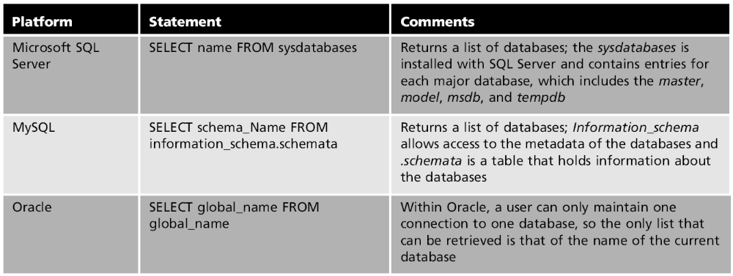
3． 取得table names
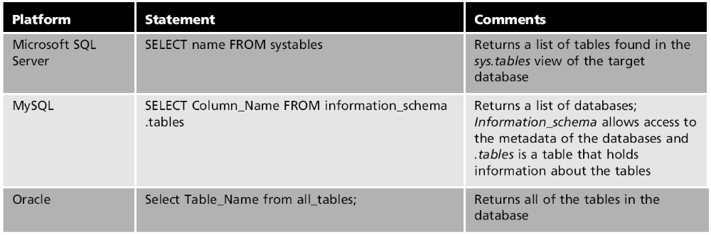
4. 取得columns
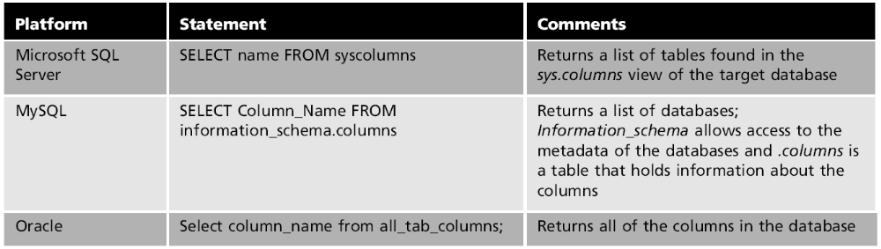
- Advanced Techniques
Filters (用于web applications)：Characteristics of filters （防止SQL injection）
入侵者应对方法： encoding (ASCII hex)
Case sensitivity (UNION uNiON)
Breaking it down (select ‘S’+ ‘ELE’+ ‘CT)
Using alternative statements (Case statements If…Then statements)

Exploitation of Privileges and Passwords
- Identifying Privileges
必须要看到Privilege tables
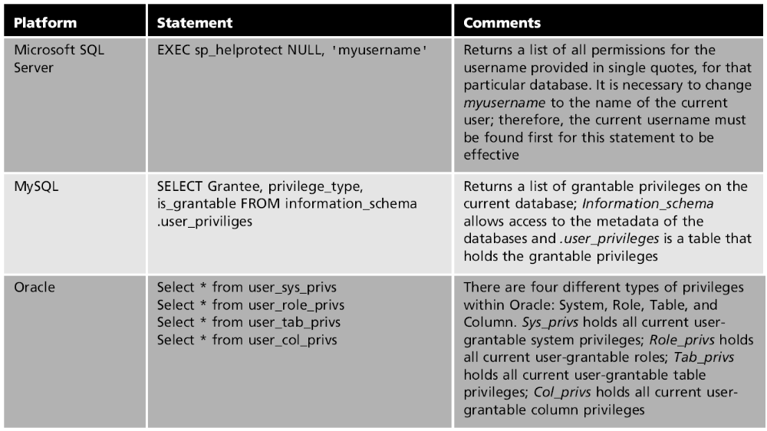
- Obtaining Passwords
如果没有HASH，存在数据库的TABLE里，应要有Privileges;
如果是HASH， 很难；
如果存的是TEXT STRINGS， 比较容易得到；
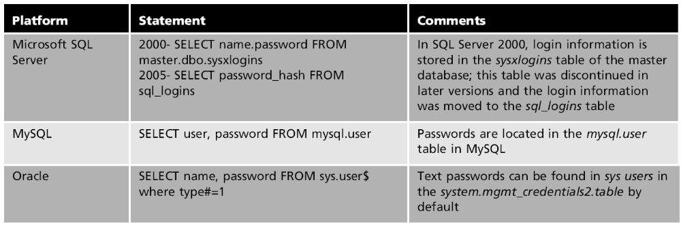
- Obtaining Privileges
要获得管理员权限。
方法：
- brute force strategies用蛮力攻击
- 用工具
- OPENROWSET：SQL Server的远程数据库（可LOGIN 不同用户，入侵者可用brute force strategies 获得权限）
- E-MAIL

Defending Against Exploitation
- Using Bond Parameters
Placeholders for binding use input
PHP: $stmt->bind_param("i", $subsidiary_id);
- Sanitizing Data 消毒数据
- Word blocking (block certain keyword)
- Word filtering (limit and mask data fileds)
- Restricting and Segregating Databases 限制和隔离数据库
不同的server分配不同的权限，
Web server给最少的权限因为SQL injection 得到的就是它的权限
Web server和Database server应该隔离
- Security-Conscious Database Design 有意的安全防护的设计
1．data infrastructure design （应考虑什么是放在外面，什么是需要隔离的）
2．Change default names on sensitive data
3．Do not use object views for critical database objects
4． Create a honeypot environment 用假信息迷惑入侵者
- Diligent Monitoring 经常监控

Key Terms – CH 8
Bond parameters Placeholders to bind user input.
Exploitation The act of using system vulnerabilities and carefully crafted SQL queries to gather information and subsequently peel away at the infrastructure’s security defense for the purpose of gaining access or control of a system.
Honeypot A fake environment that includes false data to mislead intruders who are attempting to gather information about the database.
Password hash A cryptology-encoded string version of a user or system password.
Word blocking The act of blocking keywords that are not allowed to be used as input within a Web application or a Web URL.
Word filtering A balance of blocking those known keywords that are not allowed to be used as input within a Web application or Web URL, and identifying those keywords that are allowed to be used as input within a Web application or Web URL.

Chapter 9 Security Auditing
Security Auditing review 整个安全控制和系统确认弱点 (an accurate view)
- Audit Classification
何时做：年度自我评估时； 入侵后； 确认有危险后； 为了法规或标准。
分类： informal audit; formal audit;
internal audit; external audit; automated audit
- The Goal of an Audit
内部安全控制，审计意味着提供更精准的看法，但不意味着移去易被攻击点。只有测试才能处理这个。
目标：确认安全测量的目的；锁定危险；搜寻已有程序或经验用于减轻已确认风险；报告
- The Auditing Process
Audit process characteristics: Prepare; Audit; Report
阶段：Planning and preparation phase：
confirm audit scope；
understand network and organizational structure；（须包括人，政策，系统和控制，包括有形资产和无形资产，须排出先出保全的次序）
audit plans; 包括backup策略和日常操作
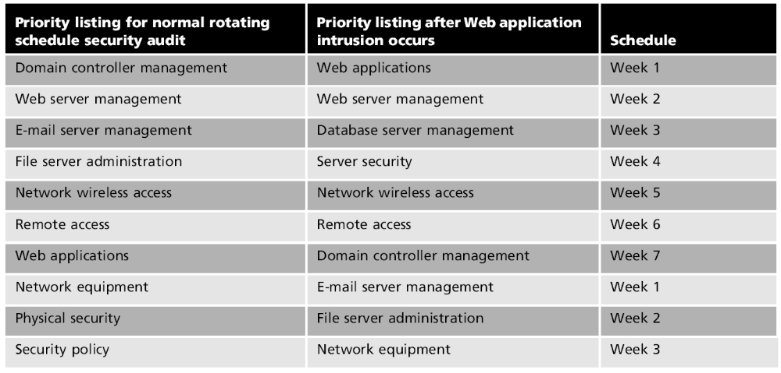
必须有准备，不可能做到任何一个细节都审核到；
Audit phase:
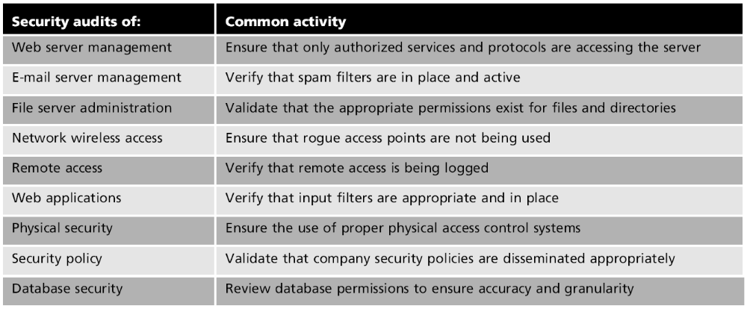
Reporting a security audit：
描述过程；汇报结果； 确认Vulnerabilities and risks
Common components of an audit report
- Background information
- Defined perimeter and scope
- Audit objectives
- Key findings
- Methodology used to identify risks
- Remediation recommendations
- Specific remediation actions to implement recommendations
背景信息—〉定义范围—〉审计目标—〉主要发现—〉确认风险—〉推荐意见—〉建议行动
- Formal or external audit includes deliverables and time frames for implementing expected actions

Database Auditing 是security audit 的一个部分，主要是审计阶段
- Preparation and Planning for a Database Security Audit
重点：database environment
- Interviews with the DBA and database system team
- Examining schemas, diagrams, policies, procedures
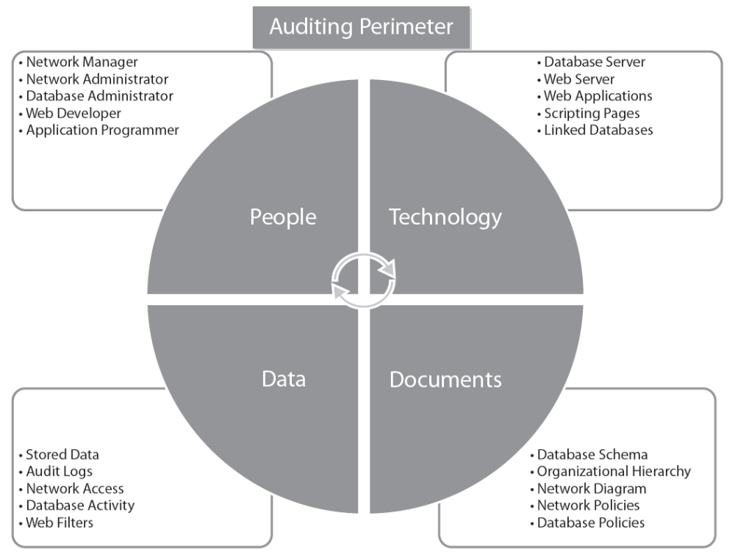
分析数据存储方式；
分析风险和危险；
Two methods of database auditing： Focus on database supporting components and then move to database itself, or vice versa
- The Database Audit
- 锁定某一具体部分，例如server maintenance（软件更新，备份策略，软件版本，资源管理，硬件更新等），
- access control （要有时效性）,
- data privilege （绝对权限要小心，给最小权限，操作系统最好没有权限，最好用group而不是个人，Privileges to stored procedures are restricted），
- password （管理要在DBMS, 设定失败LOGIN次数、有效期等，更改default passwords，尽量不存密码在数据库里，用强的加密方式）,
- account administration（定义用户帐号，移除用户帐号，应用安全政策，Assigning groups, roles, and privileges）
- encryption (stored and moving data; configured accurately; Symmetric keys; Sensitive data; Passwords are encrypted while remotely logging in to the database)
- activity (符合安全政策；监控失败的login、queries和metadata改变，验证动态SQL的执行；设定资源的consumption baselines并监控)

- Reporting a Database Security Audit
和之前一样，强调一定要有Time frame。
- Vendor-Specific Auditing Information
基本上都有，Many tools create logs。
Microsoft SQL Server：throughout all levels of the database；can be created at the server or database level；
Object explorer in SQL Server Management Studio：
步骤：创立a server audit object （instance level）--〉specification object (server audit object / database audit object)
Oracle: Monitors user sessions
Steps: enabling default security settings in the Security Settings window in the DBCA statements (audit_trail function)
MySQL: 没有专门的工具，须自己设立。

Key Terms – CH 9
Automated audit An audit conducted using tools that are either installed onto a machine or embedded within an application for the purpose of recording the typical behavior of a system.
Audit scope The area or system on which the security audit will focus. Defining the scope of the audit is one of the most important steps of the auditing process.
External audit An audit conducted using a third-party group or a number of individuals from a source outside the organization itself.
Formal audit An audit most often conducted to satisfy specific industry standards that are required by law for certain types of organizations.
Informal audit An audit conducted as a way to provide organizations evidence that their security policies and practices are effective and working properly.
Internal audit An audit conducted using a committee of individuals who are employees of the company itself.
Internal security controls The systematic measures and checks put into place to ensure that networks remain sound and secure.
Security audit The procedures by which all of an environment’s security controls and systems are thoroughly reviewed to identify and report weaknesses within an organization.

Chapter 10 Security Testing
Security Testing
Differences between auditing and security testing
- Audits conducted to locate potential weaknesses within company’s internal controls
- Security testing does not cover security policies, human resources, and legal or standards compliance（Security auditing covers these areas）
- Auditing compares documentation with the architecture（Ensures environment’s accuracy and reliability）
- Security testing measures environment’s strength and effectiveness
- Security testing can be conducted without prior knowledge of the environment （Auditing requires a great deal of infrastructure knowledge）
- Penetration入侵或浸透testing is more costly and time consuming than auditing （Often conducted with a very narrow scope）
Security test 特征：和审计类似；Ability to think and act like an intruder
- Security Testing Classification
Internal; external;
black box; white box
- External and black box testers have broad, diverse skills
- Internal or white box testers may have less expertise
- The Goal of Security Testing
Test the strength of implemented security measures

Testing Methodology 必须要有标准化的测试方法
- Planning and Preparation Phase
1． Defining the scope （由Goal of particular security test定义）
Black box testing scope不好定义 （Scopes often defined by analyzing level of access achieved by the attacker; Determine how much information would need to be obtained to access different levels of infrastructure）
2． Gathering information （其辅助工具有：Port and vulnerability scanning tools; Surveillance cameras）
Assessment之前做的是确定目标；之后做的是情报侦察，以便发现infrastructure的漏洞
- Execution Phase
这里谈及的技术主要用于black box security assessment.
1．Information reconnaissance (信息收集；最大的安全防御是时间：security logs可以capture他们的出现) 分类：Passive reconnaissance (消极被动，不用与系统互动：Network sniffer; Database and SQL sniffers) ；Active reconnaissance （主动：SQL injections；Automated tools to send pings or packets to initiate a response）
2．Obtaining access into a system infrastructure （Common initial milestone）
Common doors: physical server, wireless network
用Automated tools （有network port scanners; key logger; password scanners; network sniffers; wireless scanners; Wired Equivalent Privacy crackers; Exploiting network hardware (rogue access points; firewall penetration); port redirection and reverse Telnet）辅助可以: data capture; password cracking; finding vulnerabilities；确认硬件、软件和网络设备。
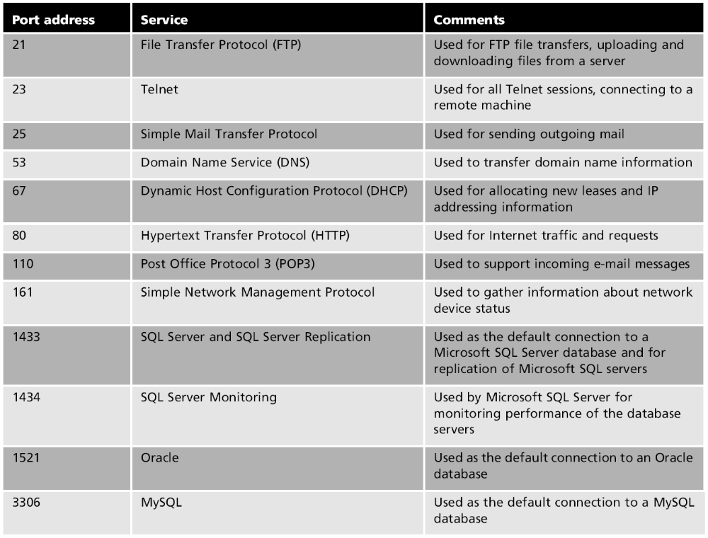
Exploiting the operating system
Exploiting Web application
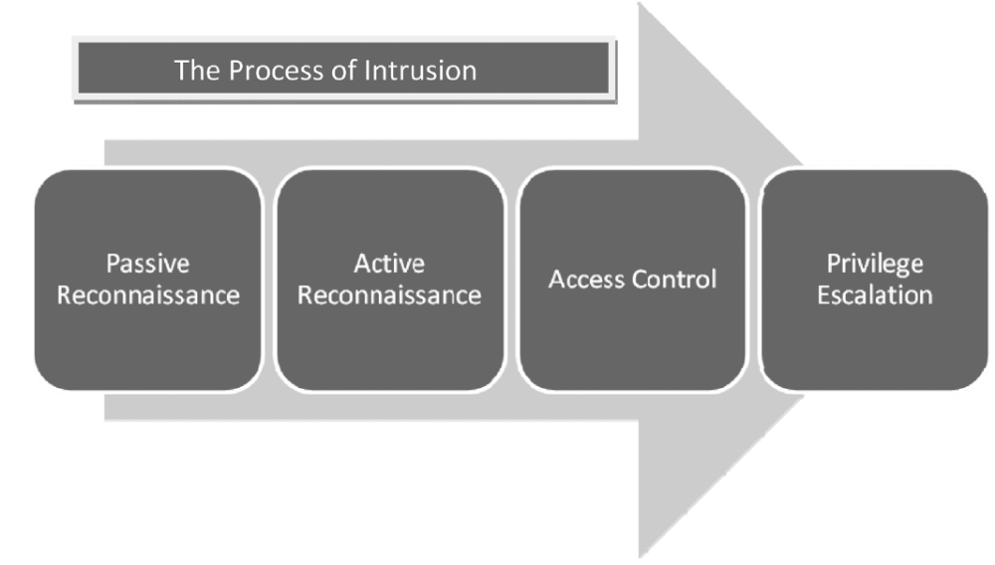
- Escalating Privileges
Common methods for escalating privileges
- Manipulate guest accounts to increase account capabilities
- Use password cracker to decrypt passwords obtained from the OS,network, or database
- Use network sniffers to discover passwords traveling across the network
- Manipulate Windows services written to be executed as the local system account
- Use third-party tools designed to allow users to run code for escalating privileges
- Use cross-site scripting techniques to run malicious code on the local machine using the Web browser
- Use brute force strategies to increase user credentials and privileges
- Use passive information-gathering techniques and the individual’s current system privileges to learn more about the system’s security structure
- Reporting Phase
- Gathered background information
- Defined perimeter and scope
- Security assessment objective
- Key findings
- Remediation recommendations, including deliverables, resources, and time frame
- Methodology used for penetration testing
- Remediation process including detailed steps
- Schedule for a repeat security assessment for remediated areas
收集背景信息—〉定义测试的周边范围—〉确定目标—〉主要发现—〉矫正建议—〉入侵所用方法—〉矫正的具体步骤—〉安排纠正地方的再次测试时间

Key Terms – CH 10
Active reconnaissance侦察 The use of active investigation methods for gathering information about a system or an infrastructure directly.
Black box testing An assessment that is conducted with no prior knowledge of the system or infrastructure that is being tested.
External testing an assessment that is conducted outside the organization’s security border; this type of testing will display attacks and liabilities that can be exploited externally from competitors, external users, and hackers. Initial tasks most commonly completed during external testing involve information gathering. An external intruder must gain information from a system or an infrastructure to break into it.
Informational reconnaissance The process of gathering information either directly (e.g., actively) or indirectly (e.g., passively) from a system or the system’s environment.
Internal testing An assessment that is conducted within the organization’s security border that will display vulnerabilities that exist among internal users such as employees and contractors. It also identifies attacks and the damage that can be caused within the network itself. A task conducted during an internal security assessment might include an evaluator logging in to a user’s computer in an attempt to raise the user’s privileges on a particular system.
Key logger Malware constructed to log every keyboard stroke that a user types on the keyboard.
Network port scanner Automated tools that are designed to traverse the network in an attempt to locate available vulnerable ports and identify the services that they use.
Network sniffers The utilities that monitor the network looking for a number of combined types of vulnerability. Network sniffers can identify missing software patches, application types, application version numbers, open ports, operating systems, and firewalls, to name a few.
Passive reconnaissance The use of passive investigation methods to gather information about a system or an infrastructure indirectly.
Password scanners Essentially, network sniffers that traverse the network searching for passwords from remote authentication systems. Password scanners capture passwords as they are sent remotely across the network and record them for the attacker to maintain.
Rogue access point A wireless access point (e.g., wireless router) that is installed within a company’s wireless range without authorization, exposing the entire network and leaving it open for anyone and everyone to navigate.
Security scope This defines the perimeter of the overall security assessment, the physical and logical area included within the assessment.
Security testing The process of identifying the feasibility and impact of an attack or intrusion of a system by simulating active exploitation and executing potential attacks within that environment.
White box testing (target testing) An assessment that is conducted by an intruder who already has information about the system or the infrastructure. It is also known as targeted testing because prior knowledge exists and known weaknesses within the infrastructure allow for intruders to focus on specific areas of the infrastructure. The goal is to assess the damage that can be done by users who understand the infrastructure that they are attempting to intrude; the results will provide a more comprehensive, thorough picture of specific system weakness than that found in black box testing.
Wired Equivalent Privacy (WEP) crackers Software applications that are used to decrypt WEP keys.
Wireless scanners Utilities that identify vulnerabilities within a wireless network, including missing encryption keys and poor security measures.

