**Hong Zhang**

**English 1105**

**Revision: 11/14/2012**

**Technical description**

**of Sony DNW-A75P Digital Videocassette Recorder**

The DNW-A75P is an editing VTR. With two of these units together, you can carry out automatic or manual editing, using either assemble or insert editing. A set of editing equipment, which has two editing VTR (one is as player and the other is as recorder) and one video monitor, is a popular set to use linear video editing to produce TV programs. Our TV new center’s edit room has 50 units. This technical description describes the basic parts of the unit and introduces its basic function. It is a guideline for new staff and teaches them how to use the unit.

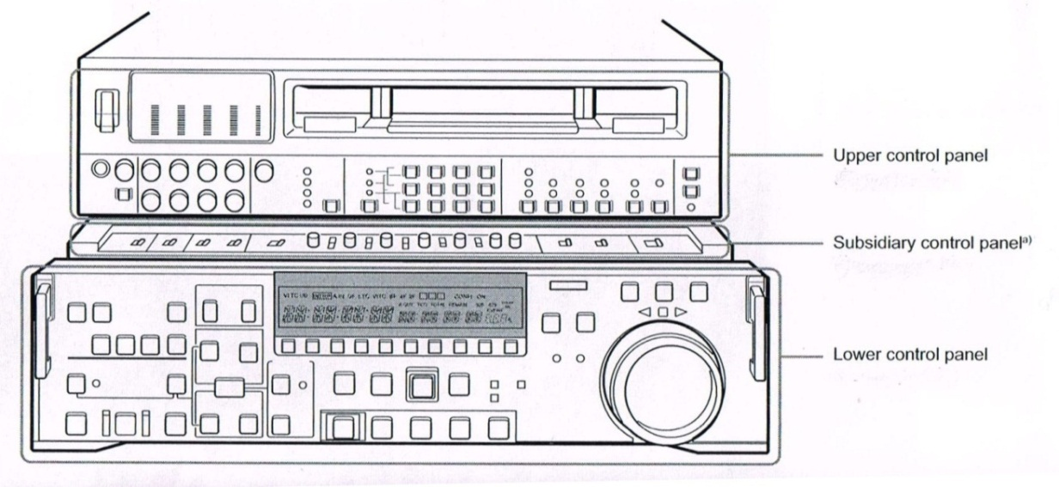

**Front View of Sony DNW-A75P Digital Videocassette Recorder**

There are three control panels in front of the unit: upper control panel, subsidiary control panel and lower control panel. If you pull the lower control panel forward, you will see the subsidiary control panel. There are some switches in the subsidiary control panel, including control panel switch, character switch, out ref switch and so on. When you use the unit to edit program, you seldom touch these switch and often use upper control panel and lower control panel.

* **Upper control panel**

1. Power switch

This powers the unit on and off.

1. Level meters

These show the audio levels of channels 1 to 4 and the video levels of input composite video signals. There are two modes for audio level indications: Full and Fine, selected by the Display Full / Fine switch.

1. Rec (recording) controls

These individually adjust the audio recording levels on channels 1 to 4.

1. Video input select switch and indicators

This switch selects the video input signal in the following sequence.

SDTI→SDI→COMPONENT→COMPOSITE→SDTI

To select SDTI requires the option for SDTI input. The rest may be deduced by analogy. The indicators light according to the selection. If there is a fault on the selected input (such as no input signal), the indicator will flash.

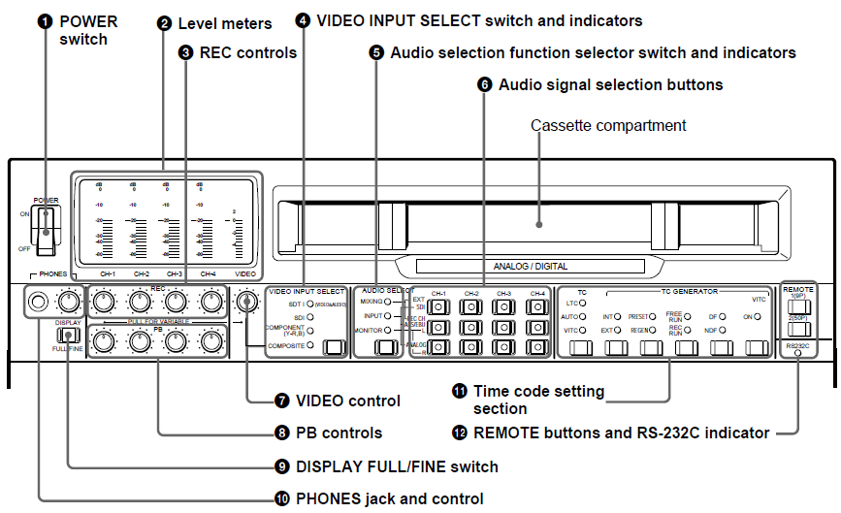

**Upper control panel**

1. Audio selection function selector switch and indicators

Pressing this switch lights the MIXING indicator, INPUT indicator and MONITOR indicator cyclically, and selects the function of the audio signal selection buttons.

1. Audio signal selection buttons

The function of these buttons depends on the setting of the audio selection function selectors switch, as follows.

When the MIXING indicator is lit; you can use the EXT and REC CH rows of the audio signal selection buttons to switch the audio to be recorded or carry out mixing.

When the INPUT indicator is lit; you can use the SDI, AES / EBU, and ANALOG L / R rows of the audio signal selection buttons to select the audio input signals.

When the MONITOR indicator is lit; you can use the L and R rows of the audio signal selection buttons to select the audio output channels.

1. Video control

This adjusts the level of a composite video signal input to the COMPOSITE VIDEO INPUT connectors.

1. PB (playback) controls

These adjust individually the playback levels on channels 1 to 4.

1. Display full / fine switch

This switches the audio level meter display full or fine.

1. Phones jack and control

Connect stereo headphones with an impedance of 8 ohms, to monitor the sound during recording, playback and editing.

1. Time code setting section

There are TC (time code) switch and indicators, INT/EXT (internal / external) switch and indicators, PRESET / REGEN (preset / regenerated) switch and indicators, FREE RUN / REC RUN switch and indicators, DF / NDF (drop – frame / non – drop - frame) switch and indicators in this part’s section.

1. Remote buttons and RS – 232C indicator

There are three buttons to select the device controlling this unit, as follow.

1(9P): this unit is controlled by the device connected to the REMOTE1 – IN (9P) or REMOTE1 – OUT (9P) connector.

2(50P): this unit is controlled by the device connected to the REMOTE1– PARALLEL I / O (50P) connector.

RS – 232C indicator: this indicator lights when this unit is controlled through the RS – 232C connector.

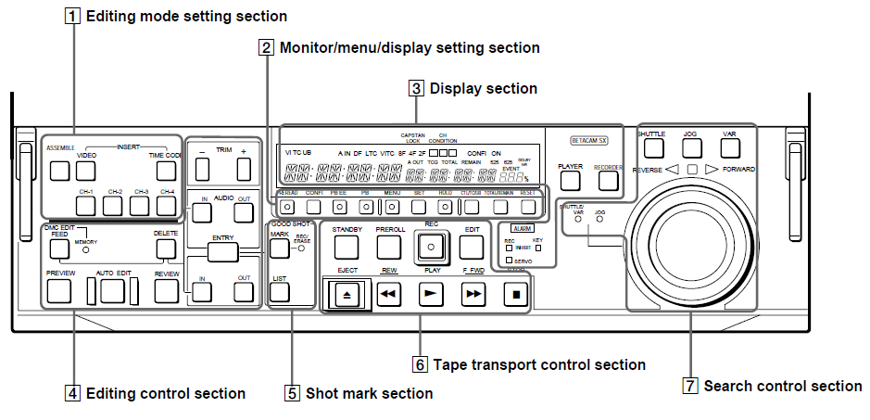

**Lower control panel**

* **Lower control panel**

1. Editing mode setting section

Through these buttons, you can select to carry out assemble editing (this means video signals, audio signals , time code signals are recorded together), video editing, audio editing or time code editing.

1. Monitor / menu / display setting section

These buttons mean that you can carry out to preread (read – before - write), playback, check the unit’s menu and select the time code type (CTL, TC and UB).

1. Display section

This part displays the time data type, tape speed, tape type and selects the unit to be player or recorder.

1. Editing control section

Through this area’s buttons, you can select to record, delete, preview, review, playback at any speed between -1 and +2 times normal and set edit point (including audio and video in and out point).

1. Shot mark section

When using a tape with shot markers recorded, you can read out the good shot marks from the tape, by simultaneously pressing the LIST button and either FFWD or REW button.

1. Tape transport control section

Through these buttons, you can play, record, edit, fast forward, rewind, stop and reject the tape.

1. Search control section

This search dial can help you to search single – frame picture in the tape.

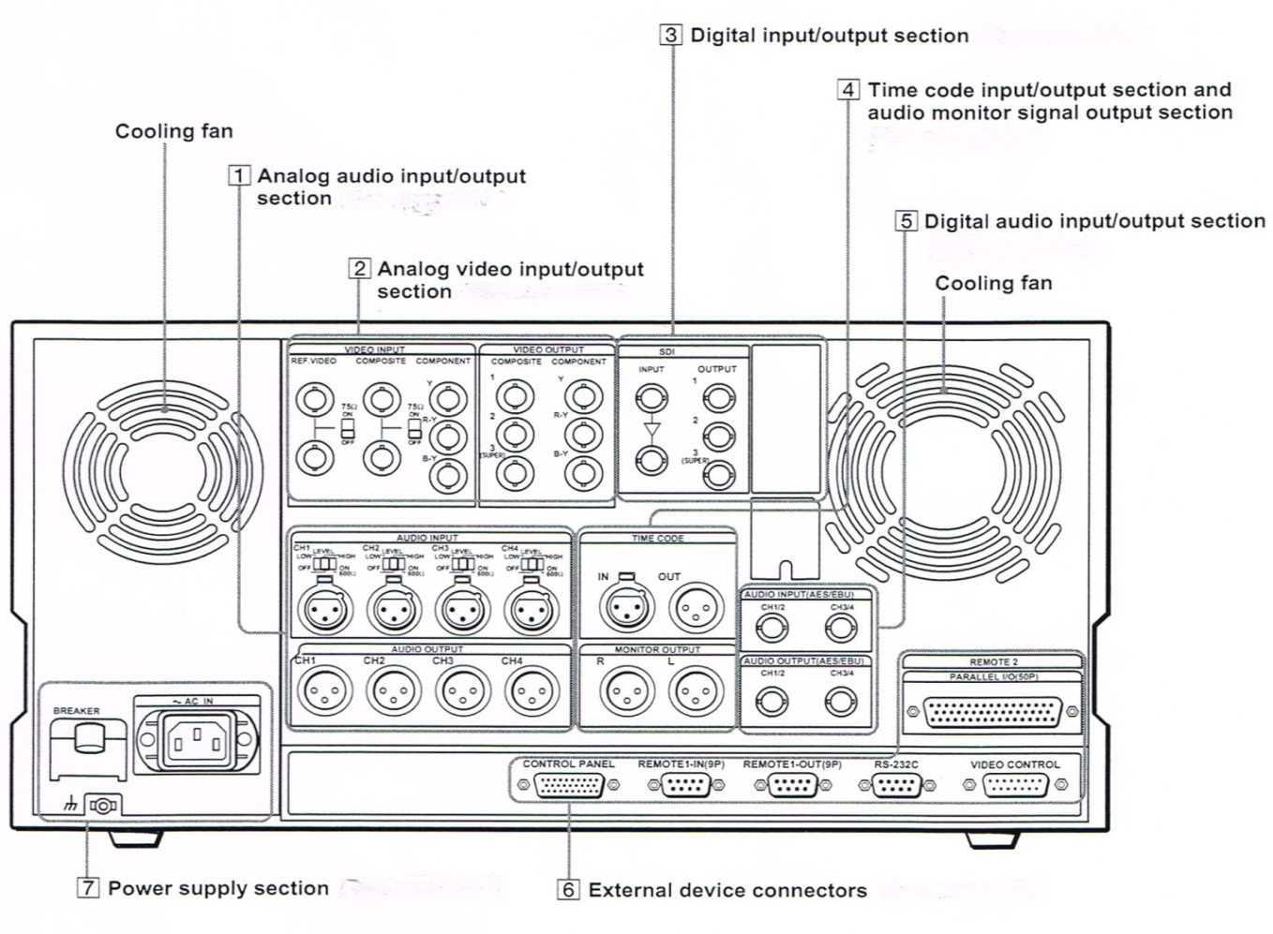

**Back View of Sony DNW-A75P Digital Videocassette Recorder**

* **Connector Panel**

There is connector panel in the back of the unit. If you want to connect analog signal, you should use cables connect outside equipment (such as video monitor) with No.1 Analog audio input / output section and No.2 Analog video input / output section in the unit. If you want to connect digital signal, you should use cables connect outside equipment with No.3 Digital input / output section and No.5 Digital audio input / output section in the unit.

If you want to indicate the time code, you should use the cable to connect with No.4 Time code input / output section and audio monitor signal output section.

If you want to use the unit together with another DNW – A 75P or a D – 1, D – 2, or Betacam VTR, or other editor connect a remote control cable from the other unit to this connector in No 6. External device connectors.

**Technical description**

**of linear video editing’s process**

Linear editing is the process of transferring segments of video and/or audio from raw footage tapes onto a record tape. These segments can be taken from any location on your original tapes and edited onto the record tape in sequence. Editor often use linear editing to edit TV program. The equipment using linear editing is the editing VTR, such as Sony DNW-A75P digital videocassette recorder.

**Linear editing’s principle**

If you want to use linear editing, you must know time code/control track at first.

Time code/control track is recorded concurrently while video is recorded. **Time code** is time data recorded on a tape. The time is expressed in units of hours, minutes, seconds and frames, and if recorded continuously from the beginning of a tape, used to determine the absolute position of video and audio recorded on the tape. **Control track** is a series of electronic pulses recorded on a tape. Those pulses are called frames and there are about 30 frames for every second of videotape. Those pulses give your tape stability and synchronicity.

Simply, linear editing is a process of tapes copying from player to recorder. However, if your tape doesn’t have time code/control track, your video or audio signals won’t record correctly on your tape. Time code/control track is to videotape like primer is to paint or railroad tracks are to trains, an essential but underlying element.

There are two way to establish time code/control track on your tape. One is to record. This way is set up time code/control track on a new tape which can’t transfer segments from other tapes. Hence, that is not very accurate when you are trying to edit. The second is through one of the two types of editing called assemble editing. This way can set up time code/control track and transfer segments from original tape.

**Two types of linear editing: assemble and insert**

**Assemble editing**

This type of editing allows you to assemble the basic pieces of your various video segments. During an assemble edit, all signals (video, audio, and control track) are recorded. This type of editing is done in chronological order, piecing together edits back to back on the finished tape. Assemble edits establish the time code/control track on your tape.

When you perform assemble edits, the beginning of the edit is very precise and clean, but the end is very rough and uneven—the time code/control track breaks at the end of every assemble edit.

**Insert editing**

Insert editing allows you to select and insert video and/or audio signals into your program. Time code/control track must already be established on your tape because insert edits only record on the chosen video and/or audio tracks; it never touches (or records!) the control track.

**Linear editing’s process**

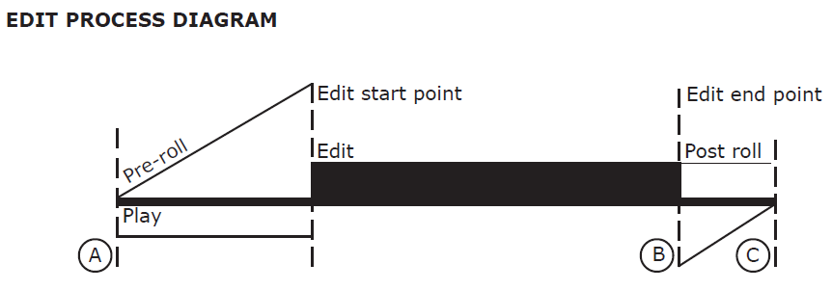

No matter which form of editing you choose, one-touch assemble or program insert, the process of linear editing is same. Through editing VTR’s search control section, you search edit start point and edit end point on the player’s tape and the recorder’s tape. Then, through editing mode setting section, you set up these edit points on recorder’s tape. Finally, when you press the edit button in recorder’s tape transport control section to carry out editing, the recorder’s tape automatically backs up for the pre-roll (A)—you will not see the pre-roll on screen. The pre-roll gets the tape up to speed to more accurately perform the edit. After the edit is performed, the tape stops recording (B), but continues to play for two seconds (C).