**Hong Zhang**

**English 1105**

**11/20/12**

**Instructions of Magellan RoadMate 5120**

This Magellan RoadMate 5120 is a GPS receiver. In other words, it is a handheld GPS vehicle-navigation device which is designed to assist you in arriving to your selected destinations.

This Magellan receiver consists of an antenna, a radio receiver and a processor. They are all contained in a box and you only see a screen display from outside. When the receiver is turned on, its radio receiver will receive Global Positioning System (GPS) signals from the constellation of 27 Earth-orbiting satellites. Then, through these signals, its processor will calculate the latitude, longitude and altitude of its current position. To make the navigation more user-friendly, it translates these raw data into a map which has stored in its process’s memory and you can see this map through its screen display. If you add the destination when you drive a car, the receiver will not only place you on the map at any particular location, but will also calculate and show you the rout, your current spend and estimated time of arrival at your destination if you maintain your current speed. Beside these capabilities, this Magellan device can give your information about nearby points of interest, such as gas stations, restaurants, and hotels.

**Safety**

Before using this device, you should know and follow these safety rules to prevent accidents that can result in injury or death to yourself or others:

* When driving, the need to view the display is minimal. Voice prompts will guide you to your destination. The driver should enter data or program the Magellan receiver only when the vehicle is stopped.
* It is your responsibility to comply with all traffic laws.
* Keep the receiver safe from extreme temperature conditions. For example, do not leave it exposed to direct sunlight for an extended period of time. The maximum operating temperature is 60℃.
* When using car cradle on the windshield, it should not obstruct the driver’s view of the road.
* The battery is rechargeable and should not be removed.

**Installation**

Before using this Magellan receiver, you should connect it with its two accessories, a vehicle power cable which can supply the power to this Magellan receiver, and a car cradle which can fix the receiver on the car and a receiver.

Firstly, you should choose a location for the car cradle to fix the receiver. It needs a clear view of the sky to receive signals from the GPS satellites so choose a location with an unobstructed view of the sky, commonly on or near the windshield.

Then, you can install the car cradle. These steps are as follow:

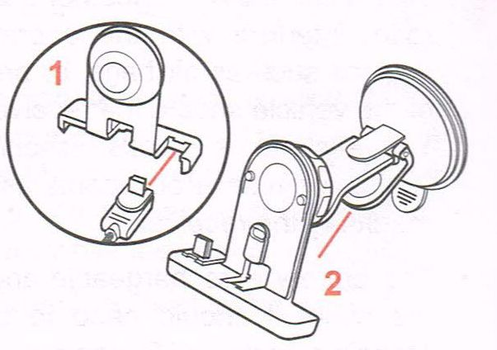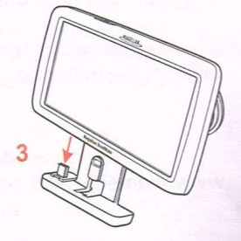

1. Attach the USB connector of the vehicle power cable to the cradle as shown.
2. Hold the cradle assembly firmly against the window surface and push lever toward the base.
3. Attach the receiver to the cradle.

Finally, you can plug the vehicle power cable into car power cord to get power.

**Operation**

The operation of this Magellan receiver is very simple. When you touch one of these icons on its screen display, the receiver will process the corresponding program.

For example, I want to create a route. These steps are as follow:

1. Slide the power switch which lies on the receiver’s top to the left to turn the receiver on, and the screen display safe rulers.
2. Touch “√” icon in the bottom to process a map screen.
3. Touch “Menu” icon to access main menu on its map screen.
4. Touch “Address” icon to enter the destination’s address on its main menu screen.
5. Type the address’s city name on the keyboard and the result will appear in the blank area prompting to enter city. If you finish the typing, touch “√” icon to process the program.
6. Type the address’s street name on the keyboard and the result will appear in the blank area prompting to enter street. If you finish the typing, touch “√” icon to process the program.
7. Type the address’s street number on the keyboard and the result will appear in the blank area prompting to enter street number. If you finish the typing, touch “√” icon to process the program.
8. Type the address’s street number on the keyboard and the result will appear in the blank area prompting to enter street number. If you finish the typing, touch “√” icon to process the program.
9. Touch the “Go” icon and the display screen will show the route’s map screen.

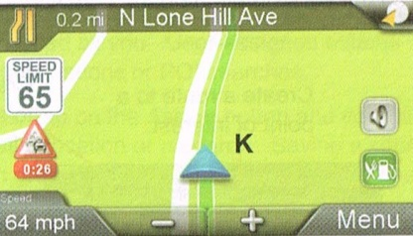

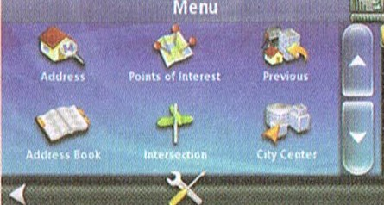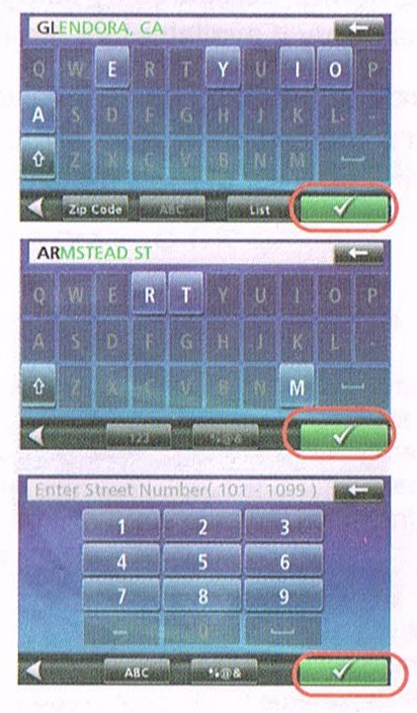

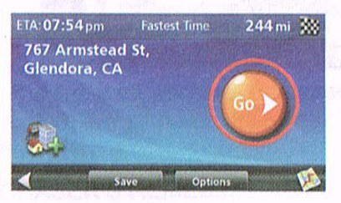

Since icons present corresponding programs, you should know the meanings of all icons and signs before you use this receiver.

**Map Screen**

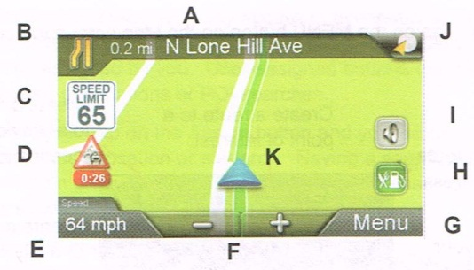

1. Displays distance and street for next maneuver. Tap to repeat last instruction. (Displayed only while adding a route.)
2. Next Turn instruction. ((Displayed only while adding a route.)
3. Displays current speed limit when traveling on a highway or main road.
4. Traffic icon with route delay time if traffic warnings appear on route.
5. Displays estimated time of arrival. Tap to select distance to destination, arrive time, speed or time remaining in the route.
6. Zoom Out/ Zoom In
7. Access main menu
8. Press to display Points of Interest found on next few highway exits. (Displayed only while traveling on a highway.)
9. Access Volume/Mute controls
10. Access OneTouch Menu which provides easy access to destinations and searches you use most
11. Current Position Icon

**Main Menu**

It includes 6 menu buttons. If you touch an icon, this receiver will access a relative program to process.

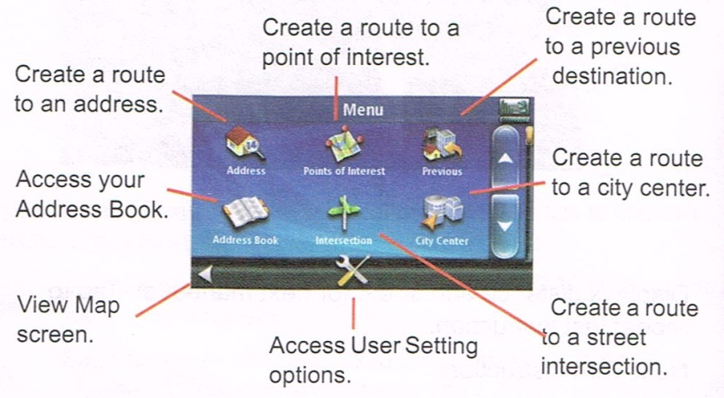

If you select route, the main menu will change some icons and add some functions.

