Macroeconomics, (Hubbard/O’Brien)
Chapter 22 Long-Run Economic Growth: Sources and Policies

1)

Which of the following accurately describes economic growth and standards of living between 1,000,000 BC and 1300 AD?

A)

Standards of living in 1300 AD were substantially better than what they were in 1,000,000 BC.

B)

Standards of living substantially declined from 1,000,000 BC to 1300 AD.

C)

Significant economic growth took place between 1,000,000 BC to 1300 AD.

D)

No sustained economic growth occurred between 1,000,000 BC to 1300 AD.

D

2)

The best measure of a country's standard of living is

A)

GDP per labor hour.

B)

GDP per unit of capital.

C)

GDP per capita. 人均GDP

D)

total GDP.

C

3)

The Industrial Revolution

A)

marked the beginning of significant economic growth in the world.

B)

started in France around the year 1750.

C)

produced goods exclusively using human or animal power.

D)

had no impact on standards of living in the world.

A

4)

Which of the following is NOT a reason why the Industrial Revolution occurred when and where it did?

A)

The British government was committed to upholding private property rights.

B)

The British government was able to eliminate arbitrary increases in taxes.

C)

The British government was able to more easily seize wealth.

D)

Institutional changes by the British government helped in protecting wealth.

C

5)

During which of the following periods was growth in GDP per capita the strongest?

A)

prior to 500 AD.

B)

500 AD to 1800 AD

C)

1800-1900 AD.

D)

1900-2000 AD.

D

6)

In the long run, ________ differences in economic growth rates result in ________ differences in GDP per capita.

A)

large; small

B)

large; no

C)

small; large

D)

small; no

C

7)

In comparing China and Japan in terms of growth rates and standards of living, we find

A)

life expectancy is longer in China.

B)

GDP growth rates currently are higher in China

C)

infant mortality is higher in Japan.

D)

standards of living are higher in China.

B

9)

The country with the lowest GDP per capita is

A)

France

B)

Mexico

C)

Sierra Leone

D)

Argentina

C

10)

The country with the highest GDP per capita is

A)

Luxembourg

B)

United States

C)

Japan

D)

Norway

A

11)

An economic growth model

A)

explains changes in nominal GDP per capita in the long run.

B)

explains changes in real GDP per capita in the long run.

C)

explains changes in nominal GDP per capita in the short run.

D)

explains changes in real GDP per capita in the short run.

B

12)

Which factors explain labor productivity?

A)

technological change; the quantity of labor per hour

B)

diminishing returns; the quantity of labor per hour

C)

diminishing returns; the quantity of capital per hour

D)

technological change; the quantity of capital per hour 每小时劳动资本量

D

13)

The per-worker production function shows the relationship between ________ per hour worked and ________ per hour worked, holding ________ constant.

A)

labor; real GDP; technology

B)

capital; real GDP; technology

C)

labor; capital; real GDP

D)

capital; labor; real GDP

B

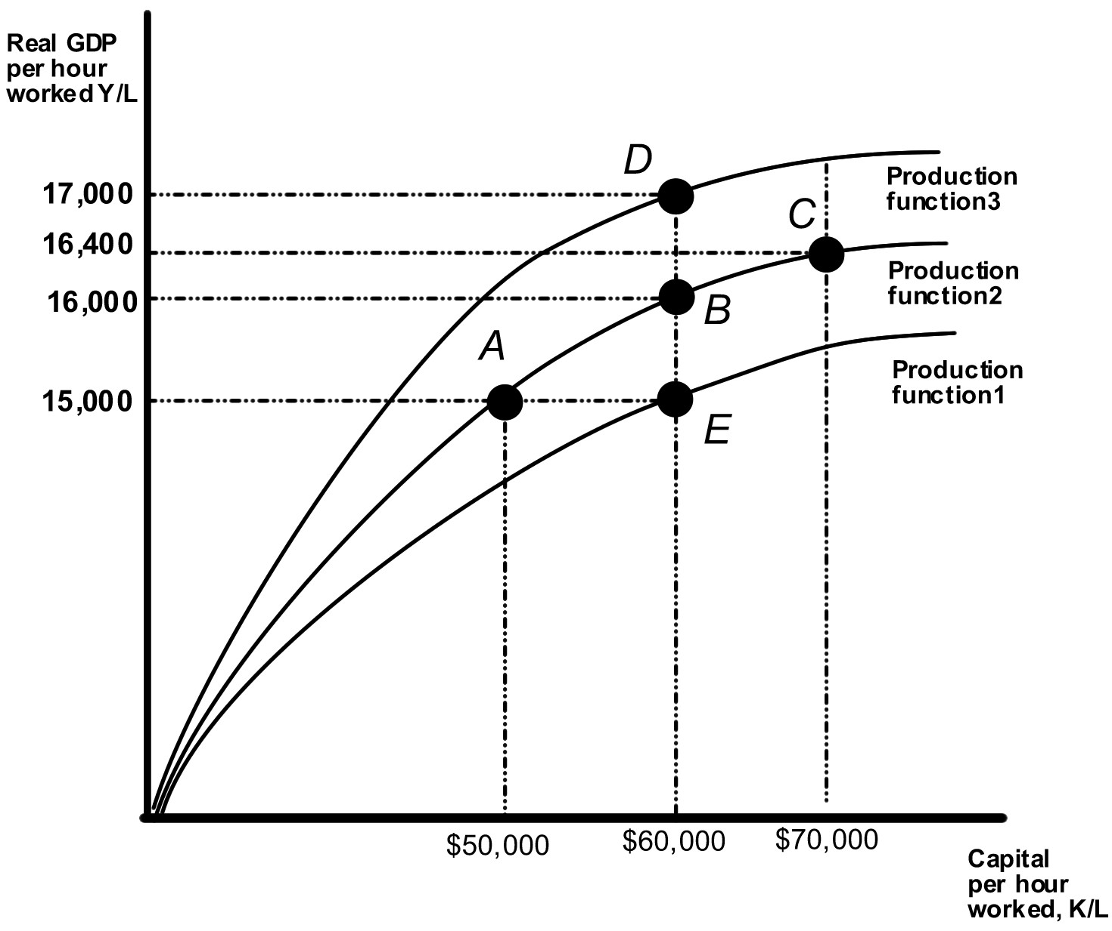

14)

Technological change is shown in the above diagram by the movement from

A)

B to C.

B)

B to D.

C)

B to E.

D)

B to A.

B

15)

Technological change will

A)

shift up the per-worker production function.

B)

shift down the per-worker production function.

C)

move the economy to a point beneath the per-worker production function.

D)

move the economy along a given per-worker production function.

A

16)

In the long run, a country will experience an increasing standard of living only if it experiences

A)

a high rate of consumption.

B)

continuous technological change.

C)

a high rate of labor force growth.

D)

a slow rate of population growth.

B

17)

Which of the following describes the Soviet Union's economy in the second half of the 20th century?

A)

The Soviet economy grew rapidly in the later half of the 20th century.

B)

The Soviet economy increased capital per worker very slowly from 1950 through 1980.

C)

The Soviet economy eventually grew slowly because of the slow rate of technological change.

D)

The Soviet economy grew because it added labor through immigration policy in the 1950s.

C

18)

Endogenous growth theory 内生增长理论

A)

states that the rate of technological change is determined outside the working of the market system.

B)

does not adequately explain the factors that determine productivity.

C)

states that the rate of technological change is caused by economic incentives.
技术进步受到经济激励

D)

states that the rate of technological change is unaffected by economic incentives.

C

19)

An increase in ________ shifts ________ the production function, and makes it possible to produce a higher level of GDP with ________ capital per hour worked.

A)

technology; down; the same amount of

B)

technology; up; the same amount of

C)

consumption; up; a lesser amount

D)

labor productivity; down; the same amount of

B

20)

Endogenous growth theory states that increases in ________ capital will result in ________ at the ________ level.

A)

knowledge; increasing returns to scale: firm

B)

physical; decreasing returns to scale; firm

C)

knowledge; decreasing returns to scale; economy

D)

knowledge; increasing returns to scale; economy

D 在整体经济层面上，知识资本的积累是回报递增的，在企业层面，知识资本的积累是受制于回报递减的。

21)

According to Joseph Schumpeter, which of the factors of production is central to economic growth?

A)

land

B)

labor

C)

natural resources

D)

the entrepreneur

D

22)

According to Joseph Schumpeter, the theory of creative destruction创造性破坏 describes a process by which

A)

new products unleash a gail of destruction that creates other new products.

B)

new products unleash a gail of destruction that drives old products out of the market.

C)

new products are created by the destruction of capital.

D)

the creation of new products never involves the destruction of old products.

B

23)

Which of the following accurately describes growth rates in the United States from 1900 to the present?

A)

growth rates rose until the 1950s; then fell until the present

B)

growth rates have risen continuously from 1800 to the present.

C)

growth rates rose until the 1950s, slowed until the 90s; then rose up to the present.

D)

growth rates have fallen continuously from 1800 to the present.

C

24)

During which of the following periods was the U.S. growth rate the slowest?

A)

1900-1950.

B)

1950-1973.

C)

1973-1995.

D)

1995-2004.

C

25)

Because of the productivity slowdown in the U.S. from the mid 1970s through the mid 1990s,

A)

real GDP per capita grew more rapidly.

B)

real GDP per capita grew more slowly.

C)

the standard of living did not change.

D)

the standard of living increased in the U.S.

B

26)

An explanation for the productivity slowdown from 1973 through 1995, is

A)

measurement problems.

B)

creative destruction.

C)

a decline in oil prices.

D)

an increase in labor quality.

A

27)

Some economists argue that the productivity slowdown from mid 1970s to mid 1990s actually didn't happen, but just "appeared" to happen because

A)

services were becoming a more important part of the economy and it was hard to measure increases of output from services.

B)

new environmental laws had passed and forced firms to spend to reduce pollution and this spending did not raise output.

C)

increased spending on health and safety raised worker productivity.

D)

A and B.

E)

B and C.

D

28)

Some economists argue that the productivity slowdown of the mid1970s to the mid 1990s was due to changes in oil prices that

A)

increased production costs, causing firms to reorganize production to conserve energy, which reduced output per worker.

B)

decreased production costs, causing firms to reorganize production to conserve energy, which reduced output per worker.

C)

increased production costs, causing firms to reorganize production to conserve energy, which increased output per worker.

D)

decreased production costs, firms increased production, which reduced output per worker.

A

29)

Knowledge capital is ________ in production and ________. As a result, firms ________ free ride.

A)

nonrival; nonexcludable; can

B)

nonrival; excludable; can

C)

rival; nonexcludable; cannot

D)

nonrival; nonexcludable; cannot

A

30)

Given the fact that the productivity slowdown affected all industrial countries, which of the following explanations for the productivity slowdown in the U.S. is not likely to be correct?

A)

a deterioration of the U.S. education system caused a decline in the quality of labor

B)

high oil prices

C)

services have become a smaller fraction of GDP

D)

stricter environmental regulations

C

31)

Which of the following is NOT an explanation for the revival in the growth of productivity starting in the mid 1990s?

A)

Information and communication innovations are increasingly geared toward improving business processes and not consumer products.

B)

Faster computers have sped up data processing.

C)

Internet use has increased the efficiency of how firms buy and sell to each other and to consumers.

D)

Cell phones and wireless Internet access increase worker flexibility.

A

32)

Information technology industries such as computers, cell phones, computer programming, and software

A)

have accounted for very little growth in real GDP in recent years.

B)

have accounted for nearly all the growth in real GDP in recent years.

C)

have accounted for as much as one third the growth in real GDP in recent years.

D)

have accounted for negative growth in real GDP in recent years.

C

33)

The fastest rate of productivity growth during the years 1995-2004 has been experienced by

A)

Japan.

B)

France.

C)

the United Kingdom.

D)

the United States.

D

34)

The U.S. economy has seen a faster increase in productivity since the mid 1990s as compared to other leading industrial economies in the G7. Which of the following explains this?

A)

U.S. unions impose stricter work rules as compared to unions in the G7.

B)

U.S. government regulations impose stricter work rules as compared to government regulations in the G7.

C)

The U.S. has a higher rate of job mobility than in the G7 countries.

D)

U.S. workers can obtain unemployment insurance for a longer period of time as compared to the G7 countries.

C

35)

The economic growth model predicts that

A)

GDP per capita of rich countries will grow more rapidly than in poor countries.

B)

GDP per capita of poor countries will grow more rapidly than in rich countries.

C)

Governments must centrally direct the economy for growth to occur.

D)

GDP per capita of poor countries will never change.

B

36)

Empirical evidence from 1960-2000 shows that convergence in economic growth is occurring in which of the following cases?

A)

low income industrial countries are catching up to high income industrial countries

B)

low income developing countries are catching up to high income industrial countries

C)

low income industrial countries are catching up to high income developing countries

D)

all low income countries are catching up to all high income countries

A

37)

Which of the following countries actually experienced negative economic growth from 1960 to 2000?

A)

Israel

B)

Singapore

C)

Niger

D)

Malaysia

C

38)

________ and ________ are two industrial countries that had low income in 1960 but grew the fastest between 1960 and 2000.

A)

Switzerland; United States

B)

Japan; Ireland

C)

Malaysia; Singapore

D)

Niger; Central African Republic

B

39)

Which of the following accurately describes the impact of the rule of law on a country's economic growth rate?

A)

Countries with a strong rule of law have faster economic growth.

B)

Countries with a weak rule of law have faster economic growth.

C)

Countries that enforce property rights through law suits have slower economic growth.

D)

Countries where favoritism and bribery are common have stronger rates of growth.

A

40)

Which of the following is a reason why low income countries might experience economic growth?

A)

The country has endured extended periods of war.

B)

The country fails to enforce a rule of law.

C)

The country suffers from poor health infrastructures.

D)

The country has a high rate of savings and investment.

D

41)

There has been catch-up among the ________ countries, but there has not been catch-up among ________.

A)

developing countries such as Niger; industrialized countries such as Japan

B)

industrialized countries such as Japan; the countries of the world together

C)

developing countries such as Niger; the countries of the world together

D)

the countries of the world together; industrialized countries such as Japan

B

42)

________ save a ________ of their income. This ________ capital in their economy and raises economic growth.

A)

Developing countries; large proportion; decreases

B)

Developing countries; small proportion; increases

C)

High income countries; large proportion; increases

D)

High income countries; small proportion; increases

C

43)

Lack of investment in strong education and health care systems

A)

causes a deterioration in human capital and a decline in labor productivity.

B)

causes a decline in physical capital and a decline in labor productivity.

C)

increases human capital and cause a decline in labor productivity.

D)

causes a deterioration in human capital and an increase in physical capital.

A

44)

Which of the following is an example of foreign portfolio investment外国证券投资?

A)

the purchase of a U.S. stock issued by a U.S. citizen

B)

the purchase of a U.S. Treasury bond by a German citizen

C)

the purchase of a U.S. mutual fund from a U.S. broker

D)

the purchase of a Japanese factory by a Korean

B

45)

Foreign direct investment 外国直接投资occurs when a Chinese corporation

A)

purchases stock issued in China.

B)

opens a new Chinese factory.

C)

purchases 1000 shares of stock issued by an American company.

D)

opens a new French factory.

D

46)

Until recently, many developing countries

A)

were quite open to foreign investment.

B)

encouraged foreign direct investment but discouraged foreign portfolio investment.

C)

sealed themselves off（seal off把什么封锁起来） from foreign investment.

D)

encouraged foreign portfolio investment but discouraged foreign direct investment.

C

47)

Foreign investment can give a low income country

A)

access to funds for investment and access to technology.

B)

the means to slow down growth.

C)

a path to dependency and low growth.

D)

no hope to break the vicious cycle of poverty.

A

48)

Globalization is positively associated with

A)

poverty.

B)

declining rates of investment.

C)

declining standards of living.

D)

economic growth.

D

49)

Globalization is defined as the process of countries becoming ________ open to foreign trade and ________ open to foreign investment.

A)

more; less

B)

more; more

C)

less; more

D)

less; less

B

50)

Corruption 贪污贿赂

A)

undermines the rule of law and curtails growth.

B)

raises the rate of growth as bribes enhance income.

C)

is eliminated by foreign direct investment.

D)

acts as a magnet for foreign direct investment.

A

51)

The United States

A)

currently is one of the most corrupt countries.

B)

has never had a significant problem with corruption.

C)

had a significant problem with corruption in the 1930s.

D)

currently ranks among the least corrupt countries.

D

52)

If property rights are not enforced in a country,

A)

the market system will still work smoothly.

B)

entrepreneurs are unlikely to risk their own funds investing in such an economy.

C)

that country's growth rate will not be affected.

D)

that country will grow more rapidly because of the reduction of law suits.

B

53)

Robert Lucas argues that there are ________ returns to human capital, and these productivity increases are not completely captured by individuals as they decide how much education to purchase. As a result, the market produces ________ education and training.

A)

increasing; too much

B)

decreasing; too much

C)

increasing; too little

D)

decreasing; too little

C 人力资本的回报是递增的，但是其生产率的提高并不完全由个人决定，比如他们能获得多少教育，因此，市场可能提供了无效的低教育和培训水平，除非教育是由政府支持的。

54)

Which of the following policies is the most direct way to enhance human capital in the economy?

A)

increased vaccinations against infectious diseases

B)

political reform to decrease corruption

C)

stronger laws to protect property rights

D)

relaxation of regulations that limit foreign direct investment

A

55)

Which of the following policies are designed specifically to directly promote technological change in an economy?

A)

government subsidation of research and development

B)

tax incentives to promote investment in 401K plans

C)

laws to strengthen property rights

D)

a vaccination program to combat infectious diseases

A

56)

Policies to promote growth by increasing savings and investment work through

A)

decreasing the supply of loanable funds, lowering the interest rate, raising the level of investment in physical capital.

B)

increasing the supply of loanable funds, increasing the interest rate, raising the level of investment in physical capital.

C)

increasing the supply of loanable funds, lowering the interest rate, lowering the level of investment in physical capital.

D)

increasing the supply of loanable funds, lowering the interest rate, raising the level of investment in physical capital.

D

57)

Not enforcing property rights in an economy will

A)

cause the market system to work inefficiently.

B)

not change the level of investment.

C)

lower the level of investment.

D)

raised the level of investment.

C

不实施财产权，市场体系不能良好运作，企业不愿意用自有资金冒险，投资者不愿意借钱给企业。

58)

All of the following are policies to promote savings in an economy except

A)

deferring taxes on interest earned from 401k plans.

B)

lowering a sales tax. 消费增多，储蓄减少

C)

establishing a program of investment tax credits.

D)

making the interest on bonds tax free.

B

59)

The movement from A to B to C illustrates

A)

an improvement in technology.

B)

a decline in capital per worker.

C)

diminishing returns to capital.

D)

diminishing returns to labor.

C

60)

Which of the following is not a normative statement about economic growth?

A)

Economic growth is associated with higher labor productivity growth.

B)

Economic growth increases GDP per capita.

C)

Economic growth hurts developing countries.

D)

Foreign direct investment stimulates economic growth.

C

61)

The movement from A to B to C illustrates

A)

an improvement in technology.

B)

a decline in capital per worker.

C)

diminishing returns to capital.

D)

diminishing returns to labor.

C

62)

The easiest way for a country to obtain access to technology is through

A)

subsidizing education and training.

B)

promoting foreign direct investment.

C)

promoting policies to enhance savings.

D)

enacting policies to promote property rights.

B

63)

Which of the following combination of points illustrates changes in the Soviet Union's economy from 1950-1980?

A)

E to B.

B)

B to D.

C)

B to E.

D)

A to B to C.

D

64)

Suppose the economy gains more capital per hour worked and experiences technological change. This is shown in the above diagram by the movement

A)

E to B to D.

B)

A to B to C.

C)

A to E.

D)

A to D.

D

