Macroeconomics, (Hubbard/O’Brien)
Chapter 23 Output and Expenditure in the Short Run

1)

The aggregate expenditure model focuses on the relationship between ________ and ________ in the short run, assuming ________ is constant.

A)

total production; total income; real GDP

B)

total spending; real GDP; total income

C)

total spending总支出; real GDP; the price level

D)

total income; real GDP; the price level

C

2)

The key idea of the aggregate expenditure model is that in any particular year, the level of GDP is determined mainly by

A)

investment spending.

B)

export spending.

C)

government spending.

D)

the level of aggregate expenditure.

D

3)

Which of the following is NOT one of the four main categories of spending identified by John Maynard Keynes?

A)

consumption

B)

planned investment

C)

government purchases

D)

transfer payments

D

4)

Economists first began studying the relationship between fluctuations in aggregate expenditures and fluctuations in GDP

A)

during the period of soaring oil prices in 1975.

B)

during the Great Depression in the 1930s.

C)

during the stock market boom of the 1990s.

D)

during the period of wage and price controls in the early 1970s.

B

5)

Domestic households spending on goods and services is known as

A)

consumption spending

B)

planned investment spending.

C)

government purchases.

D)

net exports.

A

6)

Which of the following is NOT a component of aggregate expenditure?

A)

consumption spending

B)

planned investment spending

C)

actual investment spending

D)

government spending

C

7)

Investment spending does NOT include

A)

spending on consumer durable goods.

B)

spending on new capital equipment.

C)

spending on new houses.

D)

changes in inventories.

A

8)

There is an unplanned increase in inventories when

A)

actual inventory investment equals planned inventory investment.

B)

actual inventory investment is less than planned inventory investment.

C)

actual inventory investment is greater than planned inventory investment.

D)

a firm experiences much higher sales than expected.

C

9)

Which is the largest component of aggregate expenditure?

A)

planned investment expenditures

B)

consumption expenditures

C)

government expenditures

D)

net export expenditures

B

10)

Macroeconomic equilibrium occurs when

A)

aggregate expenditure = GDP.

B)

aggregate expenditure = C+ I + G + NX.

C)

aggregate income = planned inventories.

D)

aggregate income = planned inventories.

A

11)

Consumption spending will ________ when disposable income ________ and decrease when disposable income decreases.

A)

increase; increases

B)

increase; decreases

C)

decrease; increases

D)

decrease; decreases

A

12)

An increase in taxes will ________ consumption spending, and a decrease in transfer payments will ________ consumption spending.

A)

increase; increase

B)

decrease; increase

C)

increase; decrease

D)

decrease; decrease C（可支配）=Y+TR—T

D

13)

A decrease in Social Security payments will

A)

decrease consumption spending.

B)

decrease investment spending.

C)

decrease government spending.

D)

decrease export spending.

A

14)

Household wealth is defined as the value of a household's

A)

Assets资产 minus the value of its liabilities负债.

B)

assets plus the value of its liabilities.

C)

assets.

D)

liabilities.

A

15)

An example of assets that included in household wealth would be

A)

stocks, bonds, and savings accounts.

B)

stocks, loans owed, and savings accounts.

C)

stocks, bonds, and mortgages.

D)

stocks, credit cards, and savings accounts.

A 都是负债

16)

A stock market crash which causes stock prices to fall should cause

A)

a decrease in consumption spending.

B)

an increase in consumption spending.

C)

an increase in wealth.

D)

no change in consumption spending.

A 因为股价下跌，家庭财产贬值

17)

An increase in the real interest rate will

A)

cause consumers to spend more and save less.

B)

most likely lower consumer's purchases of durable goods耐用品.

C)

most likely lower the reward to savings.

D)

most likely lower the cost of borrowing.

B

18)

Increases in the price level will

A)

lower consumption because goods and services are less affordable.

B)

raise consumption because some goods and services are more affordable.

C)

raise consumption because real wealth increases.

D)

lower consumption because real wealth decreases贬值，购买力下降.

D

19)

Which of the following will raise consumer expenditures?

A)

an increase in interest rates

B)

a general decline in housing prices

C)

an increase in expected future income

D)

an increase in the price level

C

20)

The consumption function describes the relationship between

A)

consumption spending and national income.

B)

consumption spending and aggregate income.

C)

consumption spending and disposable income.

D)

consumption spending and personal income.

C

21)

The slope of the consumption function is equal to

A)

the change in consumption divided by the change in disposable income.

B)

the change in consumption divided by the change in personal income.

C)

the change in disposable income divided by the change in consumption.

D)

the change in national income divided by the change in consumption.

A

22)

The marginal propensity to consume is defined as

A)

consumption divided by disposable income.

B)

disposable income divided by consumption.

C)

the change in consumption divided by the change in disposable income.

D)

the change in disposable income divided by the change in consumption.

C

23)

If disposable income increases by $100 million, and consumption increases by $90 million, then the marginal propensity to consume is

A)

0.9

B)

0.8

C)

0.75

D)

0.6

A

24)

If disposable income falls by $40 billion and consumption falls by $30 billion, then the slope of the consumption function is

A)

1.33

B)

0.4

C)

0.3

D)

0.75

D

25)

Disposable income is defined as

A)

national income - transfers + taxes.

B)

national income + transfers + taxes.

C)

national income - transfers - taxes.

D)

national income + transfers - taxes.

D

26)

Given the following consumption schedule,

Consumption | Disposable Income
$600 | $1,000
$900 | $1,500
$1,200 | $2,000
The marginal propensity to consume is

A)

.5

B)

.6

C)

.75

D)

.8

B

27)

If the MPC is .95, then a $10 million increase in disposable income will

A)

increase consumption by $200 million.

B)

increase consumption by $9.5 million.

C)

decrease consumption by $105 million

D)

increase consumption by $950 million.

B

28)

If national income increases by $20 million and consumption increases by $5 million, the marginal propensity to consume is

A)

4

B)

.25

C)

.75

D)

.5

B

29)

When we graph the consumption as a function of national income rather than as a function of ________, the slope of this consumption function is the ________.

A)

disposable income; MPC

B)

personal income; MPC

C)

disposable income; MPS

D)

personal income; MPS

A

30)

If the marginal propensity to consume is .75, the marginal propensity to save is

A)

.5.

B)

.25.

C)

1.

D)

3.

B

31)

Which of the following is true?

A)

National income = Consumption + Savings - Taxes

B)

National income = Consumption - Savings - Taxes

C)

National income = Consumption + Savings + Taxes （去路）

D)

National income = Consumption - Savings + Taxes

C

32)

Investment spending ________ during a recession, and ________ during an expansion.

A)

declines; increases

B)

increases; declines;

C)

increases; increases

D)

declines; declines

A

33)

________ spending follows a smooth trend whereas, ________ spending is more volatile and subject to fluctuations.

A)

Consumer; government

B)

Consumer; investment

C)

Investment; consumer

D)

Government; investment

B

34)

If firms are more optimistic that future profits will rise and remain strong for the next few years, then

A)

investment spending will fall.

B)

investment spending will rise.

C)

investment spending will remain unaffected.

D)

investment spending will rise, then fall.

B

35)

Investment spending will increase when

A)

the interest rate rises.

B)

the corporate income tax increases.

C)

business cash flow increases.

D)

firms become more pessimistic about earning future profits.

C

36)

During a(n) ________ many firms experience reduced profits, which reduces ________ and investment spending.

A)

expansion; business confidence

B)

recession; cash flow

C)

expansion; cash flow

D)

recession; business confidence

B

37)

During the period from 1979-2004, government spending

A)

grew steadily with no interruptions.

B)

fell steadily.

C)

grew steadily with the exception of the mid 1990s.

D)

fluctuated unpredictably.

C

38)

From 1979-2004, net exports for the U.S.,

A)

grew and then declined.

B)

were negative.

C)

were positive.

D)

increased as exports rose above imports.

B

39)

U.S. net export spending rises when

A)

the price level in the U.S. rises relative to the price level in other countries.

B)

the growth rate of U.S. GDP is slower than the growth rate of GDP in other countries.

C)

The value of the U.S. dollar increases relative to other currencies.

D)

the inflation rate is higher in the U.S. relative to other countries.

B

40)

Net exports usually ________ when the U.S. economy is in a recession and ________ when the U.S. economy is expanding.

A)

increase; increase

B)

decrease; increase

C)

increase; decrease

D)

decrease; decrease

C

41)

On the 45-degree line diagram, the 45-degree line shows points such that

A)

real income equals real GDP.

B)

real aggregate expenditure equals C + I.

C)

real aggregate expenditure equals real GDP.

D)

real aggregate output equals the quantity produced.

C

42)

On the 45-degree line diagram, for points that lie above the 45-degree line,

A)

planned aggregate expenditure is greater than GDP.

B)

planned aggregate expenditure is less than GDP.

C)

planned aggregate expenditure is equal to GDP.

D)

planned aggregate expenditure is less than aggregate income.

A

43)

If aggregate planned expenditures are less than total production,

A)

actual inventories will equal planned inventories.

B)

firms will experience unplanned increase in inventories.

C)

GDP will increase.

D)

the economy is in equilibrium.

B

44)

If aggregate planned expenditures are greater than total production,

A)

actual inventories will equal planned inventories.

B)

firms will experience unplanned increase in inventories.

C)

GDP will increase.

D)

the economy is in equilibrium.

C

45)

If the economy is currently in equilibrium at a level of GDP that is below potential GDP, which of the following would move the economy back to potential GDP?

A)

an increase in wealth

B)

an increase in interest rates

C)

a decrease in business confidence

D)

an increase in the value of the dollar relative to other currencies

A 提高总支出

46)

Which of the following leads to a decrease real GDP ?

A)

an increase in government spending

B)

an increase in the inflation rate in other countries, relative to the inflation in the U.S.

C)

an increase in interest rates

D)

households have increasingly optimistic expectations about future income

C

47)

If planned aggregate expenditures are below potential GDP, and planned aggregate expenditures equal GDP then

A)

actual inventory investment will be less than planned inventory investment.

B)

actual inventory investment will be greater than planned inventory investment.

C)

the economy is in a recession.

D)

the economy is at full employment.

C

48)

If inflation in the U.S. is higher than inflation in other countries, what will be the effect on net exports for the U.S.?

A)

net exports will rise as U.S. exports increase

B)

net exports will rise as U.S. imports decrease

C)

net exports will decrease as U.S. exports decrease

D)

net exports will decrease as U.S. imports decrease

C

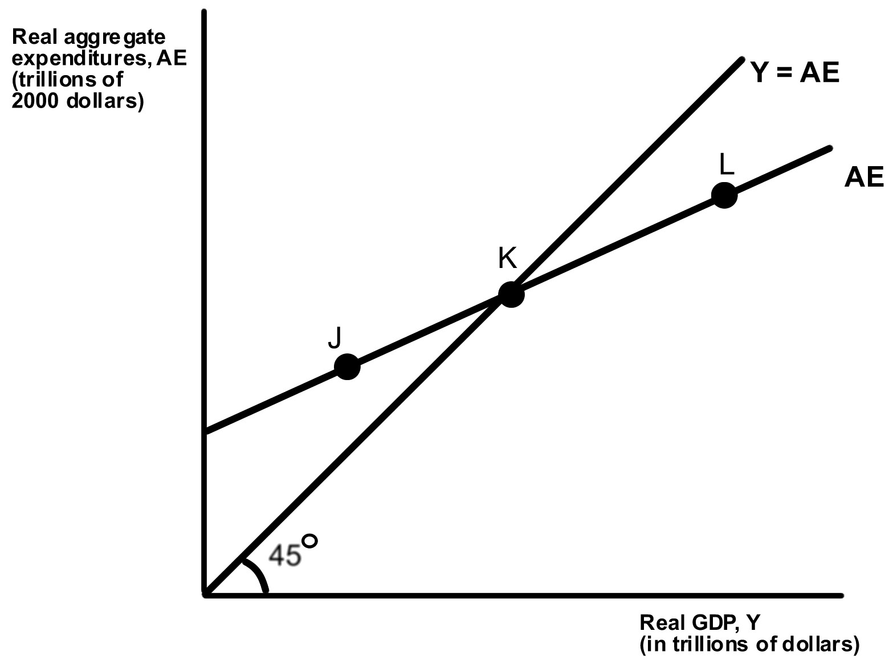

49)

If the economy is at point L, what will happen?

A)

Inventories have fallen below their desired level, and firms decrease production.

B)

Inventories have fallen below their desired level, and firms increase production.

C)

Inventories have risen above their desired level, and firms decrease production.

D)

Inventories have risen above their desired level, and firms increase production.

C

50)

How does a decrease in government spending affect the aggregate expenditure line?

A)

It shifts the aggregate expenditure line upward.

B)

It shifts the aggregate expenditure line downward.

C)

It increases the slope of the aggregate expenditure line.

D)

It decreases the slope of the aggregate expenditure line.

B

51)

If the economy is at a level of aggregate expenditure given by point K,

A)

the economy is in equilibrium.

B)

production is greater than spending.

C)

production is less than spending.

D)

inventories will increase above their desired level.

A

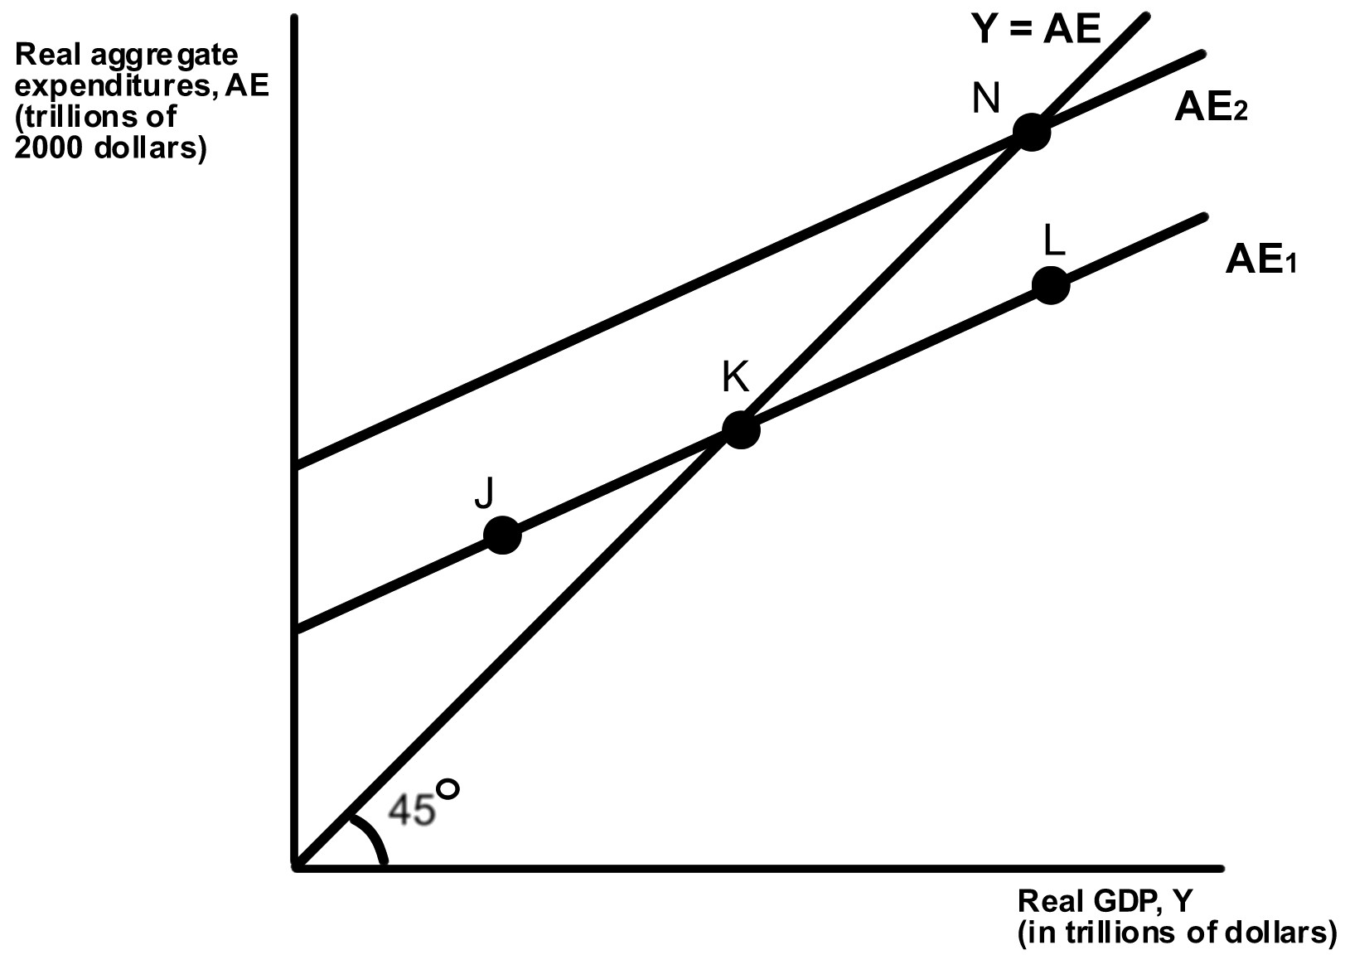

52)

If the U.S. economy is currently at point N, which of the following could cause it to move to point K?

A)

Households expect future income to decline.

B)

Household wealth rises.

C)

The firm's cash flow rises as profits rise.

D)

Government expenditures increase.

A

53)

If the U.S. economy is currently at point K, which of the following could cause it to move to point N?

A)

The price level in the U.S. rises relative to the price level in other countries.

B)

Congress passes investment tax incentives投资税激励提案.

C)

The interest rate rises.

D)

Household wealth declines.

B

