Macroeconomics, (Hubbard/O’Brien)
Chapter 24 Aggregate Demand and Aggregate Supply Analysis

1)

The static aggregate demand and aggregate supply curve model helps explain

A)

short term fluctuations in real GDP and the price level.

B)

long term growth.

C)

price fluctuations in an individual market.

D)

output fluctuations in an individual market.

A

2)

The aggregate demand curve shows the relationship between the ________ and ________.

A)

inflation rate; quantity of real GDP demanded

B)

real interest rate: quantity of real GDP supplied

C)

nominal interest rate; quantity of real GDP demanded

D)

price level; quantity of real GDP demanded

D

3)

Because of the slope the aggregate demand we can say that

A)

a decrease in the price level leads to a lower level of aggregate spending

B)

a decrease in the price level leads to a higher level of aggregate supply.

C)

a decrease in the price level leads to a higher level of aggregate spending.

D)

an increase in the price level leads to a higher level of aggregate spending.

C

4)

Which of the following would NOT be considered a positive addition to household wealth?

A)

the equity in one's home

B)

1000 shares of Microsoft stock

C)

a credit card balance

D)

the balance in your checking account

C

5)

The wealth effect is defined as

A)

when the price level falls, the real value of household wealth falls.

B)

when the price level falls, the nominal value of household wealth falls.

C)

when the price level falls, the nominal value of household wealth rises.

D)

when the price level falls, the real value of household wealth rises.

D

6)

The interest rate effect is described as

A)

an increase in the price level raises the interest rate and chokes off government spending.

B)

an increase in the price level lowers the interest rate and chokes off government spending.

C)

an increase in the price level raises the interest rate and chokes off investment and consumption spending.

D)

an increase in the price level lowers the interest rate and chokes off investment and consumption spending.

C

7)

When the price level in the U.S. rises relative to the price level of other countries, ________ will rise, ________ will fall, and ________ will fall.

A)

imports; exports; net exports

B)

exports; imports; net exports

C)

net exports; exports; imports

D)

net exports; imports; exports

A

8)

The international trade effect states that

A)

an increase in the price level will raise net exports.

B)

an increase in the price level will lower net exports.

C)

an increase in the price level will raise exports.

D)

an increase in the price level will lower imports.

B

9)

Which of the following is one if the explanations as to why the aggregate demand curve slopes downward?

A)

Increases in the price level lower the interest rate and decrease consumption spending.

B)

Increases in the price level lower the interest rate and decrease investment spending.

C)

Increases in the U.S. price level relative to the price level in other countries lowers net exports.

D)

Increases in the price level raise real wealth and lowers consumption spending.

C

10)

An increase in the price level will

A)

shift the aggregate demand curve to the left.

B)

shift the aggregate demand curve to the right.

C)

move the economy up along a stationary aggregate demand curve.

D)

move the economy down along a stationary aggregate demand curve.

C

11)

Spending on the war in Iraq is essentially categorized as government purchases. How do increases in spending on the war in Iraq affect the aggregate demand curve?

A)

This will move the economy up along a stationary aggregate demand curve.

B)

This will move the economy down along a stationary aggregate demand curve.

C)

This will shift the aggregate demand curve to the left.

D)

This will shift the aggregate demand curve to the right.

D

12)

The impact of hurricane Katrina on consumers in the economy was to make them very pessimistic about their future incomes. How does this increased pessimism affect the aggregate demand curve?

A)

This will move the economy up along a stationary aggregate demand curve.

B)

This will move the economy down along a stationary aggregate demand curve.

C)

This will shift the aggregate demand curve to the left.

D)

This will shift the aggregate demand curve to the right.

C

13)

If the U.S. dollar increases in value relative to other currencies, how does this affect the aggregate demand curve?

A)

This will move the economy up along a stationary aggregate demand curve.

B)

This will move the economy down along a stationary aggregate demand curve.

C)

This will shift the aggregate demand curve to the left.

D)

This will shift the aggregate demand curve to the right.

C

14)

Suppose the U.S. GDP growth rate is slower relative to other countries' GDP growth rates. This will

A)

move the economy up along a stationary aggregate demand curve.

B)

move the economy down along a stationary aggregate demand curve.

C)

shift the aggregate demand curve to the left.

D)

shift the aggregate demand curve to the right.

D

15)

How does an increase in the price level in the U.S. relative to the price level of other countries affect the aggregate demand curve?

A)

This will move the economy up along a stationary aggregate demand curve.

B)

This will move the economy down along a stationary aggregate demand curve.

C)

This will shift the aggregate demand curve to the left.

D)

This will shift the aggregate demand curve to the right.

A

16)

The level of long run aggregate supply is NOT affected by

A)

changes in technology.

B)

changes in the capital stock.

C)

changes in the price level.

D)

changes in the number of workers.

C

17)

The level of real GDP in the long run is called

A)

potential GDP.

B)

short run GDP.

C)

frictional GDP.

D)

low capacity GDP.

A

18)

The long run aggregate supply curve,

A)

has a negative slope.

B)

curve has a steep but positive slope.

C)

curve has a flat slope.

D)

curve has a vertical slope.

D

19)

If the economy receives an influx of new workers from immigration,

A)

the long run aggregate supply curve will shift to the right.

B)

the long run aggregate supply curve will shift to the left.

C)

we will move up along the long run aggregate supply curve.

D)

we will move down along the long run aggregate supply curve.

A

20)

The long run aggregate supply curve shows the relationship between the ________ and ________.

A)

inflation rate; quantity of real GDP demanded

B)

real interest rate; quantity of real GDP supplied

C)

nominal interest rate; quantity of real GDP supplied

D)

price level; quantity of real GDP supplied

D

21)

Changes in the price level

A)

increase the level of aggregate supply in the long run.

B)

decrease the level of aggregate supply in the long run.

C)

do not affect the level of aggregate supply in the long run.

D)

increase the level of aggregate supply in the long run only at very high levels of output.

C

22)

If technological change occurs in the economy,

A)

the long run aggregate supply curve will shift to the right.

B)

the long run aggregate supply curve will shift to the left.

C)

we will move up along the long run aggregate supply curve.

D)

we will move down along the long run aggregate supply curve.

A

23)

Suppose a developing country receives more machinery and capital equipment as foreign entrepreneurs increase the amount of investment in the economy. As a result,

A)

the long run aggregate supply curve will shift to the right.

B)

the long run aggregate supply curve will shift to the left.

C)

the economy will move up along the long run aggregate supply curve.

D)

the economy will move down along the long run aggregate supply curve.

A

24)

The short run aggregate supply curve has a

A)

negative slope.

B)

positive slope.

C)

vertical slope.

D)

horizontal slope.

B

25)

The short run aggregate supply curve has a ________ slope because as prices of ________ rise, prices of ________ rise more slowly.

A)

positive; final goods and services; inputs

B)

vertical;final goods and services; inputs

C)

positive; inputs; final goods and services

D)

vertical; inputs; final goods and services

A

26)

Which of the following is NOT a reason why the wages of workers and the prices of inputs rise more slowly than the prices of final goods and services?

A)

Contracts make prices and wages "sticky"

B)

Firms are often slow to adjust wages.

C)

Menu costs make some prices sticky.

D)

Unions are successful in pushing up wages.

D

27)

An increase in the price level will

A)

shift the short run aggregate supply curve to the left.

B)

shift the short run aggregate supply curve to the right.

C)

move the economy up along a stationary short run aggregate supply curve.

D)

move the economy down along a stationary short run aggregate supply curve.

C

28)

If workers leave a country to seek out better opportunities in another country, then this will

A)

shift the short run aggregate supply curve of the original country to the left.

B)

shift the short run aggregate supply curve of the original country to the right.

C)

move the original economy up along a stationary short run aggregate supply curve.

D)

move the original economy down along a stationary short run aggregate supply curve.

A

29)

The invention of the cotton gin ushered in the Industrial Revolution and began a long period of technological innovation. What did this technological change do the short run supply curve?

A)

It shifted the short run aggregate supply curve to the left.

B)

It shifted the short run aggregate supply curve to the right.

C)

It moved the economy up along a stationary short run aggregate supply curve.

D)

It moved the economy down along a stationary short run aggregate supply curve.

B

30)

Hurricane Katrina destroyed oil and natural gas refining capacity in the gulf. This subsequently drove up natural gas, gasoline, and heating oil prices. As a result this should

A)

shift the short run aggregate supply curve to the left.

B)

shift the short run aggregate supply curve to the right.

C)

move the economy up along a stationary short run aggregate supply curve.

D)

move the economy down along a stationary short run aggregate supply curve.

A

31)

Workers expect inflation to rise from 3% to 5% next year. As a result this should

A)

shift the short run aggregate supply curve to the left.

B)

shift the short run aggregate supply curve to the right.

C)

move the economy up along a stationary short run aggregate supply curve.

D)

move the economy down along a stationary short run aggregate supply curve.

A

32)

Long run macroeconomic equilibrium occurs when

A)

aggregate demand equals short run aggregate supply.

B)

aggregate demand equals short run aggregate supply and they intersect at a point on the long run supply curve.

C)

structural and frictional unemployment equals zero.

D)

output is above potential GDP.

B

33)

There has been an increase in investment. As a result, real GDP will ________ in the short run, and ________ in the long run.

A)

increase; increases further

B)

increase; decrease to its initial value

C)

decrease; decrease further

D)

decrease; increase to its initial level

B

34)

An increase in investment causes the price level to ________ in the short run and ________ in the long run.

A)

increase; increase further

B)

increase; decrease

C)

decrease; decrease further

D)

decrease; increase

A

35)

An increase in aggregate demand causes an increase in ________ only in the short run, but causes an increase in ________ in both the short run and the long run.

A)

the price level; real GDP

B)

real GDP; real GDP

C)

the price level; the price level

D)

real GDP; the price level

D

36)

Short run macroeconomic equilibrium occurs when

A)

aggregate demand and short-run aggregate supply intersect.

B)

the equilibrium lies on the long run supply curve.

C)

structural and frictional unemployment equals zero.

D)

A and B.

A

37)

Which of the following correctly describes the automatic mechanism through which the economy adjusts to long run equilibrium?

A)

the leftward shift in short run aggregate supply that occurs after a recession

B)

the rightward shift in short run aggregate supply that occurs after a recession

C)

the leftward shift in aggregate demand that occurs after a recession

D)

the rightward shift in aggregate demand that occurs after a recession

B

38)

Suppose the economy is at full employment and firms become more optimistic about the future profitability of new investment. Which of the following will happen in the short run?

A)

Output will decline.

B)

Prices will decline.

C)

Unemployment will decline.

D)

Aggregate demand will shift to the left.

C

39)

Suppose the economy is at a short run equilibrium GDP that lies above potential GDP. Which of the following will occur because of the automatic mechanism adjusting the economy back to potential GDP?

A)

Output will increase.

B)

Prices will decline.

C)

Unemployment will decline.

D)

Aggregate supply will shift to the left.

D

40)

Why does the short run aggregate supply curve shift to the right in the long run, following a decrease in aggregate demand?

A)

Workers and firms adjust their expectations of wages and prices downward and they accept lower wages and prices.

B)

Workers and firms adjust their expectations of wages and prices downward and they push for higher wages and prices.

C)

Workers and firms adjust their expectations of wages and prices upward and they push for higher wages and prices.

D)

Workers and firms adjust their expectations of wages and prices upward and they accept lower wages and prices.

A

41)

Why does the short run aggregate supply curve shift to the left in the long run, following an increase in aggregate demand?

A)

Workers and firms adjust their expectations of wages and prices downward and they accept lower wages and prices.

B)

Workers and firms adjust their expectations of wages and prices downward and they push for higher wages and prices.

C)

Workers and firms adjust their expectations of wages and prices upward and they push for higher wages and prices.

D)

Workers and firms adjust their expectations of wages and prices upward and they accept lower wages and prices.

C

42)

The automatic mechanism _________ the price level in the case of ________ and ________ the price level in the case of ________.

A)

raises; recession; lowers; expansion

B)

raises; expansion raises; recession

C)

lowers; expansion; lowers; recession

D)

lowers; recession; raises; expansion

D

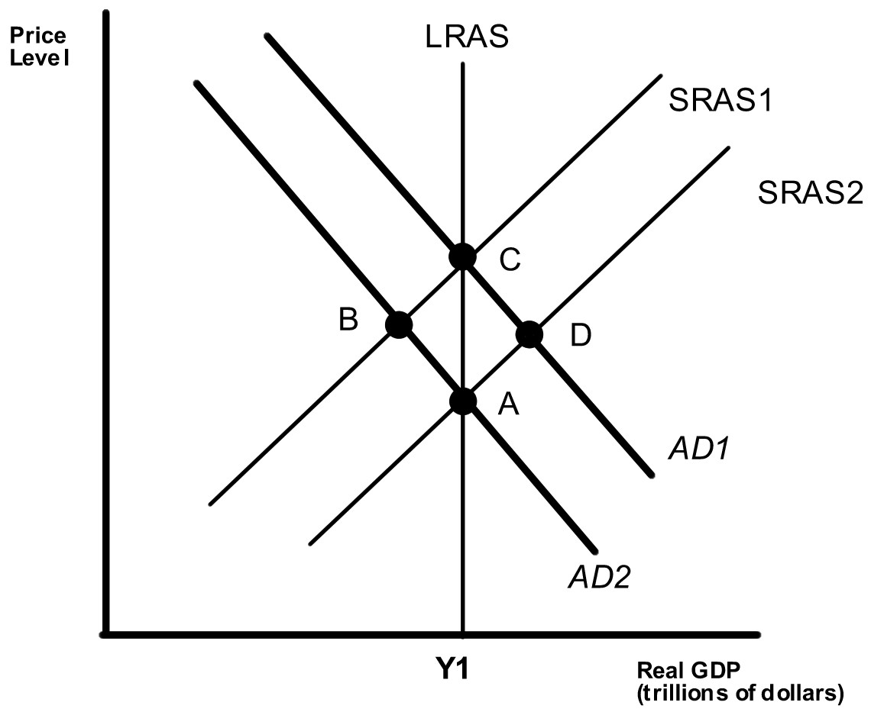

43)

Which of the points in the above graph are possible long run equilibriums?

A)

A and B

B)

A and C

C)

A and D

D)

B and D

B

44)

Which of the points in the above graph are possible short run equilibriums but not long run equilibriums? Assume that Y1 represents potential GDP.

A)

A and B

B)

A and C

C)

C and D

D)

B and D

D

45)

Suppose the economy is at point A. If investment spending increases in the economy, where will the eventual long run equilibrium be?

A)

A

B)

B

C)

C

D)

D

C

46)

Suppose the economy is at point C. If government spending decreases in the economy, where will the eventual long run equilibrium be?

A)

A

B)

B

C)

C

D)

D

A

47)

________ of unemployment during ________ make it easier for workers to ________ wages.

A)

High levels; a recession; accept lower

B)

Low levels; an expansion; accept lower

C)

Low levels; a recession; negotiate higher

D)

High levels; an expansion; negotiate higher

A

48)

Because of a supply shock, in the short run

A)

aggregate supply shifts to the left.

B)

the price level falls.

C)

unemployment falls.

D)

equilibrium real GDP rises.

A

49)

Which of the following is considered a supply shock?

A)

increasing investment in the economy causes the capital stock to rise

B)

an unexpected increase in the price of natural gas

C)

a decline in wages

D)

an improvement in technology

B

50)

The long run adjustment to a supply shock results in

A)

short run aggregate supply shifting to the right.

B)

the price level rising.

C)

unemployment rising.

D)

workers being willing to accept higher wages.

A

51)

When the price of oil rises unexpectedly, the price level ________ and the unemployment rate ________ in the short run.

A)

rises; falls

B)

rises; rises

C)

falls; falls

D)

falls; rises

B

52)

Stagflation occurs when

A)

inflation rises and GDP rises.

B)

inflation falls and GDP rises.

C)

inflation rises and GDP falls.

D)

inflation falls and GDP falls.

C

53)

Which of the following is NOT an assumption made by the dynamic model of aggregate demand and aggregate supply?

A)

Potential real GDP increases continuously.

B)

Aggregate demand shifts to the right during most periods.

C)

Aggregate supply shifts to the right except during periods when workers and firms expect higher wages.

D)

Aggregate demand and potential real GDP decrease continuously.

D

54)

The simple static aggregate demand and aggregate supply model assumes

A)

potential real GDP increases continuously.

B)

the economy does not experience long run growth.

C)

the economy experiences continuing inflation.

D)

the economy's aggregate demand curve shifts to the right in most periods.

B

55)

Which of the following is NOT a reason for the decline in aggregate demand that led to the recession in 2001?

A)

stock market decline

B)

information technology spending decline

C)

corporate accounting scandals

D)

a decline in government spending

D

56)

Which of the following describes how the economy recovered from the 2001 recession?

A)

a relatively large increase in LRAS and a small increase in aggregate demand

B)

a relatively large increase in LRAS and a large increase in aggregate demand

C)

a relatively small increase in LRAS and a small increase in aggregate demand

D)

a relatively small increase in LRAS and a large increase in aggregate demand

A

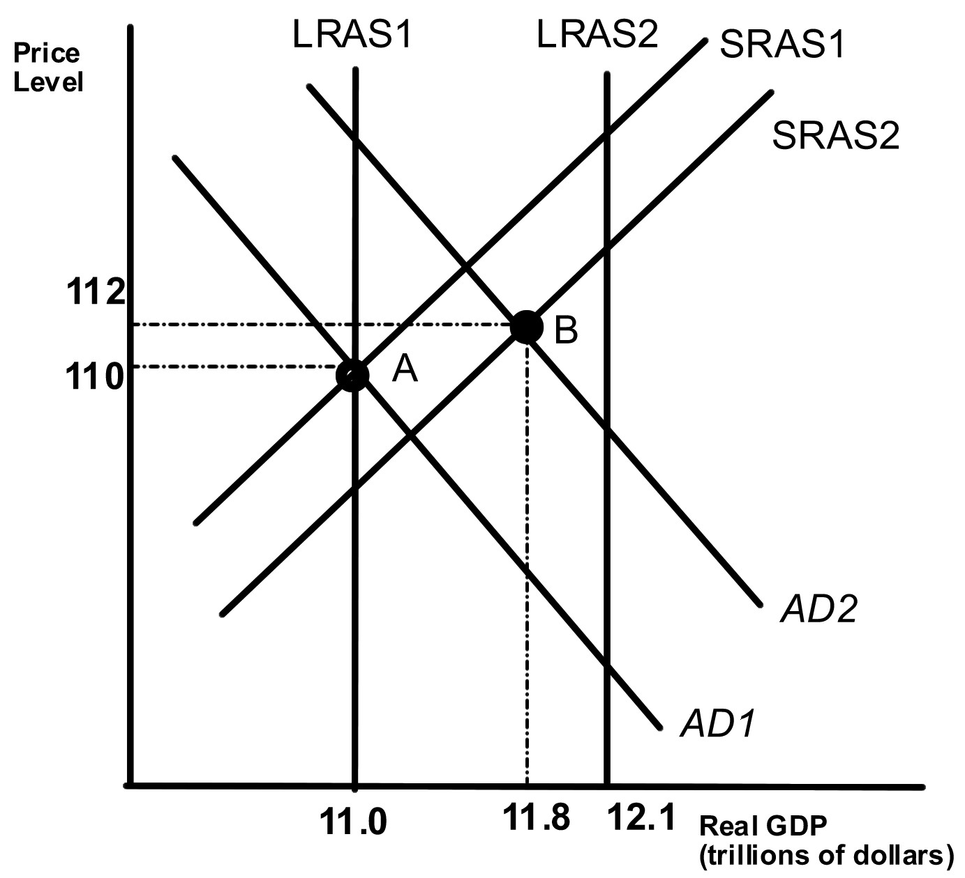

57)

Given the economy is at point A in year 1, what is the growth rate in potential GDP in year 2?

A)

9.1%

B)

8%

C)

12%

D)

10%

B

58)

Given the economy is at point A in year 1, what is the inflation rate in year 2?

A)

1.8%

B)

2.7%

C)

3.0%

D)

.9%

A

59)

Given the economy is at point A in year 1, What will happen to the unemployment rate in year 2?

A)

It will rise.

B)

It will fall.

C)

It will remain constant.

D)

Not enough information to answer the question.

A

60)

Which of the following is NOT a reason why the increase in aggregate demand in 2002 was rather weak?

A)

Firms did not want to invest as they had over-invested in technology in the 1990s

B)

Stock prices did not rise substantially so that real wealth grew slowly.

C)

Government spending was declining.

D)

Uncertainly about the future due to the war on terrorism made individuals reluctant to spend.

C

61)

During 2002 and 2003, ________ and ________ grew, while ________ grew very little.

A)

GDP; productivity; unemployment

B)

GDP; productivity; employment

C)

productivity; employment; GDP

D)

employment; GDP; productivity

B

62)

Aggregate demand increased more rapidly during the second half of 2003 and 2004. Which of the following is NOT a reason why demand increased?

A)

The value of the dollar increased compared to other currencies and this increased export spending.

B)

Low interest rates spurred consumption and investment spending.

C)

The stock market recovered, increasing wealth and consumption spending.

D)

Tax cuts increased consumption spending.

A

63)

The result of the more rapidly rising aggregate demand during the economy's recovery in 2003-2004 was

A)

falling inflation

B)

rising unemployment

C)

real GDP increasing toward potential

D)

a decline in the price level

C

64)

Rising productivity in 2003-2004 made it possible for firms to increase ________ without increasing ________.

A)

prices; sales

B)

employment; output

C)

output; employment

D)

sales; prices

C

65)

Which of the following models relies on emphasizing the importance of sticky wages and prices?

A)

the monetarist model

B)

the new classical model

C)

the real business cycle model

D)

the new Keynesian model

D

66)

Which of the following models has as its central idea that workers and firms have rational expectations?

A)

the monetarist model

B)

the new classical model

C)

the real business cycle model

D)

the new Keynesian model

B

67)

The main result of which of the following models is that the quantity of money should be increased at a constant rate?

A)

the monetarist model

B)

the new classical model

C)

the real business cycle model

D)

the new Keynesian model

A

68)

Which of the following models focuses on how productivity shocks explain fluctuations in real GDP?

A)

the monetarist model

B)

the new classical model

C)

the real business cycle model

D)

the new Keynesian model

C

69)

Proponents of the real business cycle model argue that the short run supply curve is

A)

flat.

B)

positively sloped.

C)

vertical.

D)

negatively sloped.

C

70)

According to the real business cycle model

A)

increases in aggregate demand raise GDP.

B)

increases in aggregate demand lower GDP.

C)

increases in aggregate demand do not affect GDP.

D)

increases in aggregate demand lower the price level.

C

71)

Rational expectations means that workers and firms form their expectations using

A)

all the information available to them.

B)

only information from the past.

C)

only information provided to them by the government.

D)

only information gathered from random sources.

A

72)

The proponents of rational expectations and monetarism think that the Federal Reserve should adopt

A)

an inflation target.

B)

a monetary aggregate target.

C)

a constant monetary growth rule.

D)

an interest rate target.

C

73)

According to Marx, which of the following factors of production did not contribute anything of value to production?

A)

labor.

B)

capital.

C)

natural resources.

D)

entrepreneurship.

D

74)

Monetarism is a school of thought put forth by Milton Friedman. He argued that the economy would most likely

A)

be below potential GDP.

B)

be at potential GDP.

C)

be unstable.

D)

be above potential GDP.

B

75)

After an unexpected increase in the price of oil, the long-run adjustment ________ the price level and ________ the unemployment rate as they return to their original levels.

A)

increases; increases

B)

increases; decreases

C)

decreases; increases

D)

decreases; decreases

D

76)

In the dynamic aggregated demand and aggregate supply model, inflation occurs if

A)

AD shifts faster than AS.

B)

AD shifts slower than AS.

C)

AS shifts faster than AD.

D)

AS shifts slower than AD.

A

