Macroeconomics, (Hubbard/O’Brien)
Chapter 27 Fiscal Policy

1)

Fiscal policy is defined as changes in federal ________ and ________ to achieve macroeconomic objectives such as price stability, high rates of economic growth, and high employment.

A)

taxes; interest rates

B)

taxes; the money supply

C)

interest rates; money supply

D)

taxes; purchases

D

2)

Which of the following would be considered a fiscal policy action?

A)

A city changes its hotel tax to attract tourists.

B)

A federal tax cut on hybrid cars that is designed to encourage the purchase of fuel efficient cars.

C)

Spending on the war in Afghanistan to promote homeland security.

D)

A tax cut designed to stimulate spending passed during a recession.

D

3)

Government spending and taxes that take place with conscious government action are called ________ called ________.

A)

automatic stabilizers; discretionary fiscal policy

B)

discretionary fiscal policy; automatic stabilizers

C)

automatic stabilizers; monetary policy

D)

discretionary fiscal policy; conscious fiscal policy

B

4)

Which of the following is an example of discretionary fiscal policy?

A)

An increase in unemployment insurance payments during a recession.

B)

An increase in income tax receipts during an expansion because incomes are rising.

C)

The tax cuts passed by Congress in 2001 to combat the recession.

D)

A decrease in income tax receipts during a recession because incomes are falling.

C

5)

The majority of government spending took place at the ________ prior to the Great Depression. After WWII, the ________ share(s) of government expenditures has(have) been between two thirds and three quarters.

A)

federal level; state and local

B)

state and local level; federal

C)

state level; local

D)

federal level; state

B

6)

Which of the following is a government expenditure and not a government purchase?

A)

The federal government buys a Humvee.

B)

The federal government pays the salary of an FBI agent.

C)

The federal government pays out an unemployment insurance claim.

D)

The Federal government pays to support research on Aids.

C

7)

Total federal expenditures ________ from 1950 to the early 1990s, ________ from 1992 to 2001, and have ________ since 2001.

A)

rose; fell; risen

B)

fell; fell; risen

C)

rose; rose; fallen

D)

fell; rose; fallen

A

8)

Which of the following is the largest category of federal government expenditures?

A)

defense spending

B)

transfer payments

C)

interest on the debt

D)

grants to state and local governments

B

9)

The fastest growing category of government expenditure is

A)

grants to state and local governments.

B)

defense spending.

C)

transfer payments.

D)

government purchases.

C

10)

Social Security

A)

has not been successful in reducing poverty among elderly Americans.

B)

is a system whereby current retirees are paid from taxes collected from current workers.

C)

has a greater number of workers per retiree today as compared to when it started.

D)

currently pays retirees benefits equal to what they paid into the system.

B

11)

Which of the following statements about the Social Security, Medicare, and Medicaid programs is NOT true?

A)

Spending on these three programs will rise from 8.4% of GDP currently to 17.7% of GDP by 2050.

B)

Costs are being driven up by the fact that Americans are living longer and medical costs are rising substantially.

C)

Some economists have argued for decreasing taxes to help with these programs' funding problems.

D)

Some economists have argued for reducing benefits to help with these programs' funding problems.

C

12)

Which of the following is an appropriate policy if real equilibrium GDP falls below aggregate demand?

A)

an increase in government purchases

B)

contractionary fiscal policy to increase the budget surplus

C)

an increase in individual income taxes to balance the budget

D)

an increase in business income taxes to increase tax fairness

A

13)

To fight a recession, Congress and the president should

A)

decrease government spending to balance the budget.

B)

decrease taxes to increase aggregate demand.

C)

lower interest rates by increasing the money supply.

D)

conduct contractionary fiscal policy by raising taxes.

B

14)

________ and ________ are the largest source of revenues collected by the federal government.

A)

Individual income taxes; corporate income taxes

B)

Individual income taxes; social insurance taxes

C)

Corporate income taxes; excise and other taxes

D)

Excise and other taxes; individual income taxes

B

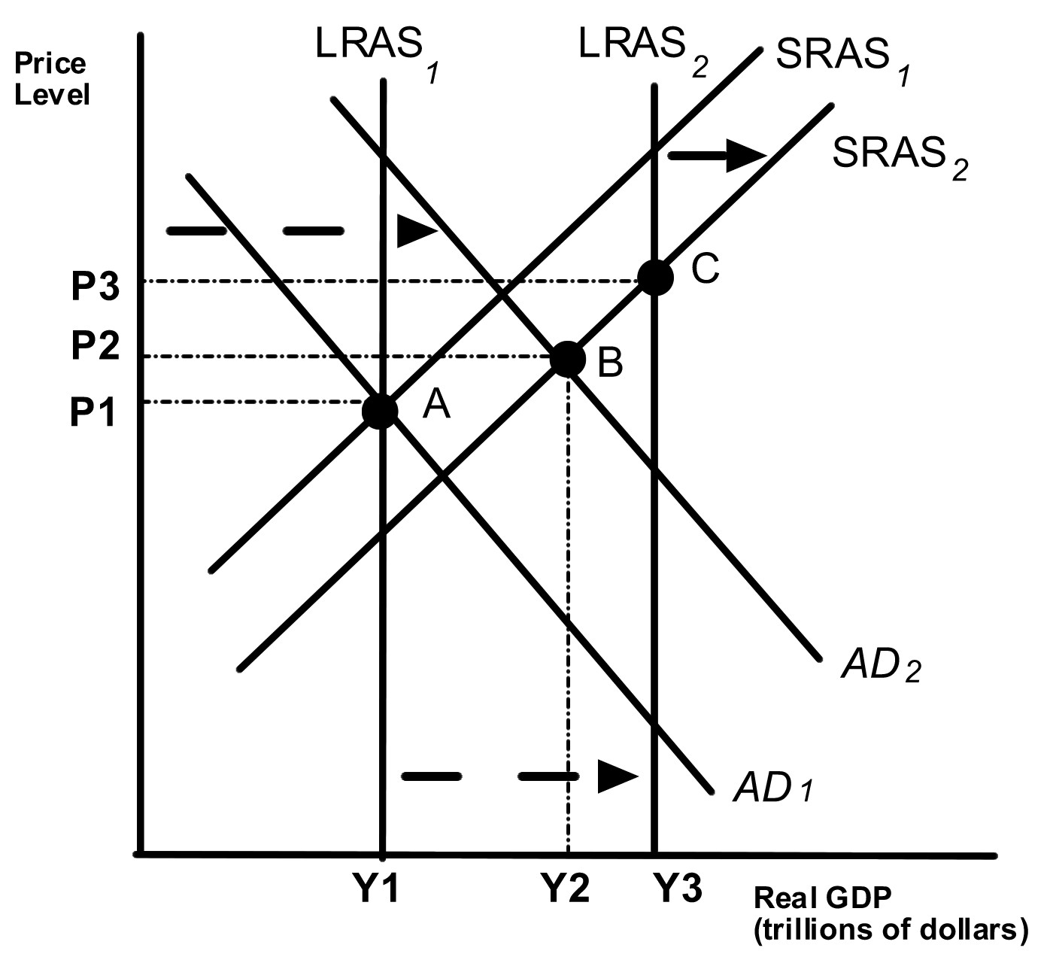

15)

Given that the economy has moved from A to B in the graph above, which of the following would be the appropriate fiscal policy to achieve potential GDP?

A)

increase taxes

B)

increase government spending

C)

contractionary fiscal policy

D)

decrease interest rates

B

16)

Expansionary fiscal policy should

A)

shift the aggregate demand curve to the left.

B)

shift the aggregate demand curve to the right.

C)

shift the short run aggregate supply curve to the left.

D)

shift the short run aggregate supply curve to the right.

B

17)

Expansionary fiscal policy ________ the price level and ________ equilibrium real GDP.

A)

decreases; increases

B)

increases; decreases

C)

increases; increases

D)

decreases; decreases

C

18)

If policy makers are concerned that the economy is in danger of rising inflation because aggregate demand is increasing faster than aggregate supply, the appropriate fiscal policy response is to

A)

increase taxes.

B)

increase government spending.

C)

use expansionary fiscal policy.

D)

increase interest rates.

A

19)

Decreasing government spending ________ the price level and ________ equilibrium real GDP.

A)

decreases; increases

B)

increases; decreases

C)

increases; increases

D)

decreases; decreases

D

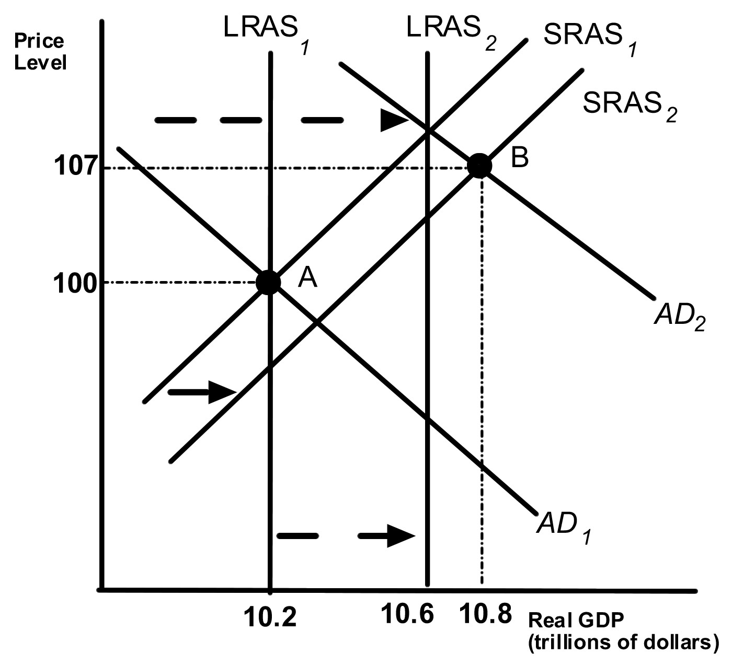

20)

Given the that the economy has moved from A to B in the graph above, which of the following would the appropriate fiscal policy to achieve potential GDP?

A)

increase taxes

B)

increase government spending

C)

expansionary fiscal policy

D)

increase interest rates

A

21)

To combat inflation, Congress and the president should

A)

decrease government spending.

B)

decrease taxes.

C)

lower interest rates.

D)

conduct expansionary fiscal policy.

A

22)

The multiplier effect is the series of ________ increases in ________ expenditures that result from an initial increase in ________ expenditures.

A)

induced; investment; autonomous

B)

induced; consumption; autonomous

C)

autonomous; consumption; induced

D)

autonomous; investment; induced

B

23)

The government purchases multiplier is defined as

A)

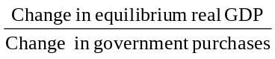

B)

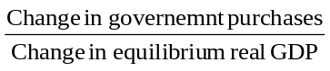

C)

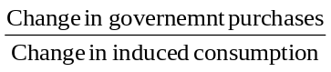

D)

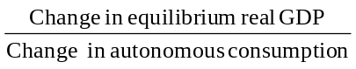

A

24)

Cutting taxes by a specific fixed amount

A)

will lower income and lower spending.

B)

will raise income and lower spending.

C)

will lower income and raise spending.

D)

will raise income and raise spending.

D

25)

The tax multiplier

A)

is negative.

B)

is larger in absolute value as compared to the government spending multiplier.

C)

only works when taxes are cut.

D)

is less than one.

A

26)

A change in tax rates

A)

has a less complicated effect on GDP than does a tax cut of a fixed amount.

B)

has a larger multiplier effect the smaller the tax rate.

C)

will not affect disposable income.

D)

will not affect the size of the multiplier.

B

27)

A cut in tax rates effects equilibrium real GDP through two channels: ________ disposable income and consumer spending, and ________ the size of the multiplier effect.

A)

decreasing; increasing

B)

decreasing; decreasing

C)

increasing; increasing

D)

increasing; decreasing

C

28)

If Congress wanted to counteract the effects of a recession it could

A)

increase tax rates.

B)

increase taxes by a fixed amount.

C)

increase government purchases.

D)

decrease defense spending.

C

29)

An equal increase in government spending and taxes will cause

A)

an increase in real GDP.

B)

no change in real GDP.

C)

an increase in any budget surplus.

D)

a reduction in any budget deficit.

A

30)

A(n) ________ in private expenditures as a result of a(n) ________ in government purchases is called crowding out.

A)

increase; decrease

B)

decrease; decrease

C)

decrease; increase

D)

increase; increase

C

31)

If crowding out occurs, an increase in government spending

A)

increases the interest rate and consumption and investment spending decline.

B)

decreases the interest rate and consumption and investment spending decline.

C)

increases the interest rate and consumption and investment spending rise.

D)

decreases the interest rate and consumption and investment spending rise.

A

32)

Crowding out results in

A)

higher interest rates, a lower exchange rate, and lower net exports.

B)

higher interest rates, a higher exchange rate, and lower net exports.

C)

lower interest rates, a lower exchange rate, and lower net exports.

D)

lower interest rates, a higher exchange rate, and lower net exports.

B

33)

Crowding out will be greater

A)

the less sensitive consumption spending is to changes in the interest rate.

B)

the further equilibrium GDP is below potential GDP

C)

the more sensitive investment spending is to changes in the interest rate.

D)

if the economy is in recession, rather than at full employment.

C

34)

Increases in government spending results in ________ in the short run, and permanent increases in government spending result in ________ in the long run.

A)

partial crowding out; partial crowding out

B)

partial crowding out; complete crowding out

C)

complete crowding out; complete crowding out

D)

complete crowding out; partial crowding out

B

35)

If policy makers implement expansionary fiscal policy and do not take into account crowding out,

A)

equilibrium GDP is likely to be at potential GDP.

B)

equilibrium GDP is likely to be above potential GDP.

C)

equilibrium GDP is likely to be below potential GDP.

D)

equilibrium GDP is likely to cause an inflationary gap.

C

36)

Increases in government spending will lower the long term growth rate of GDP, if it lowers ________ spending and the government purchases ________ and not ________ goods.

A)

net export spending; investment; consumption

B)

consumption; investment; consumption

C)

net export spending; consumption; investment

D)

investment; consumption; investment

D

37)

Which of the following characterizes fiscal policy in Japan in the late 1990s?

A)

The Japanese government has been reluctant to use fiscal policy to stimulate the economy.

B)

The Japanese government raised taxes to close the budget deficit.

C)

Fiscal policy has been effective in expanding real GDP and reducing unemployment.

D)

Government spending rose substantially during the period.

D

38)

If the federal government's expenditures are less than its tax revenues, then

A)

a budget surplus results.

B)

a budget deficit results.

C)

the budget is balanced.

D)

the government is deficit spending.

A

39)

During the twentieth century, the largest budget deficits as a percentage of GDP occurred

A)

during the 1990s.

B)

during the 1980s.

C)

during the Vietnam war.

D)

during World Wars I and II.

D

40)

Government deficits tend to increase during ________ and ________.

A)

peacetime; recessions

B)

war; recessions

C)

peacetime; expansionary periods

D)

war; expansionary periods

B

41)

The U.S. federal budget was in surplus during

A)

2001 through 2005.

B)

1998 through 2001.

C)

1990 through 1997.

D)

1980 through 1989.

B

42)

The federal budget deficit acts as a automatic stabilizer because

A)

government tax revenues decrease during a recession.

B)

unemployment insurance payments decrease during a recession.

C)

food stamp payments increase during expansionary periods.

D)

Medicaid payments increase during expansionary periods.

A

43)

The cyclically adjusted budget deficit calculates the budget surplus or deficit

A)

if the economy were in recession.

B)

if the economy were at potential GDP.

C)

if the economy was producing above potential GDP.

D)

if the economy was producing below potential GDP.

B

44)

Suppose that the federal budget is balanced when GDP is at potential GDP. If equilibrium GDP falls below potential,

A)

this will result in a budget deficit.

B)

the budget will remain balanced.

C)

transfer payments will decrease automatically.

D)

tax revenues will increase automatically.

A

45)

To counteract the effect of automatic stabilizers during a recession and keep the budget balanced, the federal government must _________ government spending, or ________ taxes, and which will ________ aggregate demand.

A)

increase; decrease; increase

B)

increase; increase; reduce

C)

decrease; decrease; increase

D)

decrease; increase; reduce

D

46)

Some economists argue that the federal government should normally run a deficit at potential GDP, to the extent that the borrowing is incurred to fund

A)

consumption goods.

B)

investment goods.

C)

current expenses.

D)

goods that provide services for less than a year.

B

47)

Borrowing to pay for long-lived capital expenditures makes sense as

A)

the benefits are received in the current year so the burden of paying for them should be spread over many years.

B)

the benefits are received over many years so the burden of paying for them should be spread over many years.

C)

the benefits are received in the current year so the burden of paying for them should be paid in the current year.

D)

the benefits are received over many years so the burden of paying for them should be paid in the current year.

B

48)

The total value of U.S. Treasury bonds outstanding is

A)

the federal government deficit.

B)

the federal government surplus.

C)

the federal government debt.

D)

the cyclically adjusted budget deficit.

C

49)

The federal government debt ________ when the federal government runs a deficit and ________ when the federal government runs a surplus.

A)

increases; increases

B)

decreases; increases

C)

increases; decreases

D)

decreases; decreases

C

50)

The federal government debt as a percentage of GDP did NOT rise

A)

during the Great Depression.

B)

during WWII.

C)

during the 1960s.

D)

during the 1980s.

C

51)

Accumulating debt can be a problem for the federal government because

A)

it is currently in danger of defaulting on on the debt.

B)

a large debt to GDP ratio causes crowding out.

C)

purchases of roads and bridges add burden but no benefit to the economy.

D)

the debt has to ultimately be paid off.

B

52)

Fiscal policy actions that are intended to have long-run effects attempt to increase ________ through changing ________.

A)

aggregate demand; government spending

B)

aggregate supply; taxes

C)

aggregate demand; taxes

D)

aggregate supply; government spending

B

53)

The _________ the tax wedge, the smaller the difference between pre-tax and post tax returns for an economic activity, the ________ of that activity will occur.

A)

smaller; more

B)

smaller; less

C)

larger; more

D)

larger; less

A

54)

Reducing the marginal tax rate on individual income will

A)

reduce the tax wedge faced by workers and increase labor supplied.

B)

raise the return to entrepreneurship and discourage the opening of new businesses.

C)

lower the return to entrepreneurship and encourage the opening of new businesses.

D)

increase the tax wedge faced by workers and increase labor supplied.

A

55)

Double taxation refers to

A)

corporations paying taxes on profits and individuals paying taxes on wage income.

B)

individuals paying taxes on wage income and individuals paying taxes on dividends.

C)

corporations paying taxes on profits and individuals paying taxes on dividends.

D)

corporations paying taxes on capital gains and individuals paying taxes on wage income.

C

56)

One of the positive effects of the flat tax is that

A)

it will increase interest rates.

B)

it reduces compliance costs.

C)

it decreases labor supply.

D)

it increases the paperwork associated with taxes.

B

57)

An argument against the flat tax is that

A)

it increases the government's ability to pursue particular policy goals, such as home ownership.

B)

it increases compliance by increasing the amount of income that is reported to the government.

C)

it is easy for taxpayers to understand and easy for the government to administer.

D)

it makes the distribution of income more unequal by reducing the marginal tax rate on high-income earners.

D

58)

If tax reduction and simplification are effective, then

A)

labor supply decreases.

B)

saving increases.

C)

investment decreases.

D)

less new firms are formed.

B

59)

Tax reduction and simplification should ________ long run aggregate supply and ________ aggregate demand.

A)

increase; increase

B)

increase; decrease

C)

decrease; increase

D)

decrease; decrease

A

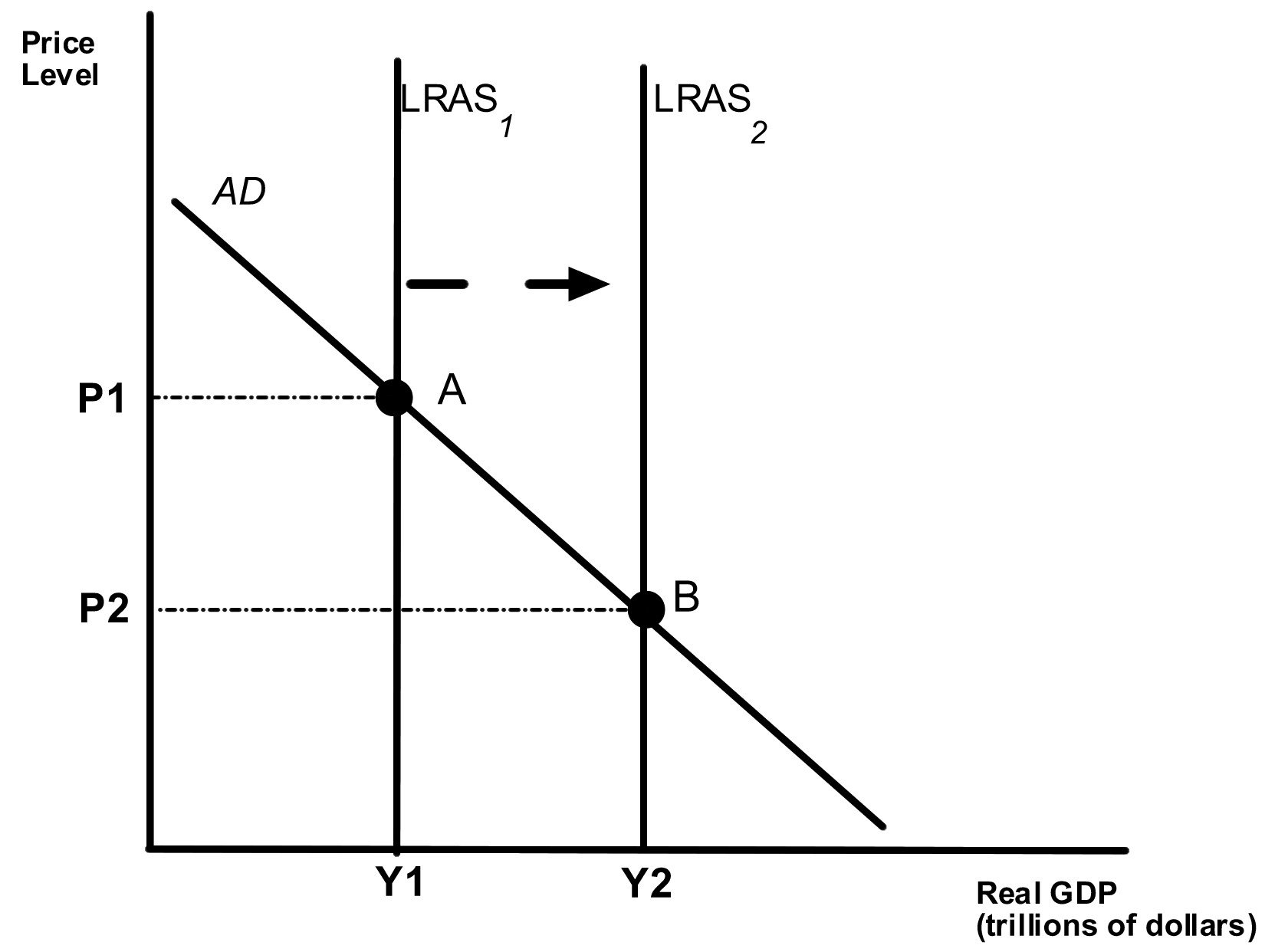

60)

Suppose Congress reduces income taxes. Assume that the movement from A to B represents normal growth in the economy before the tax change. Also assume that aggregate demand does not change. If the tax change is effective and labor supply and savings increase because of the tax change, then the tax change will

A)

decrease the price level to less than P2.

B)

decrease output to less than Y2.

C)

not change the price level.

D)

shift LRAS2 to the left.

A

61)

A recent study by Edward Prescott found that the ________ marginal tax rates in the U.S. relative to Europe resulted in a ________ quantity supplied of labor in the U.S..

A)

higher; larger

B)

lower; larger

C)

higher; smaller

D)

lower; smaller

B

62)

Assume a closed economy, that taxes are fixed, and the marginal propensity to consume is equal to 0.8. What is the government spending multiplier?

A)

10

B)

5

C)

4

D)

3

B

63)

Suppose that Congress allocates 1 billion dollars to clean up after the hurricanes of 2005. It also raises taxes by $1 billion to keep the deficit from growing. If the marginal propensity to consume = 0.9, what is the effect on equilibrium GDP?

A)

GDP does not change.

B)

GDP increases by $10 billion.

C)

GDP increases by $900,000.

D)

GDP increases by $1 billion.

D

64)

President Bush is successful in passing a $5 billion tax cut. Assume that taxes are fixed, the economy is closed, and the marginal propensity to consume is .75. What happens to equilibrium GDP?

A)

There is a $20 billion increase in equilibrium GDP.

B)

There is a $20 billion decrease in equilibrium GDP

C)

There is a $15 billion increase in equilibrium GDP

D)

There is a $15 billion decrease in equilibrium GDP

C

65)

What is the government purchases multiplier if the tax rate is 0.1 and the marginal propensity to consume is 0.9? Assume the economy is closed. The answer is rounded to the tenths place.

A)

10

B)

11.1

C)

5.3

D)

100

C

66)

Countries with a ________ marginal propensity to import will have ________ government purchase multipliers.

A)

a higher; higher

B)

a higher; lower

C)

a lower; lower

D)

a positive; negative

B

67)

Calculate the government purchases multiplier if the marginal propensity to consume equals 0.8, the tax rate is 0.1, and the marginal propensity to import equals 0.2. Round the answer to the nearest tenth.

A)

2.1

B)

1.9

C)

1.7

D)

1.4

A

68)

Suppose Congress passes a reduction in income taxes. Assume that the movement from A to B represents normal growth in the economy before the tax change. If the tax change is ineffective and labor supply and savings do not increase because of the tax change, then the tax change will

A)

decrease the price level below P2.

B)

increase output above Y2.

C)

not change the price level.

D)

shift LRAS2 to the right.

C

