Macroeconomics, (Hubbard/O’Brien)
Chapter 28 Inflation, Unemployment, and Federal Reserve Policy

1)

The Phillips curve shows the short-run relationship between

A)

real GDP and the inflation rate.

B)

real wages and real GDP

C)

real wages and the inflation rate

D)

unemployment and the inflation rate.

D

2)

The Phillips curve illustrates that there is a

A)

short-run negative relationship between unemployment and inflation.

B)

short-run positive relationship between unemployment and inflation.

C)

long-run negative relationship between unemployment and inflation.

D)

long-run positive relationship between unemployment and inflation.

A

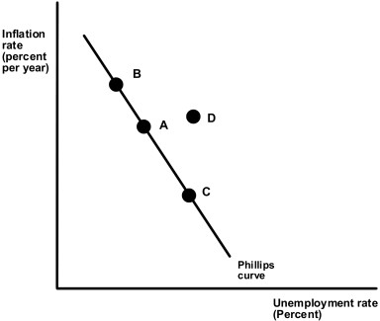

3)

Suppose that the economy is at point A on the Phillips curve graph. Suppose that the aggregate demand curve shifts to right by the same amount as long run aggregate supply. Then the economy will

A)

remain at point A on the Phillips curve.

B)

move to point B on the Phillips curve.

C)

move to point C on the Phillips curve.

D)

move to point D on the Phillips curve.

A

4)

Suppose that the economy is at point A on the Phillips curve graph. Suppose that the aggregate demand curve shifts to right by less than the long run aggregate supply. Then the economy will

A)

remain at point A on the Phillips curve.

B)

move to point B on the Phillips curve

C)

move to point C on the Phillips curve.

D)

move to point D on the Phillips curve.

C

5)

Suppose that the economy is at point A on the Phillips curve graph. Suppose that the aggregate demand curve in the economy shifts to the right by more than the long run aggregate supply. Then the economy will

A)

remain at point A on the Phillips curve.

B)

move to point B on the Phillips curve.

C)

move to point C on the Phillips curve.

D)

move to point D on the Phillips curve.

B

6)

Slow growth in aggregate demand leads to ________ inflation and ________ unemployment.

A)

lower; lower

B)

lower; higher

C)

higher; lower

D)

higher; higher

B

7)

Policymakers in the 60s believed that there was a structural relationship between unemployment and inflation. This meant that

A)

the cost of lower unemployment was a permanently higher inflation rate.

B)

the cost of lower unemployment was a permanently lower inflation rate.

C)

the cost of lower unemployment was a temporarily higher inflation rate.

D)

the cost of lower unemployment was a temporarily lower inflation rate.

A

8)

Both Milton Friedman and Edmund Phelps argued that if the long-run aggregate supply curve was vertical, then

A)

the slope of the long-run Phillips curve must be negative.

B)

the slope of the long-run Phillips curve must be positive.

C)

the slope of the long-run Phillips curve must be infinite.

D)

the slope of the long-run Phillips curve must be zero.

C

9)

Both Milton Friedman and Edmund Phelps argued

A)

there was no trade-off between inflation and unemployment in the long run.

B)

the Phillips curve represented a menu of policy choices in the long run.

C)

permanently higher inflation was the cost of permanently lower unemployment in the long run.

D)

permanently higher unemployment was the cost of permanently lower inflation in the long run.

A

10)

Just as real GDP ________ potential GDP in the long run, the unemployment rate ________ the natural rate of unemployment in the long run.

A)

is not related to; is not related to

B)

is greater than; is greater than

C)

equals; equals

D)

is less than; is less than

C

11)

If actual inflation is greater than expected inflation,

A)

the actual real wage is greater than the expected real wage.

B)

the unemployment rate falls.

C)

the actual real wage equals the expected real wage.

D)

firms will hire less workers than they planned.

B

12)

If actual inflation is less than expected inflation,

A)

the actual real wage is greater than the expected real wage.

B)

the unemployment rate falls.

C)

the actual real wage equals the expected real wage.

D)

firms will hire more workers than they planned.

A

13)
Nominal Wage | Expected Price Level, Inflation | Actual Price Level, Inflation
$25 | Expected P2009 = 106 | Actual P2009 = 102
 | Expected Inflation = 6% | Actual Inflation = 2%

Suppose that the nominal wage, the expected and actual price levels, and the expected and actual inflation rates for a hypothetical economy in 2009 are presented in the above table. Given the data, we know that

A)

the actual real wage is less than the expected real wage.

B)

the unemployment rate will fall.

C)

firms will hire less workers than they planned.

D)

the unemployment rate will not change.

C

14)
Nominal Wage | Expected Price Level, Inflation | Actual Price Level, Inflation
$30 | Expected P2009 = 102 | Actual P2009 = 105
 | Expected Inflation = 2% | Actual Inflation = 5%

Suppose that the nominal wage, the expected and actual price levels, and the expected and actual inflation rates for a hypothetical economy in 2009 are presented in the above table. What is the expected real wage rate in 2009?

A)

$28.57

B)

$29.73

C)

$29.41

D)

$28.12

C

15)

Milton Friedman argued that there is a ________ tradeoff between unemployment and inflation, and this tradeoff comes from ________ inflation.

A)

temporary; actual

B)

temporary; unanticipated

C)

permanent; actual

D)

permanent; unanticipated

B

16)

Robert Shiller conducted a survey on inflation and found that the general public believes that rising inflation will

A)

quickly lead to increases in nominal wages.

B)

quickly lead to decreases in nominal wages.

C)

slowly lead to increases in nominal wages.

D)

slowly lead to decreases in nominal wages.

C

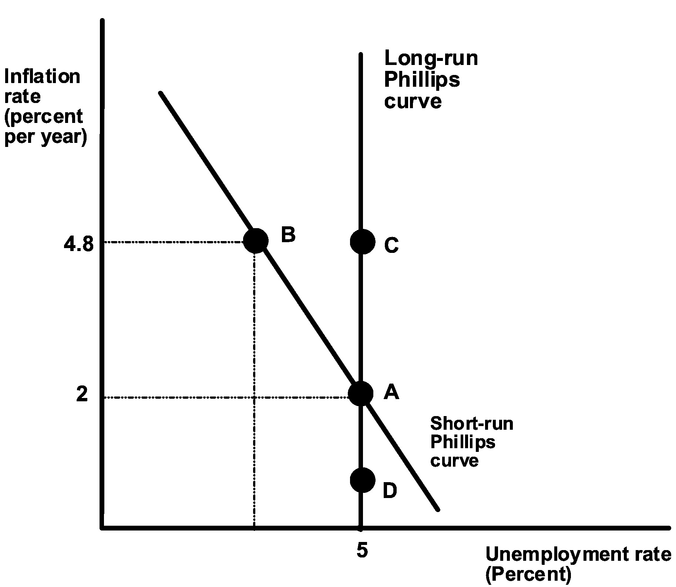

17)

Suppose that the economy is at point B. Then

A)

workers and firms expect 4.8% inflation.

B)

workers and firms expect 2% inflation.

C)

the unemployment rate is equal to the natural rate.

D)

actual inflation is 2%.

B

18)

If workers fail to believe that rising inflation will eventually result in comparable increases in wages, but firms do understand this, then

A)

there is a negative relationship between unemployment and inflation in the short run.

B)

there is a positive relationship between unemployment and inflation in the short run.

C)

there is a negative relationship between unemployment and inflation in the long run.

D)

there is a positive relationship between unemployment and inflation in the long run.

A

19)

Suppose the economy is at point B. If workers and firms adjust their expectations about inflation upward

A)

the short-run Phillips curve will become steeper.

B)

the short-run Phillips curve will shift to the right.

C)

unemployment will fall below the natural rate.

D)

each unemployment rate will be associated with lower inflation rates.

B

20)

If the long-run Phillips curve is vertical, then

A)

there is no tradeoff between inflation and unemployment in the long run.

B)

there is no tradeoff between inflation and unemployment in the short run.

C)

there is a tradeoff between inflation and unemployment in the long run.

D)

there is a tradeoff between inflation and unemployment in the long run, but not in the short run.

A

21)

On a given short-run Phillips curve, expected inflation is ________ actual inflation, for all points on the curve that lie ________ the long-run Phillips curve.

A)

greater than; to the left of

B)

less than; to the right of

C)

equal to; on

D)

equal to; to the right of

C

22)
Nominal Wage | Expected Price Level, Inflation | Actual Price Level, Inflation
$25 | Expected P2009 = 106 | Actual P2009 = 102
 | Expected Inflation = 6% | Actual Inflation = 2%

Suppose that the nominal wage, the expected and actual price levels, and the expected and actual inflation rates for a hypothetical economy in 2009 are presented in the above table. Given the data, we know that in 2009 the economy is

A)

on the long-run Phillips curve.

B)

on the short-run Phillip curve to the left of the long-run Phillips curve.

C)

on the short-run Phillip curve to the right of the long-run Phillips curve.

D)

at the natural rate of unemployment.

C

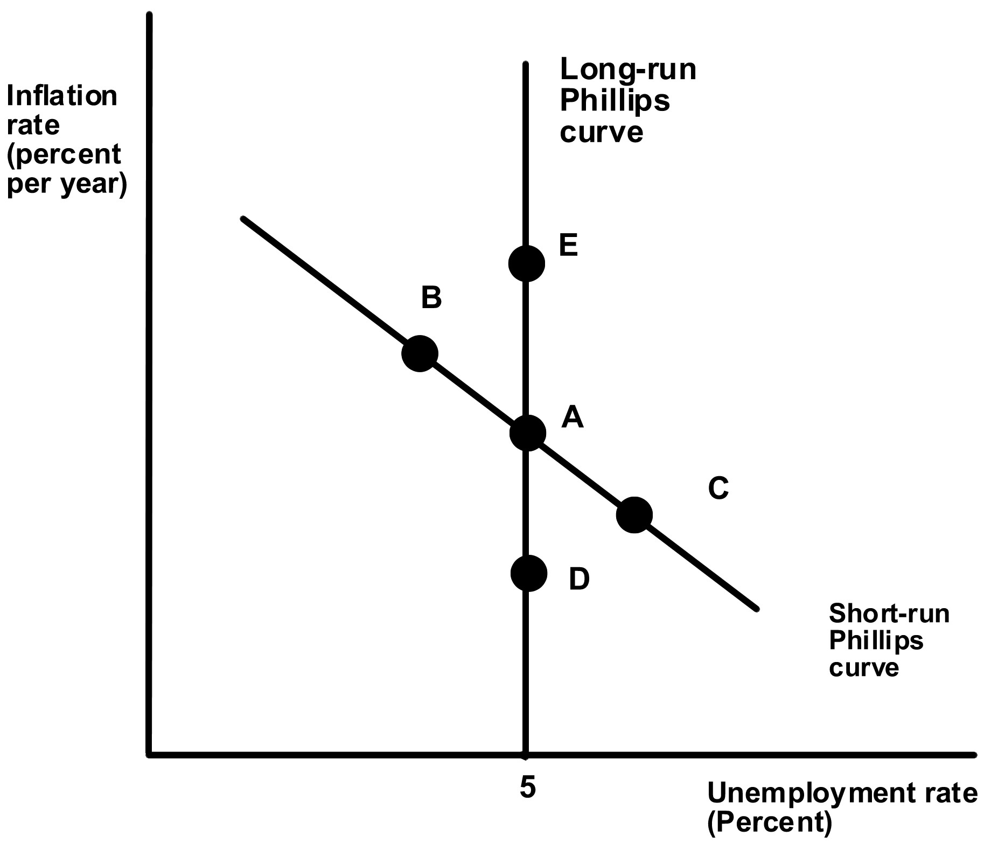

28)

Suppose that the economy is at point A. If the Fed uses contractionary policy, where will the economy move in the short run?

A)

from A to B.

B)

from A to C

C)

from A to D

D)

from A to E

B

29)

Suppose that the economy is at point A. If the Fed uses expansionary policy, where will the economy move in the long run?

A)

from A to B.

B)

from A to C

C)

from A to D

D)

from A to E

D

30)

Suppose that the economy is at point A. If the Fed uses expansionary policy an attempts to push the unemployment rate below 5% permanently, what would be the result?

A)

The economy would move from A to B.

B)

The economy would move from A to C

C)

The economy would suffer ever accelerating inflation.

D)

The economy would suffer ever accelerating deflation.

C

31)

Which of the following would reduce the natural rate of unemployment?

A)

increasing in the proportion of younger workers in the labor force

B)

eliminating the national unemployment insurance program

C)

establishing laws that restrict the firing of workers.

D)

suffering long periods of high rates of unemployment

B

32)

Inflation is stable in the long run only if the unemployment rate is

A)

equal to the natural rate of unemployment.

B)

equal to the cyclical rate of unemployment.

C)

less than the natural rate of unemployment.

D)

less than the cyclical rate of unemployment.

A

33)

According to the text, the natural rate of unemployment is ________ in European countries as compared to the U.S. in part because of ________.

A)

higher; a greater proportion of younger workers in the U.S. labor force

B)

higher; more generous unemployment insurance programs in Europe

C)

lower; a greater proportion of younger workers in European labor force

D)

lower; a greater proportion of less-skilled workers in the European labor force

B

34)

When inflation is very low, workers and firms

A)

form adaptive expectations about inflation.

B)

form rational expectations about inflation.

C)

ignore inflation.

D)

form expectations about inflation that rely on the recent past.

C

35)

If workers and firms use rational expectations in making their forecasts of inflation, then

A)

expansionary monetary policy would be effective in the short run, but not in the long run.

B)

expansionary monetary policy would be effective in the long run, but not in the short run.

C)

expansionary monetary policy would be effective in both the long run and the short run.

D)

expansionary monetary policy would not be effective in the short run.

D

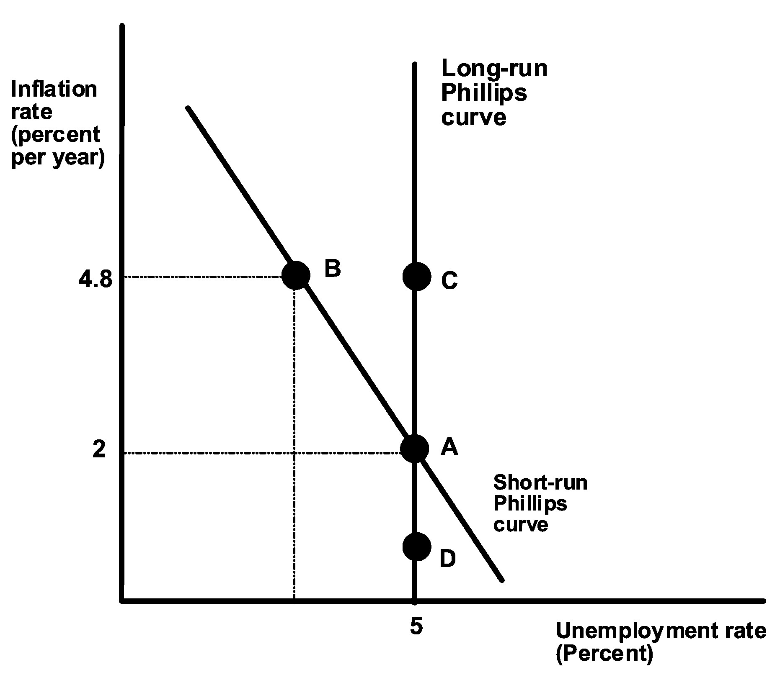

36)

Suppose that the economy is at point A, and the Fed uses an expansionary monetary policy. If the workers and firms have rational expectations, they will

A)

move from A to B in the short run.

B)

move from A to C in the short run.

C)

move from A to D in the short run.

D)

remain at A in the short run.

B

37)

Suppose that the economy is at point A, and the Fed uses an expansionary monetary policy. If the workers and firms have adaptive expectations, they will

A)

move from A to B in the short run.

B)

move from A to C in the short run.

C)

move from A to D in the short run.

D)

remain at A in the short run.

A

38)

Lucas and Sargent argued that the short-run Phillips curve should have a ________ slope, and any evidence of a ________ slope was due to the Fed's secrecy about its policy actions.

A)

positive; vertical

B)

vertical; positive

C)

negative; vertical

D)

vertical; negative

B

39)

Real business cycle models assume

A)

workers and firms form their expectations about inflation adaptively.

B)

unexplained changes in the money supply explain deviations of real GDP from full employment.

C)

fluctuations in real factors explain deviations of real GDP from full employment.

D)

wages and prices take a long time to adjust.

C

40)

If workers and firms make use of all available information, including knowledge of the policy being used in the Federal reserve, then when expansionary monetary policy occurs

A)

their expected rate of inflation is greater than the actual rate of inflation.

B)

their expected rate of inflation is less than the actual rate of inflation.

C)

their expected rate of inflation is equal to the actual rate of inflation.

D)

their expected rate of inflation is equal to zero.

C

41)

If the economy suffers a supply shock, and the Fed responds with expansionary monetary policy, this will ________ inflation and ________ unemployment.

A)

increase; increase

B)

increase; decrease

C)

decrease; increase

D)

decrease; decrease

B

42)

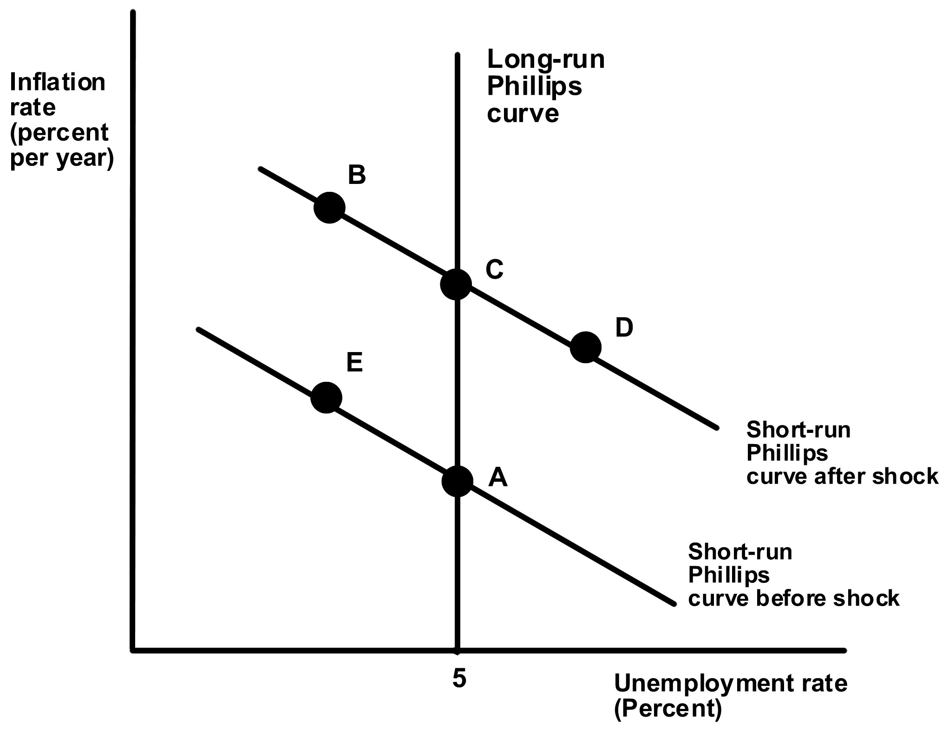

Suppose the economy is at point A in the above graph and then suffers a supply shock. If the Fed pursues no policy, where will the economy move in the short run?

A)

from A to B

B)

from A to C

C)

from A to E

D)

from A to D

D

43)

In 1979 Paul Volker's Fed used a(n) ________ monetary policy, which resulted in an episode of ________.

A)

contractionary; disinflation

B)

contractionary; inflation

C)

expansionary; inflation

D)

expansionary; disinflation

A

44)

If we assume that workers and firms believed that the Fed was fighting inflation, the economy's pattern of adjustment to Paul Volker's policies in the early 80s suggests that workers and firms

A)

have rational expectations.

B)

have adaptive expectations.

C)

adjust their expectations about inflation quickly.

D)

do not care about inflation.

B

45)

If the economy suffers a supply shock, and the Fed responds with contractionary monetary policy, this will ________ inflation and ________ unemployment.

A)

increase; increase

B)

increase; decrease

C)

decrease; increase

D)

decrease; decrease

C

46)

Suppose that the economy is at point A, and the Fed uses contractionary monetary policy. If expectations are rational and workers and firms believe that the Fed intends to lower inflation, how do we represent the policy change in the above graph?

A)

The economy will move from A to D.

B)

The economy will move from A to E.

C)

The economy will move from A to C.

D)

The economy will move from A to D to E.

C

47)

Suppose that the economy is at point A, and the Fed uses contractionary monetary policy. If expectations are adaptive how do we represent the policy change in the above graph?

A)

The economy will move from Ato B.

B)

The economy will move from A to E to C.

C)

The economy will move from A to C.

D)

The economy will move from A to D to C.

D

48)

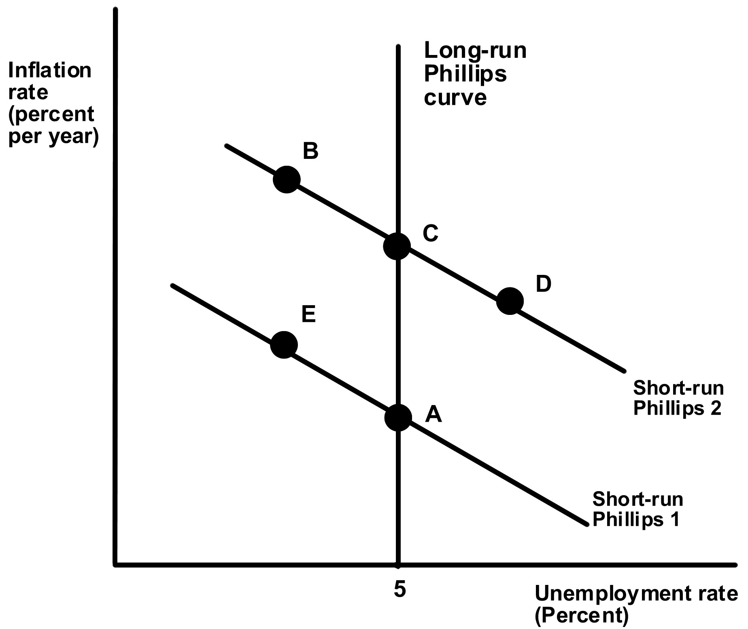

The response of the economy to Fed policy from the early to mid 1980s is shown in the above graph by the movement

A)

from A to E to C.

B)

from A to D to C.

C)

From C to E to A.

D)

from C to D to A.

D

49)
Year | Consumer Price Index
2000 | 100
2001 | 120
2002 | 125
2003 | 124
2004 | 123

In the above table, the period of time from 2000-2002 represents a period of

A)

inflation.

B)

deflation.

C)

disinflation.

D)

unchanging prices.

C

50)
Year | Consumer Price Index
2000 | 100
2001 | 120
2002 | 125
2003 | 124
2004 | 123

In the above table, the period of time from 2002-2004 represents a period of

A)

inflation.

B)

deflation.

C)

disinflation.

D)

unchanging prices.

B

51)

The ________ the short run Phillips curve, the ________ the change in the unemployment rate for a given decrease in the inflation rate.

A)

flatter; smaller

B)

flatter; larger

C)

more positively sloped; smaller

D)

steeper; larger

B

52)

Which Fed Chairman had the lowest average inflation during their term?

A)

Arthur Burns

B)

G. William Miller

C)

Paul Volker

D)

Alan Greenspan

D

53)

Monetary policy is different today as compared to what it was prior to 1987 because

A)

currently, money supply targets are used for monetary policy.

B)

currently, interest rate targets are used for monetary policy.

C)

currently, the Fed is unsuccessful in achieving low inflation.

D)

currently, the Fed's credibility is low.

B

54)

If the Fed announces that it is going to fight inflation and workers and firms do not view this as credible, then

A)

the announcement will have little impact on inflationary expectations.

B)

workers will be willing to accept lower wages in their contract negotiations.

C)

banks will be willing to accept lower interest rates on mortgage loans.

D)

monetary policy will be more effective than if the Fed's credibility were high.

A

55)

A monetary policy rule can ________ the Fed's credibility and ________ the Fed's ability to use discretionary monetary policy.

A)

increase; enhance

B)

increase; limit

C)

decrease; enhance

D)

decrease; limit

B

56)

How does an improvement in the Fed's credibility affect our model of the Phillip's curve?

A)

The short-run Phillips curve becomes horizontal.

B)

The short-run Phillips curve becomes flatter.

C)

The short-run Phillips curve shifts more rapidly.

D)

The short-run Phillips curve shifts less rapidly.

C

57)

In practice, the Fed has generally followed

A)

a rules strategy.

B)

a discretion strategy.

C)

a modified strategy such as the Taylor rule.

D)

a specific publicly announced guideline.

B

58)

The Bank of Japan has had trouble combating its economy's problems with deflation because

A)

it was unwilling to use expansionary monetary policy to reduce interest rates.

B)

workers and firms did not think its efforts to combat deflation were credible.

C)

it announced specific targets for inflation.

D)

they pursued an expansionary policy that was too aggressive.

B

59)
Nominal Wage | Expected Price Level, Inflation | Actual Price Level, Inflation
$25 | Expected P2009 = 106 | Actual P2009 = 102
 | Expected Inflation = 6% | Actual Inflation = 2%

Suppose that the nominal wage, the expected and actual price levels, and the expected and actual inflation rates for a hypothetical economy in 2009 are presented in the above table. Given the data, we know that in 2009 the economy is at an unemployment rate

A)

that is greater than the natural rate of unemployment.

B)

that is less than the natural rate of unemployment.

C)

such that there is no cyclical unemployment.

D)

that is equal to the natural rate of unemployment.

A

