CIS 1230 Assignment A and B Instruction

Use the database file, **Assignment_A_B.accdb** for this assignment. You will create and improve a parameter query which searches the Property information based on the **Property Type** and the range of **Nightly Rate** on table **Property**. Refer to Chapter 6, Flavor 6.1 of textbook, **Ingredients for Database Recipes** (IFDR). See following images for details.

**Assignment A:** You will create a form named Menu as shown on Fig 1. It contains two buttons: Open Assignment A and B, and Exit. This menu can be created by using Switchboard Manager or customizing with buttons, control wizard or macro whichever you prefer.

Figure 1: Menu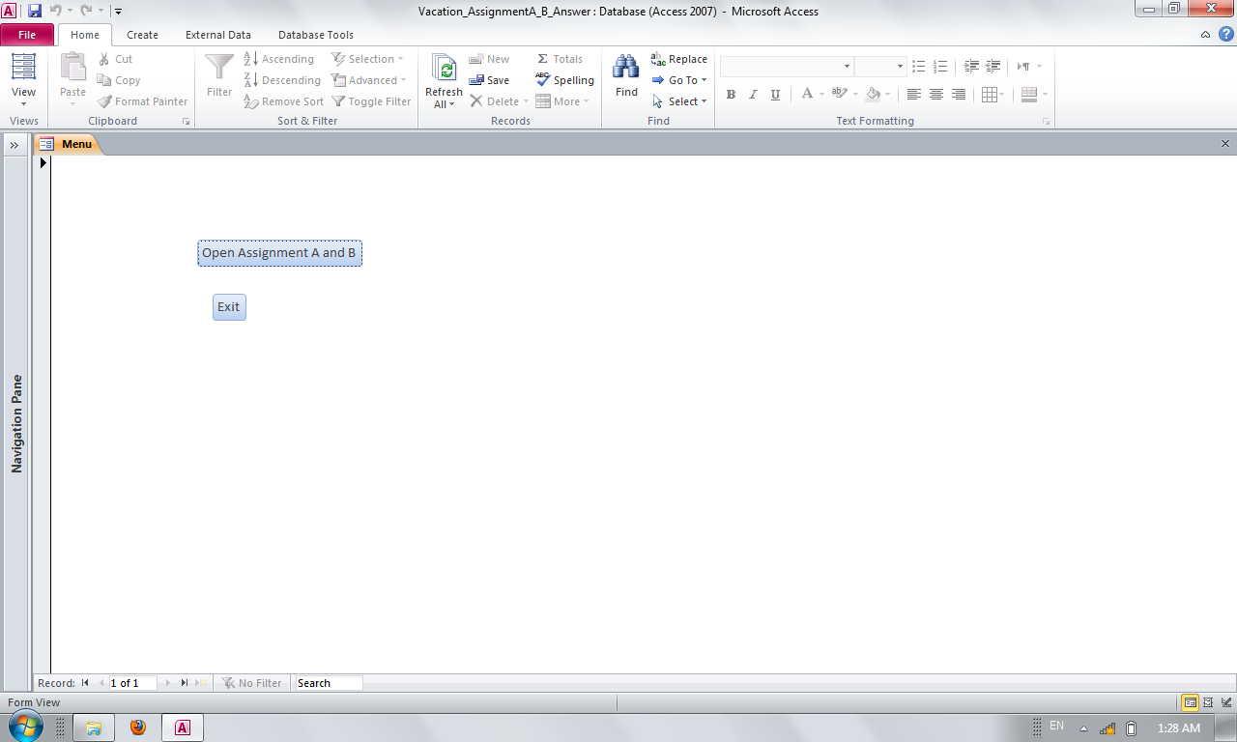 Exit button should close Access entirely.

Button Open Assignment A and B will open a form named **frmType** as shown on Fig. 2. A list box, **Property Type**, should display only three types of properties. Two textboxes will allow users to enter the range of nightly rates. Clicking buttons **Cancel** will close frmType and go back to Menu as shown on Fig. 1. Clicking button **OK** shall list all records matched the above criteria, see Fig. 3 and 4. Required fields shown on Fig. 4.

Figure 2: Form of property type. 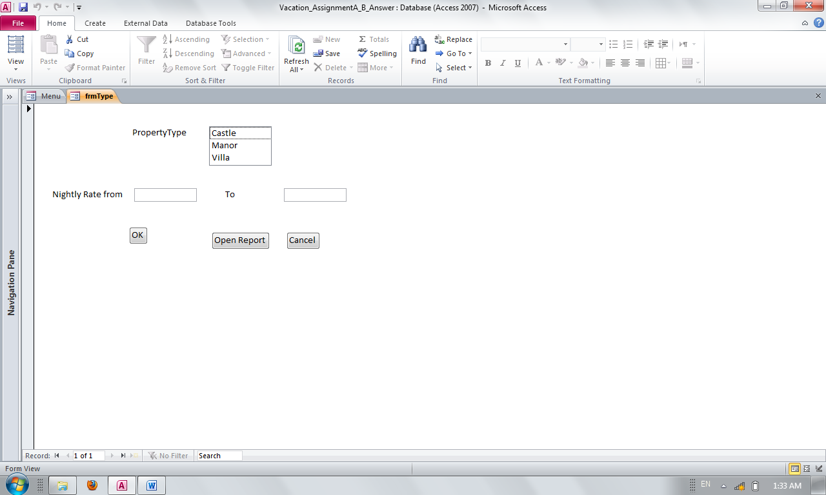

Figure 3: Test the list box and OK button by entering rates $1000 and $2000 with Villa property type.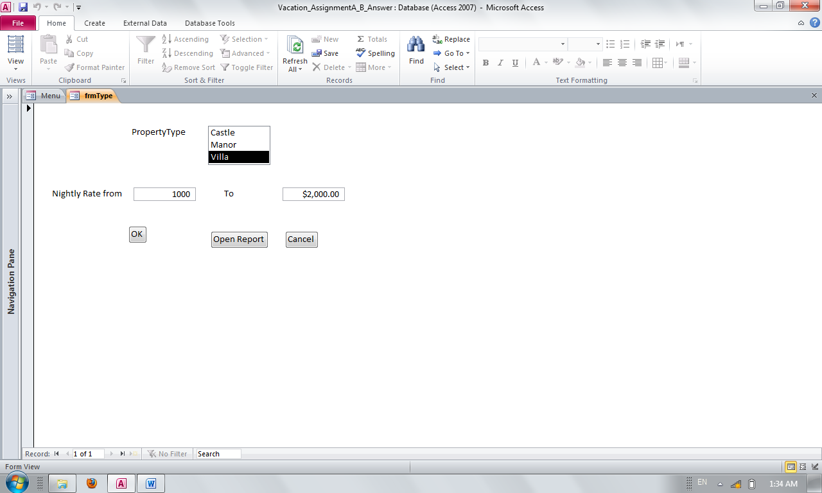

Figure 4: Result of a property Villa and nightly range between 1,000 and 2,000.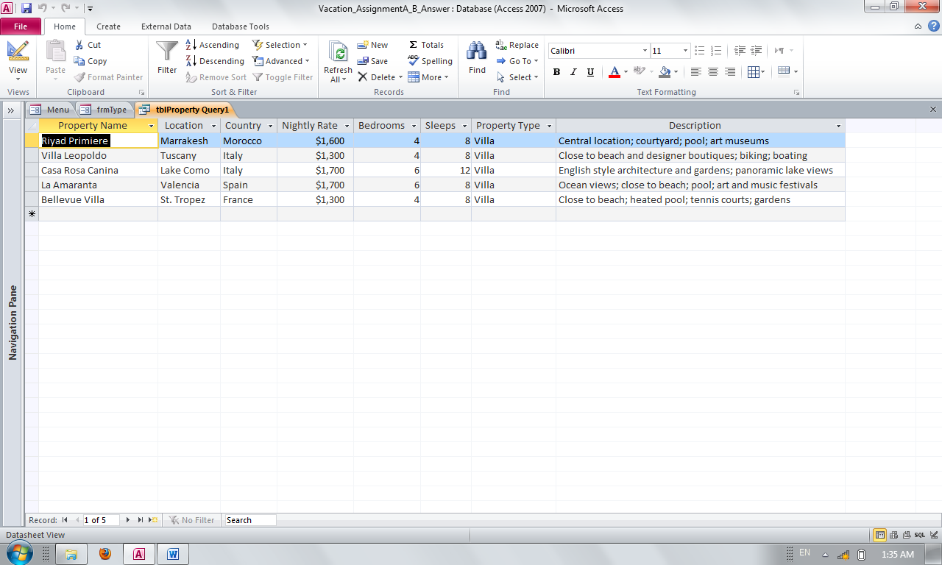

Assignment B:

On Menu form, the third button Open Report shall open a report based on the criteria as shown on Fig. 3. Fig. 5 shows a report based on the Villa property type and nightly range between $1000 and $2000. On this report, it shall list the type of property and nightly range on top of report as shown on Fig. 5. It is an Option to have page numbers and Date on the report. Menu shall show if report is closed. Pay attention to the needed fields on this table. You will receive no points if a parameter query is used by either assignment.

Figure 5: Report of property type