Chapter 2 The Database Development Process

Chapter Overview

The purpose of this chapter is to introduce students to the database development process within the broader context of information systems development. The chapter presents an expanded description of the systems development life cycle and the role of database development within it. It also presents a description of the prototyping methodology and its impact on database development. The chapter introduces the role of packaged data models and how they are used to simplify the database development process. Chapter 2 presents an updated description of the well-known three-schema architecture and uses it to summarize the various deliverables of database development. The chapter continues to emphasize the information engineering methodology in database development, including the role of the enterprise data model.

Chapter Objectives

Specific student learning objectives are included at the beginning of the chapter. From an instructor's point of view, the objectives of this chapter are to:
- Illustrate some of the database design and processing skills your students will have after completing a database course using this text.
- Provide an idea of how to structure a database development project sufficient to begin on a course exercise.
- Provide a comprehensive overview of various concepts and issues in database management. These will be developed in more detail in later chapters.
- Discuss the goal of enterprise-wide computing and the need for strategic information systems planning in achieving this goal.
- Introduce the Zachman Information Systems Architecture and its role in information systems development.
- Provide a review of systems development methodologies, particularly the systems development life cycle, prototyping, and agile software development; build an understanding of how database development fits with these methodologies.
- Build an awareness of CASE tools and how they can be used to facilitate the database development process.
- Describe how packaged data models can be used to shorten the development process and improve the quality of data models.
- Make students aware of the three-schema architecture and its benefits for database development and design.
- Develop an understanding of the different roles involved in a database development team.

Key Terms

Agile software development | Functional decomposition | Physical schema
Business function | Incremental commitment | Project
Client/server architecture | Information engineering | Prototyping
Client/server architecture | Information systems  life cycle (SDLC) | Systems development architecture (ISA)
Computer-aided software  engineering (CASE) | Information systems  life cycle (SDLC) | Systems development architecture (ISA)
Conceptual Schema | Logical schema | Top-down planning
Enterprise data modeling

Classroom Ideas

- You can discuss in class the types of systems analysis that might have been done to design the application illustration in this chapter. This is a good opportunity to discuss the linkage between your database course and the systems analysis and design course(s) your students take. You can also mention that a tool like Microsoft Access® is excellent for system prototyping since the database, screens, views, and reports shown in this chapter can be developed easily and quickly. If you are interested in teaching materials on SA&D that are consistent with this database text, the fifth edition of Modern Systems Analysis and Design, authored by Hoffer, George, and Valacich, is available from Prentice Hall.
- Discuss the importance of enterprise-wide computing in today's competitive environment and the difficulties of sharing information given the proliferation of personal computers and databases.
- Introduce the Zachman Information Systems Architecture Framework. We find in discussing this model it is especially helpful to discuss the different roles associated with each component. An excellent reference to the framework is provided at the Framework Software, Inc. Web site; the link to the PDF is:
http://www.frameworksoft.com/web-site-downloads/FSI-Enterprise-Architecture-Overview-Paper.pdf
- Discuss the major phases in the information engineering methodology (Tables 2-1 and 2-2). Illustrate sample deliverables from each of the phases using the Pine Valley Furniture Company case.
- If feasible, provide an in-class demonstration of a CASE tool that supports the information engineering methodology.
- Review the steps in the database development process (Figure 2-5). Indicate in which row the output for each step relates to the Information Systems Architecture framework as described in the text.
- Discuss the importance of strategic information systems planning with your students. Have your students give examples of poor results when planning is ignored. Also discuss factors that often interfere with effective planning.
- Discuss the role of CASE tools and a repository in information systems development. If appropriate, find out what CASE tools your students use in their work environment and their experience with these tools.
- A quick in-class demo of Microsoft Access or similar product may be used to give the students an initial exposure to an RDBMS and demonstrate a prototyping approach to database development. Consider using the PVFC prototyping request as an example.
- Your students may have examples from their workplaces to contribute about client/server architectures. Or, you may provide them with an understanding of where the RDBMS software and their data will be stored at your school as an illustration.

Answers to Review Questions

- Define each of the following key terms:
- Information systems architecture (ISA) A conceptual blueprint or plan that expresses the desired future structure for the information systems in an organization.
- Systems development life cycle (SDLC) A traditional methodology used to develop, maintain, and replace information systems.
- Agile software development An approach to database and software development that emphasizes individuals and interactions over processes and tools, working software over comprehensive documentation, customer collaboration over contract negotiation, and response to change over following a plan.
- Client/server architecture A local area network-based environment in which database software on a server (called a database server or database engine) performs database commands sent to it from client workstations, and application programs on each client concentrate on user interface functions.
- Incremental commitment A strategy in systems development projects in which the project is reviewed after each phase and continuation of the project is re-justified in each of these reviews.
- Enterprise data model The first step in database development, in which the scope and general contents of organizational databases are specified.
- Conceptual data model (or schema) A detailed, technology-independent specification of the overall structure of organizational data.
- Logical data model (or schema) The representation of data for a particular data management technology (such as the relational model). In the case of a relational data model, elements include tables, columns, rows, primary and foreign keys, as well as constraints.
- Physical data model (or schema) A set of specifications that detail how data from a logical data model (or schema) are stored in a computer’s secondary memory for a specific database management system. There is one physical data model (or schema) for each logical data model.

- Match the following terms and definitions:
f conceptual schema
h business function
d prototyping
i systems development life cycle
b functional decomposition
g top-down planning
c incremental commitment
e internal schema
a external schema

- Contrast the following terms:
- Internal schema; conceptual schema An internal schema consists both of a physical schema and a logical schema; a conceptual schema consists of a single view of the data, combining different external views. When you design the logical schema and the physical schema, it is possible that you will encounter inconsistencies or other issues with the conceptual schema or user views; it is possible to cycle back through these design steps.
- Systems development life cycle; prototyping Both are systems development processes. The SDLC is a methodical, highly structured approach which includes many checks and balances. Consequently, the SDLC is often criticized for the length of time needed until a working system is produced, which occurs only at the end of the process. Increasingly, organizations use more rapid application development (RAD) methods, which follow an iterative process of rapidly repeating analysis, design, and implementation steps until you converge on the system the user wants. Prototyping is one of them. In prototyping, a database and its applications are iteratively refined through a close interaction of systems developers and users.
- Top-down planning; functional decomposition Top-down planning approaches have the advantages of a broad perspective, an ability to look at integration of individual system components, an understanding of the relationship of information systems to business objectives, and an understanding of the impact of information systems across the whole organization. Functional decomposition is a classical process employed in systems analysis in order to simplify problems, isolate attention, and identify components.
- Enterprise data modeling; information engineering In many organizations, database development begins with enterprise data modeling, where the range and general contents of organizational databases are set. An information system’s architecture is developed by information systems planners following a particular methodology for IS planning. One such formal and popular methodology is information engineering.
- Repository; computer-aided software engineering CASE tools automate some portions of the development process and thereby improve system development time and the quality of the delivered products. A repository helps systems and database analysts achieve a seamless integration of data from several CASE tools.
- Enterprise data model; conceptual data model In an enterprise data model, the range and contents of the organizational databases are set. Generally, the enterprise data model represents all of the entities and relationships. The conceptual data model extends the enterprise data model further by combining all of the various user views and then representing the organizational databases using ER diagrams.
- Prototyping; Agile software development Prototyping is a rapid application development (RAD) method where a database and its application(s) are iteratively refined through analysis, design, and implementation cycles with systems developers and end users. Agile software development is a method that shares an emphasis on iterative development with the prototyping method yet further emphasizes the people and rapidity of response in its process.
- Information engineering steps:
- Planning phase: development of strategic information systems plans that are linked to strategic business plans. This stage results in developing an enterprise model that includes a decomposition of business functions and a high-level entity-relationship diagram.
- Analysis phase: Current business situations and information systems are studied to develop detailed specifications for the information systems required to support the organization.
- Design phase: transformation of the information models developed during analysis to models that conform to the target technology.
- Implementation phase: construction and installation of the information systems by creating database definitions and applications in the languages of the target systems.

5. Information engineering planning phase steps:
- Identify strategic planning factors. The purpose of this step is to develop the planning context and to link information systems plans to the strategic business plans.
- Identify corporate planning objects. The corporate planning objects define the business scope. The scope limits subsequent systems analysis and where information system changes can occur.
- Develop enterprise model. A comprehensive enterprise model consists of a functional breakdown (or decomposition) model of each business function, an enterprise data model, and various planning matrices.

- Three information engineering strategic planning factors:
The strategic planning factors are organization goals, critical success factors, and problem areas. These factors help information system managers to set priorities to address requests for new information systems, and hence the development of databases. For example, the problem area of inaccurate sales forecasts might cause information system managers to include additional historical sales data, new market research data, or data concerning results from test trials of new products in organizational databases.

- Five key corporate planning objects:
- Organizational units, which are the various organizational departments
- Organizational locations, which are the places at which business operations occur
- Business functions, which are related groups of business processes that support the mission of the organization (Note that business functions are different from organizational units; in fact, a function may be assigned to more than one organizational unit. For example: product development, a function, may be the joint responsibility of the sales and manufacturing departments.)
- Entity types, which are major categories of data about the people, places, and things managed by the organization
- Information systems, which are the application software and supporting procedures for handling sets of data

- Functional decomposition:
Functional decomposition is a classical process employed in systems analysis in order to simplify problems, isolate attention, and identify components. Often, many databases are necessary to handle the full set of business and supporting functions, whereas a particular database may support only a subset of the supporting functions. It is, however, helpful to have a total, high-level enterprise view so that redundancy of data can be minimized.

- Using information system planning matrices:
Planning matrices are used to show interrelationships between planning objects. Relationships between data entities and the other organizational planning objects can be represented at a high level by the planning matrices, which can be manipulated to understand patterns of relationships.

- Five SDLC phases:
- Planning
Purpose: To develop a preliminary understanding of the business situation and how information systems might help solve a problem or make an opportunity possible Deliverable: A written request to study the possible changes to an existing system; the development of a new system that addresses an information systems solution to the business problems or opportunities
- Analysis
Purpose: To analyze the business situation thoroughly to determine requirements, to structure those requirements, and to select among competing system features
Deliverables: The functional specifications for a system that meets user requirements and is feasible to develop and implement
- Design
Purpose: To elicit and structure all information requirements; to develop all technology and organizational specifications
Deliverables: Detailed functional specifications of all data, forms, reports, displays, and processing rules; program and database structures, technology purchases, physical site plans, and organizational redesigns
- Implementation
Purpose: To write programs, build data files, test and install the new system, train users, and finalize documentation
Deliverables: Programs that work accurately and according to specifications, documentation, and training materials
- Maintenance
Purpose: To monitor the operation and usefulness of a system; to repair and enhance the system
Deliverables: Periodic audits of the system to demonstrate whether the system is accurate and still meets needs

- Database development activities occur in every phase of the SDLC. Actual database development is most intense in the design, implementation, and maintenance steps of the SDLC.

- Prototyping steps:
Identify problem
- Conceptual data modeling
- Analyze requirements
- Develop preliminary data model
Develop initial prototype
- Logical database design
- Analyze requirements in detail
- Integrate database views into conceptual data model
Physical database design and creation
- Define new database contents to DBMS
- Decide on physical organization for new data
- Design database processing programs
Implement and use prototype
- Database implementation
- Code database processing
- Install new database contents, usually from existing data sources
Revise and enhance prototype
- Database maintenance
- Analyze database to ensure it meets application needs
- Fix errors in database
Convert to operational system
- Database maintenance
- Tune database for improved performance
- Fix errors in database

- Procedures and processes that are common to SDLC, prototyping, and agile methodologies include:
- Understanding and analyzing the customer’s business requirements for the system;
- Translating the customer’s requirements into specifications (logical & physical) for systems development;
- Developing databases and software programs to meet specifications; and
- Implementing an operational system.

The methodologies are considered to be different not because of what is done, but because the timing of the methodologies differ. The SDLC methodology is methodical and thorough which makes it well-suited for systems that populate and revise databases. Prototyping, with its rapidly repeating analysis, design, and implementation phases, is well-suited for systems that retrieve data and for helping to refine a customer’s requirements for a new system.
Agile software development emphasizes quick responses and rests on high-involvement from knowledgeable customers. Agile software development is well-suited to projects with unpredictable and/or rapidly changing requirements and responsible developers (per text citation of Fowler, 2005).

- Differences between user views, a conceptual schema, and an internal schema:
A conceptual schema defines the whole database without reference to how data are stored in a computer’s secondary memory. A user view (or external schema) is also independent of database technology, but typically contains a subset of the associated conceptual schema, relevant to a particular user or group of users (e.g., an inventory manager or accounts receivable department). An internal schema consists of both a physical schema and a logical schema. A logical schema consists of a representation of the data for a type of data management technology. For example, if the relational model is the technology used, then the logical schema will consist of tables, columns, rows, primary keys, foreign keys and constraints. A physical schema contains the specifications for how data from a logical schema are stored in a computer’s secondary memory.

- External and conceptual schema design:
External schemas are not necessarily developed before the conceptual schema. In fact, they are typically developed iteratively. Often, a first cut at the conceptual schema is based on the organization’s enterprise data model and the general understanding of database requirements on a project. Then external schemas (user views) are developed for each transaction, report, screen display, and other system uses.

- Three-tiered database architecture:
Database architecture that allows the data for a given information system to reside in multiple locations or tiers of computers. The purpose is to balance various organizational and technical factors. Also, the processing of data may occur at different locations in order to take advantage of the processing speed, ease of use, or ease of programming on different computer platforms. Although four (and even more) tiers are possible (that is, data on a desktop or laptop microcomputer, workgroup server, department server, a corporate mainframe), three tiers are more commonly considered:
- Client tier A desktop or laptop computer, which concentrates on managing the user-system interface and localized data—also called the presentation tier
- Department (or workgroup) minicomputer server tier Performs calculations and provides access to data shared within the workgroup—also called the process services tier
- Enterprise server (minicomputer or mainframe) tier Performs sophisticated calculations and manages the merging of data from multiple sources across the organization—also called the data services tier

- Yes, it is possible. The end user machine (in the client tier) — a P.C., for example — might have presentation logic but no database installed on it.

18. Information systems architecture (ISA) components include:
- Data, which can be represented as an Enterprise Data Model, and provides a high-level view of what will be included in an organization’s databases
- Processes, which manipulate data (represented by data flow diagrams, object-models with methods, or other notations) and indicate how data may be used in the organization
- Network, which transports data around the organization or between the organization and its key business partners (shown by a schematic of the network links and topology) and indicates likely interfaces for the organization’s databases with other systems or external organizations
- People, who perform processes and are the source and receiver of data and information; people can be shown on process models as senders and receivers of data; people will need security and authorization rights to the organization’s databases
- Events and points in time, when processes are performed (shown by state-transition diagrams and other means) that indicate key parts of business rules governing the data stored in databases
- Reasons, for events and rules that govern the processing of data (often shown in textural form, but some diagramming tools exist for rules, such as decision tables) and reflect the meaning of the business rules that govern the data stored in databases.

The ISA provides a high-level plan for the information systems in an organization, including a broad view of how the data and information resources will be managed. All of the 6 components of the ISA touch on elements of an organization’s database design at some level. However, the Data component of the ISA is the most central to an organization’s database design efforts. An organization’s enterprise data model supports an organization’s overall data architecture. An organization’s overall data architecture sets the stage for re-use of data throughout the organization as new application requirements are identified and acted upon by systems developers.

19. Entity-relationship diagrams may be drawn as early as during enterprise data modeling, when the range and general contents of organizational databases are determined. They are also drawn during the conceptual design phase. The level of abstraction varies at each stage, with the enterprise-level entity-relationship diagram being more abstract and of broader scope.

20. Three-schema architecture:
a. external schema
b. conceptual schema
c. internal schema

21. Enterprise data models are less detailed; they capture the major categories of data and the relationship between data. They are comprehensive to the whole organization. Project data models are more detailed and more closely match the way that data must be included in the database. Enterprise data models are used to cover the scope of data covered in the database. Project-level data models are used in the process of developing a database and applications which will access the database.

Answers to Problems and Exercises

- The representation of the systems development life cycle has changed from the original waterfall metaphor. While it is a more compact representation, there are still some problems. For example, it is not purely linear. Also, it is possible to conduct steps in parallel due to time overlaps. One additional problem is the inability to go back from one step to another without completing the entire five-step process.
2.
Data Entity Types | Product | Order | Work Center | Equipment | Employee | Raw Material | Customer | Invoice | Work Order
Business Function
Order fulfillment | X | X | X | X | X | X | X | X | X
Finance and accounting | X | X | X | X | X | X | X | X
Production operations | X | X | X | X | X | X |  |  | X
Order shipment | X | X | X |  | X |  | X | X
Materials management | X | X | X | X |  | X |  |  | X
Sales summarization | X | X |  |  | X |  | X | X
Business planning | X |  |  | X | X |  | X
Product development | X |  | X | X |  | X

X = data entity (column); is used within business function (row)

The matrix is ordered from those business functions that use the most data entities to those that use the fewest. The entities are also in order from those used in the most business functions to those used in the fewest. Now, if a given function has a priority in systems development, we could easily spot it on the matrix and find out whether the data entities it uses are to be accessed by many or just a few other functions.

3. EMPLOYEE, SUPPLIER, and SHIPMENT might be good examples since all of them represent major categories of data about the entities managed by the organization.

a.
Facilities

Capacity planning

Construction/Alteration

Maintenance/security

Allocation/scheduling

Curriculum

Curriculum design

Class scheduling

Instruction

Course development

Course instruction

Performance evaluation

Course evaluation

Student life

Admissions

Registrations

Student activities

Student advising

Personnel, etc.

The representation of functional decomposition may be achieved by following the example below:

Instruction
Course
Instruction
Course
Evaluation
Teach Classes
Evaluate
Performance

4b.

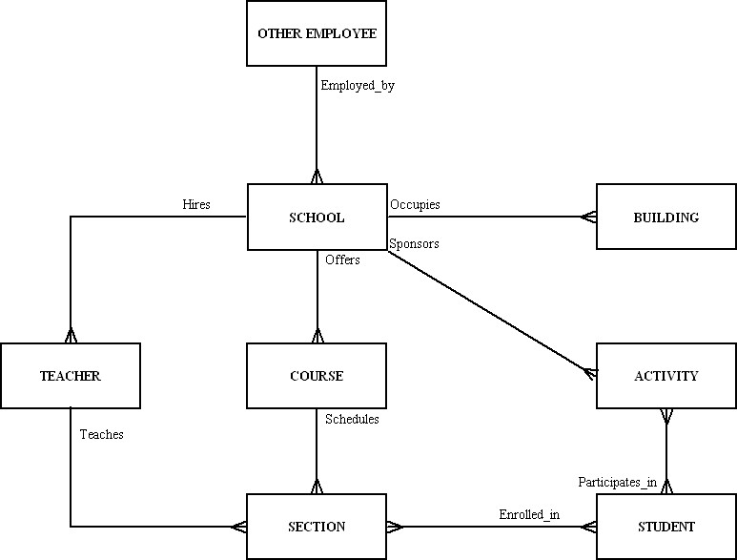
4c.

 |  | ENTITY TYPE
FUNCTION | Other  Employees |  | School | Building | Teachers | Courses | Sections | Students | Activities
Capacity  Planning | C |  | C | C | C
Construction/  Alteration |  |  |  | C
Maintenance/  Security | U |  |  | U |  |  |  |  | U
Allocation/  Scheduling |  |  |  |  | U | C | C | U
Curriculum  Design |  |  |  |  | U | U
Class  Scheduling |  |  |  |  | U | U | U | U
Course  Instruction |  |  |  |  | U | U
Course  Evaluation |  |  |  |  | U | U | U | U
Admissions |  |  |  |  |  |  |  | C
Registrations | U |  |  |  |  |  |  | U
Student  Activities | U |  |  |  | U |  |  | U | C
Student  Advising | U |  |  |  | U |  |  | U

- CSFs: Maintain academic standards; Maintain good quality of student life; Hire outstanding faculty; Maintain quality work life for faculty; Maintain current curriculum; Provide quality services within budgetary constraints.

- Considerations for using a multi-tier architecture: Since much of the data are updated from a large number of different functions (as shown on the matrix in part c), network traffic will be an issue of crucial importance. Processing close to the source data could reduce network traffic. Client technologies however, can be mixed (personal computers with Intel or Motorola processors, network computers, information kiosks, etc.) and yet, share common data. In addition, you can change technologies at any tier with limited impact on the system modules on other tiers. All this will allow for data consistency and maintaining academic standards — a critical success factor for the academic unit.
Selected as
- This is a sample list of information systems which could be employed by a fictional student organization:
- Event Management System
- General Management Support System
- Publicity Support System
- Financial Management System
- Cost Accounting System, etc.
The Event Management System could assist the club management in several ways: event production plan preparation (outline the steps necessary to implement the program proposal); setup and catering details arrangement; staffing plan and contingency plan preparation; contract arrangements on performer's pay, travel, and any special requirements; arrangement for technical requirements; event production and evaluation.

- Sample enterprise data model for fictional student organization

Notes to instructor:
1) This data model solution can be used in conjunction with the matrix solutions in parts c and d to stimulate class discussion. For instance, in the data model, we show a STUDENT entity. In the matrices, the STUDENT column is quite empty. Will non-member student data be collected by the organization? If not, do we need the STUDENT entity?
2) This data model solution may also be used to sensitize students to the importance of an organization’s business rules. Suggested questions to discuss with students include:
- What data would be kept in LOCAL ORGANIZATION?
- Is STAFF/FACULTY MEMBER data different from STUDENT or MEMBER data for this situation?
- Does the organization really track who attends a lecture?
- What reports can be generated from the OFFICER – STUDENT relationship?
- Can a STUDENT be an OFFICER and not a MEMBER?

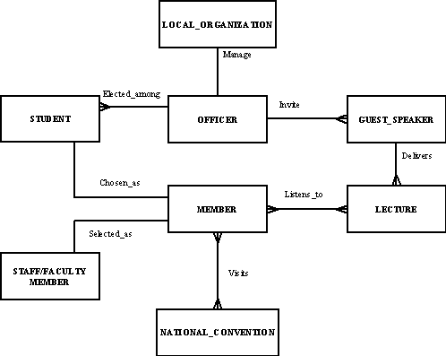

Data Entity  Types  Information  Systems | Student | Staff / Faculty  Member | Member | Local  Organization | Officers | Lecture | Guest Speaker | National  Convention
Event Management System |  |  |  |  |  | C,U,D | C,U, D | C, U, D
General Management Support System |  | C,U,D | C, U. D | C, U, D | C, U, D
Publicity Support System |  |  | R | R | R | R | R | R
Financial Management  System |  | R | R | R | R
Cost Accounting System, etc. |  |  |  | R |  | U | U | U

Data Entity  Types  Information  Systems | Student | Staff / Faculty  Member | Member | Local Organization | Officers | Lecture | Guest Speaker | National  Convention
General Management Support System |  | C, U, D | C, U, D | C, U, D | C, U, D
Financial Management  System |  | R | R | R | R
Publicity Support System |  |  | R | R | R | R | R | R
Cost Accounting System, etc. |  |  |  | R |  | U | U | U
Event Management System |  |  |  |  |  | C, U,D | C, U, D | C, U, D

Certain entities would be accessed by the majority of information systems (e.g., MEMBER, OFFICERS, LOCAL ORGANIZATION), while certain information systems may operate on data about the majority of entities. This new rearrangement of the matrix could help us understand that some of the applications would need to access most of the data in a single session, which would mean that more powerful hardware has to be set up for them. Also, some priorities have to be assigned to the different systems in the case of simultaneous data access attempts.

- We could rearrange the matrix in order to group the functions and data into subsystems. These subsystems will help us in subdividing the overall development into manageable projects. Since three of the business functions provide the bulk of the use of five of the data entities, these functions would need to have easy access to a large portion of all the data.

Data Entity  Types  Information  Systems | Customer | Product | Raw Material | Order | Work Center | Invoice | Equipment | Employee
Order Tracking System | R | R |  | R,U,D |  | R,U |  | R
Order Processing System | C, U | R,U | R,U | C,D,U | R | C,R, U | R | R
Plant Scheduling |  | R | R | R | R,U |  | R,U | R
Payroll |  |  |  | R | R |  |  | R,U
Sales Management | R | R |  | R | R | R |  | R
Inventory Control |  | R | R,U,D | R | R | R
Production Scheduling |  | R | R | R | R |  | R | R

The management information systems (e.g., Sales Management System) will tend to retrieve information, while the transaction processing systems will perform frequent updates. The only exception to this might be the case of Inventory Control, which would make changes to the inventory.

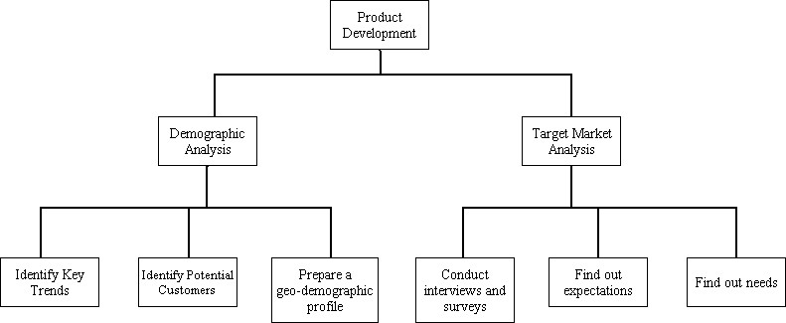

Even though order fulfillment and product development are both considered business functions, they are not overlapping in nature. Since the two diagrams represent two different subsets, none of the sub-functions would appear on the both figures at the same time.

- Enterprise data models and conceptual data models:
Enterprise data modeling results in a total picture or explanation of organizational data, not in the design for a particular database. A particular database provides the data for one or more information systems, whereas an enterprise data model, which may encompass many databases, describes the scope of data maintained by the organization. Therefore, the level of abstraction associated with an enterprise data model is higher; conceptual data models will be more detailed.

- Returning to logical database design during physical database design and creation:
Database development activities occur in each of the SDLC phases, and feedback may occur which causes a project to return to a prior phase. SDLC activities may find missing elements or errors when designing specific transactions, reports, displays, and inquiries. When a missing element is noticed, for example, it will be necessary to revisit the logical database design.

- Contrasting database development during conceptual data modeling and logical database design phases:
It is often said that conceptual data modeling is done in a top-down fashion, driven from a general understanding of the business area, not from specific information processing activities. Logical database design approaches database development from two perspectives. First, the conceptual data model is transformed into a standard notation through normalization, based on relational database theory. Then, as each computer program in the information system is designed — including the program’s input and output formats — a detailed review of the transactions, reports, displays, and inquiries supported by the database is performed. This bottom-up analysis verifies exactly what data are to be maintained in the database and the nature of those data as needed for each transaction, report, and so forth. During logical database design, you combine or integrate the original conceptual data model (more general information) along with the individual user views (more specific information) into a comprehensive design.

- Prototype development:
Workgroup and department databases are often developed in combination by end users, systems professionals working in business units, and central database professionals. A combination of people is necessary since a wide variety of issues must be balanced in the design of shared databases: processing speed, ease of use, differences in data definitions, and the like. Often, the prototype being developed will be located on a separate workgroup computer or a department computer, where those involved on the project will have easy access to the database and no likelihood of interfering with the organization's production databases.

- User views of organizational data:
A good approach in developing this problem for a bank might be to carefully select the views to be developed (similar to the example of Figure 2-1) by collecting a transaction slip, monthly statement (representing each type of account), statement of earnings, etc. Examples of data included in each message are customer information, bank information, and transaction data (checks, deposits, service charges, maintenance fees, overdraft protection fees, and so forth). Statement and deposit slip views are given below, as is the combined conceptual data model. Combining the different views could lead to the addition of new attributes or possibly entities and relationships not being shown in the original views.

Statement view:

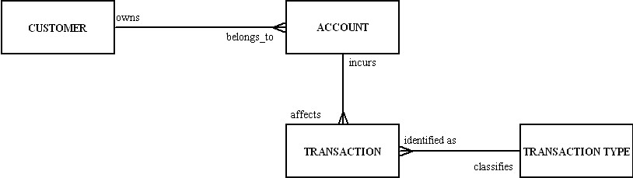

Deposit slip view:

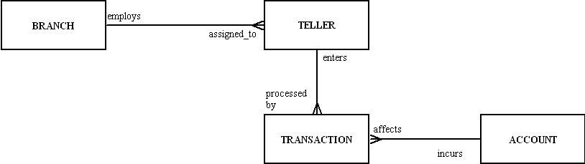

Conceptual data model:

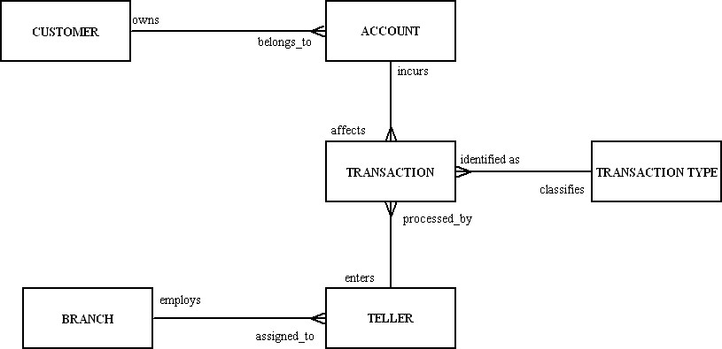

- A typical example of potential data duplication in this case would be customer information. Customer data and customer invoices reside on the Accounting Department Server (departmental database). Customer data and their order information reside on the Order Entry Department Server (a machine that hosts another departmental database). The cash flow analyst's PC hosts a local database storing data about customer receipts. If different machines hold different addresses for the same customer, for example, loss of data integrity may be experienced. Data formats could also be incompatible. In the relational model, associations are established by defining foreign keys, which are redundant data, so the inclusion of redundant data does not violate the principles of the database approach. Normalization though, should result in the elimination of unnecessary data redundancy, which does exist in the hypothetical example given here. Coordination of the metadata at the enterprise server will prevent uncontrolled data duplication, limited data sharing, lengthy development time, and excessive program maintenance. It may also be desirable to intentionally include limited additional redundancy to improve database performance.

- The single line connection indicates a one-to-one relationship between the entities. In business terms: each order is billed on exactly one invoice, each invoice is written for only one order. In contrast, many payments can be made on one order. Remember to model for the exceptions.

16.
a. Each product line name can be up to 40 characters and spaces in length. This variable
length is specified by the data type, VARCHAR, and the value in parentheses, 40.
- PRODUCT_ID is specified as required in Figure 2-14a (SQL) by the NOT NULL constraint that is included after the data type identification for PRODUCT_ID. This means that for each instance of product information entered, PRODUCT_ID must have a value. This is necessary because PRODUCT_ID is the primary key of the relation. There must be a value entered in the primary key field for each instance. The relation will be indexed and stored based on this value.
In Figure 2-14b (MS-ACCESS), PRODUCT_ID is also indicated to be the primary key by the small key icon to the left of its specification. The Required property in the bottom half of the screen is set to YES for the same reasons as described above.
- The last line establishes a relationship between the PRODUCT table and the PRODUCT_LINE table by designating PRODUCT_LINE_NAME as a foreign key that points back to PRODUCT_LINE_NAME in the PRODUCT_LINE table.

17.
- Sales_to_Date is calculated by multiplying the quantity by the price.
- Eliminating "Home Office" from the Criteria line under Product_Line_Name would result in all product line names being displayed, not just the Home Office line.

    - The following entities will be needed:
Payment, Invoice, Order, Order_Line, Product, Customer
b. All of the above entities will be needed for the SQL query.

    - PRODUCT_LINE_ID is used as the primary key in the Pine Valley database.
    - Product_Line_Name is used as the primary key in the draft of Helen’s database.
    - Helen’s version assumes that each product line will have a unique name. Helen’s database also includes two attributes that are not included in Pine Valley Furniture’s database, PL_Prior_Year_Goal and PL_Current_Year_Goal. One conclusion that could be drawn from this is that these two attributes have been generated through her department’s budgeting efforts and are tracked through her department, rather than through the organization-level database. This information is very important to Helen’s management activities and demonstrates the reason why personal databases of this sort are so common.

 | All Entities? | All Attributes? | Technology  Independent? | DBMS Independent? | Record Layouts?
Enterprise | Y | N | Y | Y | N
Conceptual | Y | Y | Y | Y | N
Logical | Y | Y | N | Y | Y
Physical | Y | Y | N | N | Y

Suggestions for Field Exercises

- Students will probably find prototyping being used for smaller database applications. Prototyping is often the systems development methodology of choice where visual programming tools such as Visual Basic, Java, Visual C++, and fourth-generation languages are used because of the ease with which the user-system interface can be modified. Large systems that require a new database are more likely to use the SDLC, requiring a team of information systems professionals, including database designers and programmers. The systems development process for Web applications can be similar, with prototyping being employed. However, students may find that there is a lot more testing involved with Web applications, since one has less control over the client interface.

- Those organizations which do have a formally recognized information systems architecture are likely to rely on an information systems architecture model developed and integrated with the help of CASE tools. When data format changes occur, or new data is added to the old database — possibly obtained from external data sources such as market research data, general economic indicators, or industry standards — those CASE tools could inform the developers about possible inconsistencies and ensure quality data throughout the organization. This problem is likely to be an eye opener for students if they each investigate a different organization and compare their findings, as many organizations will not have a formally recognized ISA. They may begin to comprehend the differences that exist among organizations as well as the difference between textbook presentations of best practices and actual organization practices.

- Again, as in the previous field exercise, this exercise will help students to integrate their new textbook knowledge with the realities that organizations must face. Some students will find organizations that are struggling to achieve client/server architecture and also deal with their legacy systems, for example.

- Students are likely to find some of the following roles on the information systems development teams in larger organizations:
- Systems analysts, who analyze the business situation and identify the need for information and information services to meet the problems or opportunities of the business
- Database analysts, who concentrate on determining the requirements and design for the database component of the information system
- Users, who provide assessment of their information needs and monitor appropriateness of the developed system
- Programmers, who design and write computer programs that have embedded in them commands to maintain and access data in the database
- Database and data administrators, who have responsibility for existing and future databases and ensure consistency and integrity across databases; as experts on database technology, they provide consulting and training to other project team members
- Other technical experts, with facility in networking, operating systems, testing, and documentation
- A senior systems or database analyst, who will be assigned to be project leader, who is responsible for creating detailed project plans as well as staffing and supervising the project team; this good project leader will possess leadership, management, customer relations and communications, technical problem solving, conflict management, team building, and risk and change management skills.

In smaller organizations, students may find that these roles are combined and performed by fewer people because the smaller organizations do not have the additional staff to assign to a diverse team. Thus, fewer people will cover these same functional responsibilities by each person having multiple roles to fulfill. Many employees in small organizations develop deep skill sets in programming, data administration, or technical database administration expertise.

- (Note to instructor: See Figure 2-5 and chapter section on “Managing the people involved in database development” for more background on this exercise.)

If a CASE tool is being used, a repository stores descriptions of the data entities and the business rules, detailed descriptions of CSFs, and objectives. The information systems department analyzes all of them. Throughout the systems development process, CASE tools are used to develop data models and to maintain (in the repository) the metadata for the database and applications. A repository maintains all of the documentation too. Various people might use the CASE tools and associated repository during a database development project: systems analysts, database analysts, users, programmers, database and data administrators, and other technical specialists. As a significant new portion of a project is completed and entries are made in the repository, a review point occurs so that those working on the project and funding the human and capital resources of the project can assess progress and renew commitment based on incremental achievements.

Project Case

Case Questions

- The tiered location plan will represent the location of databases and different machines throughout the organization. Since it would include information about the data to be hosted on each machine, a suitable approach will be to develop a business function-to-data entity matrix. It would identify which functions maintain instances of data, and which functions only use data about those entities. Then, a location-to-function matrix may be used in order to find out the locations at which those functions are performed. (A unit-to-function matrix may also be a good choice in this regard.) Accordingly, those business units which will maintain the data would need to be the data owner. At the same time, units which would only retrieve the data might have network access to it.

2.
- Quality of medical care:
- All staff members have to meet strict educational and certification requirements.
- Improve services and reduce the number of customers' complaints.
- Maintain library resources of up-to date medical journals and other types of specialized literature.
b. Control of capital costs:
- Acquire with caution new surgery equipment and electro-diagnosis technology.
- Wisely manage capital consuming, long-term projects.
c. Recruitment and retention of skilled personnel:
- Maintain a predetermined number of nursing personnel and volunteers. Maintain an attractive employee benefits plan.
- Distribute subsidies among university and college-enrolled employees.
- Offer flexible schedules.

- The three activities from the case study are: recruit volunteers, schedule volunteers, and evaluate volunteers. Some additional activities could be: train volunteers, schedule training sessions for volunteers, schedule orientation sessions for volunteers, etc.

- Hold emergency simulation and evacuation training sessions, prepare a disaster recovery plan, perform system backups, etc.

- One idea is to show the prepared function-to-entity matrix to employees involved with each function, who can identify any entities that may have been missed. This happens in enterprise modeling (part of the planning phase in the SDLC). To be more exact, enterprise modeling occurs during information systems planning and other activities. During SDLC, activities missing elements or errors may be found. This may occur while designing specific transactions, reports, displays, or inquiries in the analysis phase.

- The assignment is for the development of an information systems plan for the hospital. The roles included on the business planning study team are: one information systems person, one assistant administrator, the head of surgery, and one consultant. This varied expertise should give the team a broad view over the different business functions. However, they will still need to communicate with the rest of the staff, e.g., human resources, the accounting department, nursing staff, general physicians, etc. Additional or different team members could also be included from any of these constituencies.

7.
- Each WARD has any number of PATIENTs assigned to it.
- A SUPPLY ITEM may be provided by any number of VENDORs.
- A MEDICAL/SURGICAL ITEM may be used by one or many PATIENTs.

8. Both those functions, electro-diagnosis and surgery, require heavy capital investments. In addition, those functions are highly dependent on technology. We could further expand this notation by adding the N status (business function is not of significant importance in achieving CSF). In that way, we could show, for example, that Patient Scheduling or Patient Accounting functions are not significant in achieving capital cost control.

Case Exercises

Data Entity Types | Patient | Physician | Laboratory | Ward | Test | Facility | Staff | Medical/  Surgical Item | Supply Item | Vendor
Business Function
Rehabilitation | R
Nursing | R
Patient Monitoring | R
Dietary | R
Surgery | R | R
Patient Scheduling | R | R | R
Blood Banking | R |  | R
Patient Registration | M |  |  | R
Multiphasic Screening | R |  | R |  | M
Patient Accounting | R |  | R | R | R
Physician Orders | R | R |  |  | R
Laboratory Reporting | R |  | R |  | R
Radiology |  |  | R |  | M
Electrodiagnosis |  |  |  |  | M
Psychiatric Testing |  |  |  |  | M
Volunteering | R |  | R | R |  | R
General Accounting |  |  | M | M |  | M
Cost Accounting | R |  |  | R | R | R
Payroll |  | R |  | R |  |  | R
Personnel |  | M |  |  |  |  | M |  | R
Inventory Control |  |  |  |  |  |  |  | R | R
Housekeeping |  |  |  |  |  |  |  |  | R
Risk Management | R | R |  |  |  | R |  | R |  | R
Purchasing |  |  |  |  |  |  |  | M | M | M

M = data entity (column); is maintained by business function (row)
R = data entity (column); is used by business function (row)

Certain entities would participate in the majority of business functions, e.g., PATIENTS, PHYSICIANS, LABORATORY, while certain business functions may involve the majority of entities. This fact would be important in the development of this case since with this new rearrangement of the matrix, we could indicate what data are to be accessed most often. Also, which processes will need to access data about the majority of entities.

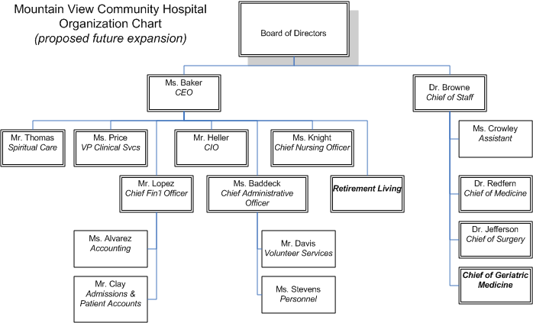

The business functions, Clinical Services and Patient Care Services (Figure 2-2), need to be expanded with some new subfunctions. The preliminary enterprise data model (Figure 2-3) does not need to be changed at this point. Some functions may be added to business function-to-data entity and business function-to-CSF matrices (Figure 2-4, 2-5), based on what is decided about the sub-functions noted in Figure 2-2.

- Note to instructor: The preliminary enterprise data model in Figure 2-3 properly depicts the stated business rules in the Case Scenario. The diagram is reproduced here solely for reference purposes. Student answers could vary if additional assumptions are made about valid business rules for the Case Scenario (e.g., use of Volunteers, etc.).

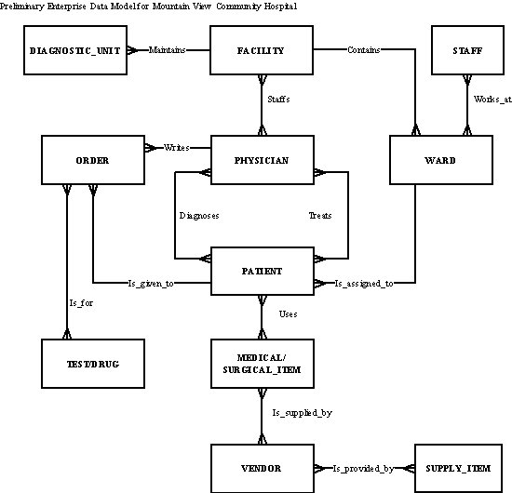

- This can be achieved by selecting the functions with an E status from the business function-to-CSF matrix (Nursing, Patient Accounting, etc.). Then find out what entities from the business function-to-data entity matrix would need to be maintained or used by those functions. The problem is that almost every entity turns out to be of a great importance for this CSF, and this could happen with the rest of the CSF. Consequently, the quality of all data is essential.

- We will have to first take a look at the Data Item/Name column of the metadata chart. It does list data items in the form of entity attributes' names. Since the preliminary enterprise data model will not show data attributes, but entities only, we could only verify if a particular entity from the metadata chart is represented on the enterprise data model; no detailed verification can be performed. Also, ITEM code and ITEM description that appear on the patient bill are not sufficient to determine whether a MEDICAL/SURGICAL ITEM or a SUPPLY ITEM is taken into consideration, e.g., some entity data may be similar in nature to other entity data. We need to go back and re-label the attributes in order to avoid misinterpretation.

- Given the high priority assigned to this project, the obvious strategy is to first determine whether packaged information systems (including associated packaged data models) are available for risk management. Most hospitals are facing the same problems, and it is very likely that hospital-specific data models and systems are available. Of course, the hospital staff will have to determine whether such systems meet their needs and are compatible with existing development efforts. If instead, Mountain View Community Hospital decides to develop the systems internally, the solution could be a combination of the prototyping and life cycle approaches. Once the enterprise model has been agreed upon, it should be possible to identify the entities and relationships involved in the desired risk management system. From there, an interim prototype of the risk management system could be built if the manager's needs are deemed to be so critical that such a step is necessary. Thus, project initiation and planning (including placing this project within the company’s information system architecture) can be addressed quickly. Then use an iterative cycle of analysis, design, and implementation to work closely with the manager of the risk management area to develop a working prototype of the system he or she needs. This system probably needs a database of limited scope, which may be used until it is integrated into the completed system.

- Since we have considered prototyping the system as a preliminary piece of the entire system, but one that will be used quickly, this system may well be developed as a stand-alone database. Then, the unstructured and unpredictable use of data will not interfere with access to the operational databases needed to support efficient transaction processing systems. Also, the confidential information will not need to travel across the network, where possibilities of interception exist.

Project Assignments

P1. It sounds as if the team should be ready to consider the requirements of the proposed expansion of the system to possibly handle the two proposed new departments, Retirement Living and Geriatric Medicine. These requirements will need to be integrated into the existing enterprise model. Once the entire enterprise model is constructed, the proposed subsystems should be identified and prioritized so that plans can be laid to move on to begin the conceptual data model.

P2.
a. Note to instructor: Based on a reading of the Case Scenario, the clearly stated business rules tend to support the preliminary enterprise data model as shown in Figure 2-3 (and Case Exercise 3 solution above); no modifications are necessary based on the stated business rules. However, a thorough reading of the Case Scenario will reveal the importance of Volunteers as well as a need to include Risk Management issues in this proposed new system and database. One of the events that a Hospital such as this may need to address is the use of an Evacuation Location. Thus, it can be implied that additions of Evacuation Location and Volunteer entities to the enterprise data model would be useful to development efforts of the project team (see revised diagram below). Adding these entities now will assist the team in remembering that the new system may require more data to support the requirements from these areas as the project progresses.

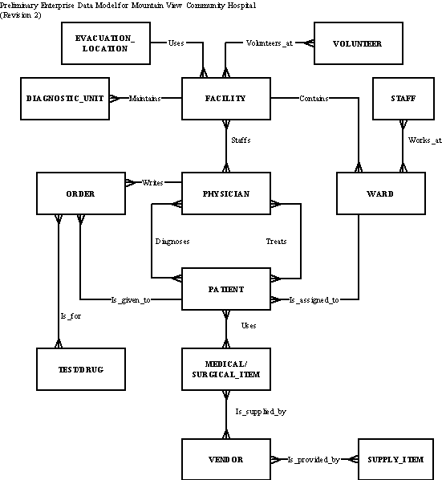

b.
A volunteer volunteers at 1 or more facilities.
A facility has 1 or more volunteers.
A facility uses 1 evacution location.
An evacuation location is used by many facilities.

c. MVCH Context Diagram

