Chapter 5 Logical Database Design and the Relational Model

Chapter Overview
The purpose of this chapter is to describe in depth the major steps in logical database design, with more emphasis on the relational model. Logical database design is the process of transforming the conceptual data model (described in Chapters 3 and 4) into a logical data model. First, we provide a concise description of the relational data model, including the properties of relations. Next, we describe and illustrate the various types of integrity constraints associated with the relational model. This section introduces SQL table definitions and the concept of well-structured relations. We then provide a detailed description of the process of transforming EER diagrams into relations. Next, we define normalization and describe the steps in normalizing relations. The chapter concludes with a discussion of merging relations and techniques for dealing with typical issues that arise during this process.

Chapter Objectives
Specific student learning objectives are included in the beginning of the chapter. From an instructor’s point of view, the objectives of this chapter are to:
- Show students the position of logical database design within the overall database development process. This is a key chapter in the textbook since students will begin to see how their databases will be implemented.
- Provide students with a solid understanding of the relational data model including the properties of relations, integrity constraints, and well-structured relations.
- Discuss the principles and detailed steps involved in mapping EER diagrams to relations. Computer-assisted techniques are often used to speed up this process, but students should still understand the principles involved.
- Provide students with a firm grasp on the principles of functional dependencies, determinants, and related concepts of normalization.
- Emphasize why normalization is important to stable database design with the relational model, and then present a concise description of the various normal forms and the normalization process.
- Discuss some of the anomalies that arise when merging relations, and discuss how to apply the principles we have learned to address these anomalies.

Key Terms

Alias | Foreign key | Recursive foreign key
Anomaly | Functional dependency | Referential integrity constraint
Candidate key | Homonym | Relation
Composite key | Normal form | Second normal form
Determinant | Normalization | Surrogate primary key
Enterprise key | Null | Synonyms
Entity integrity rule | Partial functional  dependency | Third normal form
 | Partial functional  dependency | Transitive dependency
First normal form | Primary key | Well-structured relation

Classroom Ideas
- Motivate the need for logical database design. We sometimes start by showing students the conceptual data model (E-R diagrams) for Pine Valley Furniture Company (Figure 3-22). Emphasize that this E-R diagram must be transformed through logical database design before it can be implemented.
- Review the position of logical database design in the overall database development process (see Figure 2-5). You might want to discuss who in the organization is usually responsible for this step and what CASE tools might be appropriate.
- Discuss the relational data model using Figures 5-1 through 5-4 as examples.
- Introduce the important integrity constraints in the relational model using Figure 5-5 and Table 5-1. Emphasize that these constraints will be enforced by the DBMS, but must first be specified by the designer.
- Introduce SQL table definitions (Figure 5-6). Show how these definitions specify the referential integrity constraints that are diagrammed in Figure 5-5.
- Illustrate how anomalies can occur when relations are not well structured, using Figures 5-2b and 5-7. Emphasize the fact that much real-world data (including relational data) are not well structured.
- Discuss the process of transforming EER diagrams to relations (Figures 5-8 through 5-21). We suggest you reinforce these concepts by asking your students (in teams of two) to perform Exercise 6a in class immediately following the discussion.
- Preview the steps in normalization using Figure 5-22. You will want to use this figure again to summarize normalization at the end of your discussion.
- Discuss the concepts of functional dependencies, determinants, and candidate keys. Start with your own examples on the board, and then have your students give additional examples. Summarize using Figure 5-22.
- Discuss first through third normal forms, using Figures 5-25 through 5-29. Additional normal forms (BCNF and 4NF) are presented in Appendix B, if time permits.
- Discuss merging relations and view integration problems.
- Use Figure 5-31 to discuss enterprise keys and what they are used for.
- We strongly suggest for you to ask your students to work in small teams on one or more end-of-chapter exercises. (Exercises 3 and 4 work well for this purpose.)

Answers to Review Questions
- Define each of the following terms:
- Determinant The attribute on the left-hand side of the arrow in a functional dependency.
- Functional dependency A constraint between two attributes or two sets of attributes.
- Transitive dependency A functional dependency between two (or more) nonkey attributes.
- Recursive foreign key A foreign key in a relation that references the primary key values of that same relation.
- Normalization The process of decomposing relations with anomalies to produce smaller, well-structured relations.
- Composite key A primary key that consists of more than one attribute.
- Relation A named, two-dimensional table of data.
- Normal form A state of a relation that results from applying simple rules regarding functional dependencies (or relationships between attributes) to that relation.
- Partial functional dependency A functional dependency in which one or more nonkey attributes (such as Name) are functionally dependent on part (but not all) of the primary key.
- Enterprise key A primary key whose value is unique across all relations.
- Surrogate primary key: A serial number or other system assigned primary key for a relation.

- f well-structured relation
e anomaly
a functional dependency
j determinant
g composite key
d 1NF
h 2NF
i 3NF
c recursive foreign key
k relation
b transitive dependency

- Contrast the following terms:
- Normal form; normalization Normal form is a state of a particular relation regarding functional dependencies, while normalization is the process of decomposing relations with anomalies to produce smaller, well-structured relations.
- Candidate key; primary key A primary key is an attribute (or combination of attributes) that uniquely identifies a row in a relation. When a relation has more than one such attribute (or combination of attributes), each is called a candidate key. The primary key is then the one chosen by users to uniquely identify the rows in the relation.
- Partial dependency; transitive dependency A partial functional dependency exists when a nonkey attribute is functionally dependent on part (but not all) of a composite primary key; a transitive dependency is a functional dependency between two or more nonkey attributes.
- Composite key; recursive foreign key A composite key is a primary key that consists of more than one attribute, while a recursive foreign key is a foreign key in a relation that references the primary key values of that same relation.
- Determinant; candidate key A determinant is the attribute on the left-hand side of the arrow in a functional dependency, while a candidate key uniquely identifies a row in a relation.
- Foreign key; primary key A primary key uniquely identifies each row in a relation, while a foreign key is a primary key in another table.
- Enterprise key; surrogate primary key An enterprise key is a primary key whose value is unique across all relations in the whole database and is likely to hold no business meaning. A surrogate primary key is a primary key whose value is a serial number or other system assigned value and is unique to the relation.

- Six important properties of relations are:
- Each relation in a database has a unique name.
- An entry at the intersection of each row and column is atomic (or single valued).
- Each row is unique.
- Each attribute within a table has a unique name.
- The sequence of columns is insignificant.
- The sequence of rows is insignificant.

- Describe two properties that must be satisfied by candidate keys:
- Unique identification: For every row, the value of the key must uniquely identify that row.
- Nonredundancy: No attribute in the key can be deleted without destroying the property of unique identification.

- Three types of anomalies in tables:
- Insertion anomaly: A new row cannot be inserted unless all primary key values are supplied.
- Deletion anomaly: Deleting a row results in the loss of important information not stored elsewhere.
- Modification anomaly: A simple update must be applied to multiple rows.

- Fill in the blanks.
- second
- first
- third

- A well-structured relation is one that contains a minimum amount of redundancy and allows users to insert, modify, and delete the rows in a table without errors or inconsistency. Well-structured relations are important because they promote database integrity.

- Describe how the following components of an E-R diagram are transformed into relations:
- Regular entity type: Each entity type is transformed into a simple relation. Each simple attribute of the entity type becomes an attribute of the relation.
- Relationship (1:M): A relation is created for each of the two entity types participating in the relationship. The primary key attribute of the entity on the one-side of the relationship becomes a foreign key in the relation on the many-side of the relationship.
- Relationship (M:N): A new relation is created to represent this relationship. The primary key for each of the participating entity types is included in this new relation.
- Relationship (supertype/subtype): A separate relation is created for the supertype and each of its subtypes. The primary key of the supertype is assigned to each subtype, as well as attributes that are unique to the subtype.
- Multivalued attribute: A new relation is created to replace the multivalued attribute. The primary key of this new relation consists of two attributes: the primary key of the original relation, plus the multivalued attribute itself.
- Weak entity: A new relation is created corresponding to the weak entity. The primary key of this relation consists of the primary key of the owner relation, plus the partial identifier of the weak entity type.
- Composite attribute: The simple component attributes of the composite attribute are included in the new relation.

- Four typical problems in merging relations:
- Synonyms: Two (or more) attributes have different names but the same meaning. Solution: Convince users to standardize on a single name.
- Homonyms: A single attribute has more than one meaning.
Solution: Create new attribute names that capture the separate meanings.
- Transitive dependency: Merging relations produces transitive dependencies.
Solution: Create 3 NF relations by removing the transitive dependency.
- Supertype/subtype: May be implied by content of existing relations.
Solution: Create new relations that explicitly recognize this relationship.
- Three conditions that imply a relation is in second normal form:
- The primary key consists of a simple attribute
- No nonkey attributes exist in the relation
- Every nonkey attribute is functionally dependent on the full set of primary key attributes

- Integrity constraints enforced in SQL CREATE TABLE commands:
- Entity integrity: enforced by NOT NULL clause
- Referential integrity: enforced by FOREIGN KEY REFERENCES statement

- Relationships between entities are represented by foreign key values in one relation that match primary key values in another relation.

- A 1:M unary relationship is represented by a recursive foreign key whose values reference the primary key values of the same relation.

- An M:N ternary relationship is represented by a new associative relation whose primary key consists of the primary key attributes of the participating entity types.

- A new relation (called the associative relation) is created to represent the associative entity. The default primary key consists of the primary key values from the relations that participate in the association.

- All of the nonkey attributes of a relation are functionally dependent on the primary key of that relation.

18. A foreign key must not be null when the minimum cardinality of the relationship implied by the foreign key is one.

19. The only way to eliminate ripple effects is to create an enterprise key from the very beginning of database development.

20. A unary 1:M relationship always utilizes a recursive foreign key, whereas an M:N recursive relationship dictates that a second table must be created for the relationship.

21. The following three conditions are adequate to suggest that a surrogate key should be developed for a relation:
- the presence of a composite primary key
- the natural primary key (the one initially identified by users during conceptual modeling activities) is too long or made up of more than two attributes which will cause performance issues with database software
- the natural primary key cannot be guaranteed to be unique over time (e.g., due to duplicates or re-use over time)

Answers to Problems and Exercises
Note to Instructors: In this section of the Instructor’s Manual, we have adopted a number of notational conventions to indicate the Primary and Foreign Keys in the relations. Primary Key(s) are noted with an underlined name. Foreign Key(s) are noted in Italics. Please be aware that due to the shortcomings of the drawing tool used to represent the relations, the underscore used to connect multi-part names of an attribute is sometimes hard to see when the attribute name is underlined to depict a Primary Key (e.g., Employee_ID in Problem and Exercise 1 below). Instructors may wish to: (1) modify attribute names when relations are created (e.g., Employee_ID becomes EmployeeID); (2) modify notation for Primary Keys (e.g., use Bold rather than Underline to depict Primary Keys when using a software tool); or (3) acknowledge the shortcomings of the software tools and accept the graphical representation as valid.
- Transforming E-R diagrams to relations:
a. The derived attribute Years_Employed is not going to be an actual column, so it is not displayed here.
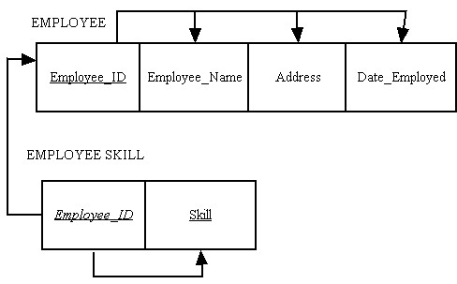

b.
Flight_No
Date
No_of_Passengers
FLIGHT

c.

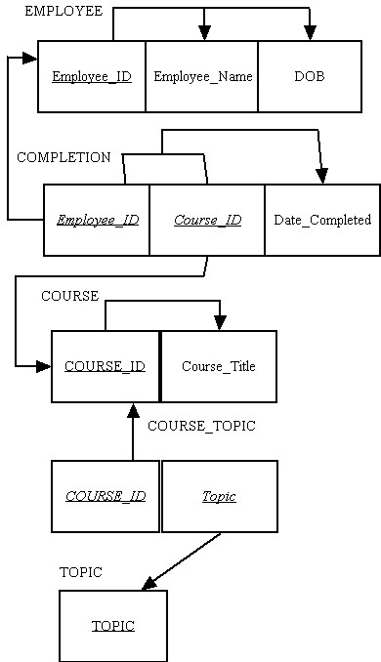

d.
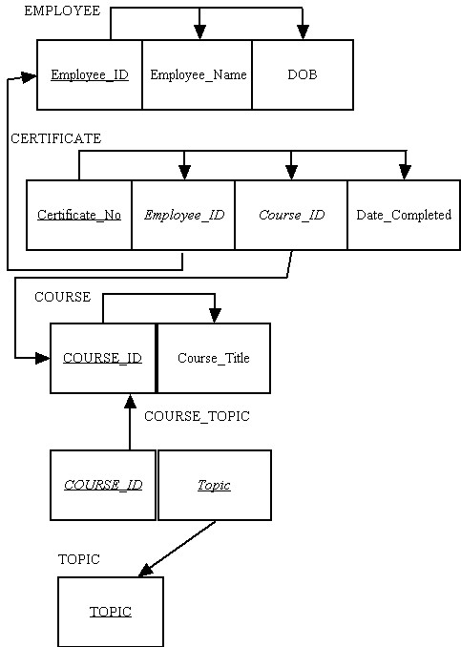
e.
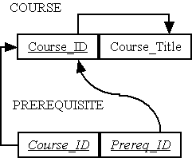

f.
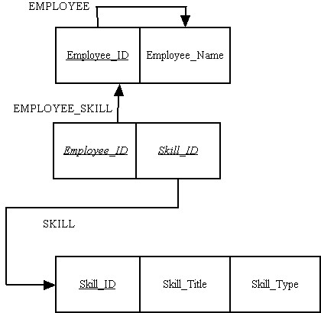.

g.
Movie_Name
MOVIE
Copy_No
Movie_Name
VIDEO TAPE

h.
Product_ID
PRODUCT
Product_ID
Effective_Date
Price

HISTORY

- Transforming EER diagrams to relations:
a.
VEHICLE
Vehicle_ID
Price
Make
Model
Engine_Displacement

CAR

C_Vehicle_ID
No_of_Passengers

TRUCK

T_Vehicle_ID
Cab_Type
Capacity

b.
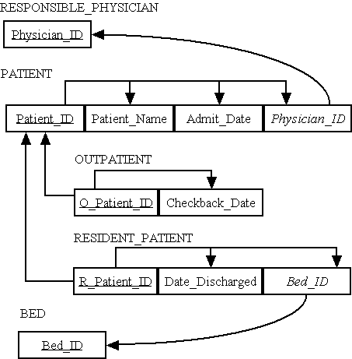

c.
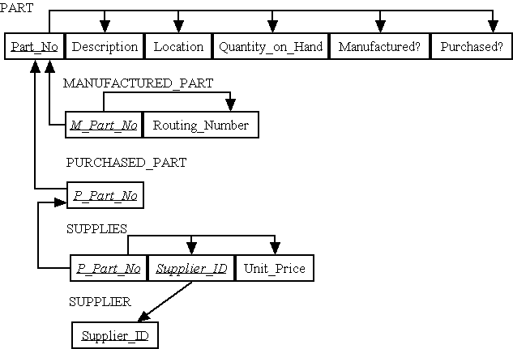

d.
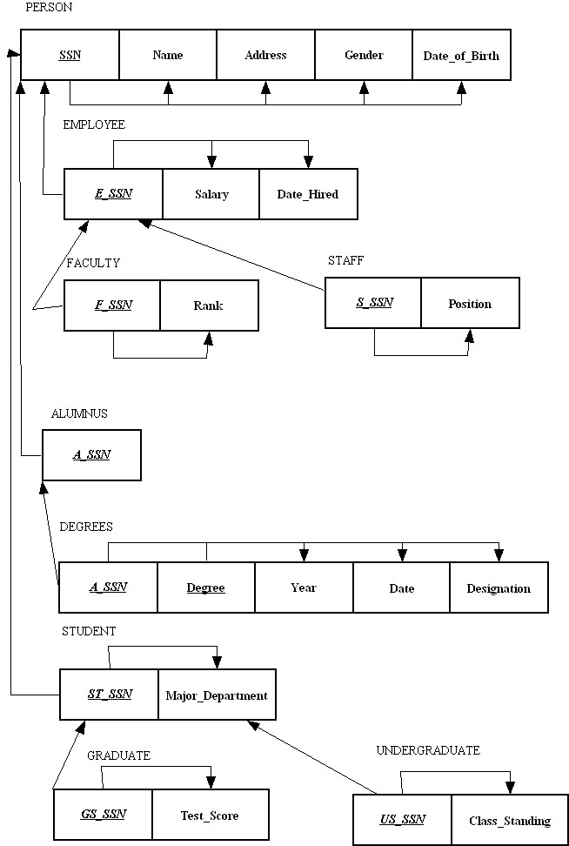

(Solution to exercise 2e is shown on the next page)
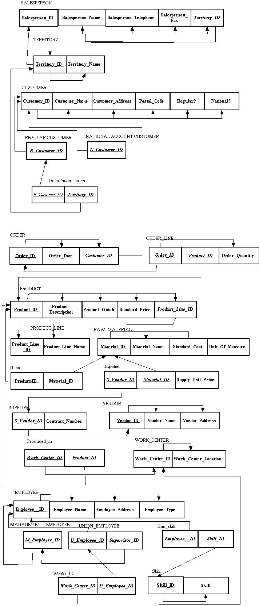
f.
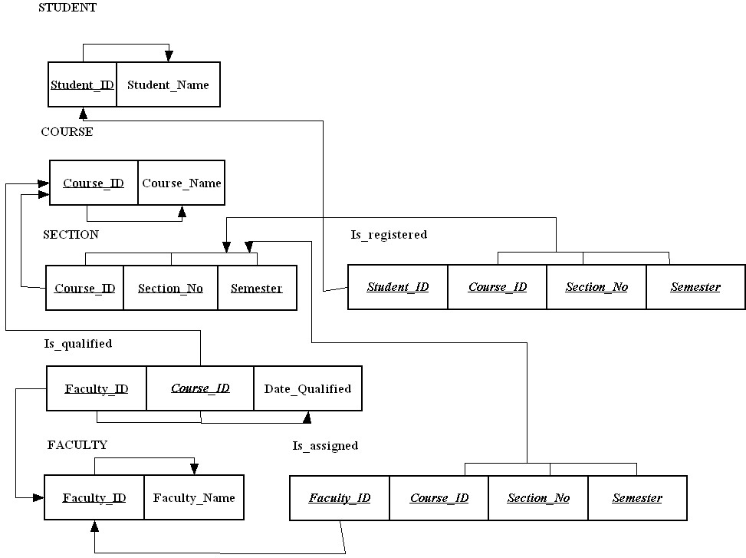

- The normal form for the relations are:
- 3NF
- 3NF
- 2NF

CLASS (Course_No, Section_No, Room)
ROOM (Room, Capacity)
- 1NF
COURSE (Course_No, Course_Name)
CLASS (Course_No, Section_No, Room)
ROOM (Room, Capacity)
- 3NF relations for Millennium College are:
OBJECT(OID,Object_Type)
INSTRUCTOR (OID, Instructor_Name, Instructor_Location)
COURSE (OID, Course_No, Course_Title, Instuctor_Name)
STUDENT (OID, Student_No, Student_Name, Major)

OUTCOME (OID, Student_No, Course_No, Grade)

- Transforming an E-R diagram to relations (parts a and b)

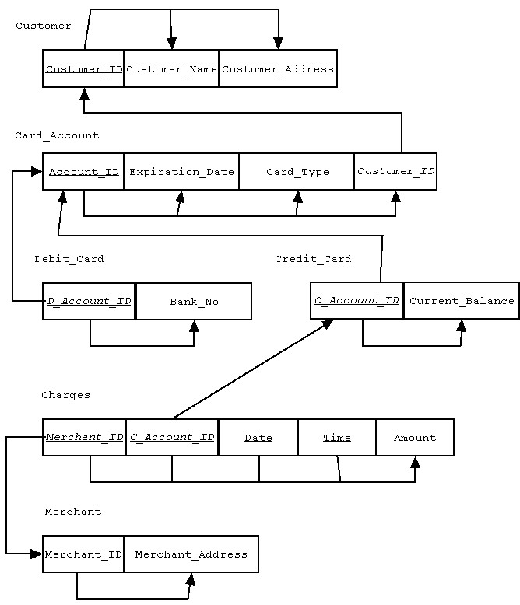

c. Using an enterprise key
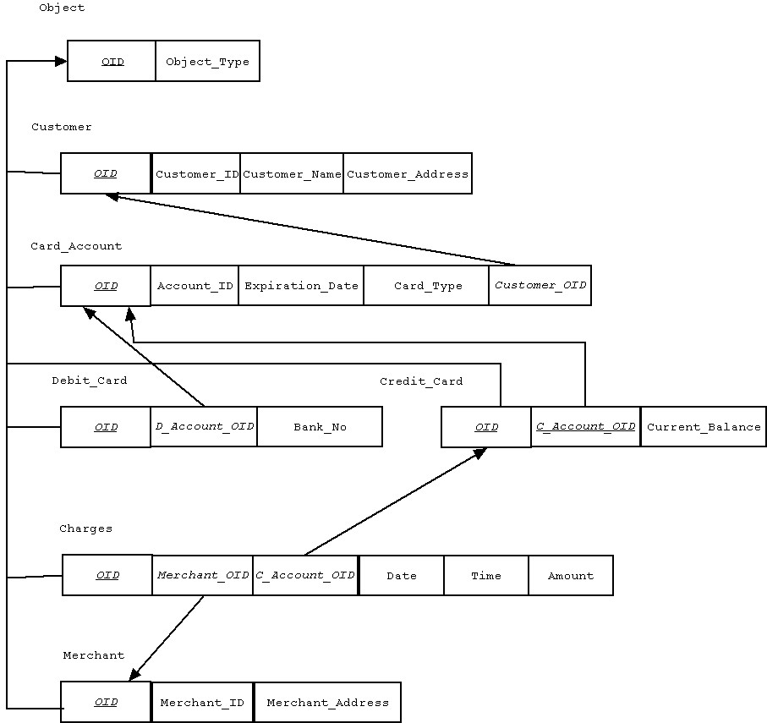

6. Transforming Table 5-2 to relations:
a. PART SUPPLIER

Part_No | Description | Vendor_Name | Address | Unit_Cost
1234 | Logic Chip | Fast Chips | Cupertino | 10.00
1234 | Logic Chip | Smart Chips | Phoenix | 8.00
5678 | Memory Chip | Fast Chips | Cupertino | 3.00
5678 | Memory Chip | Quality Chips | Austin | 2.00
5678 | Memory Chip | Smart Chips | Phoenix | 5.00

b.
Part_No
Vendor_Name
Part_No, Vendor_Name
Description
Address
Unit_Cost

c.
Insert anomaly: We cannot insert a new vendor unless we also include a part number that the supplier provides.
Delete anomaly: If we delete the last part information for a given supplier, we also lose information about that vendor.
Modification anomaly: If a vendor’s address changes, we have to modify all records (or rows) for that vendor.
d.

Part_Supplier
Part_No
Description
Vendor_Name
Address
Unit_Cost

e. 1NF

f. PART
Part_No
Description
Part_No
Vendor_Name
Unit_Cost
Vendor_Name
Address

PART SUPPLIER

VENDOR

g.

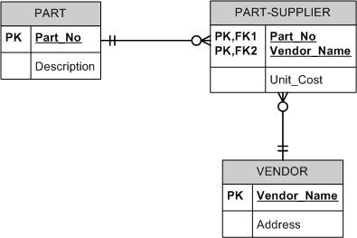

7. Transforming Table 5-3 to relations:
a.
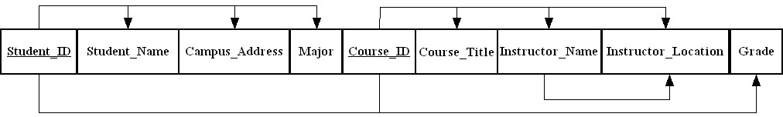

b. 1NF

c.

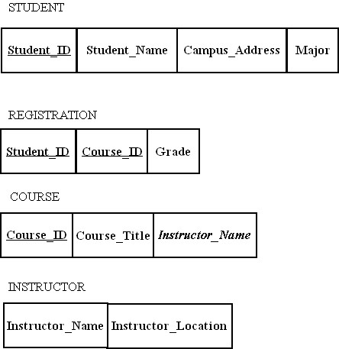

d.

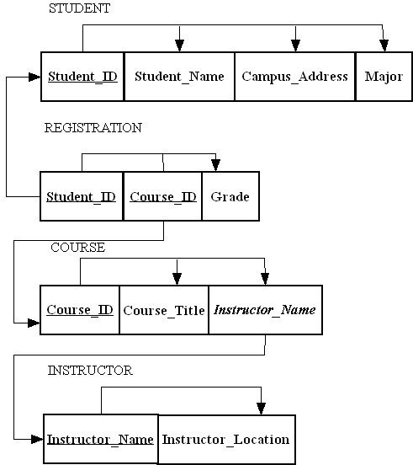.

e.

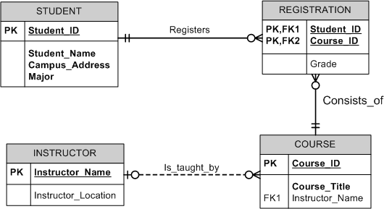

8.
a. Total weight is a derived attribute and can be calculated from weight and quantity. Therefore it is not shown here as part of the relational schema.

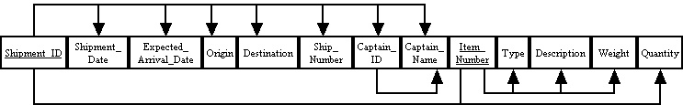

b. First normal form

c.

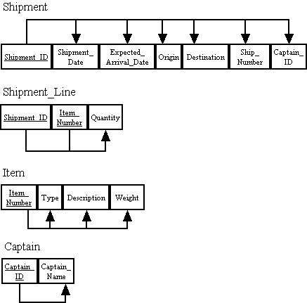

d.

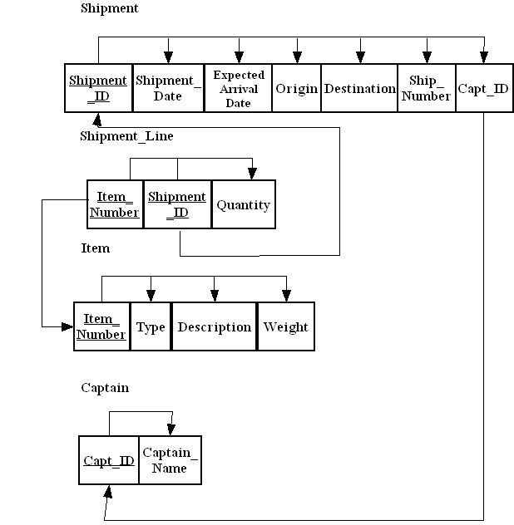

e.

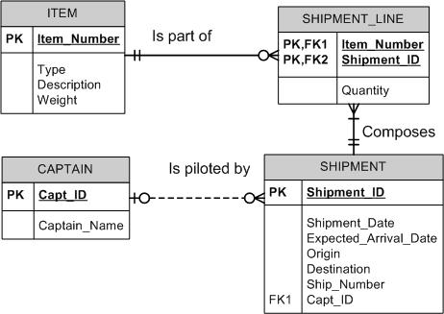

9.
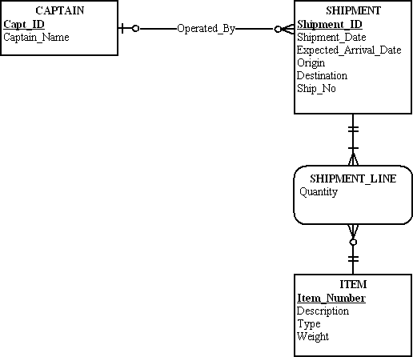

10.
Attribute version:

EMPLOYEE
Employee_ID
Employee_Name

SKILL
Employee_ID
Skill_Code
Skill_Title
Skill_Type

Relationship version:

EMPLOYEE
Employee_ID
Employee_Name

POSSESSES
Employee_ID
Skill_Code

SKILL
Skill_Code
Skill_Title
Skill_Type

The attribute version of the 3NF relations is similar to Figure 5-10. However, we have a much clearer definition of a primary key in this version. One main advantage of the relationship version is that we do not have to store Skill_Title and Skill_Type many times. If a skill title was changed or types were reclassified, this would make things much easier since update anomalies are eliminated.

11.

a. Parking ticket table

St_ID | L_Name | F_Name | Phone_No | St_  Lic | Lic_No | Ticket# | Date | Code | Fine
38249 | Brown | Thomas | 111-7804 | FL | BRY 123 | 15634 | 10/17/08 | 2 | $25
38249 | Brown | Thomas | 111-7804 | FL | BRY 123 | 16017 | 11/13/08 | 1 | $15
82453 | Green | Sally | 391-1689 | AL | TRE 141 | 14987 | 10/05/08 | 3 | $100
82453 | Green | Sally | 391-1689 | AL | TRE 141 | 16293 | 11/18/08 | 1 | $15
82453 | Green | Sally | 391-1689 | AL | TRE-141 | 17892 | 12/13/08 | 2 | $25

The determinants are: ST_ID, Ticket#, Code.

b.
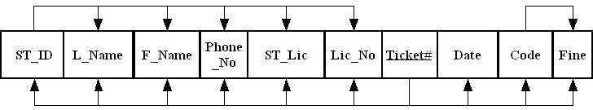

c.
An insertion anomaly occurs when you try to insert a student who has never had a parking ticket.
A deletion anomaly would occur if you were to delete a record of any student with only one parking ticket since all student information will be lost.
A modification anomaly would occur whenever you want to update the Phone_No (or name, State License, or License Number) data of a student.

d.
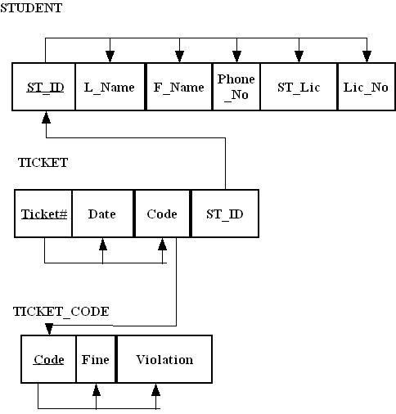
e.
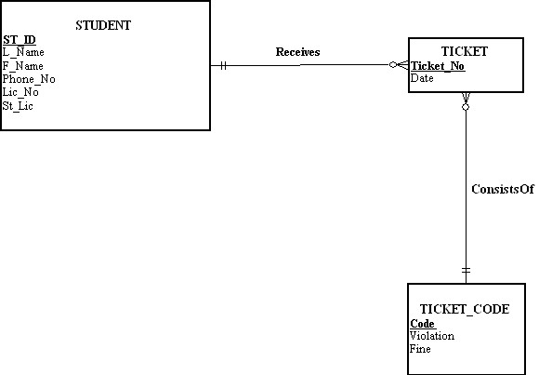

f.
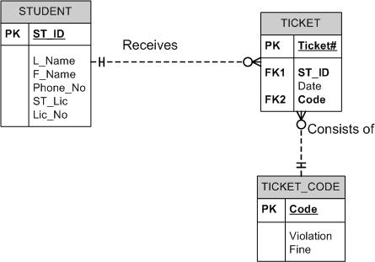

12.
a.
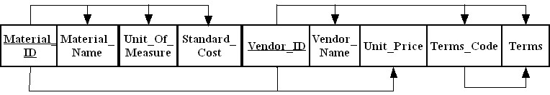

b.
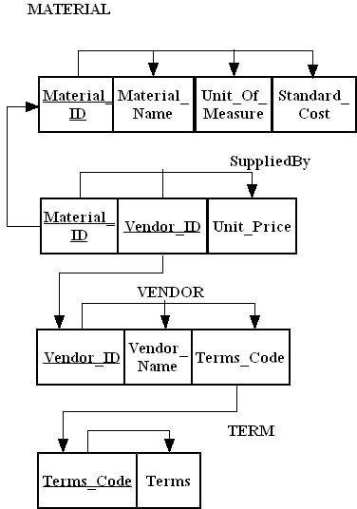

c.

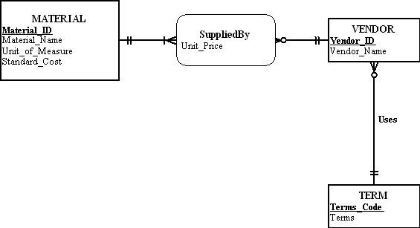

d.

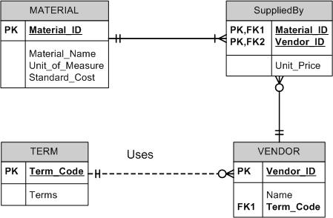

13.
a.
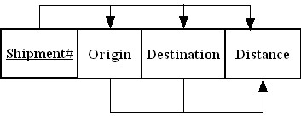

b. Second normal form. There is a transitive dependency between origin/destination and distance.
[Note to instructor: An interesting discussion point for you to make the students aware of is the issue of symmetry in this problem. By symmetry, we mean: is the distance from A to B the same as from B to A? If it is, then there is an interesting issue about whether the Distances table potentially has redundancy. You may wish to consider assigning an advanced exercise to remove the potential redundancy from the relations under these circumstances.]
c.

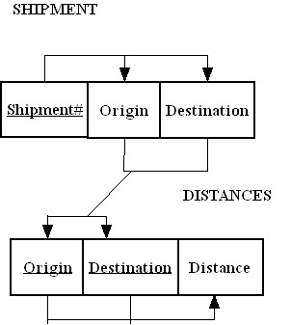
Shipment
Shipment# | Origin | Destination
409 | Seattle | Denver
618 | Chicago | Dallas
723 | Boston | Atlanta
824 | Denver | Los Angeles
629 | Seattle | Denver

Distances
Origin | Destination | Distance
Seattle | Denver | 1537
Chicago | Dallas | 1058
Boston | Atlanta | 1214
Denver | Los Angeles | 975

d.
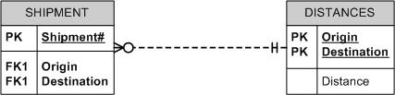

14.
a.
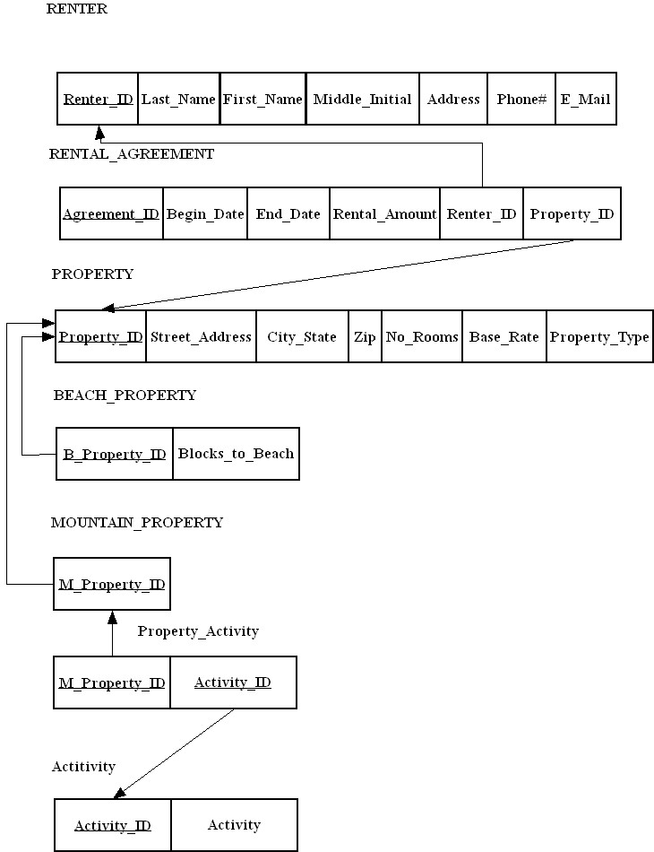

b.
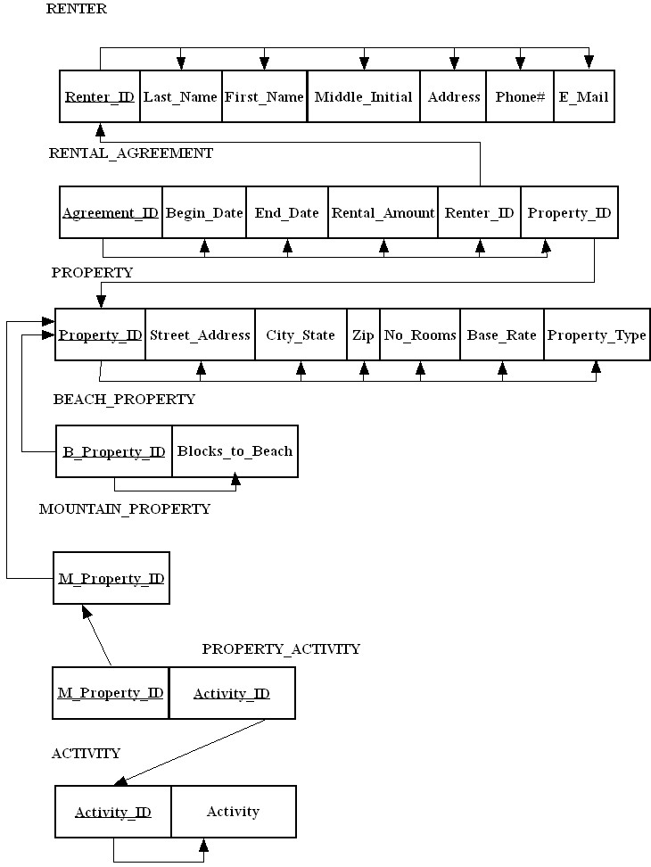

c. All relations are in third normal form.

d. An action assertion could be used such as:
A property shall have one and only one rental agreement in force at one time, where “in force” means that a given date falls between Begin_Date and End_Date.

15. Note: for this situation, we assume that Client information is stored even if there is not a corresponding instance of Retention with an Attorney and a Case. We also assume that Attorney information is stored even if there is not a corresponding instance of Retention with a Client and a Case.

All relations are in 3NF since there are no partial functional dependencies or transitive dependencies. It could be argued that zip code is determined by city and state (also by address with 9-digit zip codes). This could be a good point to discuss in class.

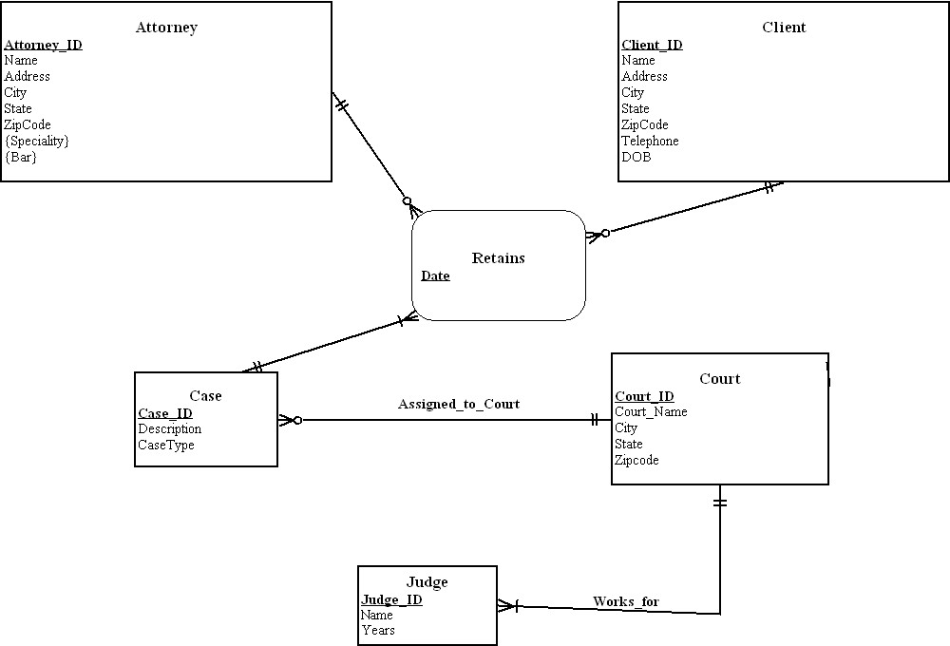

16.
Notes to instructor:
- Purchase date information refers to a Customer’s purchase of a pet from the store.
- Delivery date information refers to a Store’s receipt of a shipment of a pet from the pet’s supplier.
- Date of Last Purchase can be determined by viewing the data stored in the delivery date fields.
- Last_Customer_Name can be determined by viewing the data stored in the Customer_Name fields.
- The problem states that “Peter Corona wants to implement a Web-enabled database application” for use by his branch stores for entering inventory, ordering, and sales data. This is a good opportunity to discuss with students the issues involved in converting a legacy, flat-file “system” that mixes together inventory, customer purchases, and store purchases into a relational design that will support a web application and future growth. Stress the importance of re-designing the data structure to support the tracking of all customer purchases and store deliveries, rather than just the four presented in the flat-file. You might also note that there appears to be some data missing from the “old” system that would be useful in managing inventory and sales data at the stores (e.g., quantity sold, quantity purchased, quantity received, etc.).

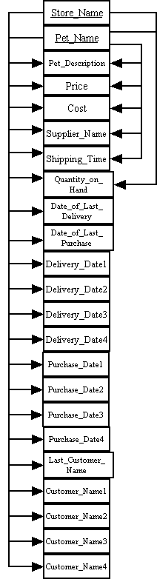
Solution to 16a
b. This structure is not a relation nor is it in any normal form due to the presence of Delivery_Date1-4, Purchase_Date1-4, and Customer_Name1-4 attributes. These attributes appear to suggest that they are repeating groups. In order to show a relation in 1NF, repeating groups must be removed. Peter might change his structure to the following 1NF solution, which will result in having more data instances in his structure to store the same data that is currently being stored in his flat-file “system”. The attributes of Last_Customer_Name, Date_Last_Purchase, and Date_Last_Delivery are not stored as part of the proposed 1NF solution as this data can be determined by viewing the stored data in the revised relation below.

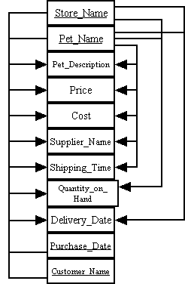

c.
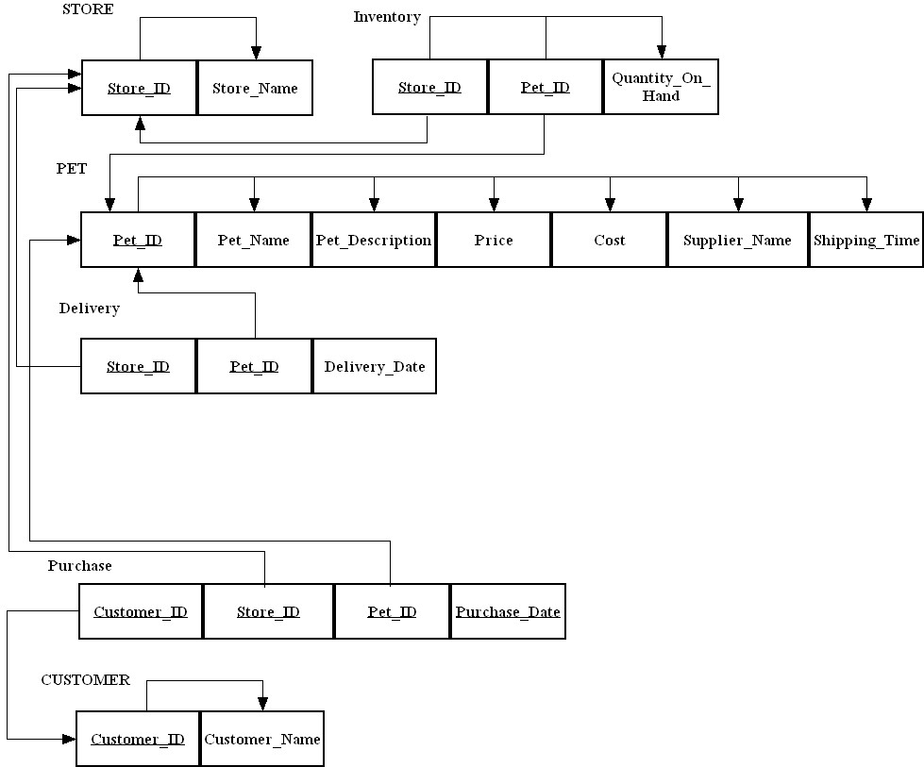

17.
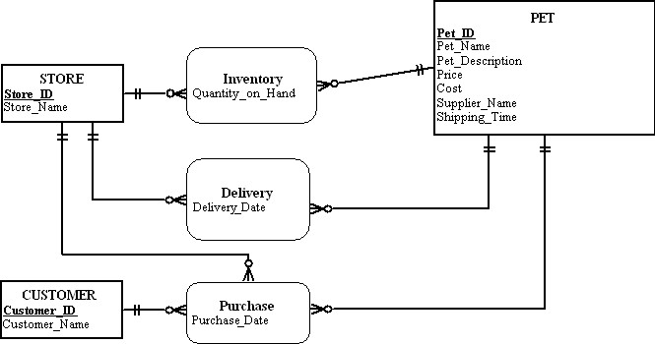

18.
Revised normalized data model:
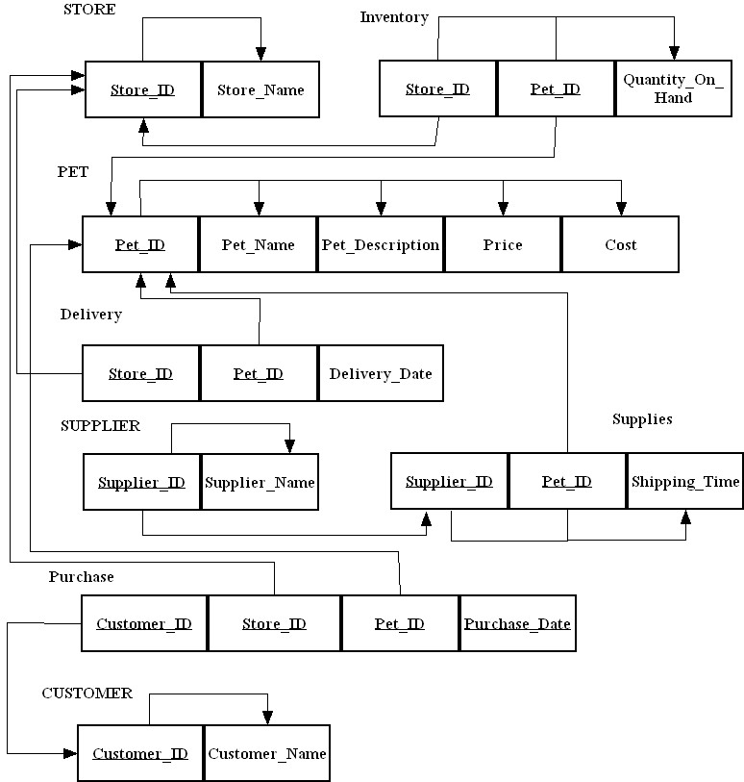

Revised E-R Diagram:
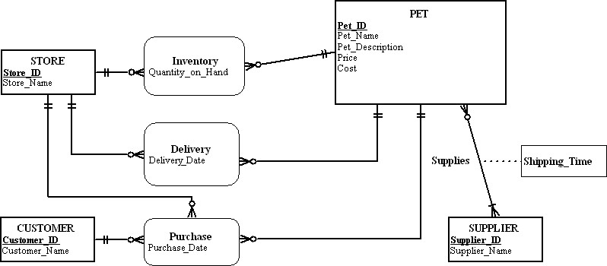

19.
a.

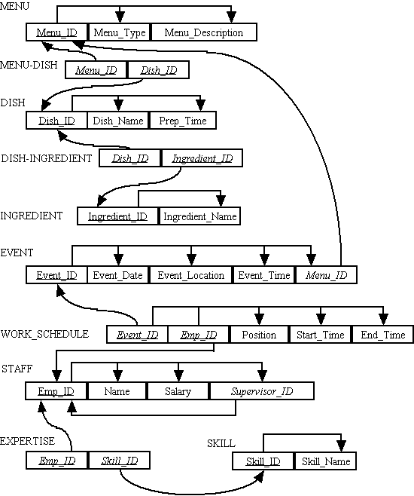

. 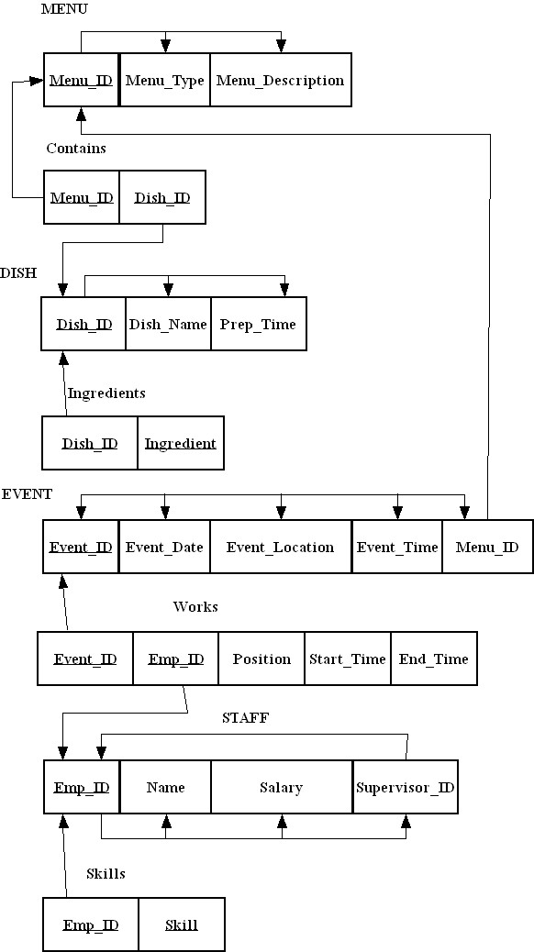
Solution to 19b

c. All relations are in 3NF.

20.
a. Chapter 3, Problems & Exercise 5b Relations

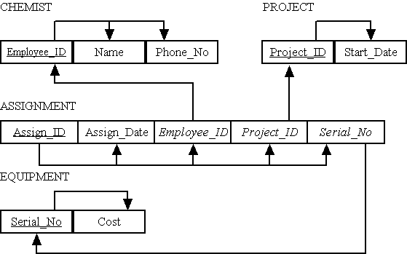

b. Chapter 3, Problems & Exercise 5g Relations

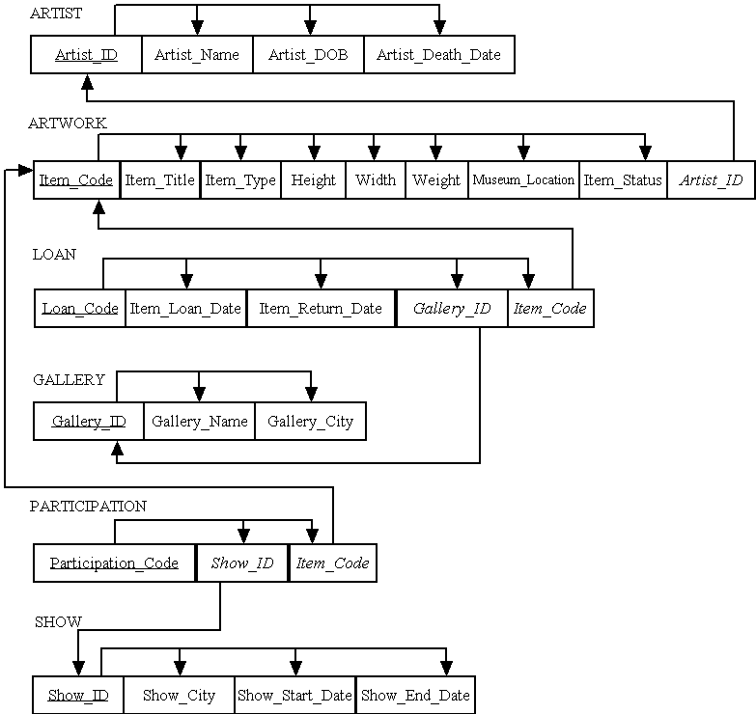

c. Chapter 3, Problems & Exercise 5h Relations

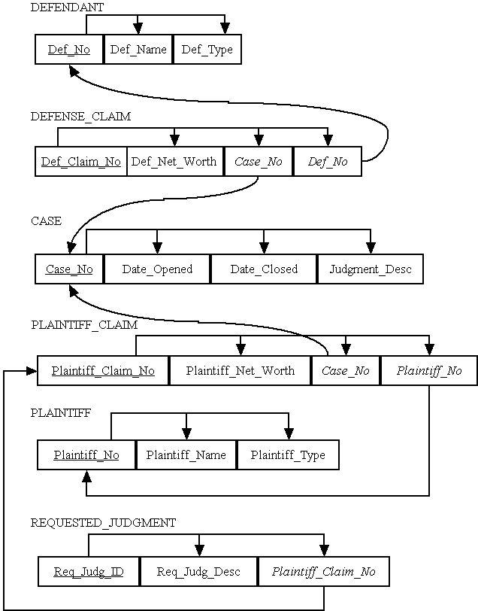

d. Chapter 3, Problems & Exercise 5i Relations

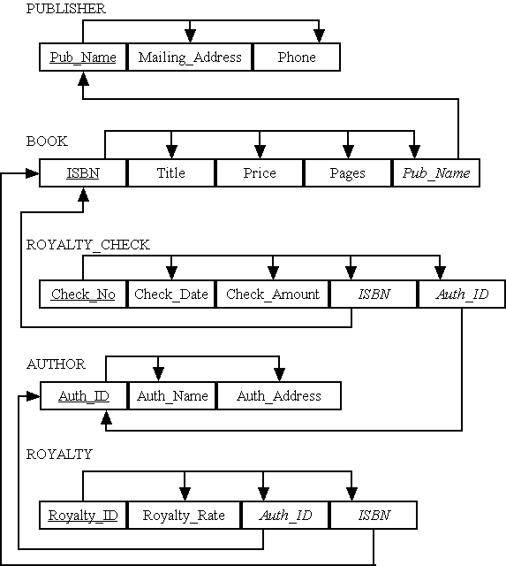

e. Chapter 3, Problems & Exercise 14 Relations

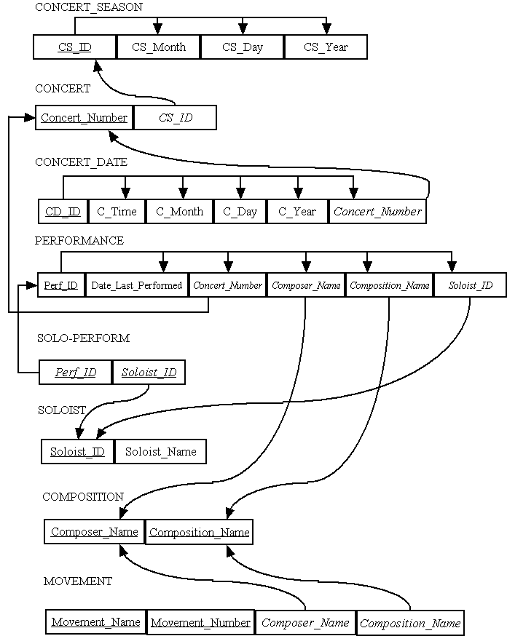

f. Chapter 3, Problems & Exercise 17 Relations

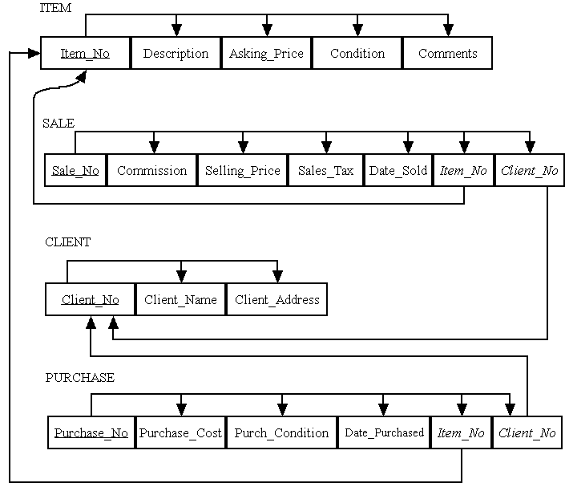

g. Chapter 4, Problems & Exercise 17 Relations

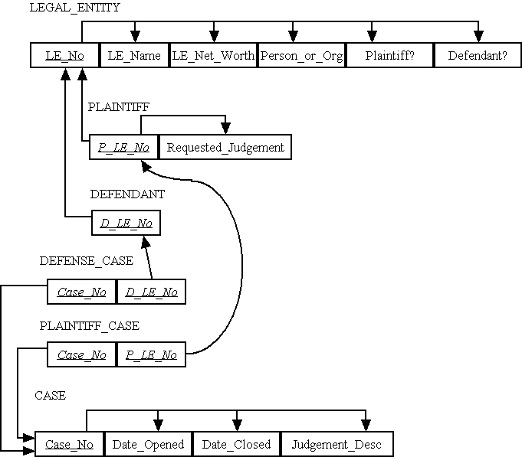

h. Chapter 4, Problems & Exercise 18 Relations

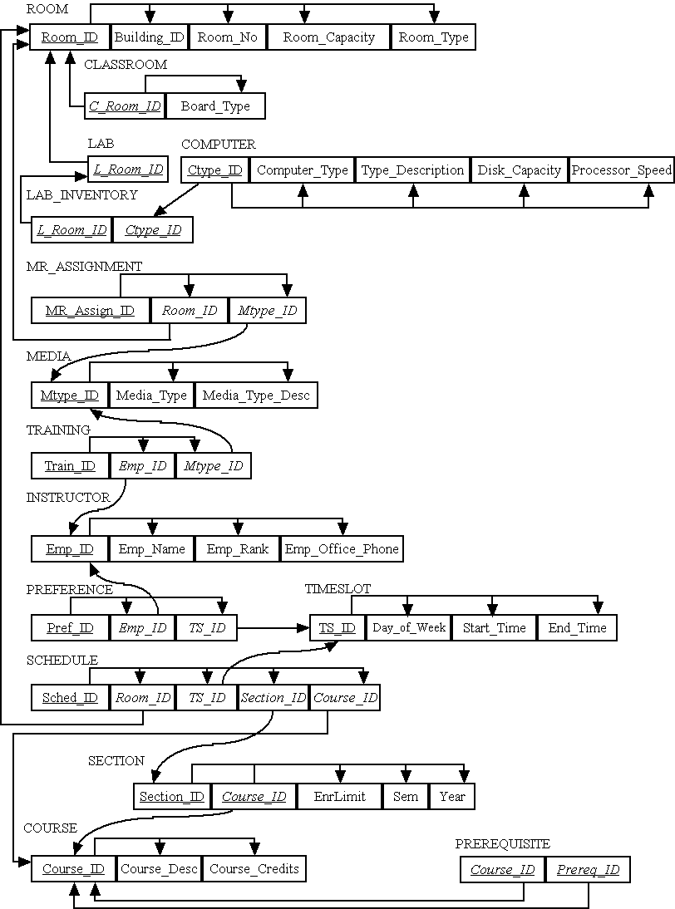

i. Chapter 4, Problems & Exercise 24 Relations

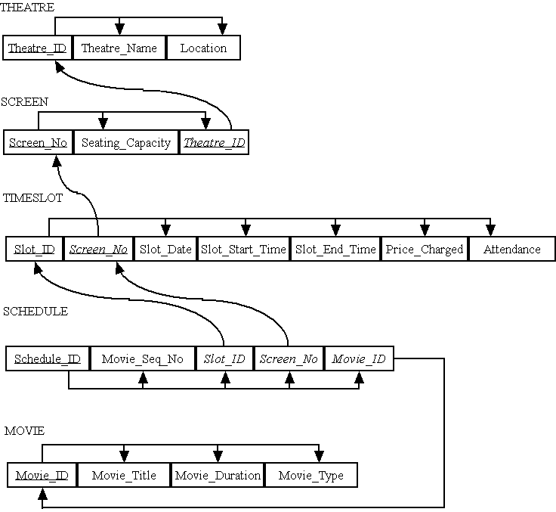

Suggestions for Field Exercises

- For this exercise, we suggest you interview at least two organizations: a manufacturing company and a service sector organization. (You may choose to combine this exercise with Field Exercise 2 in Chapter 4). First, determine what methodology, if any, each uses for conceptual design: E-R diagrams, object diagrams, etc. Then determine how these models are transformed into logical data models (relational schema, object-oriented designs, etc.). To what extent are these activities automated through the use of CASE tools? If the target data model is relational, determine the role of normalization: who is responsible for normalization, to what level is it performed, and how are users involved (if at all) in these activities?

- We suggest you first perform this as an in-class exercise with student participation in the process. Bring a copy of your own document to class, and ask the students to volunteer a document as well. This provides students with valuable “hands-on” experience in the bottom-up design process.

- (You may choose to combine this exercise with Exercise 1 above). Student answers will vary depending on the organizations and the person who is the subject of the interview. We suggest that you use the student interview notes as a means of stimulating class discussion regarding the amount of variation in practice regarding the extent of normalization activities.

- This exercise is really a continuation of Exercise 2 above, now possibly applied to a more complex document. Use a report or other document that has detail lines and requires the use of normalization skills.

Project Case

Case Questions

- Mountain View Community Hospital will continue to use relational technology for several reasons:
- The present IS staff is trained and experienced in using this technology.
- The present relational systems are stable and support existing operations quite well.
- Conversion to newer technology would be costly and would entail a number of risks.

- Yes, Mountain View Community Hospital should use normalization in designing its relational database. Normalization helps avoid anomalies that impair data quality. Normalization shows data in its most simple, atomic form, but does not constrain physical database design. (See Chapter 6.)

- Entity integrity helps assure that two real-world entities (such as patient or tests) are not confused. Also, it makes sure that no two instances of the same type of entity are confused. Certainly, primary keys are not null. Foreign keys which point to optional members in a relationship may be null. Often, when master data (strong entities) are entered, not all data are known, so many attributes may be null (e.g. Patient Home Address). For transactional data, often associative entities, most attributes of the transaction will be known (e.g., the date a test was done).

- Referential integrity helps assure that one real-world entity (such as a test result) is not lost or disassociated from its owner entity (such as patient).

- The attribute chosen to be a relation’s primary key must be unique, unlikely to change over time, and should not be an intelligent key. Although Social Security number, physician license number, DEA registration number, and a hospital assigned Physician_ID will all meet the uniqueness criterion of a primary key, there are other issues that should be reviewed. One scenario to consider is that of whether a physician’s license number or DEA registration number could possibly change over time – for instance, what happens if a license or DEA registration number is suspended or revoked? Are those numbers re-used by these external-to-the-hospital organizations that issued these numbers to physicians? Another issue to consider is that of physician privacy rights and possible identity theft – each of the non-hospital assigned attributes (Social Security number, license number, DEA registration number) is sensitive information about the physician that could potentially be abused if stolen or not kept securely within the hospital records. Given these concerns, it would seem a better course of action to use the hospital-assigned Physician_ID as the primary key of the Physician relation.

- An enterprise key will enable MVCH to have a primary key that does not have business meaning. This could be important since identifying information for a particular entity (such as Physician) could change easily in the medical environment. Also, if MVCH expands by merger, other acquired hospitals may have their own keys, and an enterprise key would make it easier to consolidate the data.

- Often times, we may need to revise the EER model based upon normalization. Normalization suggests missing data elements from the original EER models. Also, because of the passing of time from one phase to the next, new requirements may emerge which need to be added to all data models.

Case Exercises
1. In this answer, we skip from an unnormalized relation to the answer in part b.
a.
i. Patient Bill
1) Initial:
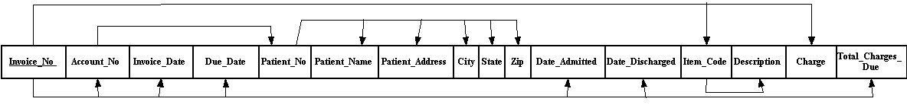

2) After normalization:
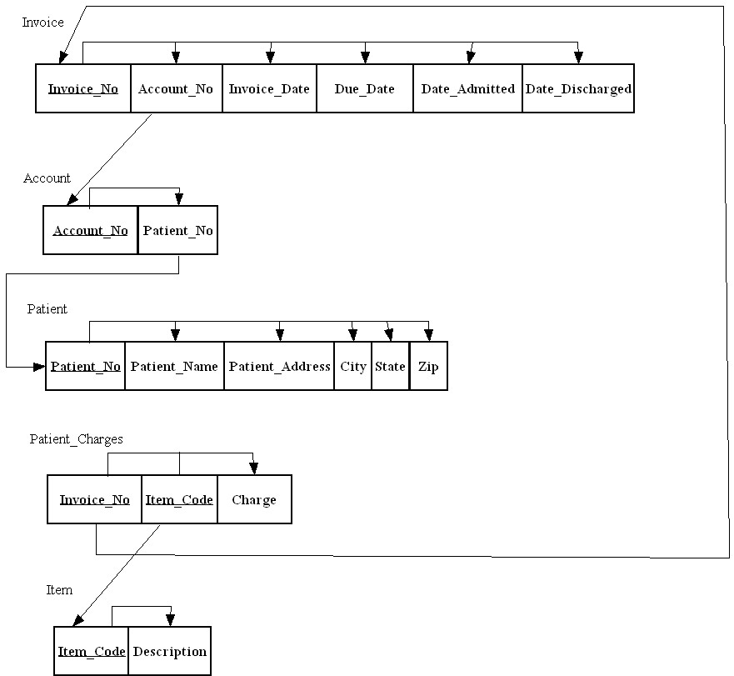

ii. Room Utilization Report

1) Initial
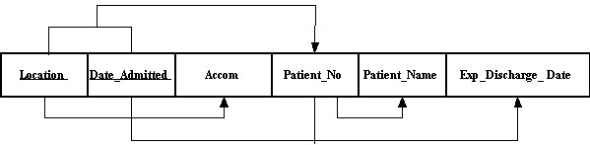

2) After normalization
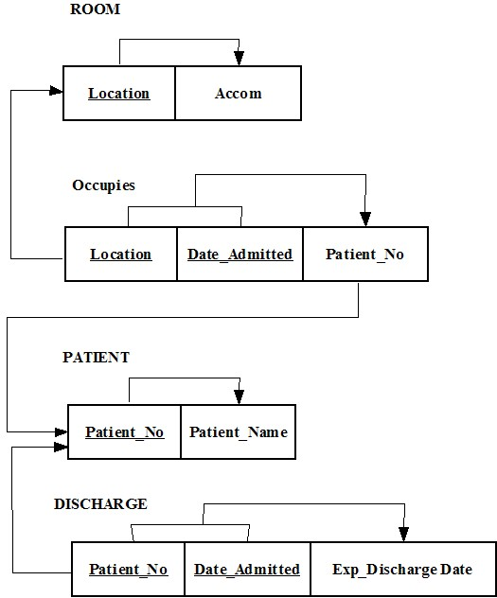

iii. Patient Display
- Initial
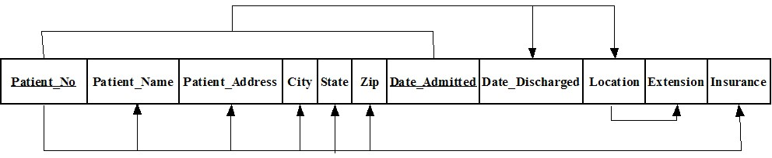
- After normalization
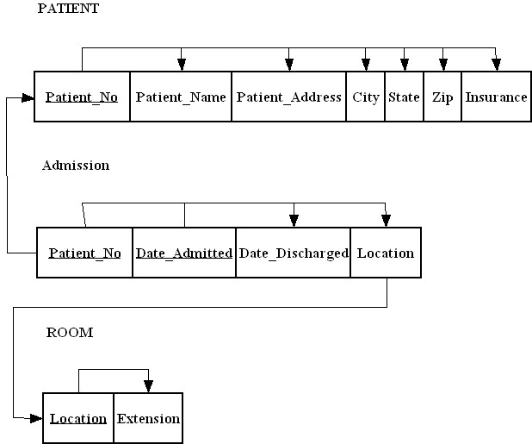

iv. Physician Report
- Initial
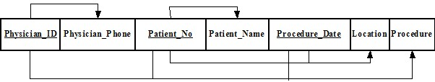
- After normalization:

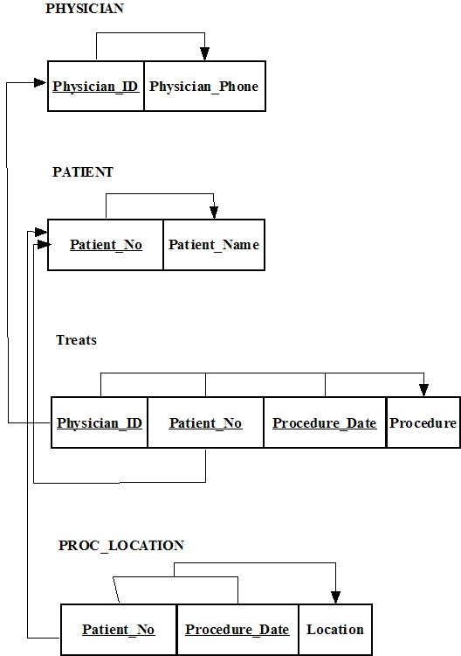

c. Merged relations:

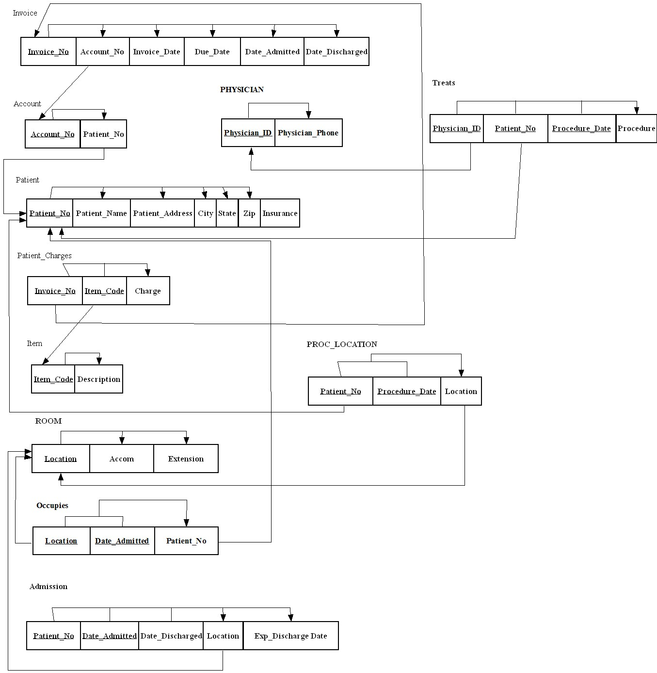

d. One suggestion:
Include a surrogate primary key for the Treats relation.

e. You could add a time column to the Treats relation. Alternately, you could assign a surrogate primary key to Treats that would be different for each treatment.

2.
a. I would suggest a composite primary key made up of Patient#, Visit_Date and Visit_Time. This would take into consideration two visits on the same day.

b. This table is not a relation since it is not even in 1NF due to repeating groups.

c. There is a deletion anomaly since Social_Worker is not stored in another relation. For example, if we delete all records for patient # 4211, any reference to social worker Lynn Riley is gone.

There is an update anomaly since a name change of the patient would need to be replicated across many relations.

There is an insert anomaly since a patient cannot be added before visiting the MS Center.

d.
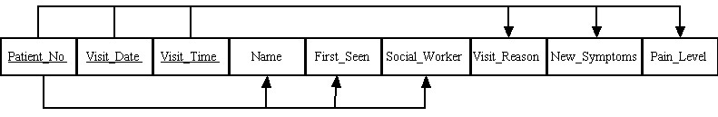

This assumes that the social worker always stays the same for the patient. If this were not the case, then the figure below would represent the functional dependencies:

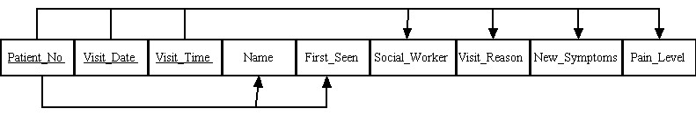

e.
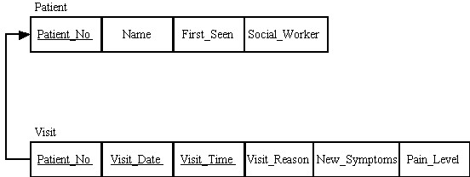

If we consider that a social worker could be different for each visit, the 3NF relations would be as follows:

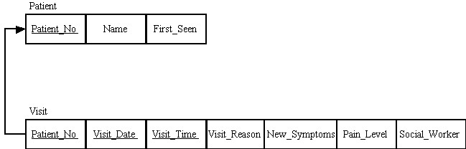

f.
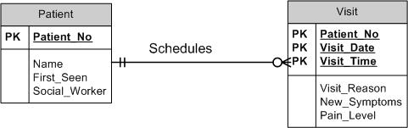
g.

create table patient
(patient_no varchar2(5) primary key,
name varchar2(35),
first_seen date,
social_worker varchar2(35));

create table visit
(patient_no varchar2(5) references patient(patient_no),
visit_date date,
visit_time varchar2(5),
visit_reason varchar2(40),
new_symptoms varchar2(50),
pain_level integer,
constraint visit_pk primary key (patient_no,visit_date,visit_time);

3.
a.
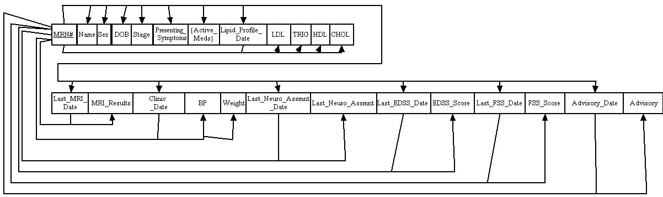

b.

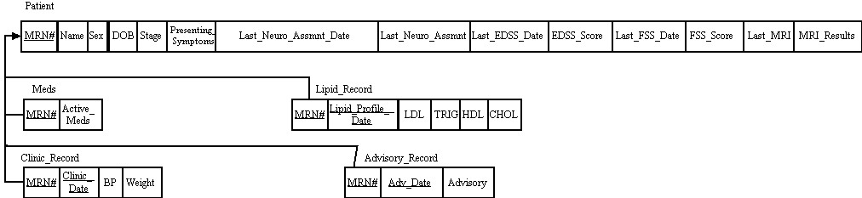

c.

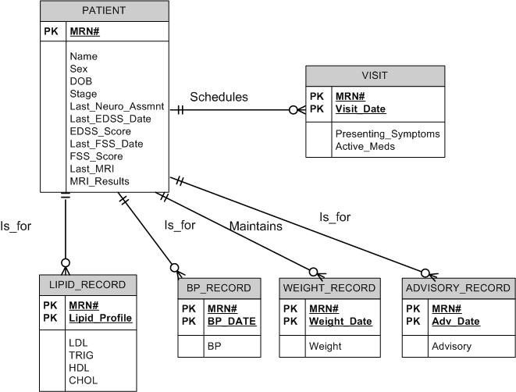

Project Assignments

Notes to instructor:
The Chapter 4 EER is very complex to support the richly described Case situation. When the EER is mapped to a relational schema, there are over 40 relations that are created. Because of the degree of detail (and multiple pages) needed to show all of these relations, we have taken the following steps in preparing the solution to the Project Assignments in Chapter 5:

- For Project assignment 1, we have listed all the relations in shorthand form. We display primary keys with an underlined name (though attribute names with an underscore character are not easy to see in this case, for example Emp_ID) and foreign keys in Italics. Attributes that are both primary keys and foreign keys (e.g., a subtype’s primary key, or a weak entity’s primary key) are shown with both italics and underline.

- For all Project assignments, we developed surrogate keys for the relations necessary to support the multivalued attributes and repeating groups shown in the EER.

- For Project assignment 2, we show only the referential integrity dependency arrows in the solution. Additionally, we show the relations in shorthand form rather than use the traditional dependency diagram “boxes” in order to save space in the solution. The same notation for PK and FK as in Project assignment 1 is used in Project assignment 2.

- For Project assignment 3, we show only the referential integrity dependency arrows for the foreign keys relation-specific Object_IDs back to the primary key relation-specific Object_IDs (e.g., VOID in VOL_MVCH_SERVICE is a FK back to the PK of VOID in VOLUNTEER). It should be noted that the primary key relation-specific Object_IDs are also serving a foreign key role for referential integrity with the Object_ID in the OBJECT relation (e.g., VOID in VOLUNTEER is FK back to PK of OID in OBJECT).

P1. All relations mapped from Chapter 4 EERD.

[Note to Instructor: In this section of the solution, the primary key (PK) of each relation is underlined, though this tends to overlay the “_” character in each PK’s attribute name. Foreign Keys are shown in Italics, rather than with a double underline. PKs that are both a primary key and a foreign key are noted in Italics with an underline. Relation names are shown in Bold.]

PERSON (Person_ID, Person_Name, Person_Str_Address, Person_City, Person_State, Person_Zip, Person_Home_Phone, Person_Work_Phone, Person_DOB, Person_Email, Is_Physician, Is_Employee, Is_Volunteer, Is_Patient)
VOLUNTEER (Vol_ID, Had_Felony, Felony_Explanation, VEC_Last_Name, VEC_First_Name, VEC_Relationship, VEC_Address, VEC_Phone, V_Employer, V_Employer_Addr, V_Employ_Position, V_Employ_Start_Date, V_Employ_End_Date, Had_MVCH_Service, Had_Vol_Exp, Why_Volunteer)
VOL_MVCH_SERVICE (VMS_ID, MVCH_Service_Info, Vol_ID)
VOL_REF_INFO (VRI_ID, VRI_Last_Name, VRI_First_Name, VRI_Relationship, VRI_Phone, VRI_Address, VRI_City, VRI_State, VRI_Zip, Vol_ID)
VOL_EXPERIENCE (VE_ID, Volunteer_Exp_Info, Vol_ID)
VOL_LANGUAGE (VL_ID, Language, Vol_ID)
VOL_SKILL (VS_ID, Skill, Vol_ID)
VOL_INTEREST (VI_ID, Interest, Vol_ID)
VOL_AVAILABILITY (VA_ID, Day_of_Week, Portion_of_Day, Vol_ID)
VOL_SERV_HISTORY (VSH_ID, Service_Begin_Date, Service_End_Date, Service_Hrs_Worked, Unit_Name, Vol_ID, Physician_ID, Emp_ID)
PHYSICIAN (Physician_ID, DEA_No, Pager_No, Specialty)
PHYSICIAN_DX (PD_ID, Diagnosis_Date, Diagnosis_Time, Physician_ID, Patient_ID, Diagnosis_Code)
DIAGNOSIS (Diagnosis_Code, Diagnosis_Name)
PATIENT (Patient_ID, Contact_Date, EC_Last_Name, EC_First_Name, EC_Relationship, EC_Address, EC_Phone, Company_Name, Policy_No, Group_No, Company_Phone, Sub_Last_Name, Sub_First_Name, Sub_Relationship, Sub_Address, Sub_Phone, Is_Outpatient, Is_Inpatient, Admit_Phys, Refer_Phys)
RESIDENT (R_Patient_ID, Date_Admitted, Date_Discharged, Bed_No, Room_No)
OUTPATIENT (O_Patient_ID)
VISIT (Visit_No, Visit_Date, Visit_Time, Visit_Reason, O_Patient_ID)
BED (Room_No, Bed_No)
ROOM (Room_No, CC_Unit_Name)
CC_ASSIGNMENT (CCA_ID, Assign_Start, Assign_End, Hrs_Worked, CC_Unit_Name, Nurse_ID)
CARE_CENTER (CC_Unit_Name, Day_in_Charge, Night_in_Charge)
RN (RN_ID)
LPN (LPN_ID, Supervisor)
NURSE (Nurse_ID, Cert_Degree, State_License_No, Nurse_Specialty, Nurse_Type)
FIELD_CERTIFICATION (FC_ID, FC_Description, Nurse_ID)
EMPLOYEE (Emp_ID, Date_Hired, Emp_Type)
STAFF (Staff_ID, Job_Class, Unit_Name)
TECHNICIAN (Technician_ID, Unit_Name)
TECHNICIAN_SKILL (TS_ID, Technician_ID, TS_Skill)
WORK_UNIT (Unit_Name, Facility_ID, Floor, Unit_Type)
FACILITY (Facility_ID, Facility_Name)
DIAGNOSTIC_UNIT (DX_Unit_Name)
TREATMENT (Trt_Code, Trt_Name, DX_Unit_Name)
TREATMENT_ORDER (TO_ID, Trt_Date, Trt_Time, Results, Trt_Code, Order_ID,)
ORDER (Order_ID, Order_Date, Order_Time, Patient_ID, Physician_ID, Item_No)
ITEM (Item_No, Item_Desc, Item_Unit_Cost)
INVENTORY (Inv_ID, Item_No, Vendor_ID)
VENDOR (Vendor_ID, Vendor_Name)
ITEM_BILLING (IB_ID, Start_Date, End_Date, Cost, Item_No, Room_No, Patient_ID)
ITEM_CONSUMPTION (IC_ID, Consume_Date, Consume_Time, Consume_Qty, Item_No, Patient_ID)
ASSESSMENT (Assessment_ID, Assessment_Date, Assessment_Time, Comments, Patient_Weight, Patient_BP, Patient_pulse, Patient_temperature, Patient_ID, Nurse_ID)
SCHEDULE (Schedule_ID, Sched_Begin, Sched_End, Facility_ID, Physician_ID)

P2. Referential integrity functional dependency arrows for all relations – shown in 3 pages. Primary keys are underlined; foreign keys are in italics; attributes that are both primary and foreign keys are underlined and italicized.

Part 1: Person, Volunteer, associated Volunteer relations, and Employee
Part 2: Person (repeated), Physician, Patient, associated relations for Physician & Patient, Care_Center, Room, Bed, Nurse, Employee (repeated)
Part 3: Facility, Work_Unit, Treatment, Order, Item, Vendor and remaining relations

P3. Relations shown after adding an enterprise key to all relations – shown in 3 pages as in P2. Note that Primary Keys (PKs) in all relations serve a double purpose as a foreign key back to the OID primary key in the OBJECT relation. Primary keys are underlined; foreign keys are in italics; attributes that are both primary and foreign keys are underlined and italicized.

Part 1: Person, Volunteer, associated Volunteer relations, and Employee
Part 2: Person (repeated), Physician, Patient, associated relations for Physician & Patient, Care_Center, Room, Bed, Nurse, Employee (repeated)
Part 3: Facility, Work_Unit, Treatment, Order, Item, Vendor and remaining relations

P4. The affected sections of the EERD are shown over two pages for this solution. The first page shows the additional entities and any changes to entities, along with the relationships that arise out of resolving multivalued attributes and repeating groups shown in the chapter 4 EERD. The second page shows the entities and their respective attributes.
