Chapter 15 Object-Oriented Data Modeling

Chapter Overview

Please note that the material for this chapter is based upon the Web version of Chapter 15, not the abbreviated version of Chapter 15 in the text.

The purpose of this chapter is to introduce object-oriented modeling concepts. This chapter presents the UML notation and defines the key terms associated with object-oriented modeling. Most of the concepts learned in Chapters 3 and 4 correspond to concepts in object-oriented modeling, but as this chapter presents, the object-oriented modeling approach builds upon and extends the EER model.

Chapter Objectives

Specific student learning objectives are included in the beginning of the chapter. From an instructor’s point of view, the objectives of this chapter are to:

- Explore the similarities between the major steps in database development and relevant elements in the object-oriented development process.
- Present the object-oriented model technique using the UML notation to model real-world situations.
- Emphasize the importance of building a model and thinking in abstract terms rather than worrying about implementation details in the analysis phase. Focus on describing what the intended system must do, rather than how it will be done.
- Introduce the terminology associated with object-oriented modeling and recognize when to use generalization, aggregation, and composition relationships to more accurately represent real-world systems.

Key Terms

Abstract class | Class-scope attribute | Object
Abstract operation | Class-scope operation | Object diagram
Aggregation | Composition | Operation
Association | Concrete class | Overriding
Association class | Constructor operation | Polymorphism
Association role | Encapsulation | Query operation
Behavior | Method | State
Class | Multiple classification | Update operation
Class diagram | Multiplicity

Classroom Ideas

- Review the major steps in the object-oriented development life cycle (Figure 15-1).
- Use the sample object-oriented diagram shown in Figure 15-2 to “jump-start” your students’ understanding.
- Use Figure 15-18 to demonstrate how complex business systems can be represented using the object-oriented notation.
- Present the object-oriented concept of encapsulation.
- Discuss the use of generalization and its role in simplifying complex systems. Reference Figure 15-9. Also discuss how this object-oriented feature should facilitate easier maintenance of the system.
- Discuss the use of overriding and the difference between overriding for extension versus restriction.
- Discuss the use of aggregation versus association.
- If your students are familiar with some object-oriented development environment, you can have them investigate (or you can show them in class) the various tools available in the environment to do the type of data modeling illustrated in this chapter.

Answers to Review Questions

- Define each of the following key terms:

- Class An entity that has a well-defined role in the application domain about which the organization wishes to maintain state, behavior, and identity.
- State Encompasses an object’s properties (attributes and relationships) and the values those properties have.
- Behavior Represents how an object acts and reacts.
- Encapsulation The technique of hiding the internal implementation details of an object from its external view.
- Operation A function or a service that is provided by all the instances of a class.
- Method The implementation of an operation.
- Constructor operation An operation that creates a new instance of a class.
- Query operation An operation that accesses the state of an object but does not alter the state.
- Update operation An operation that alters the state of an object.
- Abstract class A class that has no direct instances, but whose descendants may have direct instances.
- Concrete class A class that can have direct instances.
- Abstract operation Defines the form or protocol of the operation, but not its implementation.
- Multiplicity Indicates how many objects participate in a given relationship.
- Class-scope attribute An attribute of a class that specifies a value common to an entire class rather than a specific value of an instance.
- Association class An association that has attributes or operations of its own or participates in relationships with other classes.
- Polymorphism The same operation may apply to two or more classes in different ways.
- Overriding The process of replacing a method inherited from a superclass by a more specific implementation of that method in a subclass.
- Multiple classification An object is an instance of more than one class.
- Composition A part object which belongs to only one whole object and which lives and dies with the whole object.
- Recursive aggregation A part-of relationship between a component object and itself, treating itself as the aggregate object.

2. Match the following terms to the appropriate definitions:

c concrete class
b abstract operation
f aggregation
e overriding
a polymorphism
h association class
d composition
g class

- Contrast the following terms:

- Class; object Class refers to the structure of an object, whereas an object refers to the individual instances.
- Attribute; operation Attribute refers to an object’s data; operation refers to a function or a service that is provided by all the instances of a class.
- State; behavior State refers to an object’s properties and is characterized by its attributes; behavior refers to how an object acts and reacts.
- Operation; method An operation refers to an object’s functions or services that are provided by all the instances of a class. A method refers to how these functions or services are implemented.
- Query operation; update operation Both are operations, but the update operation alters the state of an object.
- Abstract class; concrete class Instances of objects can be created from concrete classes; they cannot be created from abstract classes.
- Class diagram; object diagram A class diagram shows the static structure of an object-oriented model, whereas the object diagram depicts instances of objects.
- Association; aggregation An association indicates a relationship between object classes. An aggregation indicates that an object class is part of another class.
- Generalization; aggregation Generalization relates object classes through the process of abstracting common attributes, operations, and relationships of a set of object classes; whereas aggregation relates distinct object classes with a part-of association.
- Aggregation; composition Aggregation relates the part-of relationship between objects that may or may not exist. A composition refers to objects that live and die with the whole object.
- Overriding for extension; overriding for restriction Both types of overriding reference the overridden method. Overriding for extension adds new processing to the existing method, whereas overriding for restriction adds new restrictions that must be met in order to process the existing method.

- Activities involved in the object-oriented development life cycle phases:

- Object-oriented analysis: Develop a model of the real-world application showing its important properties.
- Object-oriented design Define how the application-oriented analysis model will be realized in the implementation environment.
- Object-oriented implementation Implement the design using a programming language and/or a database management system.

5. Compare and contrast the object-oriented model with the enhanced E-R model.

An object-oriented model is built around classes of objects, just as the E-R model is built around entity types. However, an object encapsulates both data and behavior, implying that we can use the object-oriented approach not only for data modeling, but also for process and event modeling.

6. When to model an association relationship as an association class:

When an association itself has attributes or operations of its own or when it participates in relationships with other classes, it is useful to model the association as an association class.

7. Class diagrams of unary, binary, and ternary relationships, specifying multiplicities:

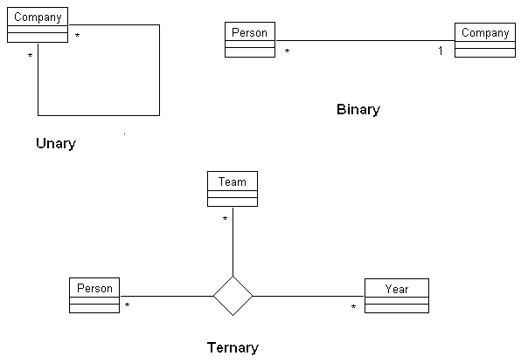

8. Role names for Review Question 7 association relationships:

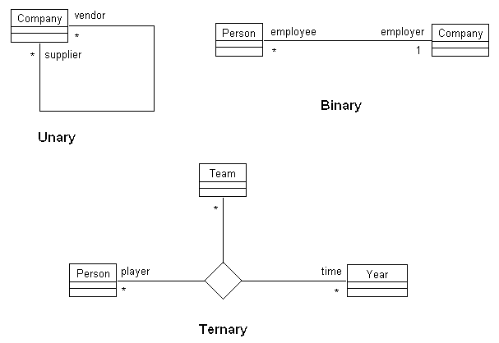

9. Add operations to some of the classes you identified in Review Question 7

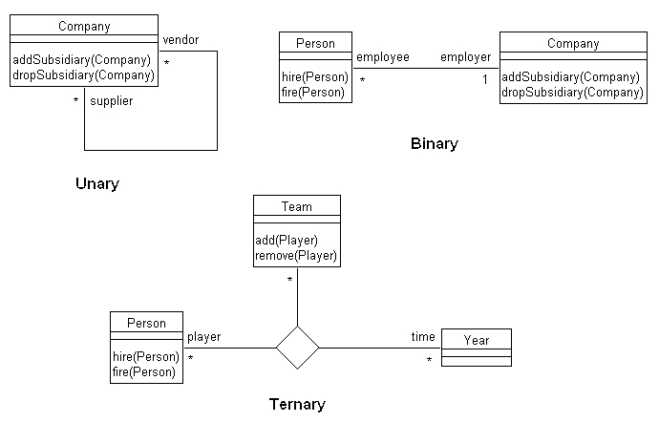

10. An example of generalization:

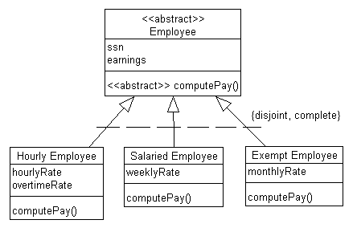

11. Extension of Review Question 10 adding at least one abstract class with at least one abstract operation, and indicating which features of a class are inherited by other classes:

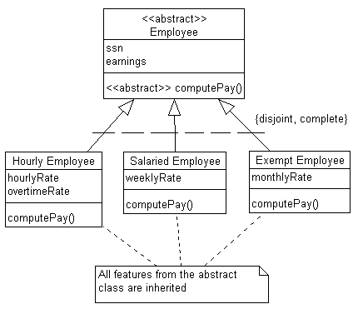

12. Extension of Review Question 11, giving an example of polymorphism. The specific details of the implementation of the method computePay() depend on the subclass even though they all receive the same message from the classes that request the computePay() service.

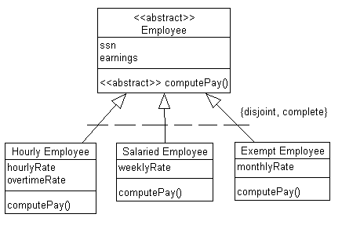

13. Aggregation example:

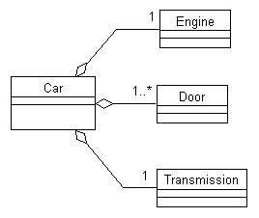

14. The concepts of encapsulation, inheritance, and polymorphism make object-oriented modeling a powerful tool for developing complex systems.

15. Because Vehicle is an abstract class, it cannot have any direct instances.

16. In order to effectively model a complex system, it is necessary to have a small set of independent views illustrating the problem from multiple perspectives. The UML provides many different types of diagrams in order to provide these different perspectives.

17. The assignment class is an association class.

18. A unary relationship would have to be represented as an association class if the relationship has attributes, such as quantity or begin and end dates.

19. /AvailBalance is a derived attribute. /purchases is a derived relationship. /AvailBalance can be computed from the valued for creditLine and balance. /purchases can be determined by examining the association between customers and items.

20. CheckFee and MonthlyFee are examples of class-scope attributes. CalcFee is an abstract operation.

21. The class diagram shown in Figure 15-23 is an example of multiple-inheritance.

22. The class diagram shown in Figure 15-24 is an example of aggregation. Although faculty could be represented as an aggregate of department, there really is not a need to do this because there will not be operations on department that will carry through to faculty. Also, faculty has independent relationships with other objects, such as courses.

Answers to Problems and Exercises

1. Class diagrams:

a. Note: The Association Class in the following diagram should be named “Assignment.” This change will be incorporated into future editions of the Instructor’s Manual.
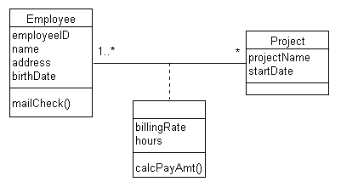

b.
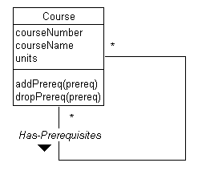
c.
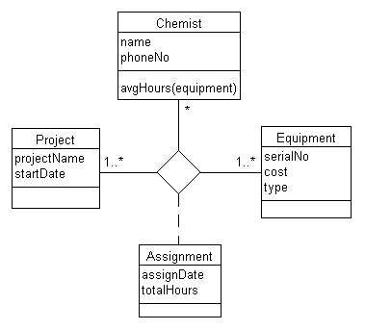

d. Note: Because primary keys are not included on class diagrams, there is no need to consider weak classes in this solution.
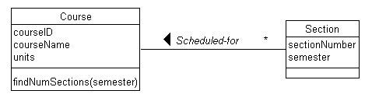

e.
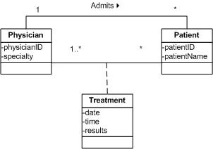

2. Note: The attribute names in the following diagram should begin with lower case letters (e.g., Address should be address). The Association Class should be named “Participation.” These changes will be incorporated into future editions of the Instructor’s Manual.

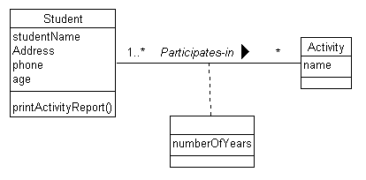

3. Class diagram with subset constraint:

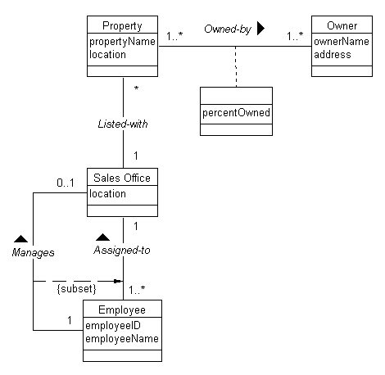

4. Sample class diagram with at least four association roles:

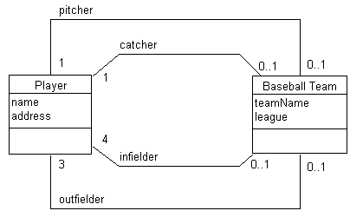

5.
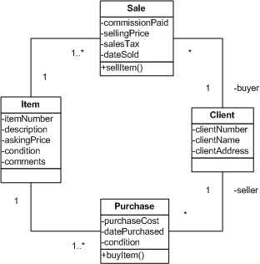

6.

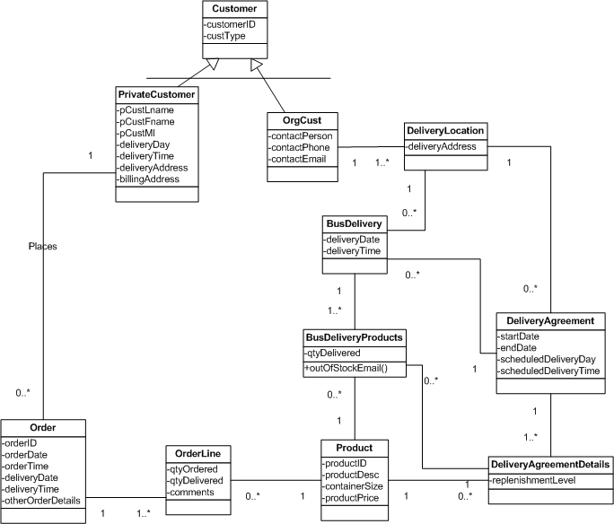

7. This is a simple library solution; more classes could be added such as author, categories, etc. itemType includes Paperback, Hardback, audiobook CD, audiobook tape, audio CD, audio tape, video DVD, and videotape; this could also be set up as reference data to the itemType in Item class. Based on reading the problem description, there do not appear to be special attributes or relationships based on the itemType thus no subclasses for itemType are presented in this solution.

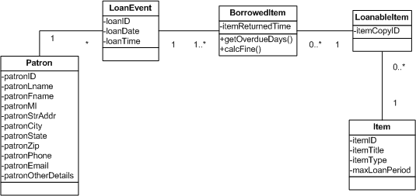
8.

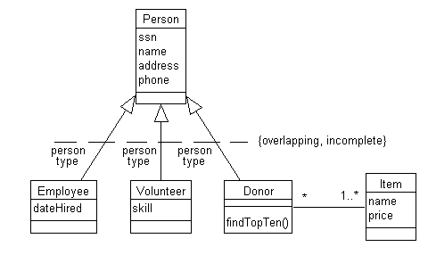

9. Note: Account should be marked as an abstract class. This change will be incorporated into future editions of the Instructor’s Manual

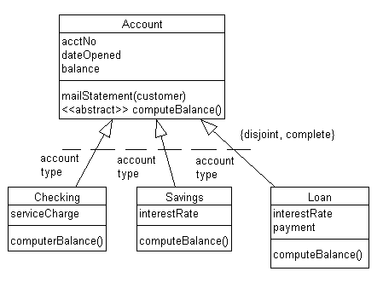

10.

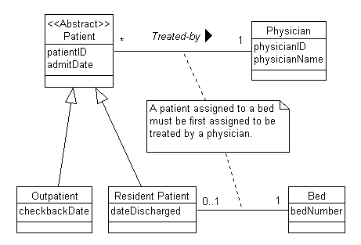

11. a.

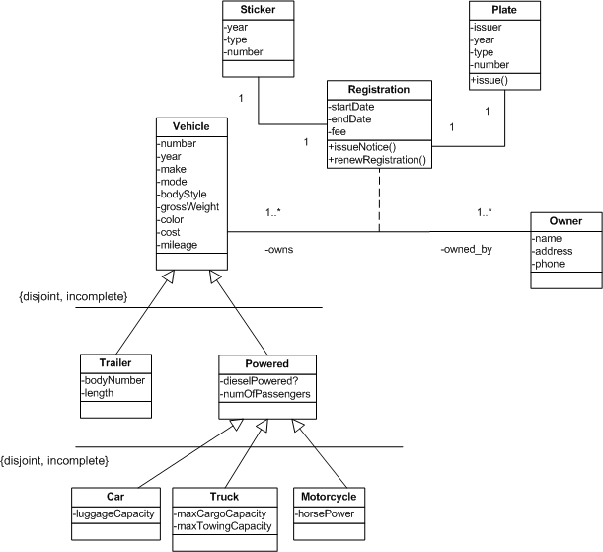

11. b.
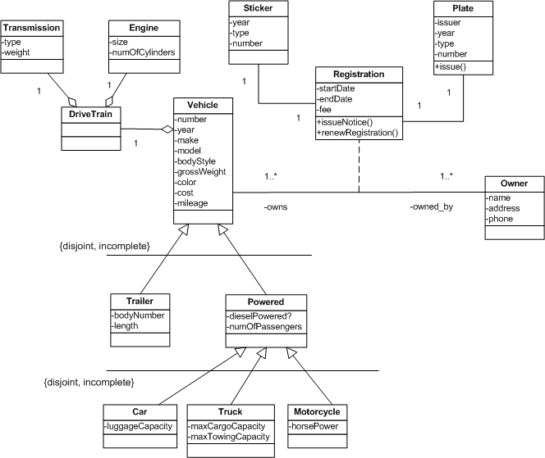

11. c.
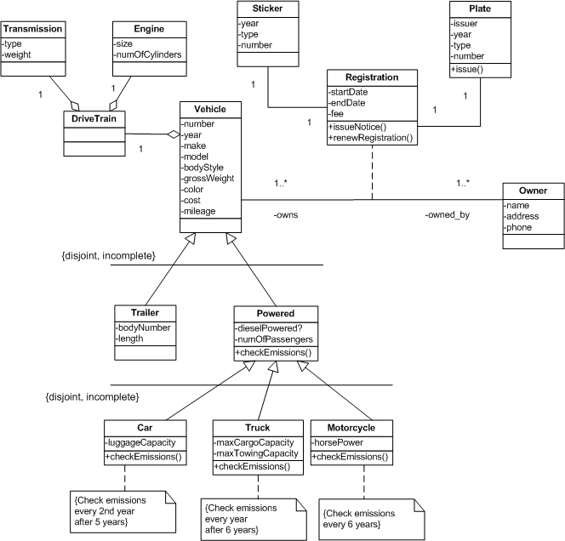

12.

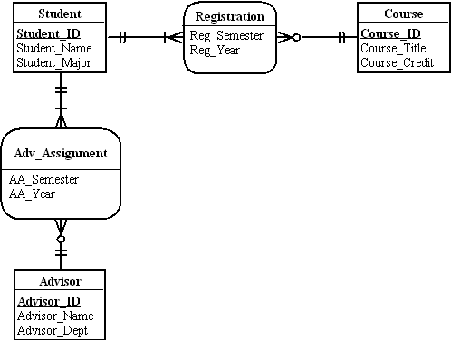

13. Please note for this exercise that the composite attribute of Address could be a class also, because both customer and location have common address attributes.

Note: The attribute names in the following diagram should begin with lower case letters (e.g., CustomerID should be customerID). The Association Class should be named “LocationRates.” The “TimeOfDay” attribute should be broken into two attributes of “startTime” and “endTime.” These changes will be incorporated into future editions of the Instructor’s Manual.

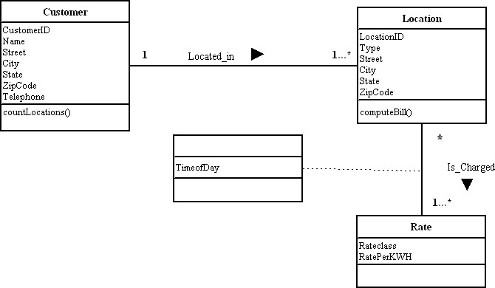

14. Note: The attribute names in the following diagram should begin with lower case letters (e.g., EmpID should be empID). The “Consists_od” association should be named “Consists_of.” These changes will be incorporated into future editions of the Instructor’s Manual.

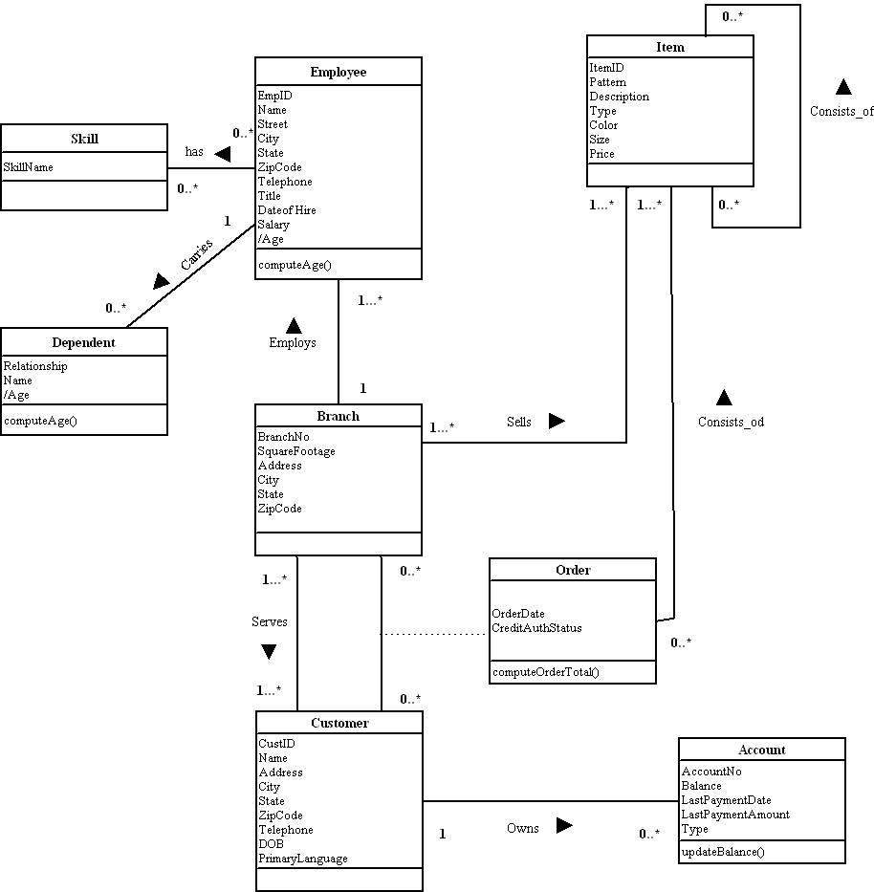

15. Note: The attribute names in the following diagram should begin with lower case letters (e.g., Address should be address). Attribute “Court_Name” should be “courtName”; “Specialty_Name” should be “specialtyName.” The “updateyears()” operation should be named “updateYears().” The association class should be named “Assignment.” These changes will be incorporated into future editions of the Instructor’s Manual.

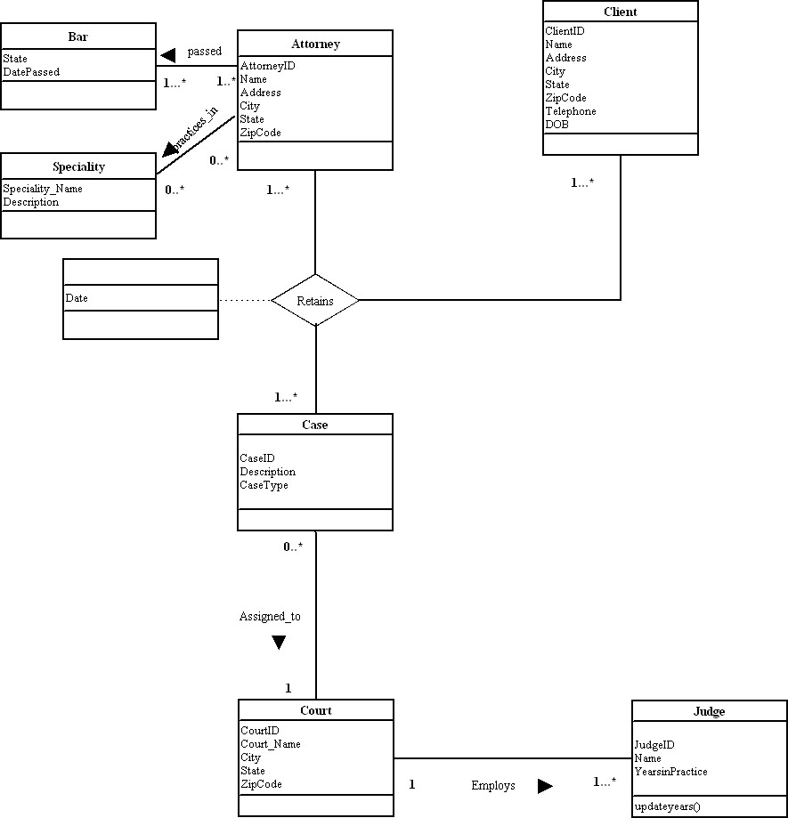

16. Note: The attribute names in the following diagram should begin with lower case letters (e.g., EmpID should be empID). The Association Class should be named “Assignment.” These changes will be incorporated into future editions of the Instructor’s Manual.
16. Class diagram
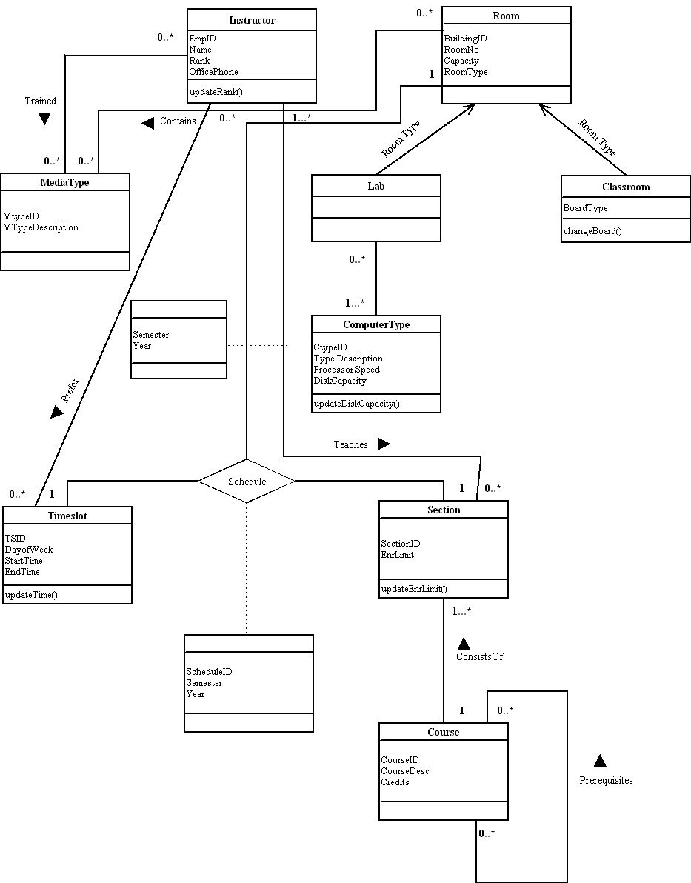
17. Please note in this solution that Estimates and ServicesPerformed both are related to location rather than customer. Although the exercise does not explicitly state this as a business rule, it has been assumed that an estimate or service performed would be for only one location, even if a customer owned multiple locations.

Note: The attribute names in the following diagram should begin with lower case letters (e.g., EmpID should be empID). The operation names should begin with lower case letters. The Association Class should be named “Expertise.” The multiplicity at the “Technical” end for the “Technical”–“Technical Skills” association should be 0…*. These changes will be incorporated into future editions of the Instructor’s Manual.

The class diagram solution is below.
17. Class diagram
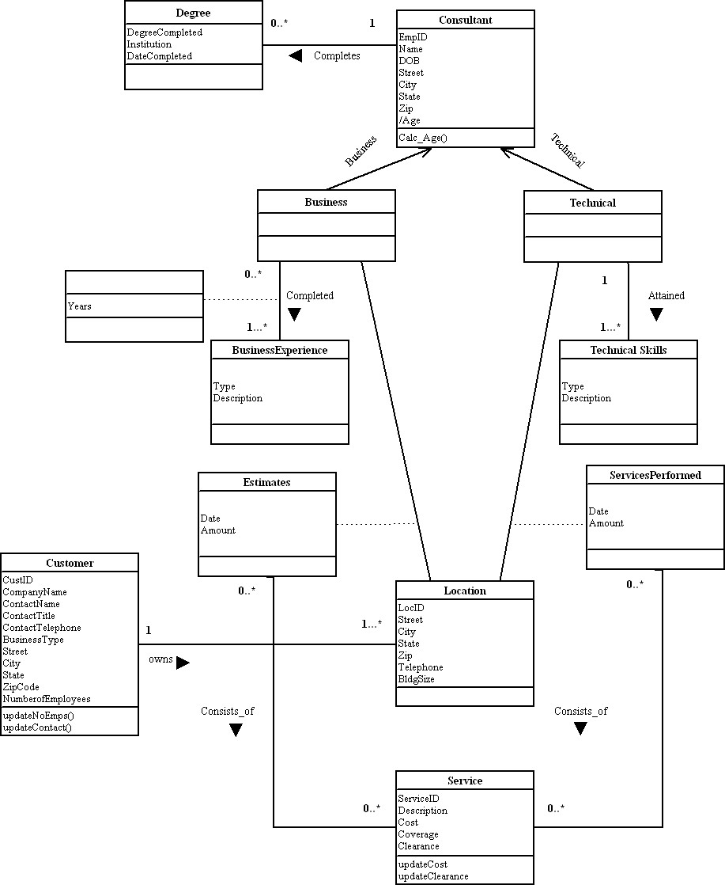
18. Note: The attribute names in the following diagram should begin with lower case letters (e.g., Street should be street). These changes will be incorporated into future editions of the Instructor’s Manual.

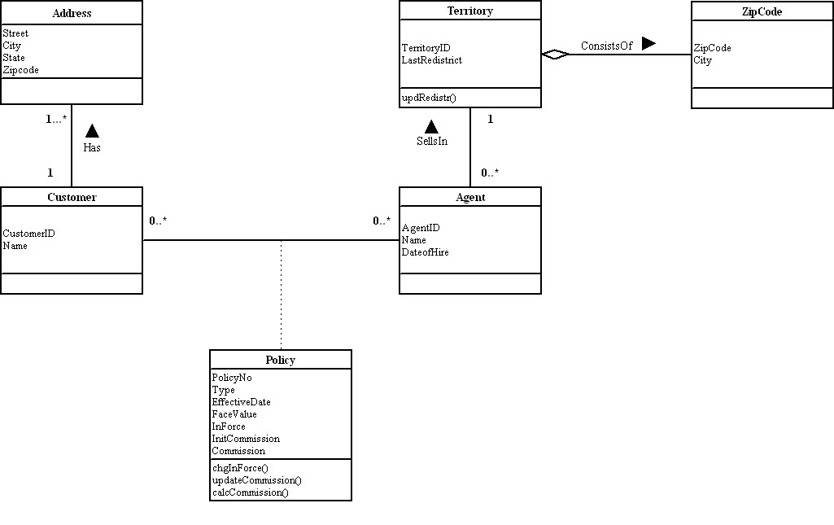

19. This solution assumes that a single issue might have several “history instances” associated with each issue.

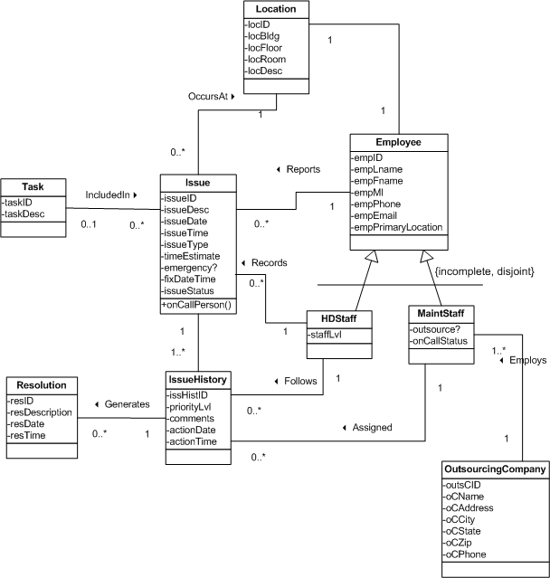
20. Note: In the following diagram, the “numberOfItem(assembly)” operation should be named “getNumberOfItems(assembly).” This change will be made in a future edition of the Instructor’s Manual.

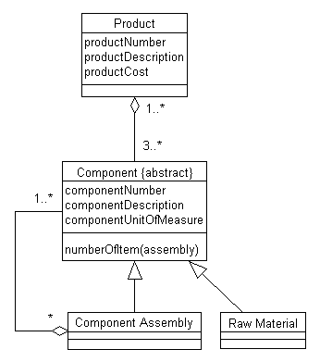

21. Note: This solution refers to Figure 15-18 in the text. For this solution, the receivePaymt method has been overloaded for cases where an electronic payment is needed.

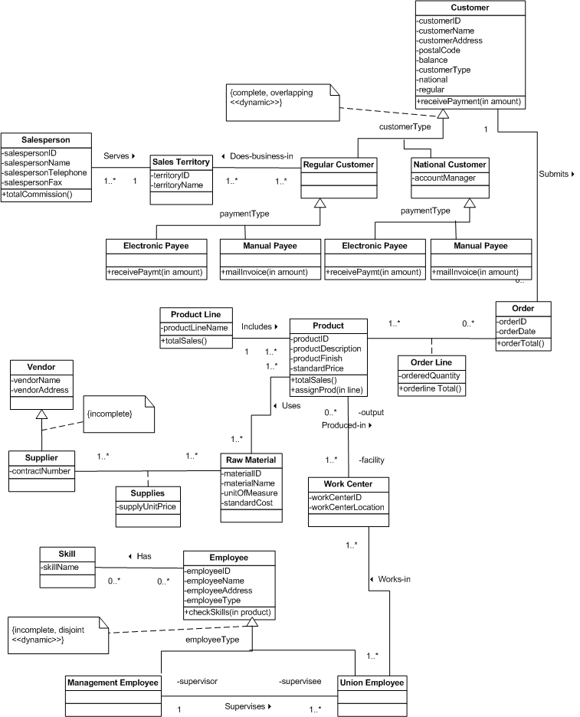

22. This solution identifies several derived associations (Customer purchases Product, Salesperson sells Product, Union Employee produces Product, Supplier supplies_for Product), although there are more to be found.

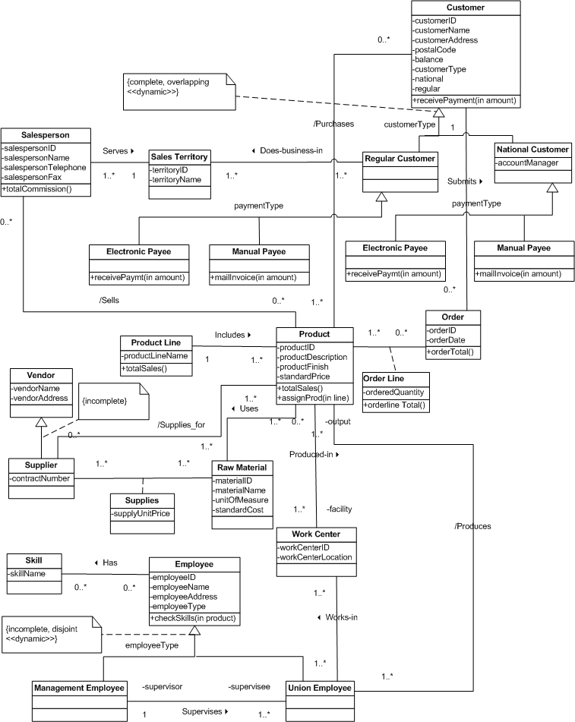

Answers to Field Exercises

1. An example of a superclass/subclass relationship is with equity securities. Equity securities represent ownership shares in a corporation. Equity securities have attributes such as name, symbol, exchange, and price. A particular type of equity security is common stock. Preferred stock is another type equity security that offers the holders fixed dividends each year. An attribute for preferred stock would be dividend rate.

2. Examples of superclass/subclass relationships should be available in both service and manufacturing businesses. In the service business you will find several classes of employees, ranging from part-time to full-time with benefits. In the manufacturing business you might find several types of engineers (electrical, mechanical). Numerous operational business rules can be found in both types of businesses. In manufacturing, rules exist regarding quality standards and how overhead should be allocated to jobs. In the service industry, rules related to processes, such as how an item is purchased, represent sequences in the object-oriented models.

3. The translation of the EER (or E-R) diagram should map the entity types and attributes into classes. EER diagrams can represent generalizations that also map to class diagrams. EER and E-R notation are different than UML. Association relationships remain the same. E-R diagrams usually show keys. Keys can be represented with class attribute names followed by the {key} notation.

4. The main differences will most likely be in the notation used to describe the model. Students may find systems analysts using Booch, OMT, or their own custom notation. Students should see if the notations in use by systems analysis can represent use cases and class diagrams as shown in the chapter.

