Check Your Answers - Chapter 02
Book: SQL Fundamentals, 3rd edition
Format of this file: Word 97 to Word 2003

How to check your answers:
Often there are many different ways to write the SQL statement.
To check if your method of writing the SQL is correct, compare your result tables to the ones here.

Section 2-4, page 41

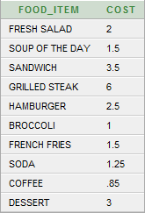

Section 2-5, page 44

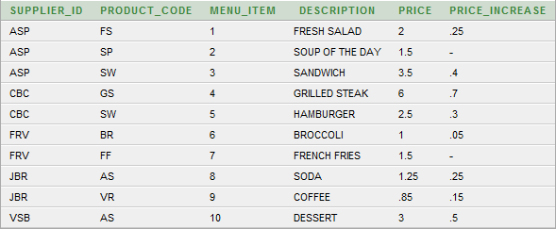

Section 2-6, page 48

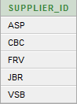

Section 2-7, page 50

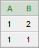

Section 2-9, page 56



Section 2-10, page 58

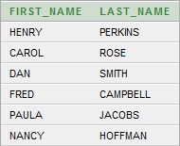

Section 2-11, page 60

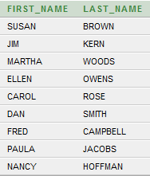

Section 2-12, page 63

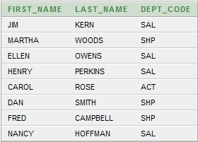

Section 2-13, page 65

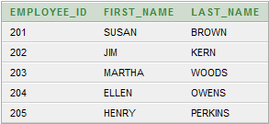

Section 2-14, page 68

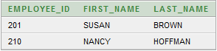

Section 2-15, page 71

Section 2-17, page 74



Section 2-18, page 76

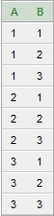

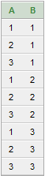

Section 2-19, page 78

