**NEED AN ESCAPE?**

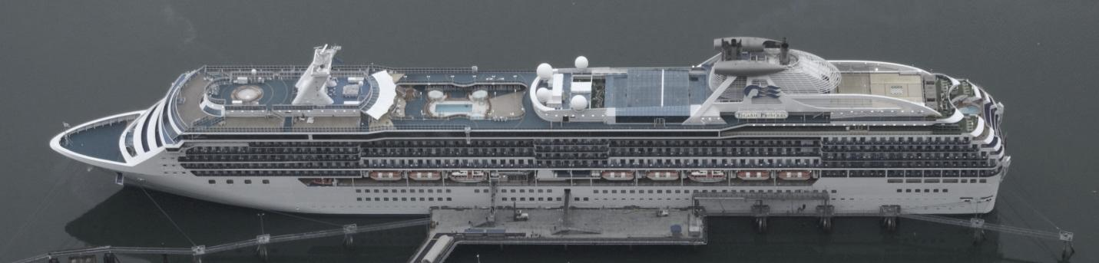

**Tango Vacation Club members receive a 10 percent discount for cruises booked during May. Select from a variety of destinations.**

***An experience of a lifetime awaits you!***

* **Ultimate relaxation**
* **Endless fun and entertainment**
* **Breathtaking scenery**
* **Friendly, attentive staff**
* **Clean facilities**

**Interested? Call TVC at 555-1029.**