Abstract
Cryo-electron microscopy (cryo-EM) has advanced three-dimensional structure determination of macromolecular complexes. De novo modelling algorithms, including ModelAngelo and CryoAtom2, have automated the construction of protein and nucleic acid backbones. However, fully automated, accurate end-to-end reconstruction of ligands involved in catalysis, allosteric regulation and drug action remains challenging. Existing tools address individual steps, with inefficient connections between region localisation, chemical identity matching and pose reconstruction. Here we introduce LigandSeek, a fully automated end-to-end framework that jointly models density and receptor information through three stages: Find, Match and Build. On a benchmark of 179 complexes, Find achieved a one-to-one PRAUC@0.3 of 0.541, increasing to 0.663 with deposited receptor structures. Both exceeded the score of 0.255 achieved by the density-only method Emap2lig-Find. Match achieved 86.6% overall matching accuracy, with a mean matching time of 0.09 s per candidate region. For Build, we incorporated continuous cryo-EM density-field constraints into a receptor-based generative model and fine-tuned it. This reduced the median root-mean-square deviation (RMSD) of top-1 small-molecule poses from 1.81 Å to 1.21 Å. In end-to-end blind evaluation without deposited receptor structures as input, LigandSeek achieved a success rate of 67.5% across 77 PDB entries. With deposited receptor structures, this rate increased to 71.4%. LigandSeek provides an efficient, fully automated workflow from continuous three-dimensional cryo-EM density maps to all-atom ligand poses.

Introduction
Single-particle cryo-electron microscopy (cryo-EM) has become an important method for determining the three-dimensional structures of macromolecular complexes^{1,2}. Deep learning tools such as ModelAngelo³, CryoAtom2⁴ and EMProt⁵ have advanced automated modelling of protein and nucleic acid structures. However, ligands bound in the binding pockets of these complexes often regulate catalysis, conformational switching and signalling cascades⁶. A key challenge is therefore to combine experimental density and the receptor environment to detect, identify and reconstruct accurate all-atom ligand structures automatically, without expert modelling. Automated, end-to-end reconstruction of all-atom ligand structures from cryo-EM density maps faces three sequential bottlenecks.
The first is region localisation, the Find bottleneck. Cryo-EM density maps span large spatial scales, with heterogeneous local signal-to-noise ratios and diffuse, intermixed densities from water molecules or lipid micelles. Existing density detection methods, such as Emap2lig-Find⁷, mainly use three-dimensional voxel segmentation networks to locate small-molecule density blobs directly across the entire map. Without information about the surrounding macromolecular receptor, these density-only approaches lack the chemical and geometric context of the binding pocket, tending to produce many false-positive candidate regions and thereby reducing the precision of instance-level localisation.
The second is chemical identity matching, the Match bottleneck. Even after a ligand region is located, associating it with the correct chemical identity remains a major challenge. Although Emap2lig⁷ combines region detection with pose reconstruction, it lacks automated identity matching. Users must specify the correspondence between regions and ligand identities, preventing full automation of the end-to-end workflow. Alternatively, EMERALD-ID⁸ provides identity matching by docking candidate ligands individually and inferring their identities from the resulting scores. Its computational complexity is $O(N_{g}×K)$, where $N_{g}$ is the number of candidate sites and $K$ is the number of competing ligand identities. This computational burden, coupled with a lack of GPU acceleration, can make scoring at a single site take hours. Furthermore, it primarily targets small-molecule ligands, limiting its use in complexes containing other ligand types. Rapid, automated identity matching is therefore a key step in connecting region localisation to pose reconstruction.
The third is pose reconstruction, the Build bottleneck. After the binding region and chemical identity have been determined, generative docking models such as DiffDock⁹ and PocketXMol¹⁰ usually rely primarily on receptor structures, failing to exploit experimental density to guide pose generation. Conversely, density-only deep learning tools such as Emap2lig-Build⁷ omit protein and nucleic acid receptors, struggling to reconcile density fitting with receptor-environment constraints. Classical non-deep-learning methods, including EMERALD, GemSpot and ChemEM, can incorporate both the receptor environment and experimental density for pose search or optimisation^{11,12,13}. However, they are computationally slow and remain disconnected from upstream localisation and identity matching.
To address these bottlenecks and unify localisation, matching and pose reconstruction, we developed LigandSeek, an automated end-to-end framework based on joint density and receptor modelling (Figs. 1–2). Across all three stages, the neural networks share a unified representation that jointly encodes the experimental density, receptor-derived simulated and difference densities, and the chemical and geometric environments of receptor atoms.
LigandSeek follows a three-stage Find–Match–Build workflow:
- LigandSeek-Find uses a hybrid point–voxel network to fuse continuous voxel-density representations with geometric and chemical information from the receptor point cloud. It detects three-dimensional ligand regions while balancing precision and recall.
- LigandSeek-Match uses a cross-modal matching network with graph and context attention. It integrates ligand language representations, molecular graph representations and contextual information from other ligand identities in the same complex. This enables rapid, accurate identity matching across a broad range of ligand types, including small molecules, metal ions and sugars.
- LigandSeek-Build fine-tunes the generative model PocketXMol with local density conditioning. This enables generated poses to satisfy both experimental density contours and pocket chemical constraints, thereby improving sampling accuracy.
We evaluated the framework on 179 complexes comprising 2,502 ligand instances. Under blind evaluation conditions, only receptors modelled de novo by CryoAtom2 were used, with no deposited receptor structures provided as input. All three LigandSeek components outperformed their respective baselines. Find achieved a one-to-one PRAUC@0.3 of 0.541, compared with 0.255 for Emap2lig-Find. Match achieved 86.6% overall matching accuracy, with a mean matching time of 0.09 s per candidate region, substantially faster than conventional reverse docking. Build reduced the median root-mean-square deviation (RMSD) of top-1 poses from 1.81 Å with the official model to 1.21 Å. In end-to-end blind evaluation across 77 complexes containing organic small molecules, LigandSeek achieved an all-atom modelling success rate of 67.5% (top-1 RMSD < 3 Å). LigandSeek connects ligand localisation, identity matching and pose reconstruction to generate accurate all-atom ligand poses from cryo-EM density maps. It provides a new tool for drug discovery and high-throughput cryo-EM screening.

Overview
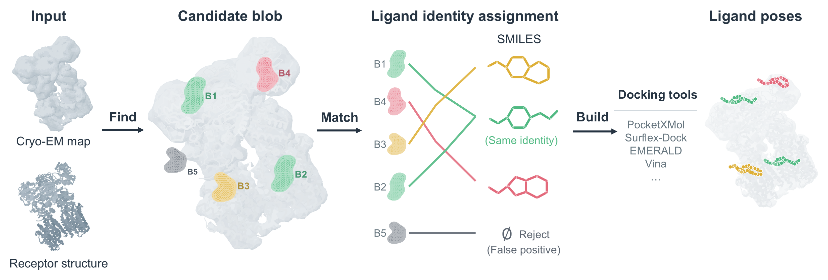
Fig. 1 | Automated end-to-end Find–Match–Build workflow for reconstructing ligand poses from cryo-EM data. The inputs are an experimental cryo-EM density map and either a deposited receptor structure or a receptor structure automatically modelled by CryoAtom2. Find locates candidate ligand regions (blobs B1–B5) across the density map. Match filters false-positive predictions and assigns valid candidate regions to ligand identities (represented by SMILES) within the same PDB entry; B1 and B2 illustrate two distinct sites assigned the same identity, whereas B5 represents a rejected candidate region. Build combines the predicted regions from Find with the matched identities from Match to generate three-dimensional ligand poses using the selected molecular docking tool.
LigandSeek takes protein and nucleic acid receptor structures, either deposited or automatically modelled by CryoAtom2, together with three-dimensional cryo-EM density maps.
We represent protein and nucleic acid receptors uniformly as $A=\{(a_{i},x_{i})\}_{i=1}^{n}$. Here, $n$ is the number of receptor atoms, and $x_{i}∈R^{3}$ is the spatial position of atom $i$. The representation $a_{i}$ encodes the atom’s attributes, such as its element type and amino acid or nucleotide type. These attributes are represented by a 50-dimensional feature vector for each receptor atom.
Let $M_{exp}∈R^{D×H×W}$ denote the voxelised three-dimensional cryo-EM density map. The receptor structure yields a simulated density map $M_{sim}∈R^{D×H×W}$ of the same dimensions. From $M_{exp}$ and $M_{sim}$, we construct a 56-channel multi-view density bank $M∈R^{56×D×H×W}$.
Fig. 1 shows the model inputs, outputs and overall workflow. LigandSeek reconstructs ligand poses end to end through three stages: Find, Match and Build. The 50-dimensional receptor-atom features and the multi-view density bank are the main inputs shared by all three stages. Fig. 2 shows the overall network architecture, with further details provided in Methods.
Find combines receptor information and experimental density information to predict ligand regions. It produces $J$ candidate ligand regions (blobs), expressed as:
$$Find(A,M)→\{B_{j}\}_{j=1}^{J}$$
Each $B_{j}$ is a 26-connected region in the three-dimensional voxel grid.
Match uses the density bank $M$, the receptor pocket $A$ surrounding each blob and auxiliary features from Find ($AUX$) to associate the predicted blobs $\{B_{j}\}_{j=1}^{J}$ with user-provided ligand identities $\{S_{k}\}_{k=1}^{K}$ in the PDB entry. Here, $K$ denotes the number of ligand identities present in that complex. Specifically, it determines whether each blob is a false-positive Find prediction and, if not, identifies its corresponding ligand identity:
$$\begin{aligned}Match(M,A,AUX;B_{j},\{S_{k}\}_{k=1}^{K})&=\left\{\begin{matrix}(1,S_{k}), & \begin{aligned}&\text{if }B_{j}\text{ is not a false positive and corresponds to ligand identity }S_{k}\end{aligned} \\ (0,∅), & \text{if }B_{j}\text{ is a false positive}\end{matrix}\right.\end{aligned}$$
Once Find locates a ligand region and Match assigns its chemical identity, downstream molecular docking tools can reconstruct the three-dimensional ligand pose. While we provide modular interfaces to standard docking tools, we developed a density-guided variant of PocketXMol as the default Build model. Specifically, PocketXMol was adapted with local density conditioning and fine-tuned from official weights, enabling pose generation constrained by both the receptor environment and experimental density.
Build takes a specified initial binding site $p∈R^{3}$, a small-molecule identity represented by SMILES and the surrounding pocket environment $P$. It also accepts optional guiding density information $M∈R^{D×H×W}$ and generates all-atom coordinates for the small molecule.
We tested the framework on a non-redundant set of 179 PDB entries. To evaluate Find’s localisation performance, we computed semantic and instance-level metrics for each full density map. To evaluate Match’s identity matching and Build’s molecular docking performance, we assessed the relevant ligands from these PDB entries.
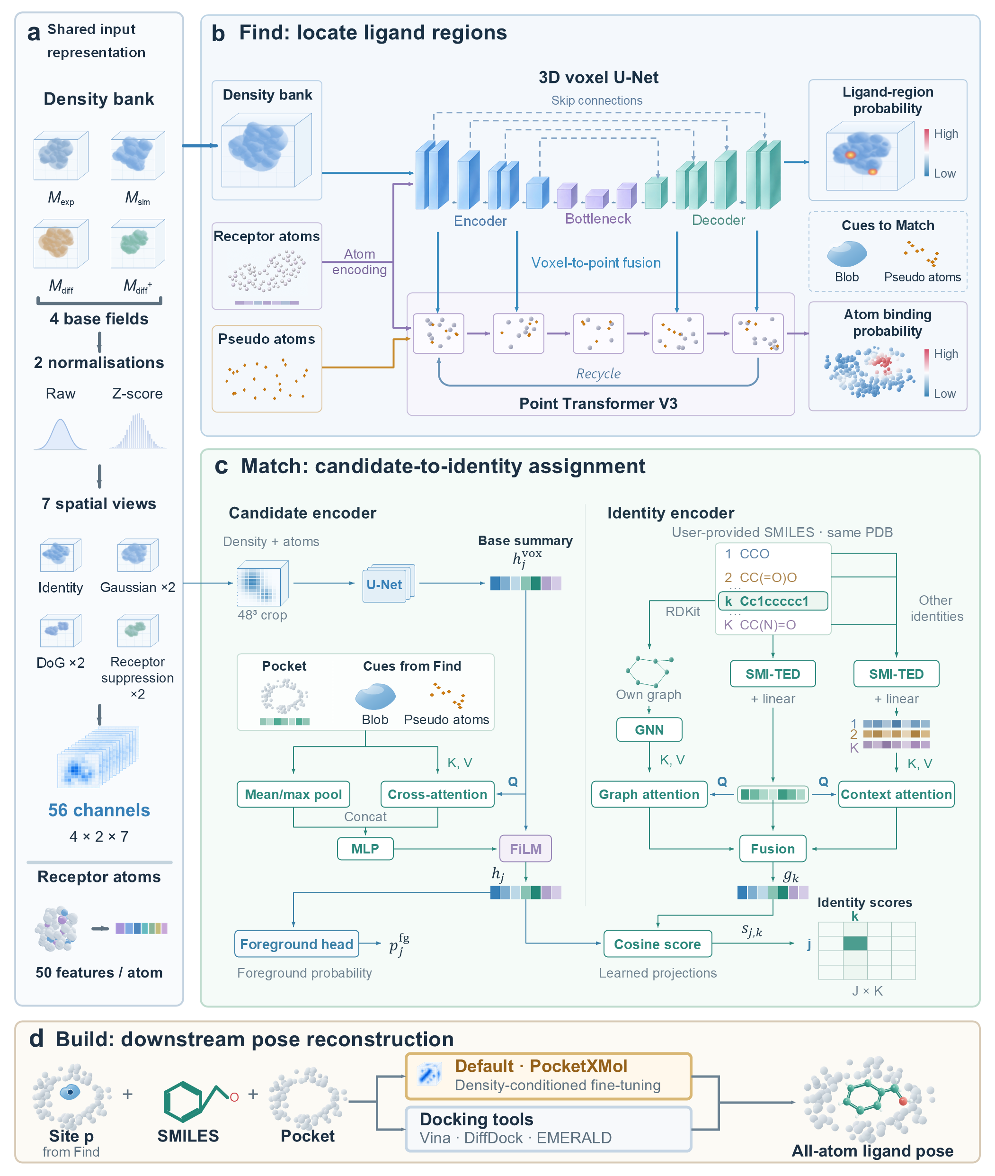
Fig. 2 | Network architecture and data flow of LigandSeek’s Find–Match–Build framework. a, Shared inputs. Experimental cryo-electron microscopy density $M_{exp}$, simulated receptor density $M_{sim}$, difference density $M_{diff}$ and positive difference density $M_{diff}^{+}$ form the base fields. Unnormalised and z-score-normalised representations undergo seven spatial transformations, including Gaussian smoothing, difference-of-Gaussians (DoG) filtering and receptor-neighbourhood suppression, producing a 56-channel multi-view density bank. Protein and nucleic acid receptor atoms have 50-dimensional features encoding chemical and geometric information. b, Joint voxel and point-cloud localisation in Find. A 3D U-Net combines density and receptor-atom features to predict voxelwise ligand-region probabilities. In parallel, Point Transformer V3 encodes receptor atoms and pseudo-atoms sampled from high-probability binding regions, incorporating voxel information through multiscale feature sampling. An AlphaFold3-style recycling mechanism iteratively refines predictions across both branches. Predicted receptor-atom binding probabilities are used to score candidate ligand regions during inference, while extracted blobs and pseudo-atoms provide local cues for Match. c, Foreground classification and identity assignment in Match. The candidate encoder processes a 48³ grid centred on each blob with a U-Net to generate voxel summary $h_{j}^{vox}$. Find-derived blob, pocket and pseudo-atom features modulate $h_{j}^{vox}$ via dual pooling, cross-attention and FiLM, yielding candidate representation $h_{j}$. The identity encoder uses SMI-TED language embeddings to query GNN-encoded molecular graph features via graph attention, while context attention incorporates other ligand identities in the same PDB entry, yielding identity representation $g_{k}$. Finally, a foreground head predicts foreground probability $p_{j}^{fg}$ from $h_{j}$, and learned cosine scoring between $h_{j}$ and $g_{k}$ produces the assignment matrix $s_{j,k}$. d, Pose reconstruction in Build. The blob geometric centre $p$, Match-assigned ligand identity and pocket environment are supplied to docking tools to generate ligand poses. The default tool is PocketXMol fine-tuned with density guidance. Vina, DiffDock and EMERALD are also supported.

Results

Stage 1

Stage 1: Evaluation metrics
For a given PDB structure, let the model predict $N_{pred}$ three-dimensional candidate blobs, $\{B_{i}\}_{i=1}^{N_{pred}}$. The structure contains $N_{gt}$ ground-truth ligand instances, $\{G_{j}\}_{j=1}^{N_{gt}}$, where $G_{j}$ denotes the ligand region of instance $j$. We set the bidirectional coverage threshold to $τ∈\{0.3,0.5\}$.
We evaluated Find at both the semantic and instance levels. At the semantic level, performance was measured using the Dice score.
At the instance level, predicted instances $\{B_{i}\}_{i=1}^{N_{pred}}$ and ground-truth instances $\{G_{j}\}_{j=1}^{N_{gt}}$ form the two vertex sets of a bipartite graph. An edge connects $B_{i}$ and $G_{j}$ if each covers at least a fraction $τ$ of the other. We then used the Hungarian algorithm to obtain a maximum matching between the two sets. Let $N_{τ}^{1to1}$ be the number of successfully matched instance pairs. We define one-to-one precision and recall as:
$${1to1P}_{τ}=\frac{N_{τ}^{1to1}}{N_{pred}}, {1to1R}_{τ}=\frac{N_{τ}^{1to1}}{N_{gt}},$$
These quantities yield the one-to-one F1 score at threshold $τ$, ${one-to-oneF1}_{τ}$. Ranking predicted instances by their mean voxel probability yields the corresponding one-to-one precision–recall area under the curve (PRAUC), ${one-to-onePRAUC}_{τ}$.
One-to-one metrics exclude both one-to-many and many-to-one matches between predicted and ground-truth instances. For example, if one predicted blob covers several ground-truth ligands, at most one pair can count as a successful match. These metrics require accurate instance localisation and separation, penalising incorrect splitting or merging as well as localisation errors. They therefore provide a more precise assessment of the model’s performance.

Stage 1: Results
Panels a, c and e of Fig. 3 show predictions on the full test set. Panels b, d and f show evaluations restricted to small molecules. Ground-truth and predicted instances from other categories, such as sugars and metal ions, were excluded from both numerators and denominators.
We compared LigandSeek-Find using either deposited or CryoAtom2-reconstructed receptors with the density-only method Emap2lig-Find (Fig. 3a, b). Across the full test set, their mean Dice scores were 0.584, 0.477 and 0.050, respectively. Their mean one-to-one PRAUC@0.3 scores were 0.663, 0.541 and 0.255, respectively (Fig. 3a). At the stricter matching threshold of 0.5, their mean one-to-one PRAUC@0.5 scores were 0.558, 0.447 and 0.126, respectively. LigandSeek-Find outperformed Emap2lig-Find even without deposited receptor structures as input, and this trend persisted in the small-molecule test subset.
Panels c and d compare LigandSeek-Find and Emap2lig-Find directly using one-to-one PRAUC@0.3 (Fig. 3c, d). With CryoAtom2-reconstructed receptors, LigandSeek-Find performed better on 112 structures, comparably on 40 and worse on 27 in the full test set (Fig. 3c). Its performance was therefore substantially better than that of Emap2lig-Find. In the small-molecule subset, the corresponding counts were 40, 36 and 18 PDB entries (Fig. 3d). Although the advantage narrowed, LigandSeek-Find continued to outperform Emap2lig-Find. Emap2lig primarily targets small-molecule identification and modelling, explaining its better detection performance for small molecules than across all ligand categories.
Emap2lig-Find tended to predict far more ligand instances than were present, resulting in much lower precision than recall in both semantic and instance-level metrics (Fig. 3e, f). Accurate localisation requires both high precision and high recall, with a good balance between them. Sacrificing too much precision to increase recall is inappropriate for this task. LigandSeek-Find achieved a good balance between precision and recall under these conditions. The low precision of Emap2lig-Find directly resulted in its low Dice score. However, subsequent analyses showed reasonable top-k success rates for Emap2lig-Find (Fig. 5, Fig. 6a). Its PRAUC, which depends on ranking instances by their mean probability, was therefore substantially higher than its Dice score.
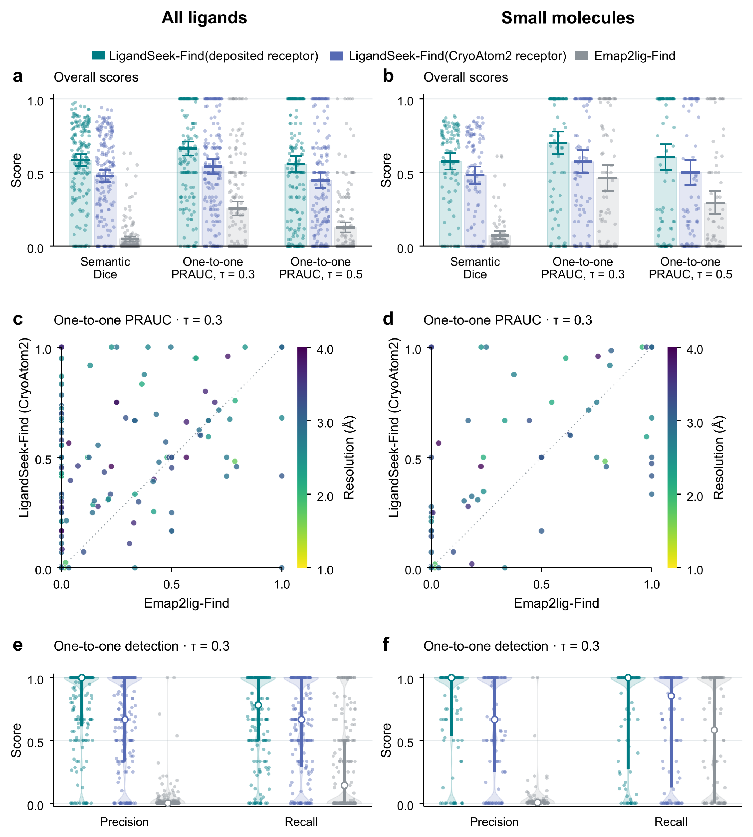
Fig. 3 | Ligand-region detection by LigandSeek-Find. LigandSeek-Find uses deposited or CryoAtom2-reconstructed receptor structures and is compared with the density-only baseline Emap2lig-Find. The left column shows all ligands (179 PDB entries, 2,502 instances); the right shows only small molecules (94 PDB entries, 821 instances). a, b, Per-PDB Dice scores and one-to-one precision–recall area under the curve (PRAUC) at bidirectional coverage thresholds of 0.3 and 0.5. Error bars show 95% intervals for the mean from 10,000 bootstrap resamples of PDB entries. c, d, Direct comparisons of LigandSeek-Find using CryoAtom2-reconstructed receptors with Emap2lig-Find. LigandSeek-Find performs better, comparably or worse on 112/40/27 PDB entries for all ligands and 40/36/18 for small molecules, respectively. e, f, One-to-one precision and recall at a bidirectional coverage threshold of 0.3. Each point represents one PDB entry; open white circles and thick bars indicate the median and interquartile range, respectively.

Stage 1: Representative cases
Four representative cases showed that LigandSeek-Find covered ligand regions more completely than the density-only method Emap2lig-Find and detected regions that it missed (Fig. 4a–d). In the viral replication-associated protein complex 9PQM, both methods detected most of the region occupied by the ATP analogue ATPγS. LigandSeek-Find and Emap2lig-Find achieved instance Dice scores of 0.816 and 0.766, respectively (Fig. 4a). For cholesterol in 9UWI, Emap2lig-Find predictions were concentrated within the ground-truth ligand region, achieving a precision of 0.990 but covering only 0.300 of that region. LigandSeek-Find increased coverage to 0.812, recovering more of the missed ligand region (Fig. 4b). At the NADPH binding site in 9WUP, Emap2lig-Find produced no prediction overlapping the ground-truth ligand region. LigandSeek-Find covered 0.922 of that region in the same comparison (Fig. 4c). Similarly, at the ADP site in 9RMI, Emap2lig-Find covered only 0.103 of the ground-truth region, whereas LigandSeek-Find covered 0.883 (Fig. 4d). These local comparisons demonstrated advantages in both detecting ligand regions and delineating their spatial boundaries more accurately.
Replacing deposited receptor structures with receptors reconstructed from density maps by CryoAtom2 retained the main detection and coverage advantages of LigandSeek-Find in these cases. With reconstructed receptors, the instance Dice scores for 9PQM, 9UWI and 9WUP were 0.816, 0.848 and 0.715, respectively. These scores were close to those obtained with deposited receptors and exceeded those of Emap2lig-Find (Fig. 4a–c). The 9RMI case illustrated a loss of precision after receptor replacement. The predicted region extended beyond the ligand, reducing precision from 0.607 to 0.396 and Dice from 0.719 to 0.532 (Fig. 4d). Nevertheless, the prediction still covered 0.810 of the ground-truth ligand region, and its Dice score exceeded the 0.131 achieved by Emap2lig-Find. Thus, across these four cases, LigandSeek-Find retained good detection performance with CryoAtom2-reconstructed receptors when deposited receptor structures were unavailable. Performance decreased in some regions, while the overall test-set comparison is shown in Fig. 3.
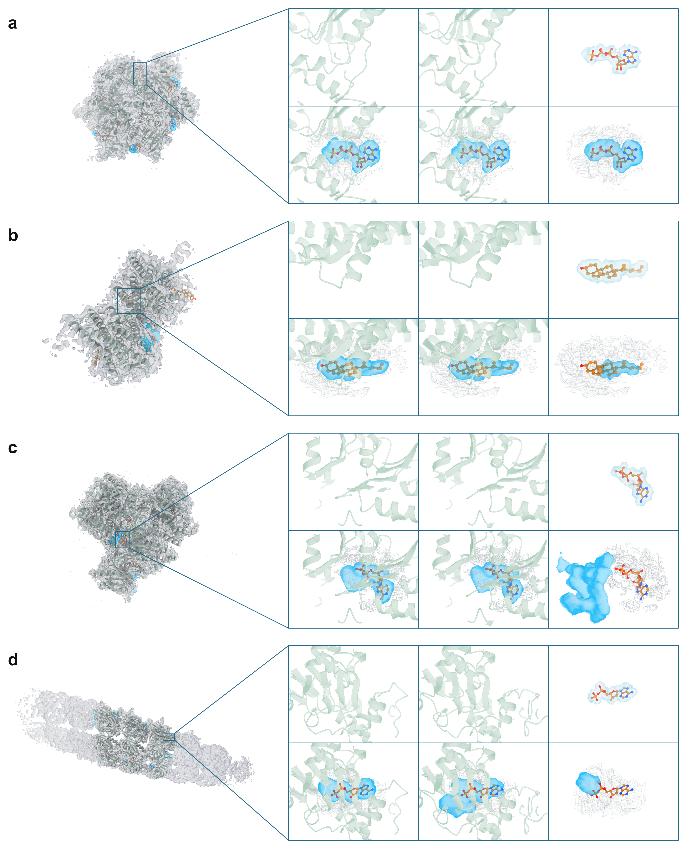
Fig. 4 | Small-molecule region detection under different receptor conditions. a–d, ATPγS in 9PQM (AGS, A:401), cholesterol in 9UWI (CLR, B:502), NADPH in 9WUP (NDP, A:1104) and ADP in 9RMI (C:401), respectively. The left view of each row shows the full complex with ligand regions predicted by LigandSeek-Find using the deposited receptor. A box marks the selected ligand binding site for the six close-up views on the right. The top row shows the deposited receptor, the CryoAtom2 receptor, and the deposited ligand with its ground-truth ligand region, from left to right. The bottom row compares LigandSeek-Find with the deposited receptor, LigandSeek-Find with the CryoAtom2 receptor, and Emap2lig-Find, from left to right. All three prediction views show the same deposited ligand and experimental density. The first two prediction views additionally show the deposited and CryoAtom2-reconstructed receptors, respectively. The six close-up views for each case use the same orientation and scale. Receptors are light green, experimental density is shown as a grey mesh, and ligand carbon atoms are orange. Other ligand atoms are coloured by element; blue envelopes show selected predicted regions, and pale grey-blue envelopes show ground-truth ligand regions.
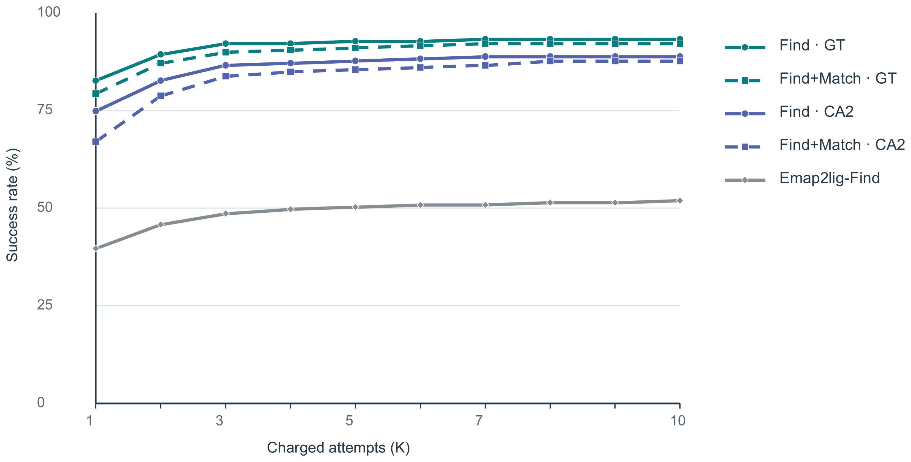
Fig. 5 | End-to-end ligand-region detection and identity matching. The curves show the percentage of 179 test PDB entries with successful predictions within an attempt budget of $K$, for $K=1$–$10$. Find and Match denote LigandSeek-Find and LigandSeek-Match, respectively, within the LigandSeek framework. Find and Emap2lig-Find curves require correct region detection; Find+Match curves additionally require correct ligand identity matching. GT denotes deposited receptor structures, and CA2 denotes CryoAtom2-reconstructed receptor structures; Emap2lig-Find uses no receptor input.
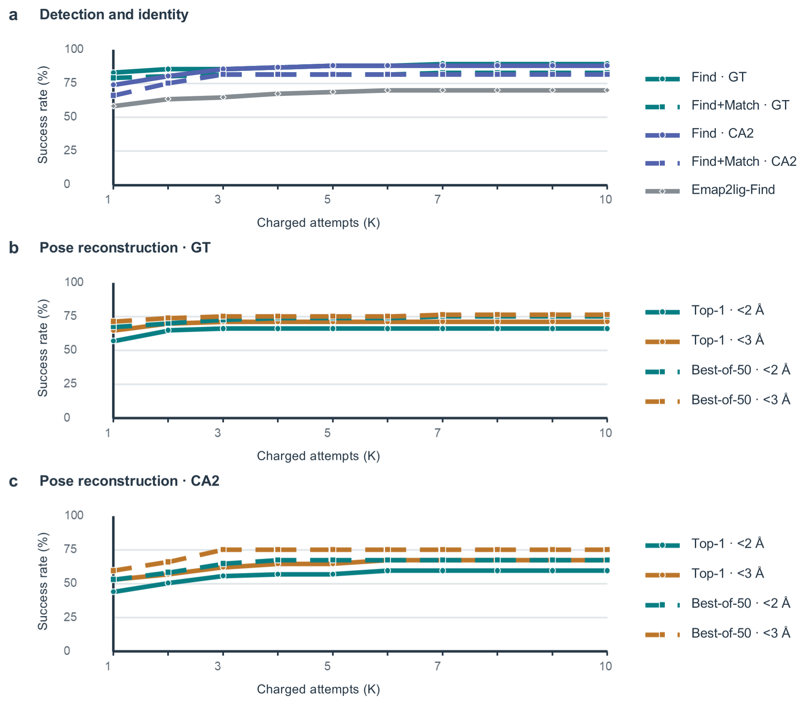
Fig. 6 | End-to-end modelling of single-residue organic small molecules with no missing atoms. The evaluation includes 77 PDB entries containing these small molecules. Find and Match denote LigandSeek-Find and LigandSeek-Match, respectively, within the LigandSeek framework. a, Find curves require correct region detection, whereas Find+Match curves require both correct region detection and correct ligand identity matching. b, c, Top-K success rates for pose reconstruction with PocketXMol-tuned using deposited and CryoAtom2-reconstructed receptor structures, respectively. Success requires a heavy-atom root-mean-square deviation (RMSD) below 2 Å or 3 Å. Solid lines show top-1 poses selected by model score; dashed lines show best-of-50 poses, selected as the lowest heavy-atom RMSD among 50 candidates. The horizontal axis shows charged attempts $K$; the vertical axis shows the percentage of PDB entries with successful predictions within that budget. GT and CA2 denote deposited and CryoAtom2-reconstructed receptor structures, respectively.
References
1. Callaway, E. Revolutionary cryo-EM is taking over structural biology. Nature 578, 201 (2020). https://doi.org/10.1038/d41586-020-00341-9.
2. Bai, X., McMullan, G., & Scheres, S. H. W. How cryo-EM is revolutionizing structural biology. Trends in Biochemical Sciences 40, 49–57 (2015). https://doi.org/10.1016/j.tibs.2014.10.005.
3. Jamali, K. et al. Automated model building and protein identification in cryo-EM maps. Nature 628, 450–457 (2024). https://doi.org/10.1038/s41586-024-07215-4.
4. Su, B. et al. CryoAtom2: inverse folding-inspired deep learning enables accurate model building of protein-nucleic acid complexes in cryo-EM. (2026). https://doi.org/10.65215/LTSpreprints.2026.04.14.000185.
5. Li, T., Chen, J., Li, H., Cao, H., & Huang, S.-Y. EMProt improves structure determination from cryo-EM maps. Nature Structural & Molecular Biology 33, 341–350 (2026). https://doi.org/10.1038/s41594-025-01723-1.
6. Cheng, Y. Single-particle cryo-EM—How did it get here and where will it go. Science 361, 876–880 (2018). https://doi.org/10.1126/science.aat4346.
7. Li, S., Jain, A., Kagaya, Y., Park, J. H., & Kihara, D. Direct Detection and Atomic Modeling of Ligands in Cryo-EM Maps Using Deep Learning. bioRxiv (2026). https://doi.org/10.64898/2026.06.01.729423.
8. Muenks, A., Farrell, D. P., Zhou, G., & DiMaio, F. Automated identification of small molecules in cryoelectron microscopy data with density- and energy-guided evaluation. Structure 33, 1760–1770.e5 (2025). https://doi.org/10.1016/j.str.2025.07.002.
9. Corso, G., Stärk, H., Jing, B., Barzilay, R., & Jaakkola, T. DiffDock: Diffusion Steps, Twists, and Turns for Molecular Docking. International conference on learning representations (ICLR) (2023).
10. Peng, X. et al. Unified modeling of 3D molecular generation via atomic interactions with PocketXMol. Cell 189, 1904–1922.e28 (2026). https://doi.org/10.1016/j.cell.2026.01.003.
11. Muenks, A., Zepeda, S., Zhou, G., Veesler, D., & DiMaio, F. Automatic and accurate ligand structure determination guided by cryo-electron microscopy maps. Nature Communications 14, 1164 (2023). https://doi.org/10.1038/s41467-023-36732-5.
12. Robertson, M. J., Zundert, G. C. P. van, Borrelli, K., & Skiniotis, G. GemSpot: A Pipeline for Robust Modeling of Ligands into Cryo-EM Maps. Structure 28, 707–716.e3 (2020). https://doi.org/10.1016/j.str.2020.04.018.
13. Sweeney, A., Mulvaney, T., Maiorca, M., & Topf, M. ChemEM: Flexible Docking of Small Molecules in Cryo-EM Structures. Journal of Medicinal Chemistry 67, 199–212 (2024). https://doi.org/10.1021/acs.jmedchem.3c01134.

