Experiment report of time series data query based on PostgreSql+TimeScaleDb and stock trading scenarios

- Introduction：
This experiment is based on the PostgreSql database and uses the time series database TimeScaleDb to analyze the data of stock transactions.
- Experiment：
- Design data table
First, prepare a stock market transaction database, including data fields such as stock id, user id, transaction time, transaction stock share, stock unit price, transaction type and so on. At the same time, create index for the data to speed up the query.

The query statement is as follows：
- drop table if exists trade_info;
- CREATE TABLE trade_info (
- stock_id text not null,--股票id
- user_id text not null,--用户id
- date_time timestamp without time zone NOT NULL, --交易时间
- amount int not null, --交易股票份额
- store_value numeric(8,2), --交易时股票单价
- kind int --交易类型，0表示买入，1表示卖出
- );
- --创建索引
- create index trade_info_index on trade_info using btree(date_time);

Operation screenshot：
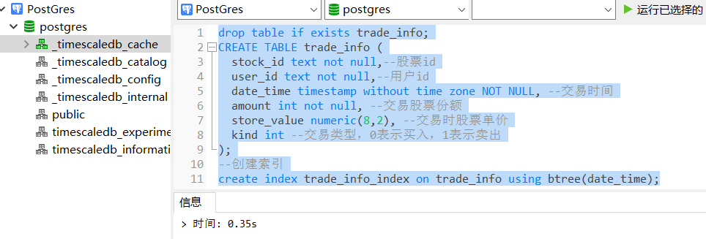

- Convert relational table into the hypertable of time series database
The query statement is as follows：
- SELECT create_hypertable('trade_info', 'date_time');

Operation screenshot：
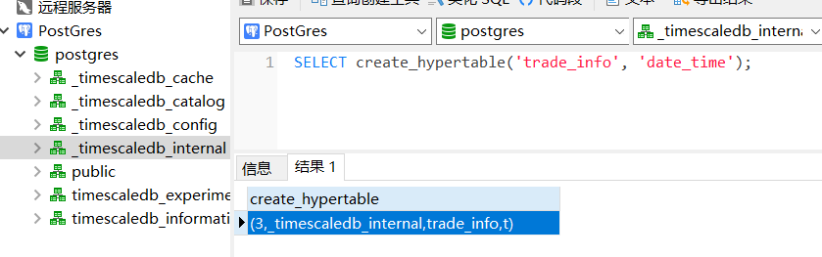

- Prepare transaction datas
I Will prepare transaction datas by simulating stock trading orders and inserting datas 1000 times in a loop. Each time the cycle time is reduced by 1 minute.Finally, 2000 transaction datas will be generated, in which the user id is UUID.

The query statement is as follows：

- do language plpgsql $$
- DECLARE
- i int;
- BEGIN
- for i in 1..1000 loop
- INSERT INTO trade_info(store_id,user_id,date_time, amount,store_value,kind)
- select generate_series(1,2000),replace(gen_random_uuid()::text,'-',''),timestamp '2022-07-06 15:00:00'- i*interval '1 minutes',ceil(random() * 1000),random()*100,round(random());
- raise notice '%',i;
- end loop;
- end;
- $$;

Operation screenshot：

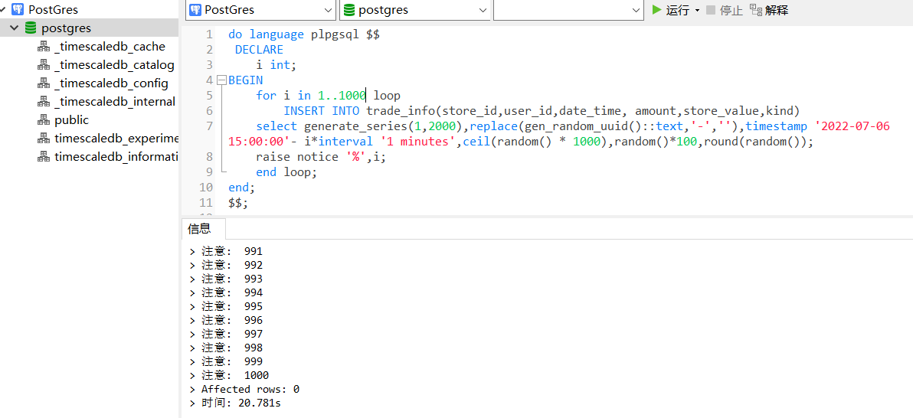
- Start query
First check how many pieces of data have been inserted in total:

The query statement is as follows：
- select count(*) from trade_info;

Operation screenshot：

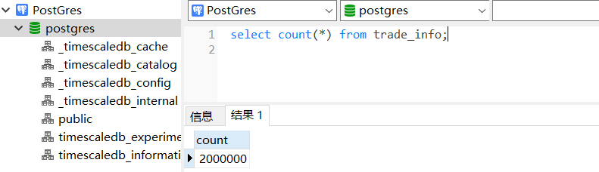

Then check the data in the afternoon of the 2022-07-06 trading day, that is, the transaction data in the time period from 2022-07-06 13:00:00 to 2022-07-06 15:00:00, and count the transaction results.

The query statement is as follows：
- select count(*) as 交易次数, sum(amount)/100 as 成交量,
- sum(amount*store_value)as 交易额 from trade_info
- where date_time>=timestamp '2022-07-06 15:00:00' - 120*interval '1 minutes';

Operation screenshot：

