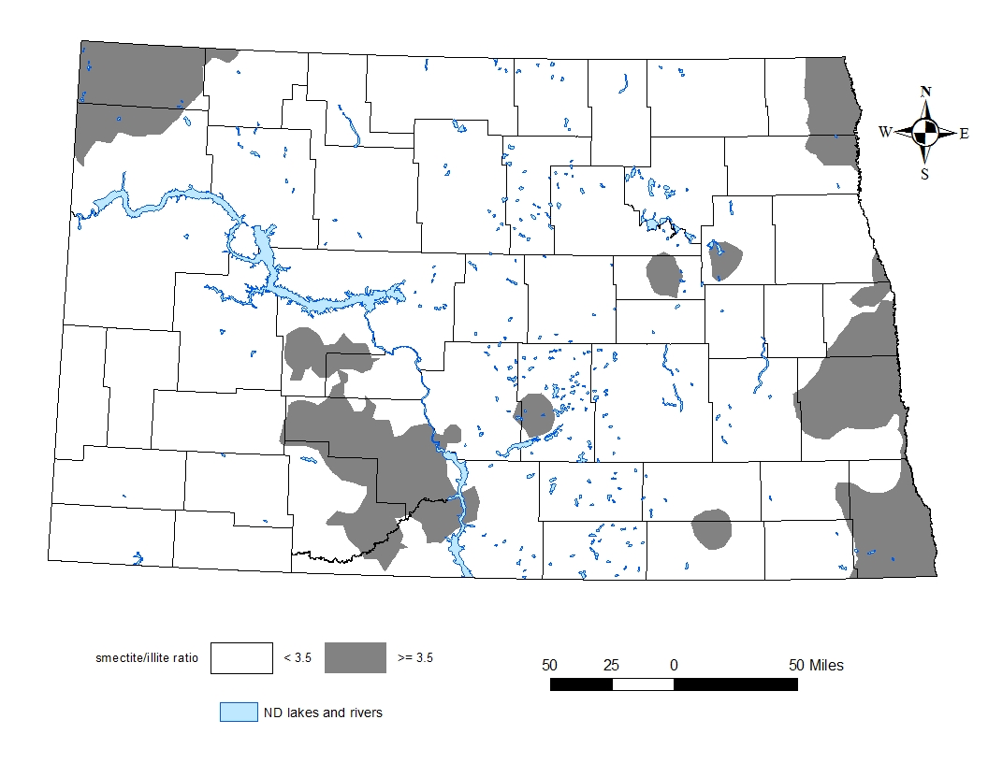

**Smectite-to-illite ratio of surface soils in North Dakota from a soil sampling conducted in spring 2017. Dark gray regions are greater than 3:5. White areas are less than 3:5.**

**Potassium recommendations for corn in soils with clay chemistry having a smectite-to-illite ratio greater than 3:5 and soil test K levels 150 ppm or less.**

|  |  |  |  |  |  |  |  |  |  |  |
| --- | --- | --- | --- | --- | --- | --- | --- | --- | --- | --- |
| **Corn price,**  **$ per bushel** | **Price per pound K2O, $ per pound** | | | | | | | | | |
| **0.125** | **0.20** | **0.30** | **0.40** | **0.50** | **0.60** | **0.70** | **0.80** | **0.90** | **1.00** |
| **Recommended pounds K2O per acre** | | | | | | | | | |
| 2 | 90 | 90 | 90 | 90 | 60 | 60 | 0 | 0 | 0 | 0 |
| 3 | 90 | 90 | 90 | 90 | 60 | 60 | 60 | 60 | 60 | 0 |
| 4 | 90 | 90 | 90 | 90 | 90 | 90 | 90 | 90 | 90 | 60 |
| 5 | 90 | 90 | 90 | 90 | 90 | 90 | 90 | 90 | 90 | 90 |
| 6 | 120 | 120 | 120 | 120 | 90 | 90 | 90 | 90 | 90 | 90 |
| 7 | 120 | 120 | 120 | 120 | 120 | 120 | 120 | 120 | 120 | 90 |
| 8 | 120 | 120 | 120 | 120 | 120 | 120 | 120 | 120 | 120 | 120 |
| 9 | 120 | 120 | 120 | 120 | 120 | 120 | 120 | 120 | 120 | 120 |
| 10 | 120 | 120 | 120 | 120 | 120 | 120 | 120 | 120 | 120 | 120 |

**Potassium recommendations for corn in soils with clay chemistry having a smectite-to-illite ratio greater than 3:5 and soil test K levels from 151 to 199 ppm.**

|  |  |  |  |  |  |  |  |  |  |  |
| --- | --- | --- | --- | --- | --- | --- | --- | --- | --- | --- |
| **Corn price,**  **$ per bushel** | **Price per pound K2O, $ per pound** | | | | | | | | | |
| **0.125** | **0.20** | **0.30** | **0.40** | **0.50** | **0.60** | **0.70** | **0.80** | **0.90** | **1.00** |
| **Recommended pounds K2O per acre** | | | | | | | | | |
| 2 | 90 | 90 | 60 | 60 | 60 | 0 | 0 | 0 | 0 | 0 |
| 3 | 90 | 90 | 90 | 90 | 60 | 60 | 60 | 0 | 0 | 0 |
| 4 | 90 | 90 | 90 | 90 | 90 | 90 | 90 | 60 | 60 | 0 |
| 5 | 90 | 90 | 90 | 90 | 90 | 90 | 90 | 90 | 90 | 60 |
| 6 | 120 | 120 | 120 | 120 | 90 | 90 | 90 | 90 | 90 | 90 |
| 7 | 120 | 120 | 120 | 120 | 120 | 120 | 120 | 120 | 120 | 90 |
| 8 | 120 | 120 | 120 | 120 | 120 | 120 | 120 | 120 | 120 | 120 |
| 9 | 120 | 120 | 120 | 120 | 120 | 120 | 120 | 120 | 120 | 120 |
| 10 | 120 | 120 | 120 | 120 | 120 | 120 | 120 | 120 | 120 | 120 |

**Potassium recommendations for corn in soils with clay chemistry having a smectite-to-illite ratio less than 3:5 and soil test K levels 100 ppm or less.**

|  |  |  |  |  |  |  |  |  |  |  |
| --- | --- | --- | --- | --- | --- | --- | --- | --- | --- | --- |
| **Corn price,**  **$ per bushel** | **Price per pound K2O, $ per pound** | | | | | | | | | |
| **0.125** | **0.20** | **0.30** | **0.40** | **0.50** | **0.60** | **0.70** | **0.80** | **0.90** | **1.00** |
| **Recommended pounds K2O per acre** | | | | | | | | | |
| **2** | 90 | 90 | 90 | 90 | 60 | 60 | 0 | 0 | 0 | 0 |
| **3** | 90 | 90 | 90 | 90 | 60 | 60 | 60 | 60 | 60 | 0 |
| **4** | 90 | 90 | 90 | 90 | 90 | 90 | 90 | 90 | 90 | 60 |
| **5** | 90 | 90 | 90 | 90 | 90 | 90 | 90 | 90 | 90 | 90 |
| **6** | 120 | 120 | 120 | 120 | 90 | 90 | 90 | 90 | 90 | 90 |
| **7** | 120 | 120 | 120 | 120 | 120 | 120 | 120 | 120 | 120 | 90 |
| **8** | 120 | 120 | 120 | 120 | 120 | 120 | 120 | 120 | 120 | 120 |
| **9** | 120 | 120 | 120 | 120 | 120 | 120 | 120 | 120 | 120 | 120 |
| **10** | 120 | 120 | 120 | 120 | 120 | 120 | 120 | 120 | 120 | 120 |

**Potassium recommendations for corn in soils with clay chemistry having a smectite-to-illite ratio less than 3:5 and soil test K levels from 101 to 149 ppm.**

|  |  |  |  |  |  |  |  |  |  |  |
| --- | --- | --- | --- | --- | --- | --- | --- | --- | --- | --- |
| **Corn price,**  **$ per bushel** | **Price per pound K2O, $ per pound** | | | | | | | | | |
| **0.125** | **0.20** | **0.30** | **0.40** | **0.50** | **0.60** | **0.70** | **0.80** | **0.90** | **1.00** |
| **Recommended pounds K2O per acre** | | | | | | | | | |
| **2** | 90 | 90 | 60 | 60 | 60 | 0 | 0 | 0 | 0 | 0 |
| **3** | 90 | 90 | 90 | 90 | 60 | 60 | 60 | 0 | 0 | 0 |
| **4** | 90 | 90 | 90 | 90 | 90 | 90 | 90 | 60 | 60 | 0 |
| **5** | 90 | 90 | 90 | 90 | 90 | 90 | 90 | 90 | 90 | 60 |
| **6** | 120 | 120 | 120 | 120 | 90 | 90 | 90 | 90 | 90 | 90 |
| **7** | 120 | 120 | 120 | 120 | 120 | 120 | 120 | 120 | 120 | 90 |
| **8** | 120 | 120 | 120 | 120 | 120 | 120 | 120 | 120 | 120 | 120 |
| **9** | 120 | 120 | 120 | 120 | 120 | 120 | 120 | 120 | 120 | 120 |
| **10** | 120 | 120 | 120 | 120 | 120 | 120 | 120 | 120 | 120 | 120 |

Users select a K2O price (A, $/pound) or a 0-0-60 fertilizer price (B, $/ton)

A= B/1200 or B=1200*A

|  |  |  |  |  |  |  |  |  |  |
| --- | --- | --- | --- | --- | --- | --- | --- | --- | --- |
| 0.125 | 0.20 | 0.30 | 0.40 | 0.50 | 0.60 | 0.70 | 0.80 | 0.90 | 1.00 |
| 150 | 240 | 360 | 480 | 600 | 720 | 840 | 960 | 1080 | 1200 |