Fama–French three factor model – Model Validation

MTH9845 HW7

Initial Version: May 6, 2016

Current Version: May 23, 2016

Reviewers: Ken Abbot, Irena Khrebtova

Authors: Howard Lewis

Vipul Bhandari

Yueyi Chen

Jing He

# Table of Contents

Table of Contents 2

1 Executive Summary 3

2 Overview 4

3 White Paper / Technical Specification / Model Description 5

3.1 Business and Model Summary 5

3.2 Model Framework and Equations 5

3.2.1 Model Assumptions and Justifications 5

3.2.2 The Equation 6

3.2.3 Model Inputs 6

3.2.4 Model Outputs 7

4 Comparison to Other Models 8

4.1 Capital Asset Pricing model (CAPM) 8

4.2 Carhart four-factor model 9

4.3 Fama-French five-factor model 9

5 Model Validation Testing 10

5.1 Model Implementation 10

6 Statistical Tests 14

7 Model to find a tensor relationship 15

8 Model Strengths and Weaknesses 17

8.1 Strengths 17

8.2 Weaknesses 18

Appendices 19

A1. Bibliography 19

A2. Source Code 20

# Executive Summary

In his report, we validate the Fama-French three factor model (henceforth called FF3FM); a model which describes stock returns.

Designed by the Nobel laureate Eugen Fama (of “efficient market hypothesis” fame) and Kenneth French, this model can be thought of as an extension to the CAPM model with two additional factors, namely the SMB (Small market capitalization Minus Big) and HML (High book to market ration Minus Low) representing company size and Price to Book ratios respectively.

We decided to test the model by working out the factor coefficients by regressing the returns data over the lifetime of the funds. We did compare our model with number returned by CAPM model over the same timeframe. In each case, Fama-French model performed better than CAPM, as our regression number suggested.

Also we did run the Fama-French over a variety of portfolios. We did cover, broad market large cap and small cap ETFs. The model performed appreciatively well over these portfolios, as would be expected from a risk model. But the model is restricted to equities only, as it performed rather poorly over Gold, or commodities portfolios. Our test for sector portfolios also didn’t fare well for the model.

For these sector portfolios, we did try to apply modern deep learning techniques to see if there is any tensor relationship which will increase accuracy of the model. But our results suggest the factor are not enough to cover these sector portfolios even using these techniques. Though, accuracy and prediction was high, and if we had more significant model like Barra with more factors, deep learning could produce much better results.

# Overview

In accordance with the OCC 2000-16 specifications, this paper lays out the model specifications and logic, tests it against other models and compares its predictions to observed market prices.

The technical specifications and model description is given in Section 3, including the model assumptions. A comparison with other similar models, such as CAPM is described in Section 4.

In Section 5 we show an implementation of the model and validate it using a small number of example portfolios. We also test the results using a number of statistical tests as outlined in Sections 6 and 7. We ultimately describe some of the models strengths and weaknesses in Section 8.

Included in Appendix 1 is a bibliography of cited sources, and the code that we used to implement the model is lastly given in Appendix 2.

In the short time available we were unable to test the model as much as we liked. We recommend a more thorough examination.

# White Paper / Technical Specification / Model Description

A summary of the Fama-French three-factor model as given in reference (Wikipedia_FamaFrench) is described below.

## Business and Model Summary

Designed by the Nobel laureate Eugen Fama (of “efficient market hypothesis” fame) and Kenneth French, the Fama-French three factor model can be thought of as an extension to the Capital Asset Pricing Model (CAPM). Like CAPM, it describes stock/portfolio returns. It however extends CAPM with the addition of two additional factors, namely the SMB (Small market capitalization Minus Big) and HML (High book to market ration Minus Low) representing company size and Price to Book ratios respectively.

The model came about with their observation that Small Caps and stocks with low Price to Book rations (sometimes called value stocks) tend to do better than the market as a whole.

Their equation is given in Section 3.2.2 and Inputs/outputs explained in Sections 3.2.3 and 3.2.4 respectively.

## Model Framework and Equations

### Model Assumptions and Justifications

The key assumption, as stated above, is that Small Caps and stocks with low Price to Book rations tend to do better than the market as a whole.

The model is said to explain 90% of a diversified portfolio’s returns as opposed to 70% by the CAPM model.

They find positive returns from small size as well as value factors, high book-to-market ratio and related ratios. Examining β and size, they find that higher returns, small size, and higher β are all correlated. They then test returns for β, controlling for size, and find no relationship. Assuming stocks are first partitioned by size the predictive power of β then disappears (taken from (Wikipedia_FamaFrench)).

Further analysis by Griffin shows that the factors are country specific, although I would expect this is to be less true now than in the past as global markets become more integrated.

### The Equation

The model equation is:

r = Rf + β3(Km – Rf) + bs SMB + bv HML + εt

where:

r = portfolio’s expected (average) rate of return (monthly)

Rf = risk-free return observed at the end of each month

Km = expected market return

β3 = Market Beta = Cov(r, Km)/Var(Km)

SMB = **S**mall [market capitalization] **M**inus **B**ig – historic excess returns of small caps over big caps

HML = **H**igh [book-to-market ratio] **M**inus **L**ow – historic excess returns of value stocks over growth stocks

εt = multivariate Gaussian with variance-covariance matrix Ω.

The factor coefficients β3, bs, bv, and α are found using a least squares regression.

### Model Inputs

As shown above, the key inputs are:

* The risk free rate (monthly). Published quarterly by French.
* The market return (monthly). This depends on the portfolio in question. So for a US Equity portfolio, we would use the S&P return
* The SMB number. Again this is dependent on the market of the portfolio. This is published quarterly by French.
* The HML number. Again this is dependent on the market of the portfolio. This is published quarterly by French.
* The monthly portfolio returns. Can be calculated from market data sources

The French data is available on the web at (French)

### Model Outputs

On regressing the model, we calculate the coefficients β3, bs, bv, and α.

We can then use the model to predict future returns by updating the market return, SMB and HML numbers.

# Comparison to Other Models

## Capital Asset Pricing model (CAPM)

This section is summarized from reference (CAPM).

CAPM is a one factor model which describes portfolios returns. It was introduced by Jack Treynor, William Sharpe, John Lintner and Jan Mossion independently based on the work of Harry Markowitz.

Its model can be stated thus:

r = Rf + βi(Km – Rf) + εt

where

r = portfolio’s expected rate of return

Rf = risk-free return

Km = expected market return

εt = multivariate Gaussian with variance-covariance matrix Ω.

The factor coefficients, β3 and α, are found using a least squares regression.

CAPM assumptions:

* Aim to maximize economic utilities (Asset quantities are given and fixed).
* Are rational and risk-averse.
* Are broadly diversified across a range of investments.
* Are price takers, i.e., they cannot influence prices.
* Can lend and borrow unlimited amounts under the risk free rate of interest.
* Trade without transaction or taxation costs.
* Deal with securities that are all highly divisible into small parcels (All assets are perfectly divisible and liquid).
* Have homogeneous expectations.
* Assume all information is available at the same time to all investors.
* Variance of returns is an adequate measurement of risk

CAPM has a number of significant weaknesses as can be seen from the assumptions above; these assumptions do not hold under many circumstances, and in terms of zero transaction/taxation costs, never.

It is however a very simple model and is easy to calculate/test.

## Carhart four-factor model

See (Carhart four-factor model).

It is an extension to the Fama-French three-factor model with an extra momentum factor :

r = Rf + β3(Km – Rf) + bs SMB + bv HML + bz UMD + εt

where

UMD = monthly premium on winners – losers (zero-investment portfolio long previous 12-month return winners and short previous 12-month loser stocks)

## Fama-French five-factor model

See (Wikipedia_FamaFrench).

It is another extension to the Fama-French three-factor model, published by Fama and French in 2015, with extra profitability (RMW) and investment (CMA) factors:

r = Rf + β3(Km – Rf) + bs SMB + bv HML + br RMW + bc CMA + α + εt

where

RMW = the difference between the returns of firms with robust (high) and weak (low) operating profitability

CMA = the difference between the returns of firms that invest conservatively and firms that invest aggressively.

Though, in our tests we did not cover these models and decided to stick to traditional Fama-French model.

# Model Validation Testing

## Model Implementation

Data for the Fama-French models was sourced from the quandl database. Weekly Fama-French factors are available from this database from the year 1927 onwards. Our implementation of the model, coded in the Python computer language within an IPython notebook (but converted to a PDF for easy viewing), is included in Appendix 2.

We first decided to do an exploratory data analysis on the factors to see if there is a correlation or dependence between the factors. Using Exploratory Data Analysis (EDA) techniques, we tried to visualize the data in order to detect any patterns. The diagram below shows the results of this; we noticed that the y-axis in the below figure did not make much sense to us.

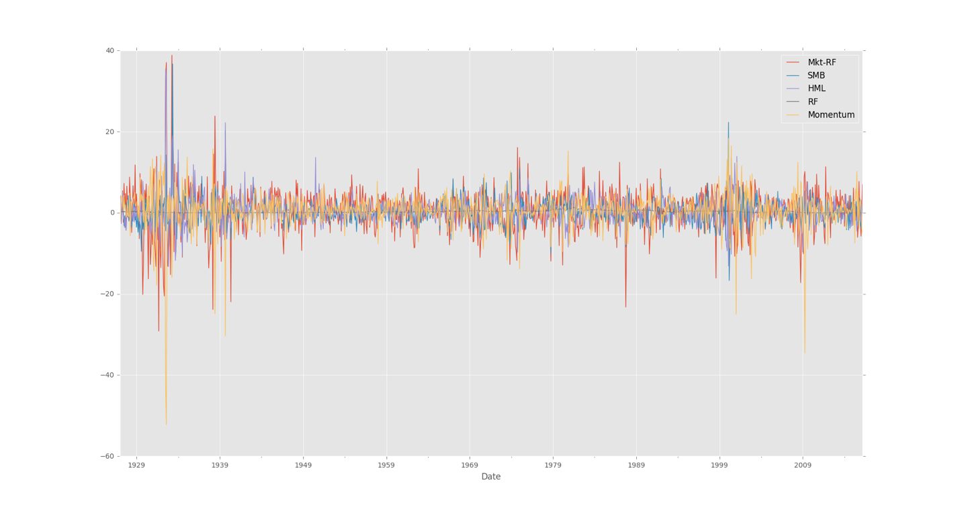

The above is a non-scaled version of the data. We then scaled the data by dividing every factor by its maximum value. The y-axis is is a relative scale whereas x-axis is from 1927-2016. See the diagram below.

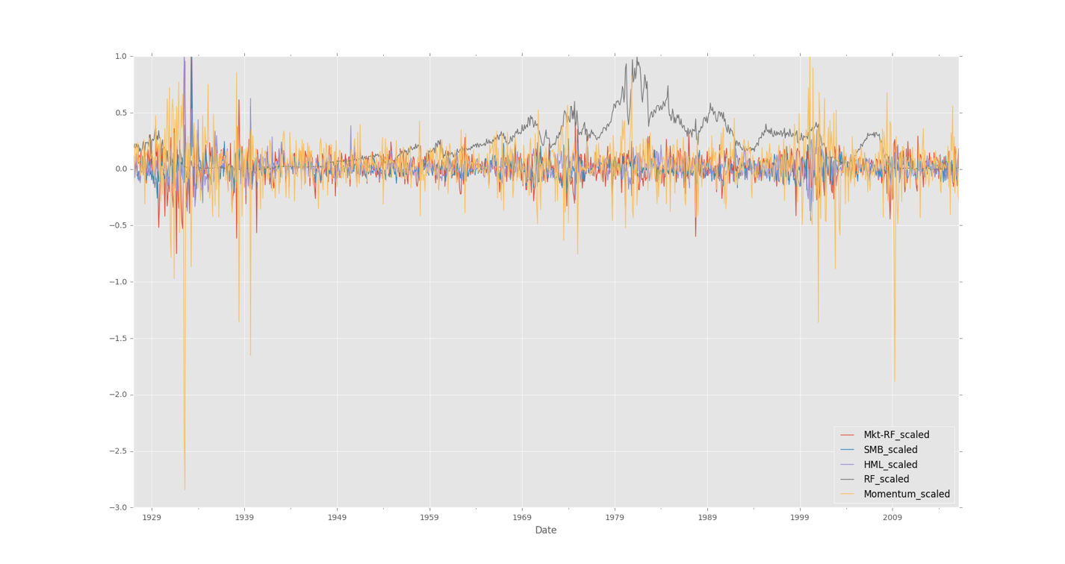

Now, the risk free rate seems independent of any pattern but other factors like SMB and HML seems to be mean reverting and do convey the cyclical nature of the market. To verify the auto-correlation, we run an auto-correlation test and the below plot does show what our intuition is already saying about the HML and SMB following a mean-reversion. Risk-free rate does not follow any such pattern.

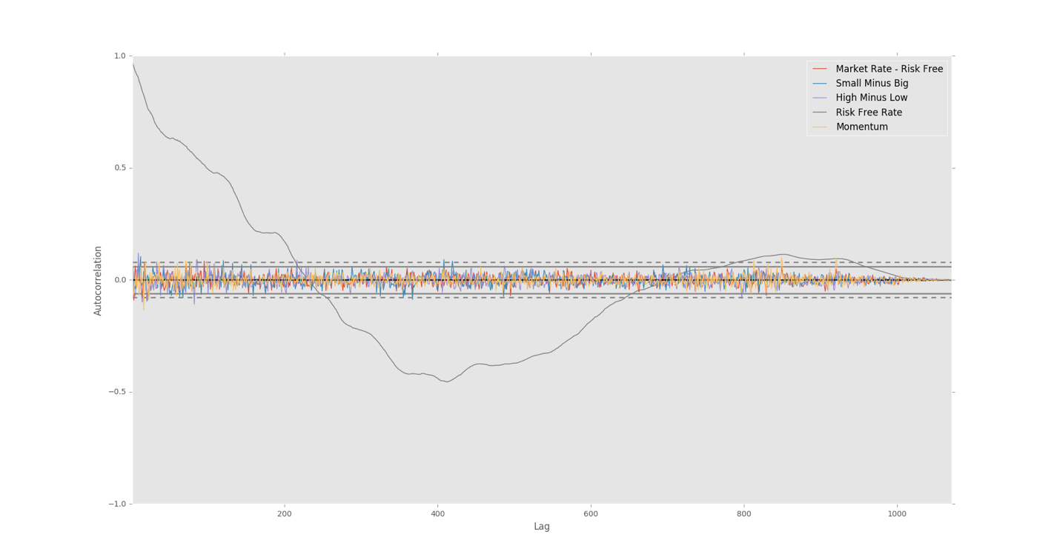

We then run a correlation test over these factors before running a regression. There is no significant relationship found between these factors. Auto correlation plot does show the same.



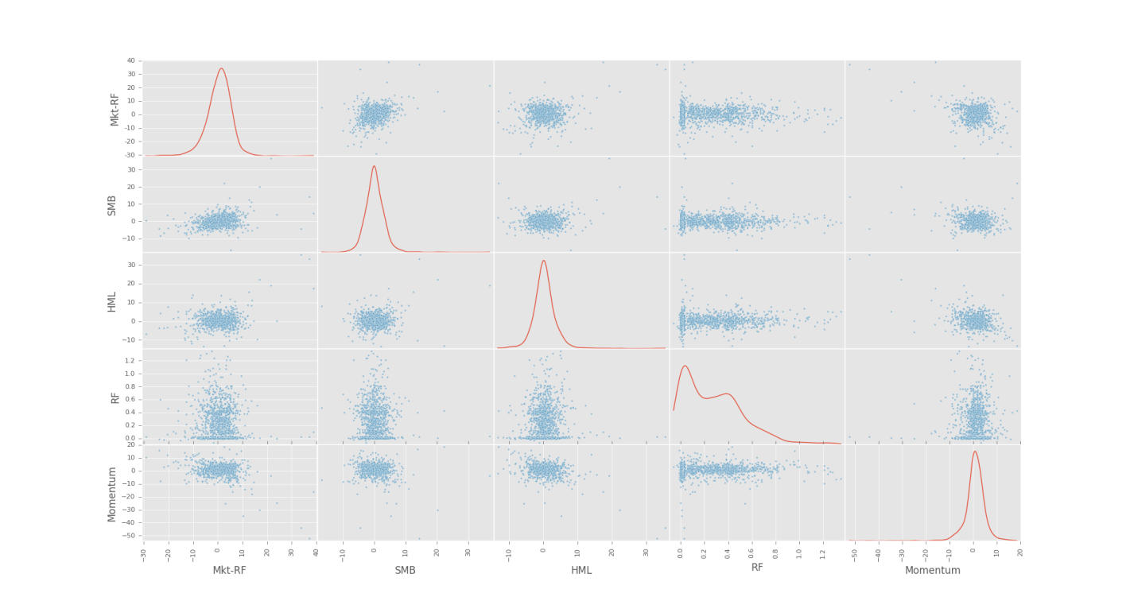

Finally, we picked two major ETFs, IJT and IVW and list of top ten mutual funds from http://www.zacks.com/funds/top-ranked-mutual-funds.php for our testing. We downloaded the daily returns of these ETFs from Yahoo and did a conversion of returns to obtain weekly return for these portfolios.

In next section, we do show the results.

Broad market ETFs like IJT and IVW did well on the model and better than CAPM. Though we found both both models valid and appropriate, Fama-French was much more accurate than CAPM. Thus we do recommend Fama-French as a risk model for such broad equity covering ETFs. This should be expected as the factor calculation is based on the broad market.

For mutual funds covering Gold, Metals or commodities, namely UNWPX, UTPIX, FSAGX, VUIAX, BULIX, the model did very poorly. We could not find any linear relationship between the model factors and the returns for these mutual funds. Though, Fama-French was better than CAPM in all cases, the results were not good enough.

For mutual funds covering sectors in the market like FSRPX, we do see Fama-French providing a better relationship. Though, adjusted R-squared values are still not good enough.

For this reason, we do try to find if there is a different relationship between these factors and sector returns. We cover that in alternative model in section 7.

# Statistical Tests

We conducted F-test to all the OLS regressions on different funds and obtained F-statistic, p-value, adjusted R-square respectively. Below is a summary of all the statistics and corresponding comments of regression model.

|  |  |  |  |  |  |  |
| --- | --- | --- | --- | --- | --- | --- |
| Name of fund | Test on linear relation | | | Test on appropriation | | Overall conclusion |
|  | F-statistic | P-  value | Significant  Linear relation? | Adjusted  R-square | Appropriation | Valid & Appropriate |
| IJT(Fama) | 3108 | 5.47e-225 | Yes | 0.969 | Yes | Yes |
| IJT(CAPM) | 2077 | 3.94e-137 | Yes | 0.873 | Yes | Yes |
| IVW(Fama) | 6419 | 5.05e-271 | Yes | 0.985 | Yes | Yes |
| IVW(CAPM) | 1.052e+04 | 3.67e-236 | Yes | 0.972 | Yes | Yes |
| UNWPX(Fama) | 20.63 | 3.57e-12 | Yes | 0.163 | No | No |
| UNWPX(CAPM) | 46.68 | 4.64e-11 | Yes | 0.131 | No | No |
| UTPIX(Fama) | 66.67 | 4.90e-33 | Yes | 0.395 | No | No |
| UTPIX(CAPM) | 170.2 | 3.85e-31 | Yes | 0.359 | No | No |
| FSAGX(Fama) | 9.917 | 2.98e-06 | Yes | 0.081 | No | No |
| FSAGX(CAPM) | 20.03 | 1.08e-05 | Yes | 0.059 | No | No |
| VUIAX(Fama) | 66.32 | 6.68e-33 | Yes | 0.394 | No | No |
| VUIAX(CAPM) | 171.1 | 2.86e-31 | Yes | 0.36 | No | No |
| BULIX(Fama) | 151.3 | 1.2e-59 | Yes | 0.599 | No | No |
| BULIX(CAPM) | 402 | 2.21e-57 | Yes | 0.57 | No | No |
| BGEIX(Fama) | 10.29 | 1.82e-06 | Yes | 0.084 | No | No |
| BGEIX(CAPM) | 20.29 | 9.51e-06 | Yes | 0.06 | No | No |
| VTCAX(Fama) | 199.1 | 6.08e-71 | Yes | 0.663 | Yes | Yes |
| VTCAX(CAPM) | 577.2 | 5.86e-72 | Yes | 0.656 | Yes | Yes |
| FSRPX(Fama) | 283.1 | 5.21e-87 | Yes | 0.737 | Yes | Yes |
| FSRPX(CAPM) | 728.9 | 2.17e-82 | Yes | 0.707 | Yes | Yes |
| SVAAX(Fama) | 258.4 | 1.10e-82 | Yes | 0.719 | Yes | Yes |
| SVAAX(CAPM) | 627.4 | 1.35e-75 | Yes | 0.675 | Yes | Yes |
| SNPIX(Fama) | 305 | 1.24e-90 | Yes | 0.751 | Yes | Yes |
| SNPIX(CAPM) | 782.1 | 1.10e-85 | Yes | 0.721 | Yes | Yes |

We divided the statistical test into two parts for explanation purposes, the first one is to see whether there is significant linear relationship between predictor variables and dependent variable; the second part is evaluating whether the model can appropriately explain the relation based on adjusted R-square.

For p-value smaller than significant level (usually 0.05 or 0.1), we consider that there is significant linear relationship between predictor variables and dependent variable; For adjusted R-square greater than 0.6, which means over 60% of the variance can be explained by the model, we consider the model to be valid and appropriate.

# Model to find a tensor relationship

Since, both Fama-French and CAPM faired rather poorly for sector mutual funds like FSAGX, VTCAX, FSRPX, we used modern neural network techniques to find if there is a tensor relationship between factors and returns.

To do so we reclassified it as a classification problem. All positive returns were taken as 1 and all negative returns were taken as -1. We ran a simple neural network and treated this as a binary problem. In our second test, to find deeper relationship amongst the factors, we introduced two hidden layers in our neural network.

We divided our data into train and test ratio 80%:20%. Though our network has a training accuracy of 85% over thirty thousand iterations, this could have been result of over fitting.

We define some metrics here to evaluate the models, namely

* Precision - The ability of the classifier not to label as positive a sample that is negative.
* Recall - The ability of the classifier to find all the positive samples.
* F1 Score - A weighted average of the precision and recall, where an F1 score reaches its best value at 1 and worst score at 0.
* Accuracy - The percentage correctly predicted in the test data.

Results from Binary classifier:

* Precision= 0.678571428571
* Recall= 0.863636363636
* F1Score= 0.76
* Accuracy= 0.803278688525

Results from Deep learning binary classifier:

* Precision= 0.72
* Recall= 0.818181818182
* F1Score= 0.765957446809
* Accuracy = 0.819672131148

Though, we did have a high accuracy and precision rate but we think they are not high enough to merit recommending this model.

Another disadvantage of a deep learning model is all the weights and learning are what your model learns and are difficult to explain to a trader/regulator. The results though are somewhat encouraging and further research and/or use of Barra style factors may provide a much better risk model.

# Model Strengths and Weaknesses

This section summarizes the strengths and weaknesses of the Fama-French three factor model (FF3FM).

## Strengths

Strengths of the model are shown below. Note that many of these are really strengths compared to the CAPM model which it improves upon.

* CAPM in empirical tests was a failure; Miller and Scholes (1972) found that betas in CAPM are measured with error and that measurement error in the right-hand variables biases down regression coefficients. Fama and MacBeth (1973) and Black, Jensen, and Scholes (1972) addressed the problem by grouping stocks into portfolios because it has lower residual variance and more stable over time as individual stock betas vary over time as the size, leverage, and risks of the businesses change. Book/Market sorted portfolios show a large variation in returns that is unrelated to market betas. Merton (1971, 1973a) recognized the theoretical probability that factors, state variables, or sources of priced risk beyond movements in the market portfolio explain why some average returns are higher than others. The Fama-French three-factor models successfully explains the average returns of the 25 size and book market sorted portfolios with a three-factor model, consisting of the market, a small minus big (SMB) portfolio, and high minus low (HML) portfolio.
* CAPM failed to explain value-size puzzle i.e. stocks are sorted into portfolios based on size and book/market ratio rather than size alone. Variation in size produces a variation in average returns that are positively related to variation in market betas. Variation in book/market ratio produces a variation in average returns that is negatively related to market beta. CAPM is a disaster when confronted with these portfolios whereas the three-factors resolve this puzzle by producing consistent results.
* A central part of the Fama-French model is that these three pricing factors also explain a large amount of the ex post (based on actual result) variation in the tested portfolios; the R2 in time-series regression are very high, in the 90-95% range.
* It can be regarded as a model in arbitrage pricing theory. If the returns of the book/market portfolios could be replicated by the returns of the three-factor portfolios (SMB and HML can be seen by self-replicating portfolios), near-arbitrage opportunities exist if value and small stocks did not move together in the way described by the Fama-French model.
* Hints of some sort of “distress” or “recession” factor implied by Fama-French factors as proxies of macroeconomic risks. Liew and Vassalou(1999) found that in many countries counterparts to HML and SMB contain information above and beyond that in the market return for forecasting GDP growth.
* It saved the whole EMH or modern financial economic field by augmenting the CAPM!

## Weaknesses

The model shares some of the weaknesses to that of CAPM:

* The assumption that Small Caps and stocks with low Price to Book rations tend to do better than the market as a whole is not necessarily true in all markets and in all time periods.

In addition:

* Size and book value have no well-founded theoretical background. There is really no fundamental reason to sort portfolios based on two-way or larger sorts of individual characteristics. The argument over the status of size and book/value factors continues.
* Sorting stock based on past performance, a portfolio consisting of longing long-term losers and shorting long-term winners does better than the opposite. The mean reversal effect is explained by the Fama-French model. However, a portfolio that buys short-term winners and sells short-term losers also does well—“momentum”, hence a puzzle is not explained by the Fama-French model. Hence, the Cahart four-factor model was introduced to address this puzzle.

# Appendices

1. Bibliography

CAPM, W. (n.d.). *Capital Asset Pricing Model*. Retrieved from Wikipedia: https://en.wikipedia.org/wiki/Capital_asset_pricing_model

*Carhart four-factor model*. (n.d.). Retrieved from Wikipedia: https://en.wikipedia.org/wiki/Carhart_four-factor_model

French, K. (n.d.). *Kenneth French Data Library*. Retrieved from Dartmouth: http://mba.tuck.dartmouth.edu/pages/faculty/ken.french/data_library.html

Wikipedia_FamaFrench. (n.d.). *Fama-French three-factor model*. Retrieved from https://en.wikipedia.org/wiki/Fama%E2%80%93French_three-factor_model

Google tensorflow code. Retrieved from https://cloud.google.com/solutions/machine-learning-with-financial-time-series-data

Data retrieved from yahoo and quandl.

1. Source Code

See attached IPython Notebook PDF.

