Introduction
Citation counts, the number of times that research is cited, are predominantly used to assess the academic impact of research (Daud et al., 2019). A large body of scholars employs such metrics to study the correlations between linguistic features and the citation performance of academic papers.
For example, Wang et al. (2023) studied the effect of the Chinese phrase jiyu (基于), which means “based on”, and the phrase kaolv (考虑), which means “in consideration of”, on the academic impact of research embedded within paper titles. Similarly, Zhu and Liu (2023) analyzed the relationship between online attention and linguistic features of article titles.
However, to the best of our knowledge, previous studies rarely examine how an abstract can affect the academic impact of research. Actually, in most cases, researchers merely study the relationship between titles and academic impact. Nevertheless, more attention should be paid to abstracts, because the quality of abstracts equally matters, especially when readers are primarily attracted by a compelling title while being discouraged by a poorly written abstract. In such cases, readers may miss an excellent article.
This study aims to extract the linguistic features of abstracts. To define our data scope and to secure a sufficient sample size, we need to narrow down our scope. Finally, we choose the field of corrosion science, which has a large number of papers with standardized data reporting norms. Also, it is a field that we are relatively familiar with. Furthermore, we seek to find a probable academic impact facilitator and predictor in abstract writing.
Two main questions are studied in this paper:
(1) What is the relationship between the linguistic features of abstracts and the citation counts of research articles?
(2) Which linguistic feature of abstract is most suitable for citation counts prediction?
We will adapt the strategy of machine-learning to extract some specific features, which will be expatiated in Methods.

Method

Material

Corpus Construction
The corpus employed by this research is the abstracts of the research articles published by Corrosion Science from January 2023 to May 2026. The data source is OpenAlex, an open-source tool that catalogs scholarly works and their metadata including the Digital Object Identifier (DOI), title, year of publication and citation counts. OpenAlex has been proved as a reliable data source and it provides an easy way for scientometric researchers to conduct quantitative analysis. (Culbert et al., 2025) The abstracts extracted by PyAlex are the form of abstract inverted index, a mapping from words to their positions in the original abstract. A python program was designed by us to transform the abstract inverted index to readable sentences. Finally, we combined the metadata and abstracts into a Pandas DataFrame as our dataset with 376 articles.

Normalized Citation Count
the same potential to attain academic focus, the article which has been published earlier may get more citations. Thus, we conduct mean scaling normalization to decouple the dependent variable and eliminate the time accumulation affect by introduce the context.
Normalized citation count (NCC) is calculated by the formula below:
$$NCC_{p}=\frac{RCC_{p}×N_{p}}{Sum_{RCC}}$$
where $NCC_{p}$ stands for the normalized citation count of the article p, and $RCC_{p}$ is the raw citation count of p, the $N_{p}$ is the number of articles in the same year with p, the $Sum_{RCC}$ is the sum of $RCC_{p}$ in the same year with p. The mean scaling normalization is proved to be a efficient way to normalize citation counts by its citation performance related to the average citation levels of its publication year.(Zhu & Liu, 2024)

Feature Engineering

Mean Word Length (MWL)
This feature is calculated by the mean length of words (measured by number of letters) in abstract. It is an significant factors of an article’s readability. (Sawyer et al., 2008)

Lexical Complexity (LC)
This feature is measured by Type-token Ratio (TTR), calculated as the proportion of unique words to total words in abstracts. Higher lexical richness indicates greater lexical diversity and a wide range of vocabulary utility.

Lexical Density (LD)
This feature is the proportion of non-essential words in the abstract. Essential words are identified using the essential word list provided by Dang and Webb (2016), which consists of high-frequency function words, pronouns, prepositions, conjunctions, and other commonly used English words. It is another feature which has the potential to describe the information density of certain text.

Abstract Length (ASL)
This feature is the number of words in abstracts. Longer abstracts may include more information which might lead to more citations.

Jargon Density (JD)
This feature is defined as the proportion of domain-based jargons in abstracts. The jargon list is provided by National Materials Corrosion and Protection Scientific Data Center (2019). A higher proportion of jargon may indicate a higher specification in corrosion field.

Hedging Density (HD)
This feature is defined as the proportion of hedging words in abstracts. The hedge list is extracted from a publicly available hedge lexicon obtained from a github repository, which contains modal verbs, epistemic verbs, probability markers and other uncertainly-related expressions. A higher hedging density suggest writers’ caution.

Data Analysis

Linear Regression Analysis

Decision Tree Analysis

results

Descriptive Statistics
The primary descriptive statistics of 6 linguistic features is shown in Table 1, where a comprehensive overview of the dataset (N = 377). It describes the central trends and the distribution of these linguistic features. We could separate these features into to 2 groups with different distribution features according to the skewness. Group 1 including MWL, LC and LD with the skewness smaller than 0.5 shows highly symmetric in distribution curve. And the group 2 consisting of ASL, JD and HD presents a right-skewed distribution.
Table 1 Descriptive statistics of features
Features | N | Mean | SD | Median | Min | Max | IQR | Skewness
MWL | 377 | 6.710 | 0.520 | 6.750 | 4.770 | 8.140 | 0.680 | -0.180
LC | 377 | 0.571 | 0.103 | 0.569 | 0.279 | 0.837 | 0.160 | 0.040
LD | 377 | 0.711 | 0.044 | 0.711 | 0.583 | 0.831 | 0.055 | -0.080
ASL | 377 | 19.810 | 5.380 | 19.360 | 7.440 | 42.500 | 5.880 | 0.830
JD | 377 | 0.038 | 0.018 | 0.036 | 0.007 | 0.094 | 0.025 | 0.690
HD | 377 | 0.015 | 0.012 | 0.012 | 0.000 | 0.071 | 0.013 | 1.180

To access a direct presentation of the skewed distribution of these features, we drawn the box plot Figure 1. In Figure 1 the red lines represent the mean value of these features and the blue line shows the median value. The distance of the red line and the blue line straightforward displays the skewness of each feature, witch is coordinate with the data in Table 1.
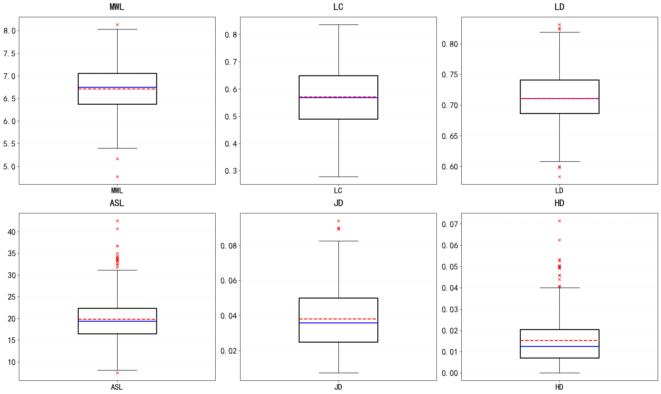
Figure 1 Box plots of the six linguistic features

Correlation Analysis
The result of the correlation analysis is organized as a correlation matrix in Table 2. The RQ1 “What is the relationship between the linguistic features of abstracts and the citation counts of research articles?” is answered by the last line of the correlation matrix. The Pearson’s correlation coefficients between NCC and the 6 linguistic features are all smaller than 0.3, which shown a negative result in relationship. Besides, other coefficients in Table 2 are also smaller than 0.3, which suggest that these features are not coupled with each other deeply and offering a potential in single variable linear regression.
Table 2 Correlation matrix of features
 | MWL | LC | LD | ASL | JD | HD | NCC
MWL | 1.000
LC | 0.503 | 1.000
LD | 0.110 | -0.040 | 1.000
ASL | -0.030 | 0.028 | -0.241 | 1.000
JD | 0.326 | 0.490 | 0.029 | -0.064 | 1.000
HD | 0.050 | 0.139 | -0.189 | 0.021 | -0.023 | 1.000
NCC | 0.122 | 0.044 | 0.152 | -0.092 | 0.142 | -0.013 | 1.000

To prepare for linear regression analysis, Figure 2 illustrates the scatter spot matrix of the 6 linguistic features and NCC, which offers a direct presentation of the correlation matrix. The last line of the matrix shows the distribution of NCC and the relationship between the independent variables and the dependent variables. The histograms on the diagonal shows the right-skewed distribution of NCC, which might lead to the weak correlation coefficient and the regression effect.
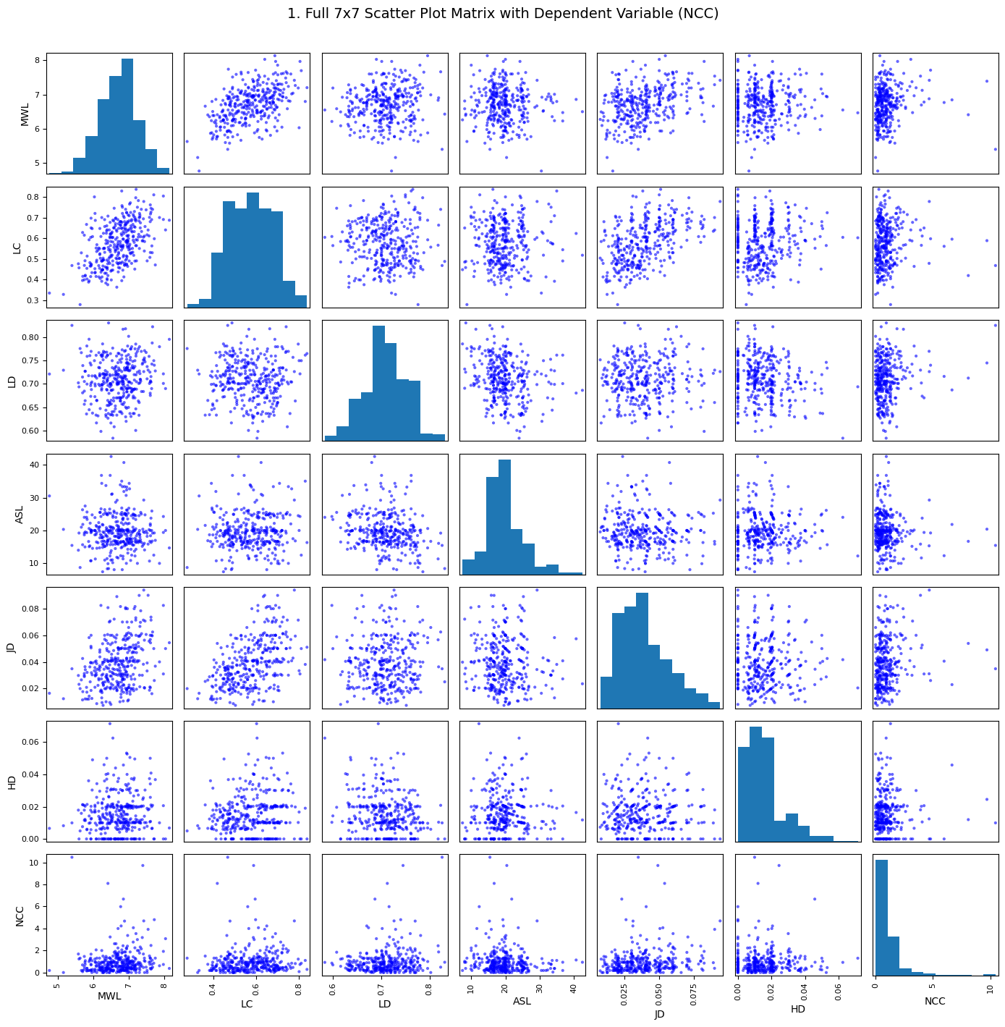
Figure 2 Scatter spot matrix of features

Regression Results
Due to the weak regression effect proved by the Figure 2, we have just conducted single variable linear regression from JD to NCC with the machine learning model powered by scikit-learn library as an examination to the effect of regression. The result is reported in Figure 3. The X-axis shows the JD feature and the Y-axis shows the NCC under log1p transform, which aim to level the right-skewed effect. However, the feature of the research question causes that the regression line dose not seem like to be a great predicter.
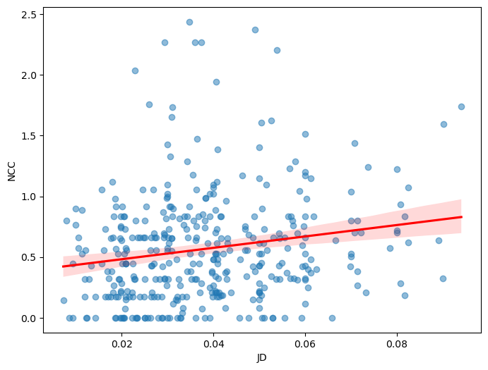
Figure 3 Single variable linear regression fitting between JD and log(1+NCC)
Table 3 summarize the result of the linear regression, which address the weak predict effect suggested by Figure 2 and Figure 3. Though the t-value and p-value indicate that the regression result efficiently shows the trends of NCC-JD impact, the R² = 0.033 represents that the JD fit line can only explain 3.3% of the variation. Given that JD is almost the most related feature with NCC, this regression test suggests that there is no need to conduct other regression for the weak predict effect.
Table 3 Summary of single variable linear regression results for JD predicting log-transformed NCC
Variable | Coefficient (β) | Standard Error (SE) | t-statistic | p-value | 95% Confidence Interval
Constant | 0.388 | 0.055 | 7.072 | < 0.001 | [0.280, 0.495]
JD | 4.698 | 1.303 | 3.605 | < 0.001 | [2.136, 7.260]

Decision Tree Results
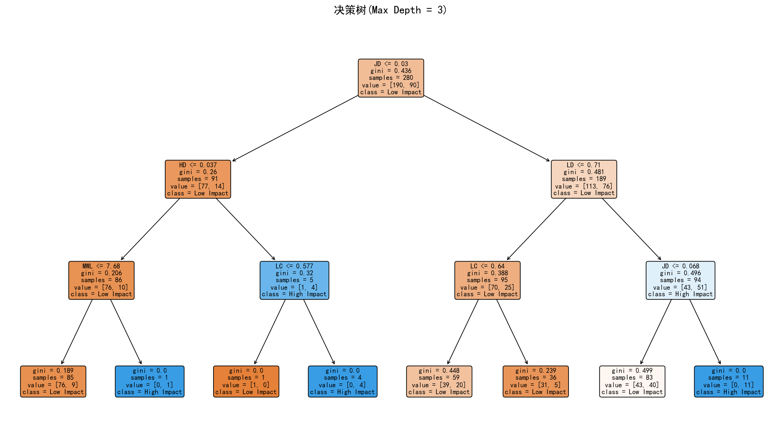
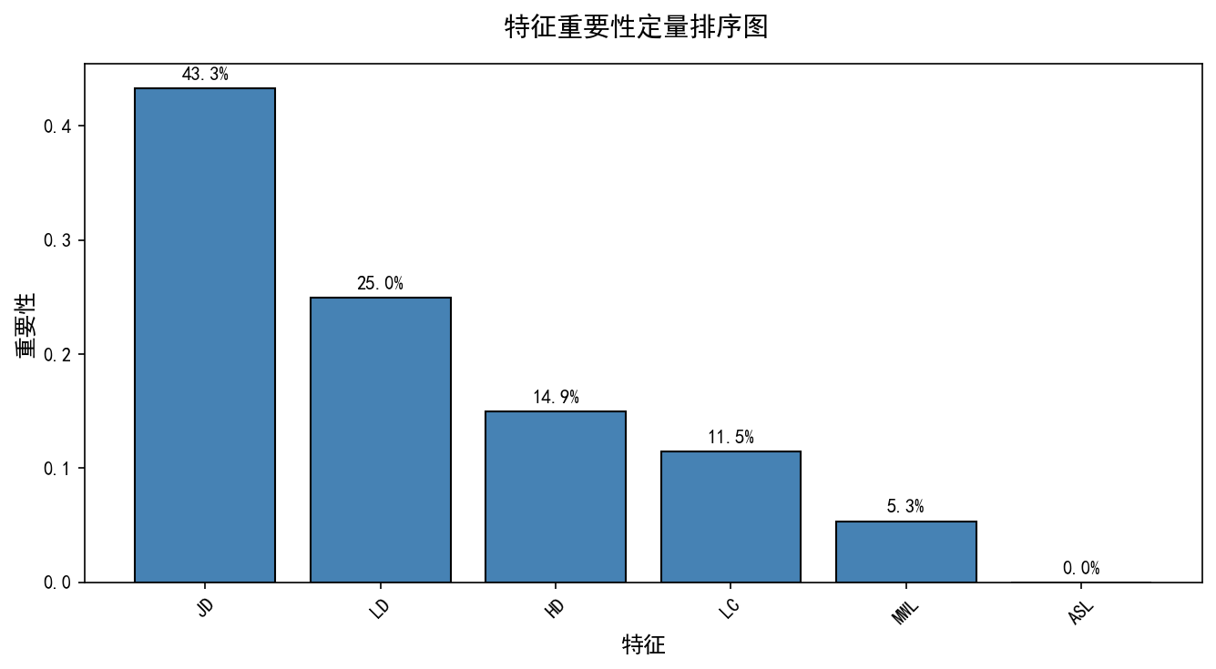

Discussion & Conclusion
This research concentrated on the relationship between the linguistic features of the abstract of research article and its citation count based on a corpus of 377 articles. For the RQ 1, the correlation analysis explained that there is a significant relationship, though it is too weak to explain the inner reason. This result is also demonstrated by the linear regression analysis. The RQ 2 is addressed by the decision tree analysis which reveal that the JD feature shows a strong potential in predicting the citations. However, the result of RQ 1 sets a surprising conflict to discuss in the RQ 2. We will try to explain the conflict in following paragraphs.
To explain the reason why the weak relationship can coexist great predicting effect, we begin with the deep mechanism of the correlation. The analysis of relationship like the Pearson’s correlation coefficient and the single variable linear regression are based on the hypothesis that the distribution of data is globally homogeneous and linear. However, in the field of academic writing, the linguistic features present a highly diversity among the different authors. Besides, the citation count is a multi-factor depended variable (Tahamtan & Bornmann, 2019), which eliminate the validity of linear regression. That explains why the regression result is weak but significant.
To explain non-linear relationship, the decision tree model is introduced to simulate the reading-citing progress. This model is very different from linear regression because it does not think the data is same across all authors.
In this simulation, the first split point is Jargon Density at 0.03. This can be explained as a basic entrance score for this academic community. If an abstract has a JD lower than 0.03, the researchers will feel it is too simple or descriptive. They will not cite it. Then, another interesting point is when JD is higher than 0.068. When this feature combine with LD higher than 0.71, the model find 11 papers and they are all high-cited papers. This simulate that when a reader find a very professional abstract with big information, they will believe it is a great innovation. This localized step-wise process explained the "surprising conflict" we mentioned before. Linear regression cannot see this because it try to draw a straight line, but the reading-citing progress actually works by these different threshold checkpoints.
A former study proved that while a paper's overall length and reference count help increase citations, abstract readability exhibits the strongest positive impact on scientific visibility, though linguistic characteristics as a whole still exert a limited influence on acquiring citations (Porwal & Devare, 2024). Our research is coordinated with Porwal and Devare’s analysis. Though the simulation of reading-citing progress indicate that JD could be a significant predictor of citation counts, the predictive effect is still limited because of the multi-factor dependency. However, our result of JD is totally different from Martinez and Mammola’s study (2021), which claimed that the density of jargon might reduce the citation of article. To the best of our knowledge, this could be caused by the difference between different fields. But this requires further research in conducting this method to more different topics.
This study provides several valuable insights, but it also has some limitations. For the contributions, this research successfully settles the RQs and the surprising conflict between the RQs by introducing a machine learning lens. Simulating the reading-citing progress via a decision tree provides a new method to understand how scientific texts are evaluated by the academic community. This can help researchers optimize their abstract writing, especially by balancing the professional jargon and information density to pass the peer checkpoints. However, we must acknowledge some limitations. First, our corpus only contains 377 research articles, which is a relatively small sample size and might limit the generalizability of the tree thresholds. Second, this dataset is collected from a specific scientific discipline, so the exact checkpoints like 0.03 and 0.068 might change in other fields like social sciences or humanities. Future studies can expand the corpus size and test this cognitive simulation framework across different disciplines to verify if these localized non-linear mechanisms are universal.

