**Description**

In this programming homework, you will write a program that uses the Q-learning algorithm to determine the best path to a goal state

###### Format

Similar to the format described in the class, you will work with a 4*4 board. Each of the 16 squares has a unique index, as shown on the corner left of the two example boards in Figure 1. There are five special squares on the board. These five squares are the start, goal, forbidden, and wall squares. The remaining 11 squares are empty and ordinary squares. The starting square (shown with the letter S) is fixed and always at square 2. The location of the two goals, forbidden, and wall squares are determined from the input. An agent has four possible actions of going to the north, east, south, and west. The board is bounded from the sides.

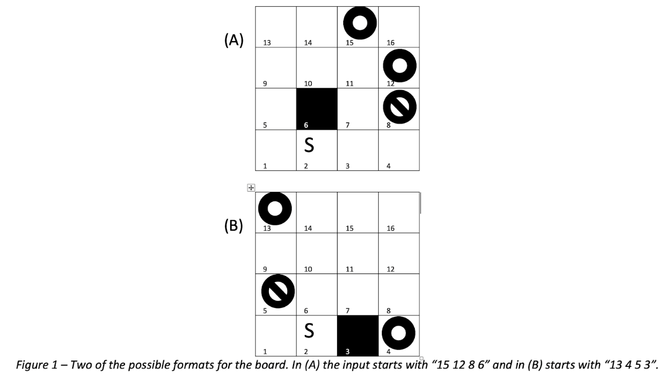

**Input**

The input to your program consists of four numbers, one character, and possibly an additional number [# # # X (#)]. The first four numbers show the location of the two goals, forbidden, and wall squares respectively. Figure 1 shows two possible inputs and the corresponding board configuration based on each of those inputs. The remaining items in the input, determine the output format. The fourth item is either character “p” or “q”, and if it’s “q”, there will be an additional number at the end. Item “p” refers to printing the optimal policy (Π*), and “q” refers to the optimal Q-values (Q*). You can assume that the five special squares are distinct (non-overlapping).

**Implementation**

You should use Q-learning to calculate the best action for each square to reach the goal square. In the beginning, all of the Q-values are set to zero. The (hypothetical) agent should start from the S square. The agent iteratively updates the Q-values for each state, by following the main formula discussed in the class:



In this problem, the living reward for every action (each step) is r=-0.1. The discount rate is γ = 0.1, and the learning rate is α = 0.3. The reward for performing the exit action (the only available action) in both goal squares is +100, and for the forbidden square is -100. The agent cannot enter or pass through the wall square. After hitting the wall, the agent’s position will not be updated. It will remain in the same square and will keep getting a -0.1 reward every time it hits the wall. For the purpose of exploring the board, use an ε-greedy method with ε = 0.5. This means that with the probability ε, the agent acts randomly, and with the probability 1-ε, it acts on current policy. In order to have a similar random value use 1 as the seed value of your random function.

**Convergence**

If needed, you can also set a maximum number of iterations to 100,000. After that, you can set ε= 0.

**Output**

If the input contains “p”, your program has to print the best action that should be chosen for each square or in other words print Π*. To do this, in separate lines print each state’s index and the action. Here is an example:

*Input:*

  15 12 8 6 p

*Output:*

1    up

2    right

3    up

4    left

5    up

6    wall-square

7    up

8    forbid

9    up

10    up

11    up

12    goal

13    right

14    right

15    goal

16    up

If the input contains “q” following a number n, the program has to print the four Q-values associated with each of the four possible actions in the state that has an index n. Here is an example:

*Input:*

  15 12 8 6 q 11

*Output:*

 up    100.0

right    100.0

down    3.88

left    3.88

**Tie-Breaking**

In some situations, there might be similar q-values for different actions in the final stage when we want to print the final policy. For example:

Input: 15 12 8 6 q 11

Output:

up 100.0

right 100.0

down 3.88

left 3.88

Here we have two similar maximum q-values for the up and right actions. In these situations, to have a convention for the output, let’s assume a clockwise priority for printing the final policy which starts from up. In this case, **up, right, down, left** would be our priority order.

**Additional examples**

Input:10 8 9 6 p

output:

1 right

2 right

3 up

4 up

5 down

6 wall-square

7 right

8 goal

9 forbid

10 goal

11 left

12 down

13 right

14 down

15 down

16 down

input:10 8 9 6 q 2

output:

up    -0.01

right    0.89

down    -0.01

left    -0.1

         input:12 7 5 6 p

         output:

                     1 right

2 right

3 up

4 up

5 forbid

6 wall-square

7 goal

8 up

9 up

10 up

11 up

12 goal

13 up

14 up

15 up

16 up

         input:12 7 5 6 q 3

         output:

up    100.0

right    0.89

down    9.9

left    0.89

Input: 13 11 16 5 p

Output:

1  right

2  up

3  up

4  up

5  wall-square

6  up

7  up

8  up

9  up

10  right

11  goal

12  left

13  goal

14  left

15  down

16  forbid

Input:

13 11 7 15 p

Output:

1 up

2 up

3 right

4 up

5 up

6 up

7 forbid

8 up

9 up

10 right

11 goal

12 left

13 goal

14 left

15 wall-square

16 down