**Effects of Colors, Numbers, and Priming on Memory Span**

Jemuel Santos and Hongyuan Zhang

**Introduction**

According to Kuiper and Sklar (2013, p. 172), memory is the process of retaining and recalling knowledge or experiences, and human memory is very complex and can be tested in many ways. We are specifically interested in one type of memory test, serial recall. According to Kreutzer, Caplan and DeLuca (2011, p. 2265), a serial recall task requires participants to recall a list of items in a specific order, usually the order in which they were presented. Kuiper and Sklar (2013, p. 172) stated that memory span is defined as how many items a subject can remember in order without an error. Kreutzer, Caplan and DeLuca (2011, p. 2265) stated that many factors, for example, list length, recall order, modality, and participant age affect memory span.

In this study, we are specifically interested in whether two kinds of visual cues, colors and numbers, and the priming effect impact memory span. According to Dzulkifli and Mustafar (2013), colors have been found to influence memory performance by increasing our attention level, and arousal. Numbers, compared to colors, have been less explored as a factor impacting memory performance. How numbers’ effect size compares to colors’ has been explored even less. Avons and Mason (1999, p. 4) showed that serial memory for patterns is sensitive to visual similarity, and more specifically, when the objects are more visually similar, the error scores measuring the errors made when recalling the order of these objects increase. We expect that the added dissimilarity to objects from adding colors or numbers will improve memory span. Thus we hypothesized that both colors and numbers are significant factors improving memory span.

We are also interested in whether two visual cues (colors and numbers) improve memory span more than one visual cue (colors or numbers) does. According to Kovattana and Kraemer (1974, p. 256 - 257), a single cue model occurs when a subject is presented with two cues, views them as competing, and can use only one, and the single model cue thus assumes that the probability of a correct response using the double cue is no better than the probability associated with the stronger of the two single cues. Kovattana and Kraemer (1974, p. 257) also state that a double-cue model assumes that the two cues can be used simultaneously, and the probability of a correct response when presented with two cues is greater than the probability associated with the stronger single cue. In the case where both numbers and colors are present, we want to see whether the participants will follow the single-cue model, or the double-cue model. We personally thought that the double-cue model would be the model that would be followed by the participants when both cues are present, since two cues provided more dissimilarity to an object than a single cue. Thus we hypothesized that when two visual cues are present, people’s memory spans are longer than when only one is present.

We are also interested in the impact of priming on memory. According to Coren (2004, p. 961), priming is the effect in which the occurrence of one stimulus may make it easier to perceive a later stimulus that is related to it in some way. However, little has been explored about whether priming affects memory span. We hypothesized that a priming experience will improve memory spans if there are visual cues related to that priming experience in a serial recall task. In this study, we explored the impact of colors, numbers and priming on memory spans through an online game, Memorathon[1]. According to Kuiper and Sklar (2013, p. 172), in this game, the subject is expected to repeat a sequence of buttons provided by an electronic device. Each time the subject successfully repeats the given sequence of buttons, the sequence gets longer. The challenge is to remember as long a sequence as possible. The Colors (colors on the buttons) and Label (numerical labels on the buttons) settings in this game specifically allow us to test the effect of colors and numbers on memory spans; an online arithmetic game[2] and two online poems (by Percy Bysshe Shelly)[3] , serving as the pre-exposure devices (priming treatments), allow us to test colors, numbers and priming on people’s memory, as well as the effectiveness of the presence of double cues instead of a single one.

**Methods**

Participants, Materials and Apparatus

Participants were 13 students in our statistics class and 1 class mentor. 1 participant was sick during the normal data collection process, and this participant went through this data collection process on her own starting around 10:30 pm, Oct. 31st in her quiet dorm room. The class mentor did not realize that he had been asked to be one of the participants. He went through the data collection process on his own around 1 pm, Nov. 1st in math commons in the Noyce Building. Materials used include the online arithmetic game, the two online poems and the online Memorathon game. Computers in our statistics classroom were used as apparatus for accessing the materials. The Memorathon game automatically records the result of each trial of the game in its query database. We provided each participant with a Participant ID and a Group ID. Each participant received a distinct Participant ID; the Group ID was the same for every participant. Individual Participant IDs are needed to record a single player’s game results into the database. A group ID is needed to retrieve a group’s game results in the query database. The game records Group ID, Participant ID, Priming Treatment, all the game settings, elapsed time, maximum level completed, item missed and a time stamp for each trial of the game.

Procedure

We assigned half of the 14 participants randomly to one group, call it the arithmetic group. The arithmetic group people were asked to play the arithmetic game for 300 seconds under the settings in Figure 1 before they started the Memorathon game. This arithmetic game experience would serve as a pre-exposure prior to the Memorathon game. For the arithmetic game group, we expected the numerical labels may trigger the priming effect. The 7 participants in another group, call it the poem group, were asked to read the two poems for 300 seconds before they started the Memorathon game.

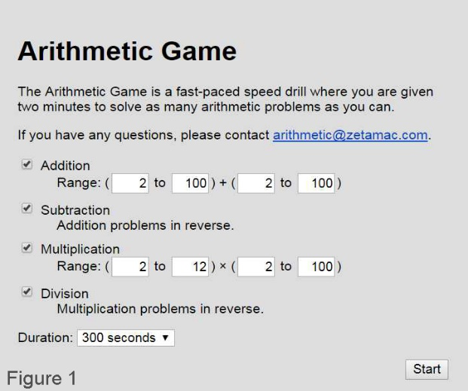

Figure 1. The arithmetic game settings used by the arithmetic game group participants for playing the arithmetic game.

We sent the instructions to each participant via email before we started the data collection process. In the instructions, we asked the participants to make sure that “Speed” was set to “Medium”, “# buttons” to “4 buttons” and “Sound” to “Off” for each trial of the game played. Our participants were also required to fill one row of “External Variables” to make us able to record their Priming Treatment. The label of the row is “Prev”, standing for “Previous Exposure”. The participants from the arithmetic group were asked to fill with “Math” for the value of “Prev”, and the participants from the poem group were asked to fill with “Poem”.

The instructions sent to each participant include a link to the Memorathon game and either a link to the arithmetic game or two links to the two poems, depending which group each participant was belong to. The instructions asked each participant to play Memorathon four times, each time with a different Colors-Label setting. We chose not to use the “Standard” option under the Label setting, since the “Shuffled” option can produce standard-order labels and since we were not interested in how standardly ordered numerical labels would impact memory spans differently from the shuffled numerical labels would. We are interested in how numbers would impact memory spans generally. Notice that then there were two levels for each of Colors and Label: Multicolor and Gray for Colors, Shuffled and Off for Label. Thus there are four level combinations: MulticolorShuffled, MulticolorOff, GrayShuffled and GrayOff. We randomized the order of these four combinations for each participant and included their individual order in the instructions. We asked the participants to play Memorathon four times, each time changing the Colors and Label settings according to the order in the instructions but keeping all the other settings unchanged.

The 12 participants followed and went through our instructions starting around 2:35 pm, Oct. 26 in the statistics classroom. After all the 12 participants finished, we retrieved our dataset from the games’ database. However, the dataset originally contained 53 entries. Two of the participants played 6 times the Memorathon game, but both played all the four combinations. We randomly removed two of the three entries with the same Colors-Label combination for both participants. One entry in our dataset could not be used since the Participant ID is missing and the number of buttons is 3, whereas the number of buttons should have been kept as 4 throughout the data collection process. Thus we eliminated that entry. This leaves us with 48 game results from the 12 participants. Then we contacted the missing classmate and the mentor, and they also went through the data collection process later.

**Design**

We used a split-plot model to analyze our data.

Whole-plot factor: Priming Treatment with two levels (arithmetic game and poems)

Whole-plot unit (blocks): each of the 14 participants

Split-plot factor 1: Colors with two levels (multicolor and gray)

Split-plot factor 2: Label with two levels (shuffled and off)

Split-plot unit: each of the 56 game trials

Response: each of the 56 maximum level completed

We chose to use maximum level completed as our response variable since people’s reaction time differ and since items missed cannot accurately describe our participants’ memory spans. For example, a person who reaches a high maximum level completed may have a high or low number of items missed.

**Results**

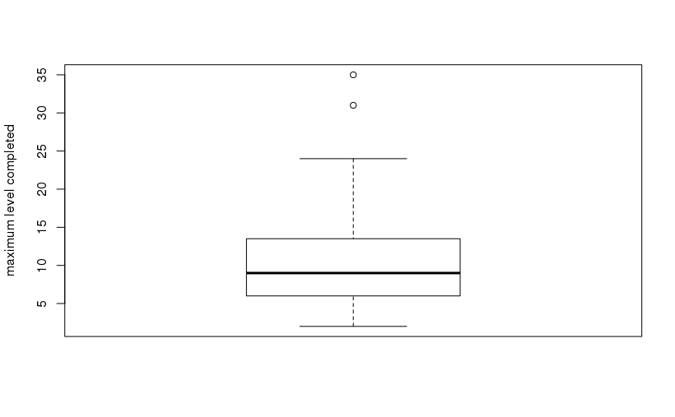

Figure 2. Boxplot of maximum level completed.

Figure 2 shows us that our data is right skewed (but not extremely), and there are two outliers. These two outliers came from two of the 12 participants who were doing the data collection process together and we also watched the 12 participants during this process. Since these 12 participants were in the same environment during the process and we could not think of any factors that could possibly make these two outliers invalid, and since we have a small sample size of 56, we chose to keep them in our data set.

An ANOVA test was performed on the data to determine if any of the variables, or interactions had a significant impact on our participants' memory spans.

Error: as.factor(studentID)

Df Sum Sq Mean Sq F value Pr(>F)

v1value 1 274.6 274.57 6.999 0.0214 *

Residuals 12 470.8 39.23

---

Signif. codes: 0 ‘***’ 0.001 ‘**’ 0.01 ‘*’ 0.05 ‘.’ 0.1 ‘ ’ 1

Error: Within

Df Sum Sq Mean Sq F value Pr(>F)

colorOption 1 4.6 4.57 0.137 0.713

labelOption 1 87.5 87.50 2.620 0.114

colorOption:labelOption 1 77.8 77.79 2.329 0.135

v1value:labelOption 1 31.5 31.50 0.943 0.338

v1value:colorOption 1 28.6 28.57 0.856 0.361

Residuals 37 1235.6 33.39 Table 1. ANOVA results.

From Table 1, we see that the only significant factor is v1value (Priming Treatment), with a p-value of 0.0214 (< 0.05). Thus, we conclude that there exists a mean difference in maximum level completed across different levels of Priming Treatment (arithmetic game and poems). Figure 3 shows that there is an obvious difference between the two group’s means and that the arithmetic group participants had longer memory spans (represented by maximum level completed) for Memorathon on average than the poem group. We did expect that there is a mean difference, since only the arithmetic game treatment is related to one of the visual cues (numerical labels), but the poem treatment does not directly related to either visual cues. Thus, the arithmetic game group participants should have a higher mean overall if the priming effect was at work. However, this p-value and Figure 3 alone do not tell us that the priming effect is a significant factor. Only after examining the interaction between Priming Treatment and Label and the interaction between Priming Treatment and Label can we derive a conclusion, since priming describes an interaction between a pre-exposed experience and a later similar experience.

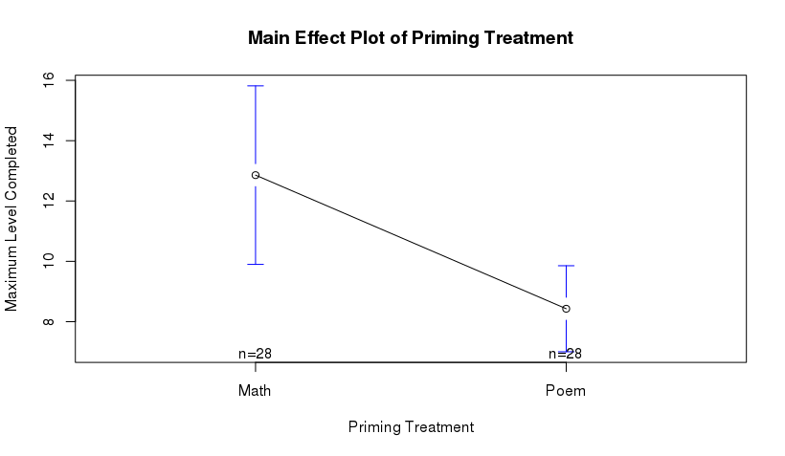Figure 3.

The interaction between Priming Treatment and Label has a p-value of 0.338, and the interaction between Priming Treatment and Colors is 0.361. Although the p-values are close and both indicate an insignificant interaction, the interaction plots tell us different stories. Figure 4, the interaction plot between Priming Treatment and Label, and Figure 5, the interaction plot between Priming Treatment and Colors, first of all, confirms what is shown in Figure 3: the arithmetic group participants had a longer average memory span in any case.

According to the definition of priming, we expected a significant p-value for the interaction between Priming Treatment and Label, but an insignificant p-value for the interaction between Priming Treatment and Colors. The reasons are as following. Since playing an arithmetic game can prime a participant for playing Memorathon with the numerical labels on the buttons, we expected a non-horizontal line for the arithmetic group in Figure 4; however, since poems are not directly related to either visual cues (colors and numbers), we expected the line for the poem group to be horizontal for Figure 4. We also expected the two groups have the same mean maximum level completed for “Off”, but the arithmetic group should have a mean much higher than the poem group for “Shuffled.” We expected two horizontal lines in Figure 5, with the line for the arithmetic group higher than the poem group, since both the arithmetic game and the poems are not directly related to the two visual cues, and thus there would be no priming effect and no mean difference in average maximum level completed, and since for both “color” and “gray”, there was a situation where the numerical labels were on, and thus the priming effect should help the arithmetic group participants.

Figure 4, however, shows us both group had longer mean memory spans when there were numerical labels on the buttons, and the arithmetic game group participants improved more than the poem game group, but not much. Also, the arithmetic game group participants had a higher mean maximum level completed even when no visual cues were present.

Figure 5, however, shows us a slight trend for the arithmetic group participants to have longer memory spans when there were no color cues, and a slight opposite trend for the poem group participants.

Since the p-values and interaction plots for the two interactions contradict our expectations about the priming effect, we cannot say that the priming effect was a significant factor; what we can say only is that the type of previous exposure is a significant factor.

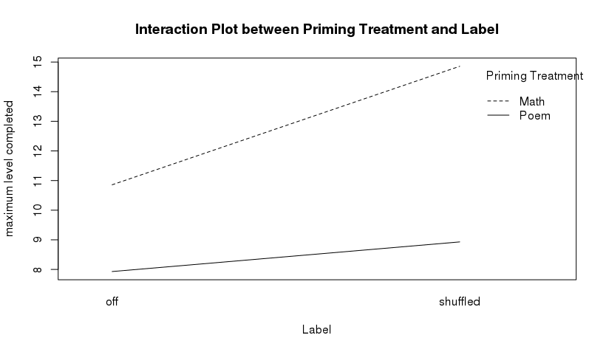 Figure 4.

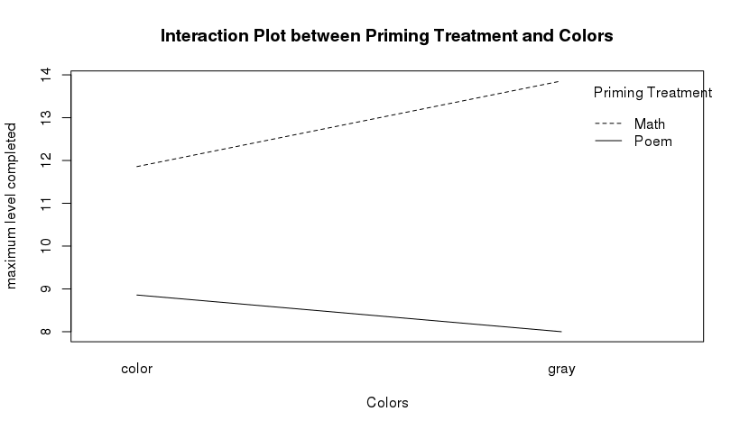 Figure 5.

Although the p-values for both Colors and Label are insignificant (0.713 and 0.114, respectively), Colors is much more insignificant than Label. Figure 6, the main effect plot of Label, and Figure 7, and main effect plot of Colors, confirms these p-values by showing us a more obvious mean difference in maximum level completed in Figure 6. The relative significance of Label can be deduced from Figure 4, since Figure 6 is when we combine the two lines in Figure 4 together. In the same way, the relative insignificance of Colors can also be deduced from Figure 5.

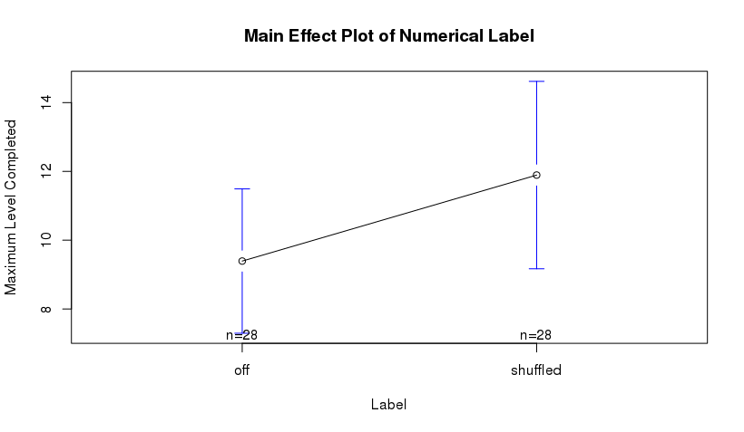Figure 6.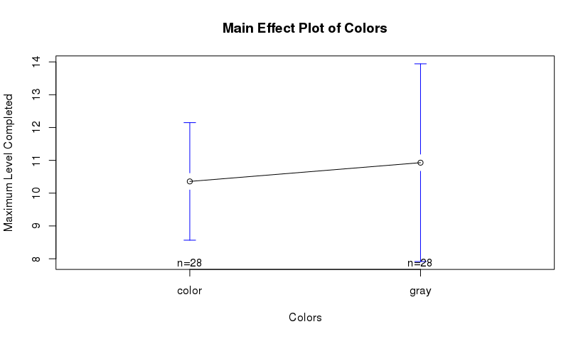Figure 7.

The p-value for the interaction between Colors and Label is 0.135, and thus is insignificant (> 0.05). We tested this for our second question of interest: was the double-cue model followed or the single-cue model followed? Although this interaction is not significant, the important trend is told in Figure 8, the interaction plot between Colors and Label. Figure 8 shows us that our participants did better when there was one visual cue present than there were no visual cues. However, when both visual cues were present, the participants’ mean maximum level completed is less than when only the numerical cue was present. Thus, Figure 8 provides some evidence for the single-cue model. Further, this also provides some evidence that when both cues were present, our participants might use the color cue only, since the mean maximum level completed is almost the same across different Label options.

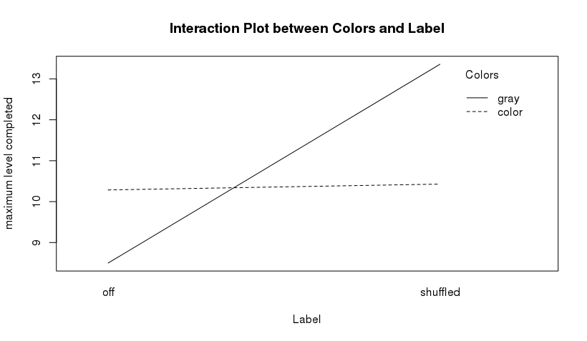Figure 8.

**Discussion**

Results from the ANOVA test shows that only the priming treatments is a significant factor in affecting maximum levels completed in the game, which represents memory spans. This indicates that there may be a possibility that playing an arithmetic game or utilizing some other appropriate tools can improve memory spans. Our research questions (1. Whether colors, numbers and priming effect impact memory spans and 2. Whether the double-cue model is followed in case of a serial recall task) each get some evidence but no solid conclusions. This study provides evidence for the effect of different types of previous exposure on memory spans.

The study employed random allocation by randomly allocating the participants to one of the priming treatments and randomly giving each participant the order of the four level combinations. This allows us to conclude a causal relationship between priming treatment types and memory spans. These results allow us to conclude that an arithmetic game serves as a better primer for this game than poems. What we can say is that the arithmetic game helped our participants to have a higher mean memory span than their poem counterparts, but we do not have enough evidence to say that that help related to the priming effect. Random sampling could not be used in our study due to our limitations in sampling. Due to this, we cannot generalize the results to the general population outside of our Statistics class.

We did our best to control for the environment extraneous variables (gaming location and time) by making the 12 participants follow the data collection procedure at the same time at the same location. We also asked our 2 originally missing participants to do the data collection in a quiet environment. The 2 participants did do the data collection process in quiet environments, however, one of them started around 10 pm and the other one started around 1 pm. Our 12 participants went through our instructions starting around 2:40 pm and in a quiet environment. Thus, these two participant’s participating time may bias their results. However, we could not force them to do it around 2:40 pm. We controlled for the subject-to-subject variability (variability between our participants) by making each participant a block. However, many limitations exist in our study. The sample size of our study was relatively small, with only 14 students partaking in the study. This small sample size also impedes us from checking the ANOVA model assumptions validly (see Appendix A).

For future studies, we would be interested in replicating this experiment with a larger sample size and random sampling to make the results more valid and accurate. We would like to try to answer the question “Why would the participants exposed to the arithmetic game have larger memory spans on average than the ones exposed to the poems?” We would also like to further investigate how numbers impact memory recall. How colors impact memory has already explored, but less was explored for numbers. We would also be interested in how people utilize and memorize numbers when they are present as visual cues. Did our participants utilize the chunking technique when the numerical labels were present? Finally, we are interested in validating whether appropriate types of pre-exposure should be implemented in an educational setting in order to help students remember course contents.

**References**

Avons, S. E., & Mason, A. (1999). Effects of Visual Similarity on Serial Report and Item Recognition. The Quarterly Journal of Experimental Psychology A, 52(1), 217-240.

Craighead, W. E., & Nemeroff, C. B. (2004). The concise Corsini encyclopedia of psychology and behavioral science. Hoboken, NJ: John Wiley & Sons.

Mustafar, M. F., & Dzulkifli, M. A. (2013). The Influence of Colour on Memory Performance: A Review. The Malaysian Journal of Medical Sciences, 20(2), 3-9.

Kuiper, S., & Sklar, J. (2013). Practicing statistics: guided investigations for the second course. Boston: Pearson.

Kreutzer, J. S., Caplan, B., & DeLuca, J. (2011). Encyclopedia of clinical neuropsychology. New York: Springer.

Appendix A (Model Assumptions)

Normality assumption:

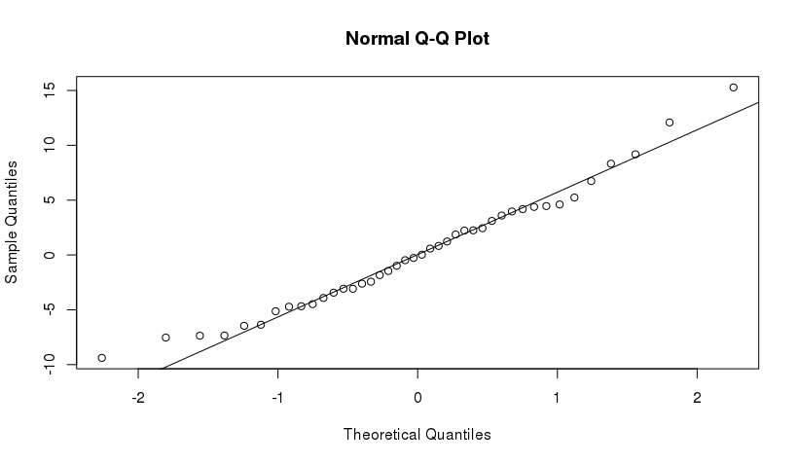

According to the normal Q-Q plot above, we see that our data is approximately normally distributed in the middle, but there are some outliers at the end of both sides.

Equal variance assumption: 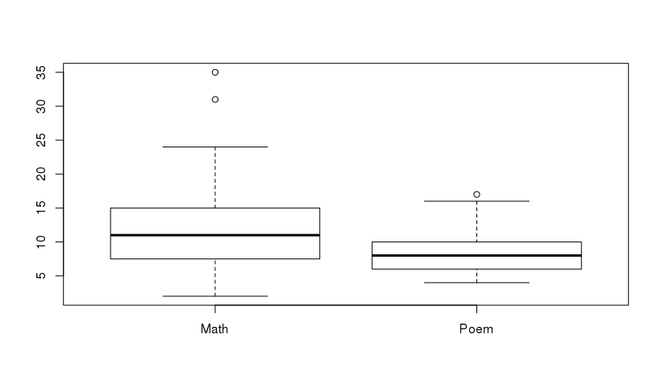

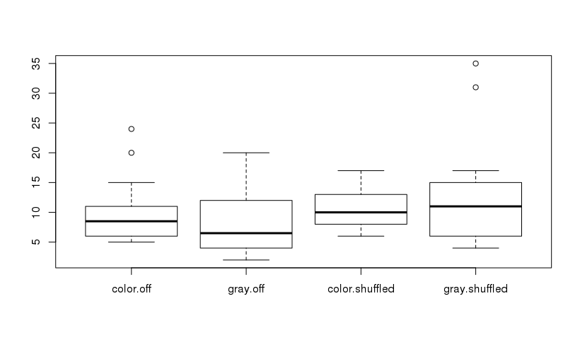

These boxplots for the whole-portion of the model and for the split-plot portion of the model show that the variances are not quite the same across different groups, with some outliers for the arithmetic game group, poem group, Color-Off group and the Gray-Shuffled group.

Independence:

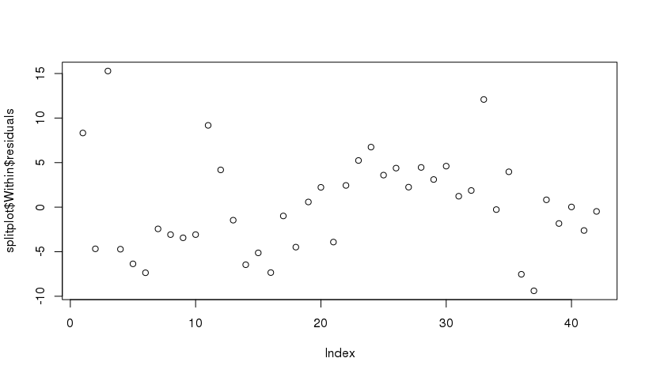

The residuals vs. order plot above shows that the error terms has some pattern, not fully independent.

Having only 14 participants, we chose to include all the data. We also cannot tell if the assumptions are really violated since our sample size is small. We thus still decided to use ANOVA model.

1. <http://kuiper.pearsoncmg.com/memorathon/>
2. <http://arithmetic.zetamac.com/>
3. <https://www.poetryfoundation.org/poems/45112/adonais-an-elegy-on-the-death-of-john-keats>

   <https://www.poetryfoundation.org/poems/45117/the-cloud-56d2247bf4112>