Lab1 report
This lab contains six components of ARM processor. Thus, I will illustrate the functionality of my code and give out the simulation wave form to demonstrate what is happening.
- AND2 component
This component has been written in lab0. The waveform of that component is
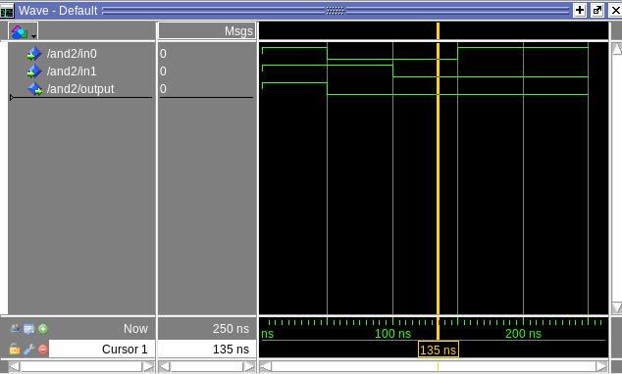

We can see that only at the beginning, when in0 and in1 are both giving out “1“, the output gives out “1”. During the rest of the time, there is always a “0” exist in in0 or in1. Thus, by the logic of “and” the output should always be “0”.
That waveform shows the simple AND2 logic, where the output gives the logic ‘and’ outcome of two inputs.
- MUX5 component
Mux5 aims at choosing 5-bits-inputs, which is controlled by a single bit ‘sel’ gate.
The waveform of that component is
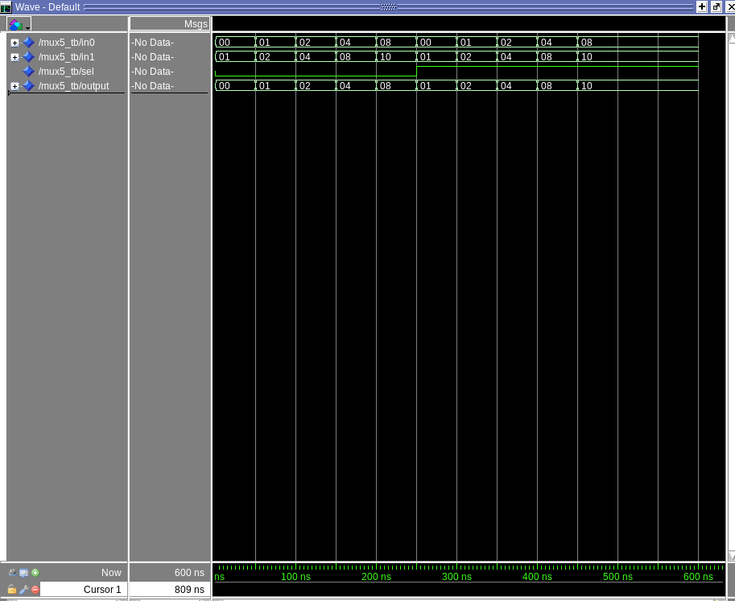

On the waveform, we can see that in the first 250ns, the ‘sel’ bit is 0. And that means the output of MUX5 should be the same as In0. After 250ns, the ‘sel’ bit turns to 1. The output at that time begins to choose In1.

The waveform shows the logic that output stays the same as either In0 or In1. A single-bit ‘sel’ is used to control which one to choose.

- MUX5 component
Mux5 aims at choosing 5-bits-inputs, which is controlled by a single bit ‘sel’ gate.
The waveform of that component is
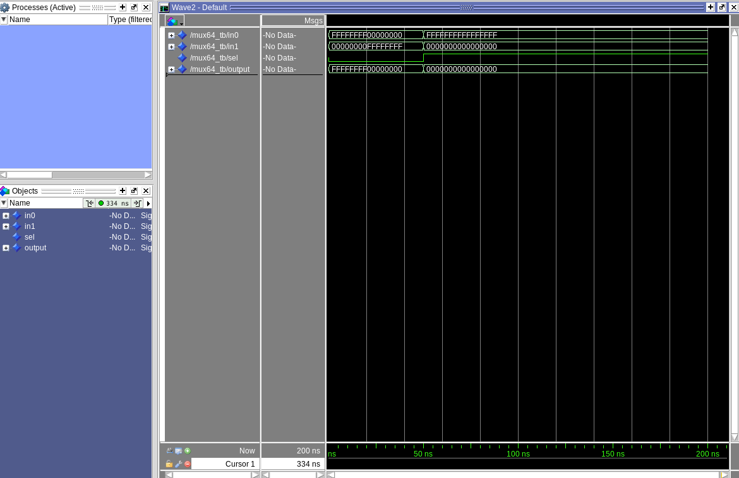

Just the same as MUX5, the ‘sel’ starts as 0, which force the output stays the same as In0. After 50ns, the ‘sel’ jumps to 1 and the component begins to use In1 as output.

The whole logic of that component is just the same as MUX5, where ‘sel’ determines which signal (In0 or In1) that output to choose. The only difference between MUX5 and MUX64 is the width of lines connected to the component.
- SignExtend component
Mux5 aims to extend the original signal, which is 32-bits-width, to 64-bits. The extended signal is determined by the highest bit of the original signal. The waveform of it goes as
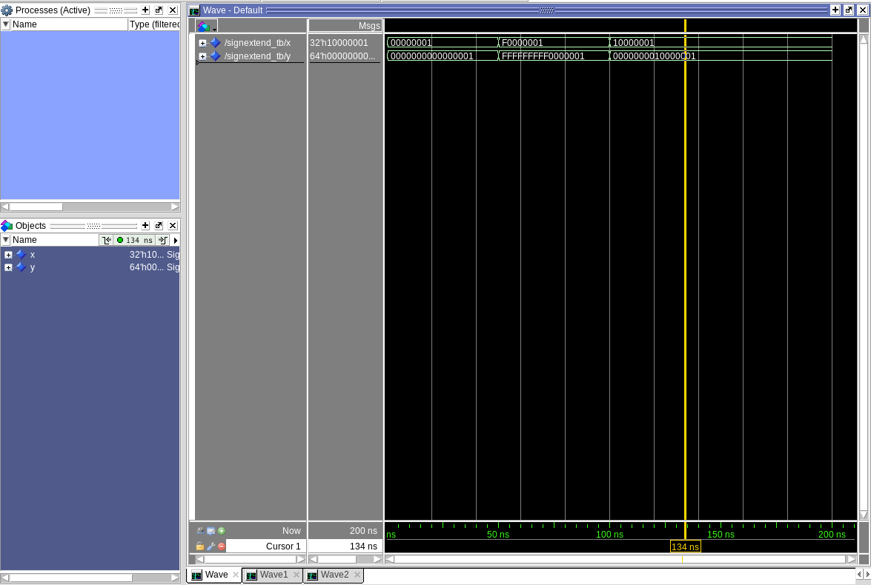

In the beginning. The input x’s highest bit is 0. Thus, the output extends it to a 32-bits 0. After 50ns, The input x’s highest bit changes to 1 (F is described as 1111 in binary bits). Then the output filled the higher 32-bits with 1, which shows as F. However, at 100ns, as the 1 in decimal is 0001 in binary, the highest bit of x again turns to 0. Then the output gives out 00000000 as higher 32-bits.

- ShiftLeft2 component
Mux5The ShiftLeft2 component is used to shift input signal 2 bits left and fill the lowest 2 bits with 0. The waveform gives as:
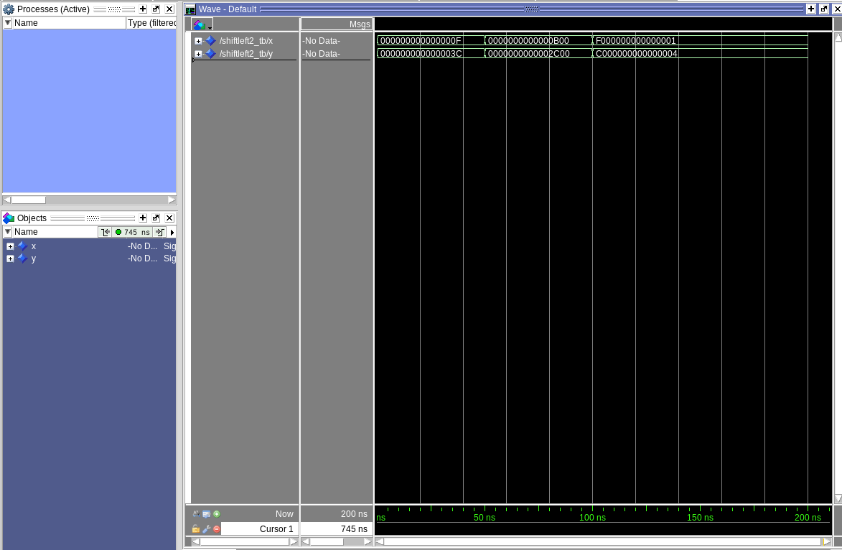

This component simple do the 2-bit-left-shift to the input x. Thus, in the first 50ns, the lowest 8-bits of the input x signal is “00001111” and output y signal is “00111100”. For every 50ns, the output do exactly the same to the input x signal.
- PC component
PC component is a 64-bit rising-edge register, which is controlled by a ‘clk’ signal. For every rising-edge of the ‘clk’, the component will examine whether the ‘rst’ goes to 1. If the rst turns to 1, then the output, AddressOut will be refreshed as 0x0. Otherwise, the output AddressOut will gives out the AddressIn once the write_enable bit stays at 1. The waveform of the component is:
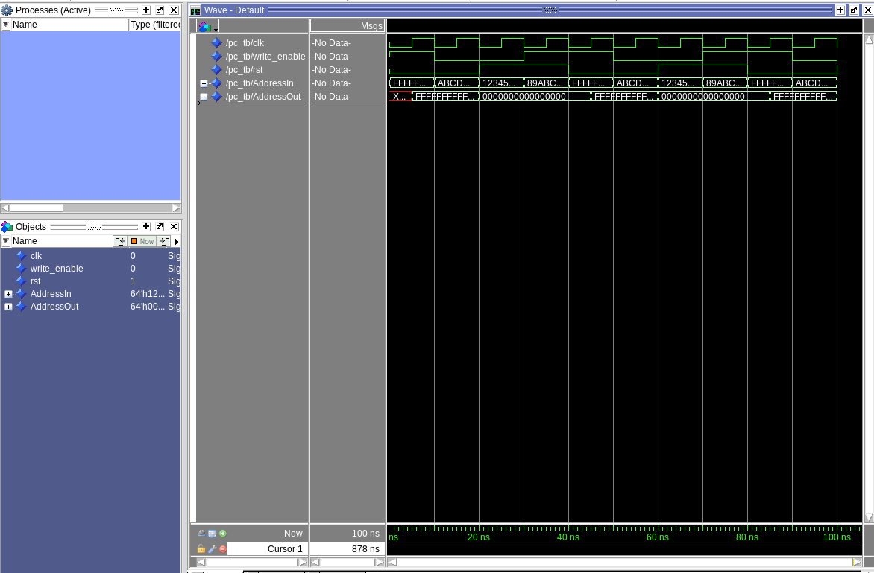

Just the same as what I described before, the AddressOut will only flips potentially when it detects the rising-edge of the ‘clk’ signal, which happens at 5ns, 15ns, 25ns…… Just at 5ns, the rst is set to 0 and write_enable is on. Thus the AddressOut changes to the same as AddressIn. And every time, when rst is 1, the AddressOut is forced to 0x0, once rising-edge of clk is detected.

