Lab3 report
The main object of this lab is to build a single cycle CPU consists of the components that we implement in lab2 and lab1. To make a more complete and clear description of my implements and test result, I will show the test results of three IMEMs and explain what has happened separately.

1.Comp-instruction set of IMEM
The output signal of all the wire drawn on our ARM picture have been shown in the following figure:
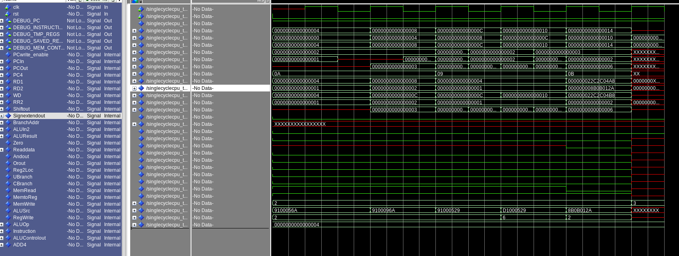

From the figure above, we can see that the CPU operate five instructions in total. For the first four I-format instructions, the ALUSrc signal stays at 1, where at the final R-format instruction, it stay at 0. That is the main difference in CPUControl’s output between I-format instruction and R-format instruction. Also, the most important output is the IMEM’s output, which is flagged as the “Instruction” in the figure and shown in the third-to-last line. It describes the machine code of our input instruction. And the Signextendout signal shows the immediate of the instruction.

2.LdStr-instruction set of IMEM
The waveform of its output is given as follows:

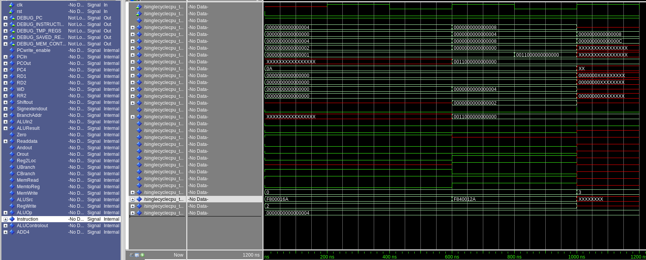

We can see that the offset of the DMEM address is 0. Thus the output of Signextendout stays at 0. The ALUControl gives the ALU Opcode at “10”, which means that ALU should do a D-format instruction. The output of CPU control works pretty well with a MemRead=’0’ and MemWrite=’1’ at first, followed by a MemRead=’1’ and MemWrite=’0’.
3.P1-instruction set of IMEM
P1 instruction set is just a combination of Comp set and the LdStr set, added with a CBranch and UBranch instruction. As the instruction is too long to shown in one figure. I split the instruction in the following two figures.
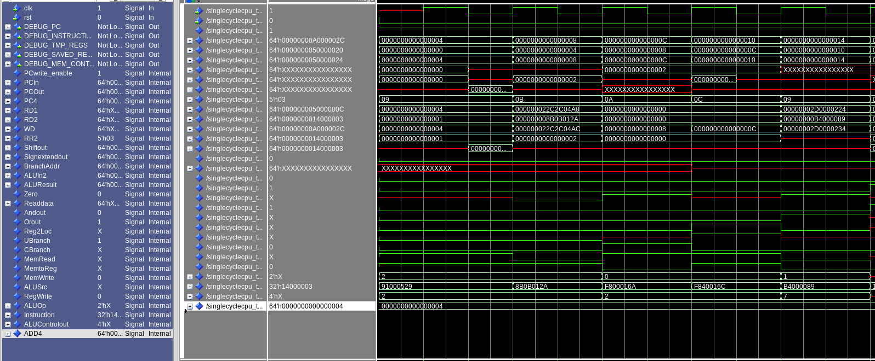

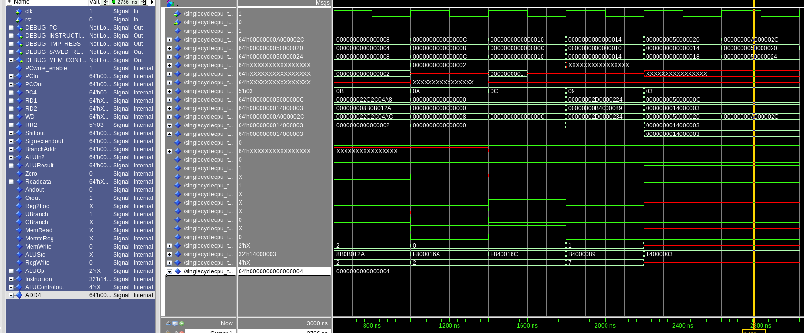

For the first figure, we can see that it has done the majority of work, including the add, ldstr and Cbranch. And for the second one, it contains mainly the computation of different registers.
I have also tested the output of given condition X9=-1, the result stored to DMEM is just the value of X11.
Thank you for your patience!

