AeroQuad Software Architecture

Overall Block Diagram
Although this diagram depicts a specific flow, each object actually runs independent of one another other with respect to time. Each object contains a processing method that runs based on a configured timing frequency, not in a serial fashion. The flow diagram is depicted in this way to make it easier to communicate how the software is architected.

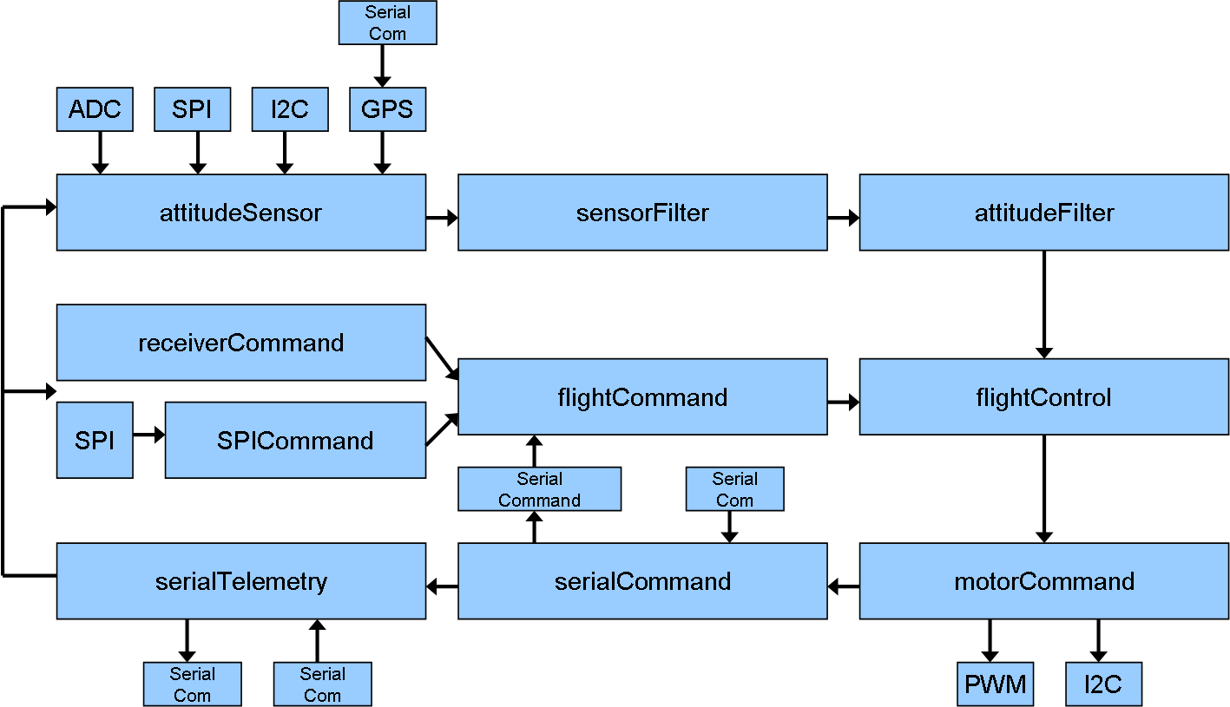

Class Descriptions

I2C
Requests data over the I2C bus

SPI
Requests data over the SPI bus

ADC
Initiates and returns measurements from the analog input pins of the Arduino

GPS
Listens to the specified serial port for incoming data from the GPS and parses it to extract position and altitude information

SubSystem
This class defines the timing interval each of the following subclasses will start operating
The following classes are subclasses to SubSystem

attitudeSensor
Measures sensors attached to AeroQuad

sensorFilter
Filters sensor data to remove unwanted noise from the raw data such as a digital low pass filter or a simple average

attitudeFilter
Combines sensor data to calculate attitude information such as a Kalman Filter or a Complementary Filter

flightCommand
Receives pilot commands from an R/C receiver, via SPI from a receiver daughter board, or a wireless serial connection from the Configurator

receiverCommand
Detects pin changes using PCINT to measure PWM pulses sent from an R/C receiver

SPICommand
Requests pilot commands from a receiver daughter board

flightControl
Processes a control algorithm using data from the attitudeFilter and flightCommand objects to generate motor commands such as PID or DCM

motorCommand
Generates motor commands for PWM or I2C electronic speed controllers (ESC’s)

serialCommand
Listens to the specified serial port and executes commands sent remotely

serialTelemetry
Listens to the specified serial port and returns requested data from the AeroQuad

