Analgy:
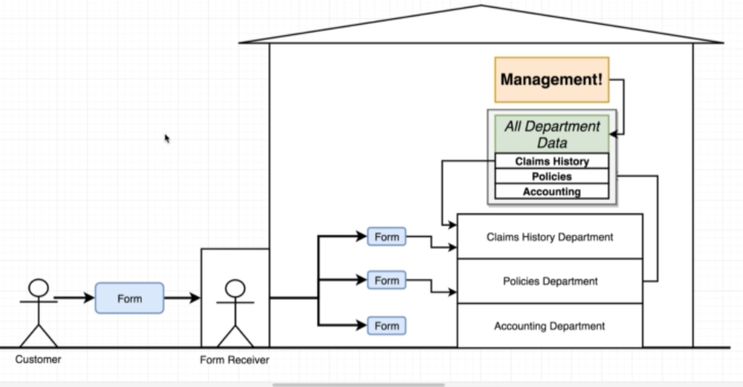
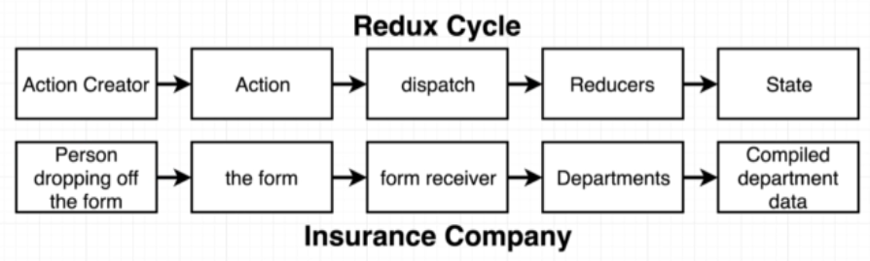

- Action Creator is a function return a JS plain object
- Action is this plain object contains type and payload as propties, discribe some changes in our data
- Dispatcher makes copies of this object and passes them to different parts of our reducers.
- Reducer: a function to process actions, process them depends on the object.type
- State: centrol repository of data created by Reducer, purpose is for the react app easy to get access a well managed and centrolised data.

Redux action creator demo:

console.clear();

// Action creators
// Customer drop off a form
const createPolicy =(name, amount)=>{
return { // Action
type:'CREATE_POLICY',
payload:{
name:name,
amount:amount
}
}
}

// Customer cancel a policy
const deletePolicy =(name)=>{
return {
type:'DELETE_POLICY',
payload:{ name:name }
}
}

// Customer create a claim
const createClaim =(name, moneyToCollect)=>{
return {
type:'CREATE_CLAIM',
payload:{
name:name,
amount:moneyToCollect
}
}
}
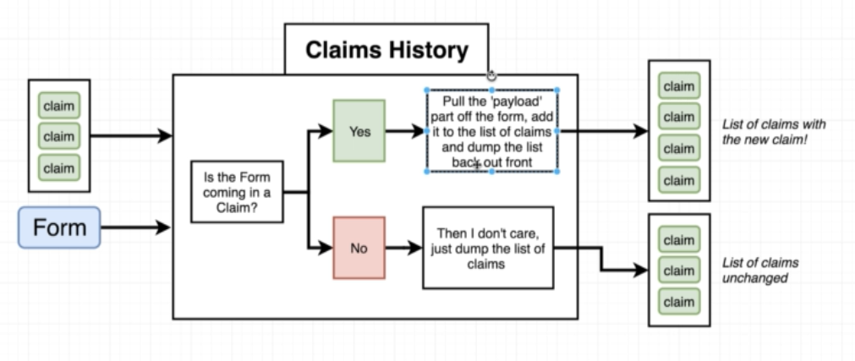

const claimHistory =(oldListOfClaim, action)=>{
if(!oldListOfClaim){
return [];
}

if(action.type === 'CREATE_CLAIM'){
// return a brand new array
// alway avoid modify an existing object, because other component may ref it
return [...oldListOfClaim, action.payload];
}
return oldListOfClaim;
}

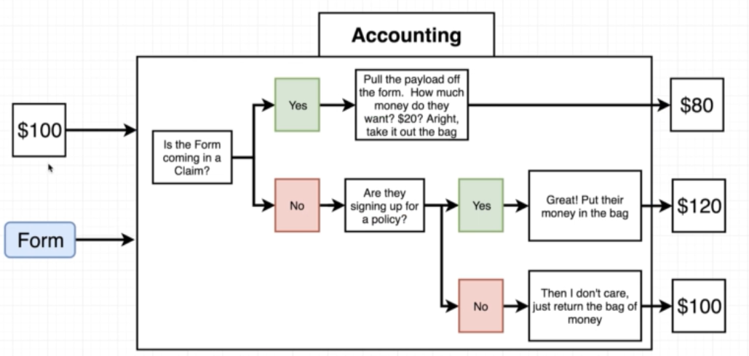

const accounting =(money, action)=>{
if(!money){
return 100;
}

if(action.type === 'CREATE_CLAIM'){
return money - action.payload.amount;
} else if(action.type === 'CREATE_POLICY'){
return money + action.payload.amount;
}

return money;
}

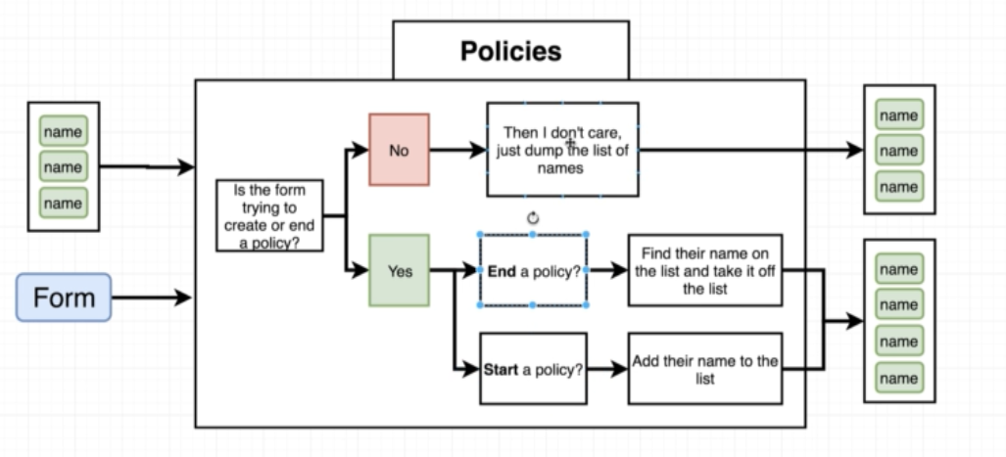

const policy =(oldListOfPolicy, action)=>{
if(!oldListOfPolicy){
oldListOfPolicy = [];
return oldListOfPolicy;
}

if(action.type === 'CREATE_POLICY'){
return [...oldListOfPolicy, action.payload.name]
} else if(action.type === 'DELETE_POLICY'){
return oldListOfPolicy.filter(policy => {
// filter will return a brand new array meets a certain condition
return policy !== action.payload.name;
})
}

return oldListOfPolicy;
}

// import Redux lib first, then

const { createStore, combineReducers } = Redux;

const Department = combineReducers({
claimHistory:claimHistory,
accounting:accounting,
policy:policy
});

const store = createStore(Department);

const policy_1 = createPolicy('Alex', 80);
const policy_2 = createPolicy('Bob', 80);
const policy_3 = createPolicy('Dva', 80);
const policy_4 = createPolicy('Ash', 80);

const del_plc_4 = deletePolicy('Ash');

const claim_plc_1 = createClaim('Alex', 30);
const claim_plc_3 = createClaim('Dva', 10);

// pass an action to a reducer, and reducer processes it
store.dispatch(policy_1);
store.dispatch(policy_2);
store.dispatch(policy_3);
store.dispatch(policy_4);

store.dispatch(del_plc_4);

store.dispatch(claim_plc_1);
store.dispatch(claim_plc_3);
store.dispatch(policy_1);

console.log(store.getState());

output:
{claimHistory: Array(2), accounting: 380, policy: Array(3)}
accounting: 380
claimHistory: Array(2)
0: {name: "Alex", amount: 30}
1: {name: "Dva", amount: 10}
length: 2
__proto__: Array(0)
policy: (3) ["Alex", "Bob", "Dva"]

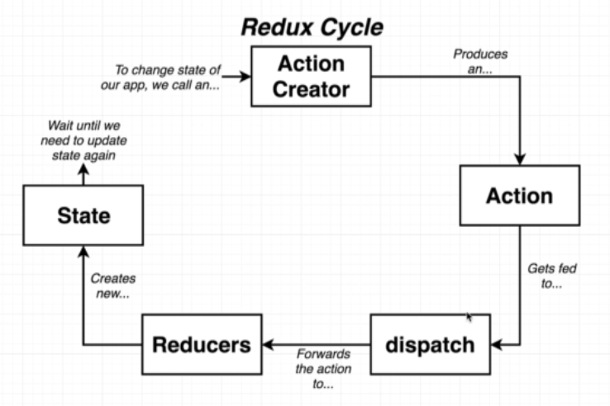
Cannot modify state manually, changes can only be made by dispatch.

