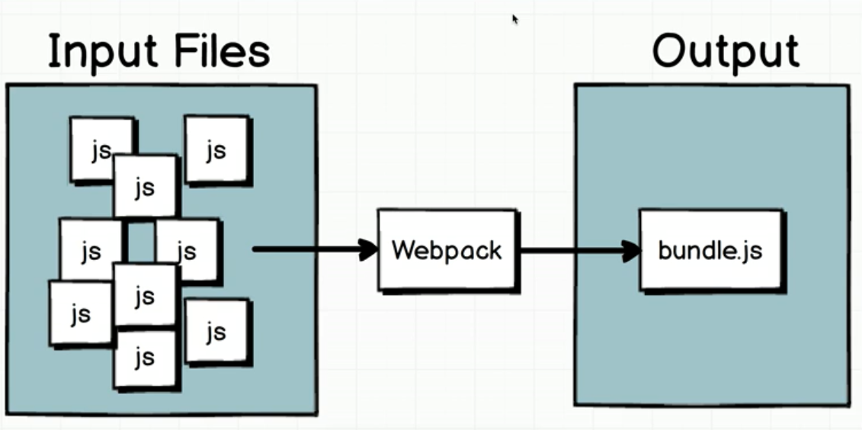

Reduce number of HTTP request and these JS files will be executed in order.

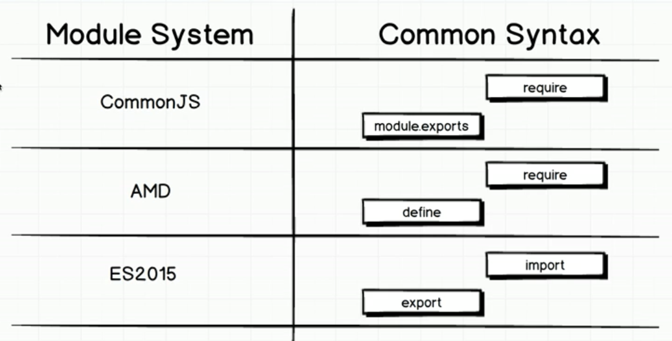

sum.js:

const sum =(a, b)=> a+b;

// make a variable available outside

**module.exports = sum;**

index.js

**const sum = require("./sum");**

const total = sum(2,6);

console.log(total);

* intellisense:  **npm install --save @types/node**