Project Portfolio Resource Allocation

# Overview

The purpose of this projest is to develop a portfolio-level resource allocation dashboard for IT projects. The goal of this report is to answer following question: How are resources allocated across current and planned projects?

# Business Requirements

Before commencing the project, the following assumptions were made:

1. **Standard Project Structure**
   * All projects follow the same phase breakdown: *Initiation, Planning, Execution, Closure*.
2. **Role Demand per Project (Monthly FTE Hours)**
   * Developers: **320h** (2.0 FTE)
   * QA: **160h** (1.0 FTE)
   * Scrum Master: **80h** (0.5 FTE)
   * Product Owner / Business Analyst: **160h** (1.0 FTE)
   * UX/UI: **80h** (0.5 FTE)
   * DevOps: **40h** (0.25 FTE)
   * Architect: **40h** (0.25 FTE)
3. **Resource Capacity**
   * 1 FTE = **160h per month**.
4. **Resource Sharing Rule**
   * Each resource may be allocated to a maximum of **3 projects per month**.

# Data Sources

This report utilizes a fabricated dataset created solely for visualization and analytical demonstration. The data, imported from CSV files, has been structured to mirror the schema of relational database imports, ensuring realism without exposing sensitive information.

The data was imported from following files:

1. HumanResources – this file consists of employees names with their position and salary

2. Projects – this file consists of list of all the projects with their timeframe, duration and status.

3. Projects_Monthly_Role_Demand – this file consists of needed demand for execution of all of the projects with division between project roles

4.Projects_Resource_Assigment – this file consists of information about which resources are assigned to which executed project

5. Projects_Planned_Allocation – this file consists of demand for projects that are planned or in sales process and are not yet executed in division between project roles

# Data Model

The following diagram presents the relationship between tables:

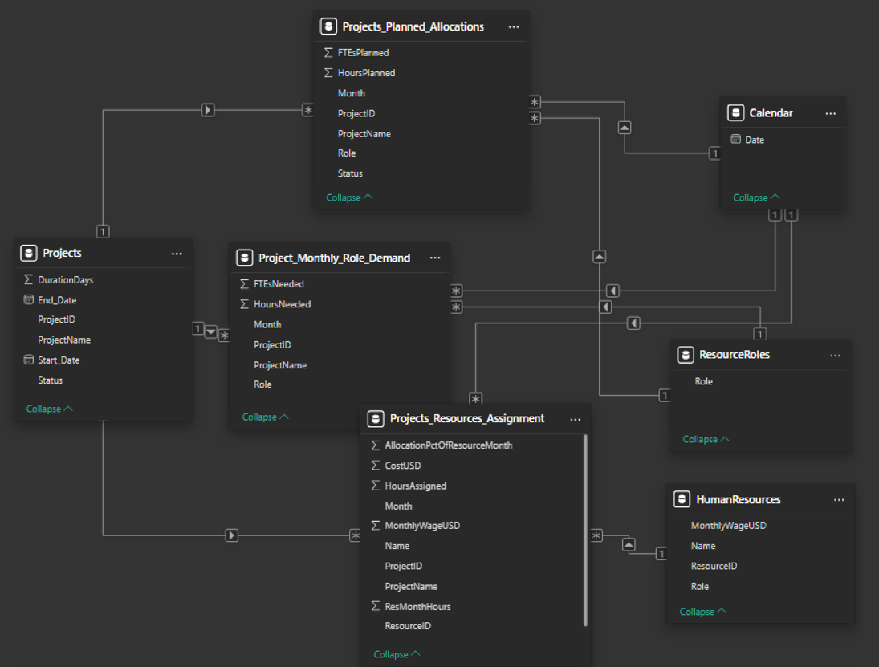

Two additional tables were added in course of development of the project, Calendar which purpose is unification of dates and second one being ResourceRoles which is dictionary of positions includeed in the portfolio.

# Visuals

The report currently consists of two pages: one provides an overview of the entire project portfolio, while the other focuses on resource assignments across the portfolio.

### Project Portfolio – Page 1

The first page provides a comprehensive overview of the entire project portfolio. It includes insights into hours already assigned, hours planned for projects in execution, as well as projects that are scheduled or still under consideration. The page also shows how these hours are distributed across different resource roles, along with the projected costs for each project and for the portfolio as a whole. Interactive slicers allow stakeholders to filter this information by project, project status, resource role, and time period.

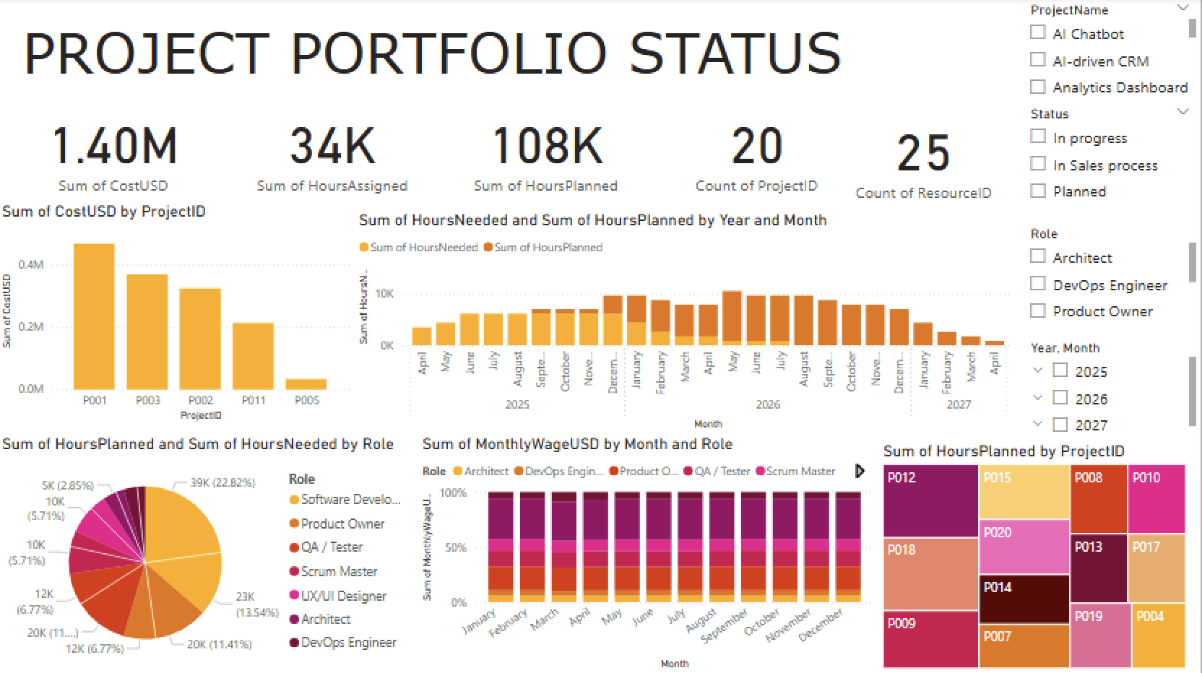

Project Portfolio Resource Allocation – Page 2

This page highlights how people are allocated across the project portfolio. It shows who is working on which projects, how their time is being utilized, and the related wage costs. Stakeholders can see resource workloads and costs by project, by time period, and for the portfolio as a whole. 