Threat Hunt & Incident Analysis Report

Executive Summary
Multiple external threat actors conducted a sequential, multi-layered attack targeting our external network infrastructure and public-facing web applications. The adversary's primary objective was to gain unauthorized root access to our web servers, map the underlying network environment, and actively disable our security monitoring capabilities to hide their tracks.
The attack progressed through automated network mapping, web application exploitation (attempting to bypass directories and execute malicious scripts in memory), and highly targeted strikes against our network monitoring services (tcpdump). By attempting a buffer overflow attack on our packet capture tools, the threat actor aimed to blind the Security Operations Center (SOC), disrupt intrusion detection systems (IDS/IPS), and potentially achieve Remote Code Execution (RCE) on critical security infrastructure. All events have been mapped to the MITRE ATT&CK framework for defensive tracking.
The intended impact by the attacker which was to disable network monitoring – Service Stop (T1489) failed because the target port was closed. business operations are up and running smoothly because the attack surface was hardened

Technical Incident Breakdown & Analyst Assessment
1. Reconnaissance (TA0043)
- Technique: Active Scanning (T1595)
- Target IPs: 121.41.[REDACTED].[REDACTED], 172.56.[REDACTED].[REDACTED], 34.78.[REDACTED].[REDACTED], 39.100.[REDACTED].[REDACTED], 47.95.[REDACTED].[REDACTED], 47.99.[REDACTED].[REDACTED], 85.217.[REDACTED].[REDACTED]
- Alerts Identified: (port_scan) TCP portscan, (icmp4) ICMP ping Nmap, (stream_tcp) reset outside window
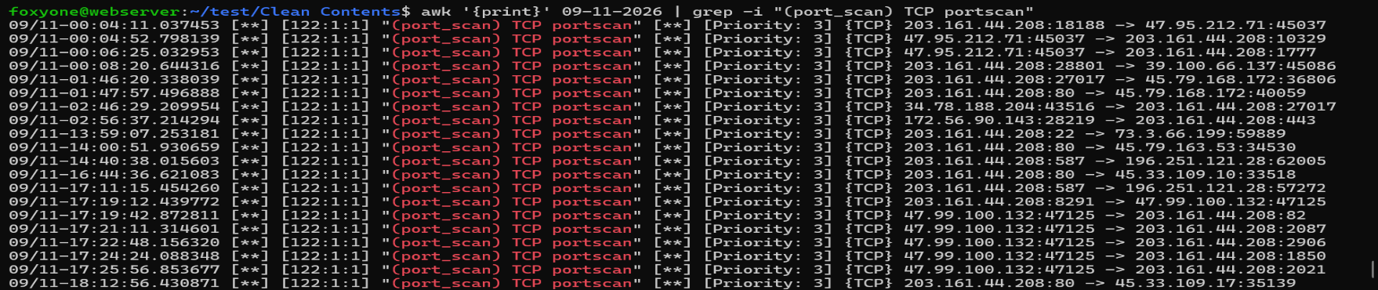
Analyst Thought Process: The threat actor is gaining the lay of the land. They are actively mapping the attack surface to understand exactly what ports are open, what ports are closed, and what specific services are running on the web server. The reset outside window alerts are network artifacts (byproducts) resulting from the aggressive timing of these automated port scans
[Image of Portscan Alerts]
2. Initial Access (TA0001) & Content Injection (T1659)
- Technique: Exploit Public-Facing Application (T1190), Content Injection (T1659)
- Target IPs: 168.144.[REDACTED].[REDACTED], 169.58.[REDACTED].[REDACTED], 35.243.[REDACTED].[REDACTED], 43.167.[REDACTED].[REDACTED], 45.148.[REDACTED].[REDACTED], 85.239.[REDACTED].[REDACTED], 45.33.[REDACTED].[REDACTED], 45.33.[REDACTED].[REDACTED], 45.79.[REDACTED].[REDACTED]
- Alerts Identified: Apache HTTP Server httpd directory traversal, PHP PHP-CGI command execution, URL Percent/Double-Encoding, TCP data sent on reset.
Analyst Thought Process: Using the intelligence gathered during reconnaissance, the attacker shifted to exploiting the web application.
- Path Traversal: The actor manipulated the URL input (e.g., bypassing standard domains using /../ encoded strings) to navigate outside the intended web directories. The goal was to access sensitive content directly through the shell.
- PHP-CGI Execution: The actor embedded malicious instructions inside the HTTP request body. The objective was to force the server to execute a malicious script and embed it dynamically within the server's memory while the website was running, ultimately aiming for root access.
- Content Injection (Network Layer): Shifting tactics, the attacker targeted the network itself rather than just the web app. By attempting to tamper with sequence numbers (TCP data sent after reset), the actor attempted TCP session hijacking to gain a foothold.
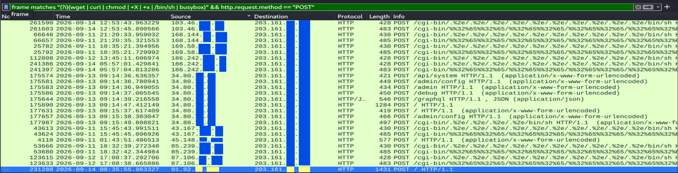
[Path Traversal & PHP-CGI HTTP Requests]
3. Execution (TA0002) & Discovery (TA0007)
- Technique: Command and Scripting Interpreter – Unix Shell (T1059.004), Network Sniffing (T1040)
- Target IPs: 221.159.[REDACTED].[REDACTED], 139.162.[REDACTED].[REDACTED]
- Alerts Identified: TP-Link Archer Router command injection attempt
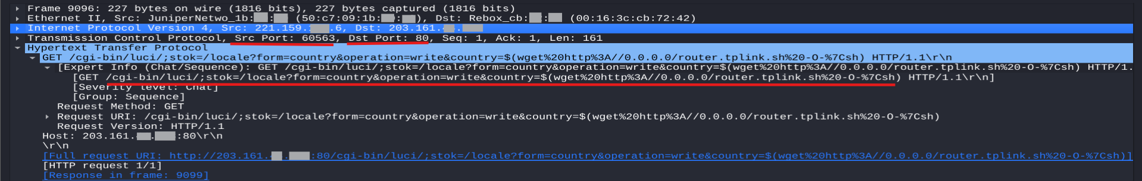
Analyst Thought Process: Once initial access probes were underway, the attacker sought to expand their attack surface. By executing Unix shell commands against edge devices (specifically targeting a TP-Link Archer Router), the actor attempted to pivot. The discovery objective here was clear: compromise the router to perform network sniffing, allowing the attacker to understand the deeper internal network environment hosting our core servers.
[TP-Link Router Command Injection Payload]

4. Defense Impairment (TA0005)
- Technique: Exploitation for Defense Impairment (T1687 / T1211)
- Target IP: 139.162.[REDACTED].[REDACTED]
- Alerts Identified: tcpdump ISAKMP parser buffer overflow attempt
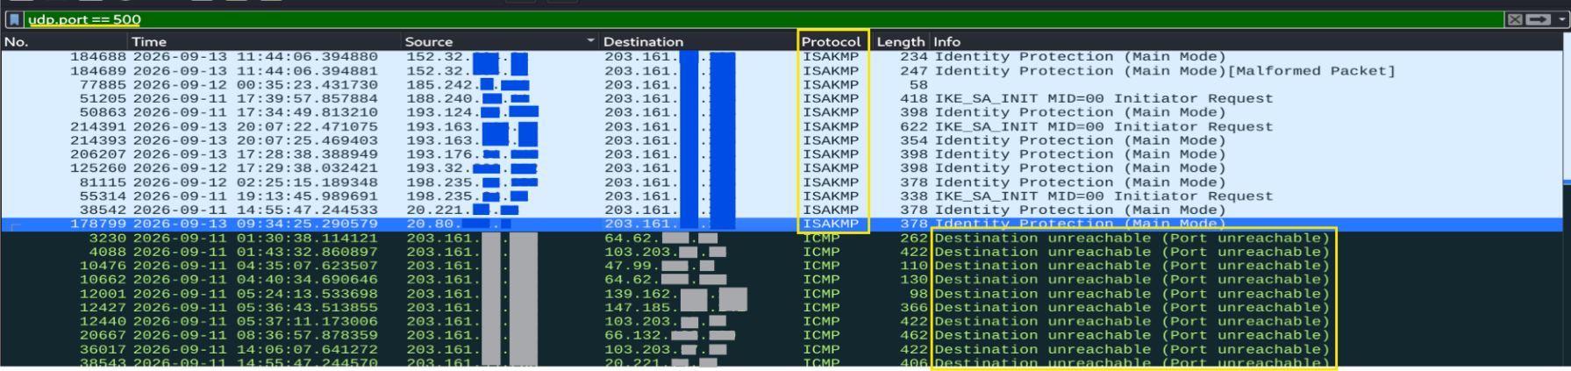
Analyst Thought Process: This is a critical escalation. The attacker realized they were likely being monitored and launched a targeted buffer overflow attack against tcpdump. Because tcpdump captures network packets used for monitoring, logging, and feeding our IDS/IPS systems, taking it down creates a massive blind spot. If this service crashes, our ability to monitor network bottlenecks, identify active threats, and maintain visibility—especially critical within a cloud-hosted environment—is severely impaired.
[tcpdump ISAKMP Buffer Overflow Wireshark Stream]

5. Intended Impact (TA0040)
- Technique: Service Stop (T1489), Endpoint Denial of Service: Application or System Exploitation (T1499.004)
- Target IP: 139.162.[REDACTED].[REDACTED]
- Alerts Identified: tcpdump ISAKMP parser buffer overflow attempt (Outcome Context)
Analyst Thought Process: The intended impact of the ISAKMP buffer overflow attempt is twofold:
- Service Stop / Endpoint DoS: Successfully crashing the tcpdump application denies the Security Operations team legitimate access to their own monitoring tools. It halts the organization's critical monitoring and control services, stripping away situational awareness of the server's status.
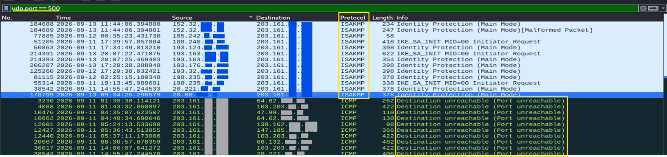
- System Exploitation (RCE Potential): Because this is a buffer overflow, the attack does more than just crash the service; it corrupts memory data. This memory corruption can grant the attacker access to restricted system data, provide a vector to reach out to other internal applications, and ultimately allow them to achieve Remote Code Execution (RCE) directly on the security infrastructure.
[Failed Intended Impact]

IP | Snort Alerts | Technique ID | Tactic
121.41.[REDACTED].[REDACTED], 172.56.[REDACTED].[REDACTED]  34.78.[REDACTED].[REDACTED]  39.100.[REDACTED].[REDACTED]  47.95.[REDACTED].[REDACTED]  47.99.[REDACTED].[REDACTED]  85.217.[REDACTED].[REDACTED] | (port_scan) TCP portscan, (icmp4) ICMP ping Nmap,  (stream_tcp) reset outside window | Active Scanning  (T1595) | Reconnaissance
168.144.[REDACTED].[REDACTED]  169.58.[REDACTED].[REDACTED]  35.243.[REDACTED].[REDACTED]  43.167.[REDACTED].[REDACTED]  45.148.[REDACTED].[REDACTED]  85.239.[REDACTED].[REDACTED] | (http_inspect) URI has percent-encoding of an unreserved character,  (http_inspect) URI has percent-encoding of an unreserved character,  (http_inspect) URI path contains /../ pattern moving up a directory,  (http_inspect) URI path includes /../ that goes above the root directory,  (http_inspect) URI contains double-encoded hexadecimal characters  SERVER-WEBAPP Apache HTTP Server httpd directory traversal attempt,  SERVER-WEBAPP PHP PHP-CGI command execution, | Exploit Public-Facing Application  (T1190) | Initial  Access
45.33.[REDACTED].[REDACTED]  45.33.[REDACTED].[REDACTED]  45.79.[REDACTED].[REDACTED]  45.79.[REDACTED].[REDACTED]  45.79.[REDACTED].[REDACTED]  139.162.[REDACTED].[REDACTED] | (stream_tcp) data sent on stream after TCP reset sent,  SERVER-OTHER tcpdump ISAKMP parser buffer overflow attempt | Content Injection  (T1659) | Initial  Access
221.159.[REDACTED].[REDACTED],  139.162.[REDACTED].[REDACTED]  168.144.[REDACTED].[REDACTED]  169.58.[REDACTED].[REDACTED]  35.243.[REDACTED].[REDACTED]  43.167.[REDACTED].[REDACTED]  45.148.[REDACTED].[REDACTED]  85.239.[REDACTED].[REDACTED] | SERVER-WEBAPP TP-Link Archer Router command injection attempt,  SERVER-OTHER tcpdump ISAKMP parser buffer overflow attempt  (http_inspect) URI has percent-encoding of an unreserved character,  (http_inspect) URI has percent-encoding of an unreserved character,  (http_inspect) URI path contains /../ pattern moving up a directory,  (http_inspect) URI path includes /../ that goes above the root directory,  (http_inspect) URI contains double-encoded hexadecimal characters  SERVER-WEBAPP Apache HTTP Server httpd directory traversal attempt,  SERVER-WEBAPP PHP PHP-CGI command execution, | Command and Scripting Interpreter – Unix Shell  (T1059.004) | Execution
221.159.[REDACTED].[REDACTED] | SERVER-WEBAPP TP-Link Archer Router command injection attempt | Network Sniffing  (T1040) | Discovery
139.162.[REDACTED].[REDACTED] | SERVER-OTHER tcpdump ISAKMP parser buffer overflow attempt | Exploitation for Defense Impairment  (T1687) | Defense Impairment
139.162.[REDACTED].[REDACTED] | SERVER-OTHER tcpdump ISAKMP parser buffer overflow attempt | Service Stop (T1489),  Endpoint Denial of Service: Application or System Exploitation (T1499.004) | Intended  Impact

6. Detection Engineering & Network Hardening
Although the unauthorized exploitation and probing attempts failed due to the services being inactive (closed ports), relying solely on inactive services is not a complete defense strategy. To establish a Zero-Trust network boundary, the security operations team utilized Detection Engineering to build custom network telemetry rules, paired with a strict firewall policy to actively drop and log all anomalous network noise.
Custom Intrusion Detection (IDS) Rules
To gain complete visibility into background threat actor noise and targeted port scanning, two custom Snort rules were engineered and deployed. Because this server exclusively hosts HTTP/HTTPS services, any TCP traffic targeting non-web ports, and all inbound UDP traffic, is classified as implicitly malicious.
Code snippet
Rule 1: Flags any TCP exploit or scan targeting a port other than 80 or 443
alert tcp any any -> $HOME_NET ![80,443] (msg: "Rogue Packet - Target Port is not 80 or 443"; sid:1000001; rev:1;)

Rule 2: Flags any inbound UDP traffic (e.g., ISAKMP buffer overflows, DNS amplification)
alert udp any any -> $HOME_NET any (msg: "Rogue Packet - No UDP Packet Allowed"; sid:1000002; rev:1;)

Enforced Firewall Policy (UFW) Implementation
To ensure the custom IDS detections remain strictly telemetry (logging) rather than active threats, the host-level Uncomplicated Firewall (UFW) policy has been engineered using a strict Zero-Trust model.
The following commands formulate the baseline, ensuring that even if an application layer vulnerability is bypassed, network-level restrictions will neutralize the attacker's payload.
1. Establish the Zero-Trust Baseline We begin by dropping all traffic in both directions by default. This ensures no ports are accidentally left open.

sudo ufw default deny incoming
sudo ufw default deny outgoing

2. Secure Administrative Access Before enabling the firewall, administrative SSH access is explicitly whitelisted to a trusted VPN IP. This prevents the security team from being locked out while ensuring external threat actors cannot brute-force the SSH port. (Note: Replace [VPN_IP] with the actual authorized IP).

sudo ufw allow from [VPN_IP] to any port 22 proto tcp

3. Allow Public Web Services Explicitly allow inbound connections required to serve the web application to legitimate users.

sudo ufw allow 80/tcp
sudo ufw allow 443/tcp

4. Restrict Outbound DNS (Prevent DNS Tunneling) Threat actors often use arbitrary DNS queries to exfiltrate data or establish hidden Command and Control (C2) channels. To prevent this, outbound DNS is heavily restricted to a single trusted resolver (e.g., Google's 8.8.[REDACTED].[REDACTED]).

sudo ufw allow out to 8.8.8.8 port 53 proto udp

5. Restrict Outbound Time Synchronization (NTP) Accurate server time is critical for security logging and cryptography. This rule allows outbound Network Time Protocol (NTP) updates, which operate on UDP port 123, restricted exclusively to a trusted time server to prevent abuse.

sudo ufw allow out to 162.159. port 123 proto udp

6. Review and Activate Enable the firewall. It will prompt you with a warning that this may disrupt existing SSH connections. Because you added the rule in Step 2, it is safe to press y.

sudo ufw enable
Verification: Once enabled, you can run sudo ufw status numbered verbose to view the active rules and confirm the policy is strictly enforcing your intended network boundary.

7. Strict Egress Filtering (Anti-Reverse Shell Policy) By default, standard outbound HTTP/HTTPS (80/tcp, 443/tcp) access to the wider internet is completely denied.
Reasoning: If an attacker successfully executes a command injection or path traversal exploit, their immediate next step is usually to spawn a reverse shell connecting back to their own server on port 80 or 443. By keeping these outbound ports blocked, the firewall silently kills the reverse shell before it can connect.
Maintenance Procedure: When system updates or package downloads are required, the systems administrator will temporarily apply the following rules, perform the updates, and immediately delete the rules afterward to restore the hardened baseline:

Apply ONLY when updates are needed:
sudo ufw allow out 80/tcp
sudo ufw allow out 443/tcp

Delete immediately after updates are complete:
sudo ufw delete allow out 80/tcp
sudo ufw delete allow out 443/tcp

