TITLE: SMART FIRE DETECTION AND EXTINGUISHING SYSTEM

DEPARTMENT OF MECHATRONICS ENGINEERING

TABLE OF CONTENTS

I. Title Page
II. Table of Contents

III. Chapter One: Introduction
1.1 Background of the Study
1.2 Problem Statement
1.3 Aim and Objectives
1.4 Scope of the Study
1.5 Significance of the Study
1.6 Report Outline

IV. Chapter Two: Literature Review

V. Chapter Three: Methodology
3.1 System Architecture
3.2 Hardware Implementation
3.3 Software Design
3.4 Operation Sequence
3.5 Summary

VI. Chapter Four: Results and Performance

VII. References

CHAPTER ONE: INTRODUCTION
Fire outbreaks remain a critical safety challenge in Nigeria, causing significant loss of lives and property every year. Recent studies in the South-Eastern Zone of Nigeria recorded thousands of structural fire incidents between 2010 and 2019, with single-room dwellings accounting for about 42% of fire-related deaths and roughly 50% of injuries and financial losses (Adekunle et al., 2020). In peri-urban Ibadan, residents ranked fire incidence as the most serious environmental hazard, ahead of road accidents and flooding (Oloke et al., 2021). Major causes include faulty electrical equipment, unsafe cooking practices and electric surges, which remain common in residential areas.
Conventional fire-safety measures in many Nigerian homes and public buildings are still limited to manual extinguishers or basic smoke alarms, leaving a dangerous response gap. Even when smoke detectors are installed, timely action is not always guaranteed. This motivates the need for low-cost, automated systems that can both detect fire early and act immediately to reduce damage.
This project presents the design and implementation of a smart fire detection and extinguishing system built on an ESP32 microcontroller. The prototype combines dual sensing (flame and smoke) with a 5 V pump-driven extinguisher and provides both a web interface that works over an existing Wi-Fi network or through the device’s own fallback access-point mode, and a Telegram bot that delivers real-time alerts and allows remote manual control. These features demonstrate how affordable, readily available components can be integrated into an accessible fire-safety solution for Nigerian homes, schools and small businesses.
The objectives of the project are as follows:
- To develop a prototype that integrates fire detection with an automatic extinguishing unit, ensuring immediate action beyond mere alerts.
- To design a smart fire safety system capable of detecting fire outbreaks through sensors and activating response mechanisms.
- To implement the system on a small scale to demonstrate its ability to both detect and extinguish fires.

CHAPTER TWO: LITERATURE REVIEW
Research on microcontroller-based fire detection and control systems has grown steadily, offering a wide range of approaches and identifying challenges that shape the present project. Dauda and Toro (2020) designed an Arduino-based fire detection and control system that monitored temperature and automatically triggered alarms, cut off mains power, and activated a 5 V DC pump to suppress fire. While the system successfully combined early detection with active extinguishing, the authors noted that further work was needed to strengthen the reliability of the suppression mechanism in more varied real-world settings. This highlights the importance of a robust extinguishing unit, which the present project addresses through a simple but effective 5 V pump driven by the ESP32 relay.
Suwarjono et al. (2021) developed a home fire detection system using an Arduino Uno with temperature and gas sensors, a GSM module, and a buzzer. Their tests showed reliable detection, yet the MQ2 gas sensor operated only at a minimum gas pressure of 220 ppm, forcing the use of an external gauge for calibration. In addition, the time needed to heat the room to the threshold temperature for testing was significantly longer than that required for gas detection. These constraints reveal the value of using sensors whose response is less dependent on strict environmental preparation, a feature that strengthens the practicality of the flame and smoke sensors used in the current project.
Yadav and Rani (2020) designed a sensor-based smart fire detection and alarm system using Arduino, combining temperature and smoke sensors with a GSM module and an automatic water sprayer. The prototype proved capable of quick smoke detection (about 45 s) and reliable suppression; however, the authors emphasised the need for better integration of modules to improve portability and for a design that would allow individual modules to be easily upgraded. The project described here benefits from a more compact design in which the ESP32 unifies sensing, control and communication, simplifying future sensor or module replacement.
Baba et al. (2022) proposed a multisensory Arduino-based fire detection and alarm system that used flame, smoke, butane and thermal sensors and provided alerts via GSM, RF and an Android mobile app. Despite its broad functionality, the system faced limits in communication range as the RF transmission remained reliable only up to about 804 m line of sight, and delays occasionally occurred in GSM communication when network signals were weak. Moreover, its backup battery lasted only about two and a half hours without external power. By contrast, the present project relies on Wi-Fi for its web interface and Telegram bot alerts, eliminating dependence on long-range RF and reducing susceptibility to GSM delays, while allowing power requirements to be met by standard mains supply or appropriately sized backup units.
Ali et al. (2025) presented an integrated automated fire control system that detects smoke, flame and gas and activates sprinklers, an exhaust fan and a solenoid valve to cut gas supply. Although no specific limitations were reported, this work demonstrates how multi-hazard detection can be achieved with inexpensive components. The current project focuses instead on dual sensing of flame and smoke with built-in extinguishing, favouring simplicity and affordability over the more complex multi-hazard design.
See and Ho (2020) explored an IoT-based fire safety system using the MQTT protocol for cloud communication.
Their work illustrates the trend toward remote real-time fire monitoring, but it requires advanced networking and server infrastructure. The present project delivers remote notification through a direct Telegram bot and local web interface without the added complexity of MQTT-based cloud services, keeping both cost and technical requirements low.
Across these studies, certain patterns emerge. Affordable microcontroller-based platforms are effective for early fire detection and can incorporate automated suppression and remote notification. However, limitations such as sensor sensitivity thresholds, communication delays, short backup power life and complex network requirements remain common. The project described here addresses these issues by combining straightforward flame and smoke detection with an ESP32-based control unit, a local web interface, and Telegram-based mobile notifications, achieving timely detection and automatic extinguishing without dependence on expensive or advanced network infrastructure.

CHAPTER THREE: METHODOLOGY
The Smart Fire Detection and Extinguishing System was implemented as an Internet of Things (IoT) prototype that integrates sensing, processing and actuation into a single automated framework.
The development process can be described in three major phases: sensing, processing and action, with each phase realised in both hardware and software. Below is the list of components utilized for the project:
- ESP 32 Development Board
- Flame Sensor
- Smoke Sensor
- 5V Relay Module
- 5V DC Pump
- Buzzer
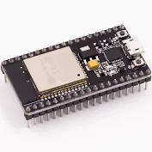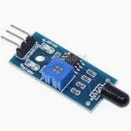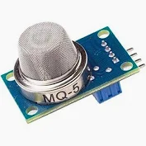
Figure 3.1: ESP 32 Development Board Figure 3.2: Flame Sensor Figure 3.3: MQ-5 Smoke Sensor

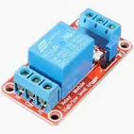
Figure 3.4: 5V Relay Module Figure 3.5: 5V DC Pump

3.1 System Architecture

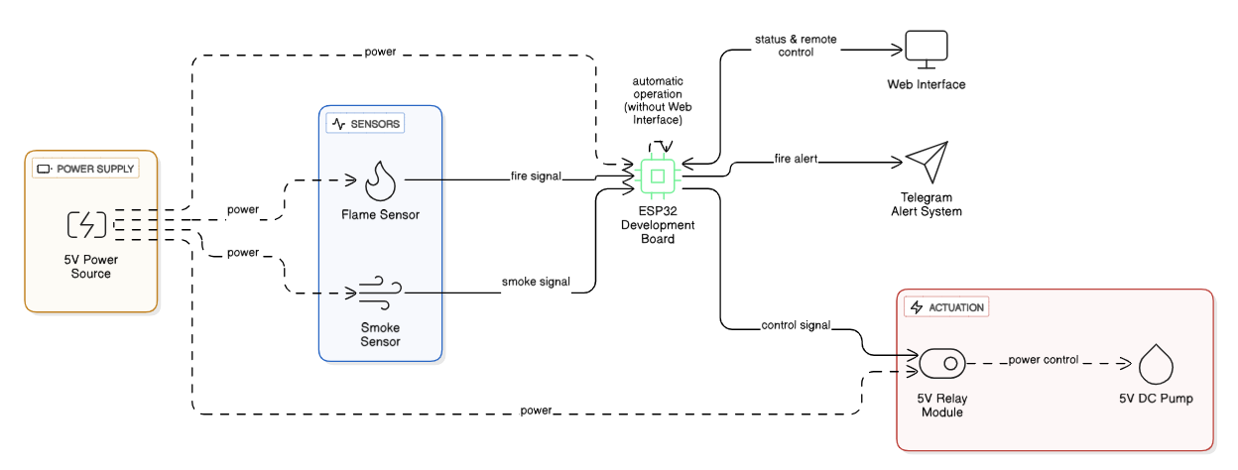
Figure 3.1: Block Diagram of the Complete System
The system combines two key sensors: a flame sensor and an MQ-2 smoke sensor. These sensors continuously monitor fire-related conditions such as open flame and smoke particles. An ESP32-S2 microcontroller serves as the central processing unit and also provides Wi-Fi connectivity for remote notification. Output devices include a 5 V DC water pump controlled by a relay module, a buzzer for audible alarms, and two LEDs for visual status indication.

3.2 Hardware Implementation
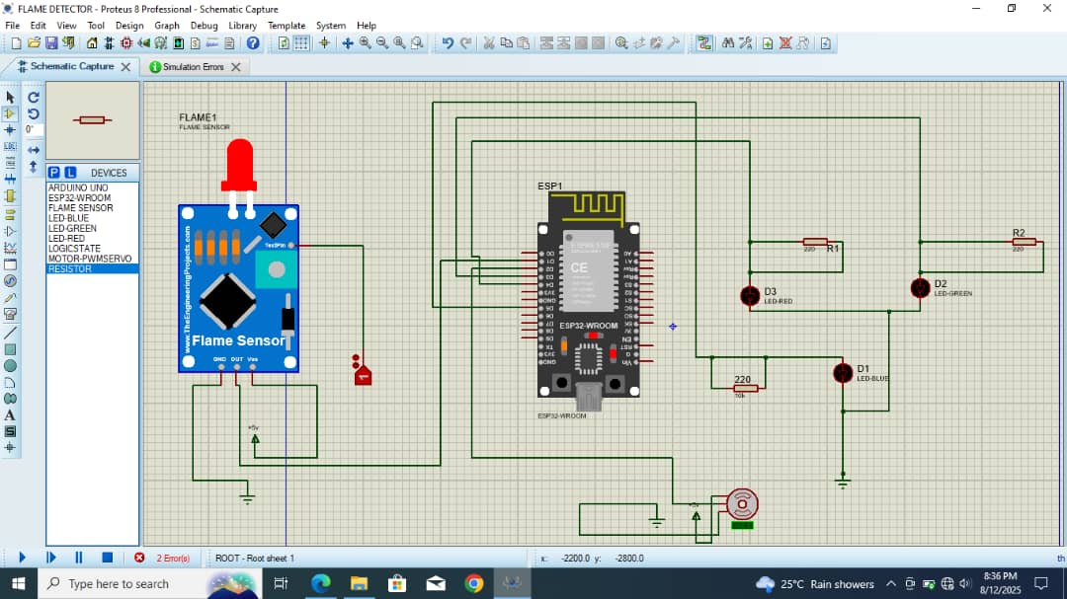
Figure 3.6: Circuit schematic showing sensor connections
The flame sensor is interfaced to GPIO15 and the MQ-2 digital output to GPIO16 of the ESP32-S2. Visual indicators are connected to GPIO5 (red LED) and GPIO18 (yellow LED) while the buzzer is on GPIO19. The relay module that drives the 5 V DC pump is connected to GPIO21. All components are powered through the ESP32 supply rail with appropriate isolation for the relay.

3.3 Software Design
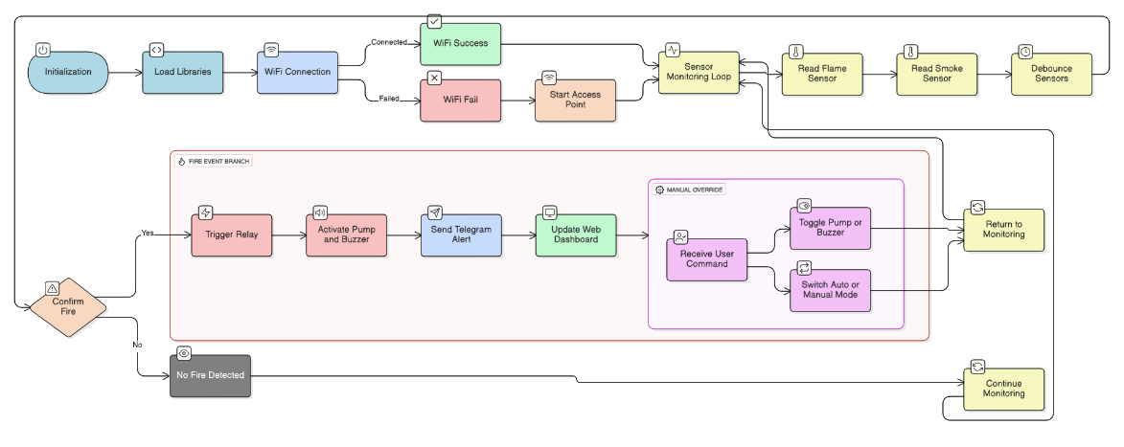
Figure 3.5: Software logic diagram
The control program was developed in C++ using the Arduino framework.
Key libraries include WiFi.h and WebServer.h for network communication, UniversalTelegramBot.h and ArduinoJson.h for Telegram messaging, and NTPClient.h for time synchronisation.
- Sensor Debouncing and Confirmation
To reduce false alarms, the code implements a 50 ms debounce delay and a 500 ms confirmation interval. A fire event is confirmed only when both flame and smoke sensors consistently indicate a hazard within this interval.
- Operating Modes
The system defaults to automatic mode, in which the relay controlling the pump is triggered whenever both sensors detect fire conditions. Manual override commands allow the user to turn the pump on or off and to toggle the buzzer. These commands can be issued through a web interface or via Telegram.
- Wi-Fi and Access Point Handling
On start-up the microcontroller attempts to connect to a configured Wi-Fi network. If this fails, it automatically creates an access point named FlameGuard-AP for local control. The code periodically checks connection status and attempts reconnection when necessary.
- Remote Notification
When a fire is confirmed, the ESP32 sends a critical alert message through the Telegram Bot API to a predefined chat ID. The message includes real-time status of sensors, pump, buzzer and the current time in West Africa Time (WAT). A web server hosted on the board also provides a control dashboard with live system status and control buttons.

3.4 Operation Sequence
- Sensing Phase: The flame sensor and MQ-2 smoke sensor continuously acquire environmental data.
- Processing Phase: The ESP32-S2 analyses sensor readings in real time, applies debounce filtering, and checks detection stability.
- Action Phase: If fire is confirmed, the red LED and buzzer are activated while the relay energises the water pump to extinguish the fire. Simultaneously, a Telegram alert and a status update on the web dashboard are issued.

Summary
This methodology ensures that the prototype integrates detection, notification and active response in a single compact design. By combining stable sensor logic with both local and remote-control interfaces, the system demonstrates how IoT-based fire safety can be realised on a small scale.

CHAPTER FOUR: RESULTS AND PERFORMANCE
The smart fire safety prototype was successfully built and demonstrated to operate as intended. Throughout a series of controlled trials, the system consistently detected the presence of fire and responded automatically. When heat or smoke was introduced, the sensors triggered the alarm sequence, which included both an audible warning and the activation of the water-spraying extinguishing unit. This rapid chain of actions confirms the reliability of the detection and the immediate effectiveness of the suppression mechanism. The finished unit integrates all key modules—sensing, control, alerting, and extinguishing—into a single, compact design. The components were selected for their affordability and availability in Nigeria, showing that an effective fire-safety solution can be achieved without expensive, specialized equipment. The system remained stable during repeated tests and required minimal human supervision, demonstrating that it can function as an independent safety device for domestic or small-scale commercial settings.
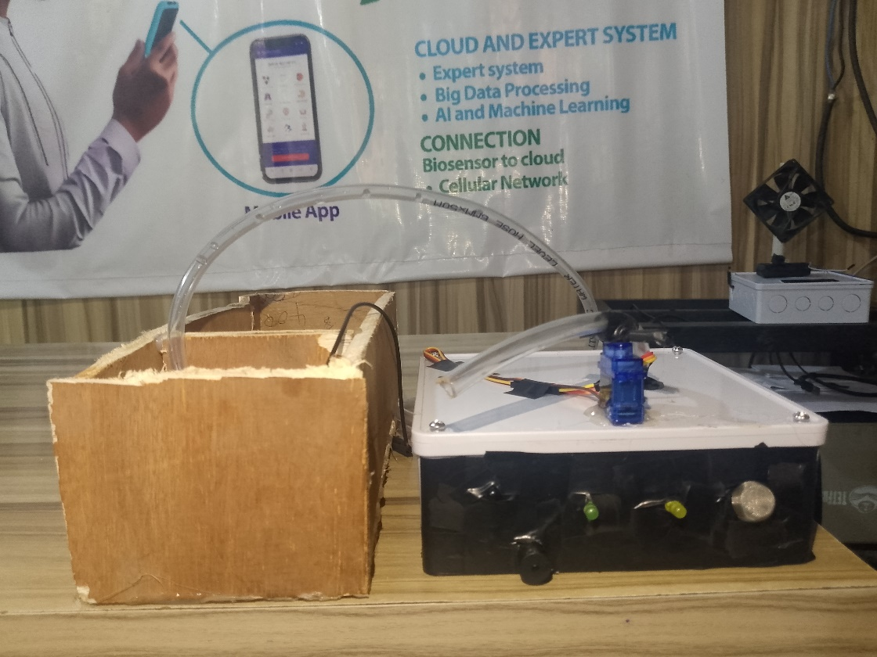
Figure 4.1. Completed Smart fire detection and extinguishing system prototype
Overall, the project met its main objectives:

It proved that low-cost sensors and microcontroller technology can reliably identify early signs of fire,

It successfully linked detection to an automated extinguishing response, and

It delivered these capabilities in a portable, easy-to-assemble package.

These results highlight the potential of the design as a practical, affordable tool for improving fire preparedness in Nigerian homes and similar environments.

REFERENCES
Adekunle, A., Arowolo, T. A., Omojola, O. O., & Ibrahim, H. D. (2020). Structural fire analysis in residential and commercial buildings based on ignition frequency, fire extinguisher performance, and fire risk indexes in the South-East Zone of Nigeria from 2010 to 2019. Journal DOI, 6(10).
Ali, S. S., Ali, S., Ali, S., Zaidi, A. A., Zafar, A., Munawwar, S., & Shafique, M. (2025). Development of automated fire control system: An integrated solution for gas, fire, and smoke detection. Pakistan Journal of Engineering, Technology and Science, 13(1), 69–77.
Baba, M. C., Grado, J. J. B., Solis, D. J. L., Roma, I. M., & Dellosa, J. T. (2022). A multisensory Arduino-based fire detection and alarm system using GSM communications and RF module with an Android application for fire monitoring. International Journal of Innovative Science and Research Technology (IJISRT), 964–968. https://doi.org/10.5281/zenodo.6433836
Dauda, M. S., & Toro, U. S. (2020). Arduino based fire detection and control system. International Journal of Engineering Applied Sciences and Technology, 4(11), 447–453.
Oloke, O. C., Oluwunmi, O. A., Oyeyemi, K. D., Ayedun, C. A., & Peter, N. J. (2021, February). Fire risk exposure and preparedness of peri-urban neighbourhoods in Ibadan, Oyo State, Nigeria. IOP Conference Series: Earth and Environmental Science, 655(1), 012079. IOP Publishing.
See, Y. C., & Ho, E. X. (2020). IoT-based fire safety system using MQTT communication protocol. International Journal of Integrated Engineering, 12(6), 207–215.
Suwarjono, S., Wayangkau, I. H., Istanto, T., Rachmat, R., Marsujitullah, M., Hariyanto, H., … & Glowacz, A. (2021). Design of a home fire detection system using Arduino and SMS gateway. Knowledge, 1(1), 61–74.
Yadav, R., & Rani, P. (2020, November). Sensor based smart fire detection and fire alarm system. In Proceedings of the International Conference on Advances in Chemical Engineering (AdChE).

