


FINAL PROJECT

Contents
I. Induction 3
II. Data Collection 3
III. Data visualisation and Descriptive Statistics 4
1) Data visualisation 4
2) Descriptive Statistics 6
i. Mean Calculation 6
ii. Variance Calculation 6
iii. Standard Deviation Calculation 7
IV. Hypothesis testing. 7
V. Simple Linear Regression 8
VI. Critical Assessment. 8
1) Advantages and Disadvantages: 9
i. Linear Regression 9
ii. Standard Deviation 9
iii. Hypothesis testing. 9
2) Final conclusion 10

- Induction
Mathematics is a tool that helps to express, analyze and solve problems rigorously and reasonably, bringing practical benefits. Statistical probability is an extremely important area that helps us in many ways. many professions later. Know how to describe economic problems in the form of appropriate mathematical models, apply statistical probability methods to solve, analyze and annotate as well as test results, predict changes in economic conditions. Logical economics is always an urgent requirement for experts working in the field of economic analysis. Understanding the importance of mathematics to economics and answer some questions about the average salary of an assistant professor in the US, in the last project, our team used statistical probability methods to prove the truth or falsehood of the hypothesis “The average salary of an 'AssocProf' professor in the US is $130,000”.
In this project, the main tasks involve collecting and analysing the given dataset Assessed Unit Learning Outcomes:
- Gain some experience with data collection and reflect on that experience.
- Perform and justify the use of appropriate descriptive and inferential statistical analyses.
- Communicate the results of statistical analysis effectively and accurately.
- Create graphics and tables for effective communication of the results of data analysis.
- Analyse the factors that make statistics reliable, credible and trustworthy.
- Data Collection
The job group that our group selected is professor and associate professor in US to carry out this research project.
First, we collect data from "Kaggle" in the form of a csv file to analyze and draw charts based on the use of statistical operations, using tests such as T-test, Hypothesis testing to establish Create data for prediction.
To analyze the problem, we have set out the data that need to be collected such as salary and working time to compare and contrast, thereby clarifying the hypothesis.
Based on the criteria to be able to make predictions as well as prove the right or wrong of the topic. We have chosen to collect the following data:
-Rank are the people who collect data, including professors (Prof) and associate professors (AssocProf).
-Discipline includes two types of qualifications: A and B.
-Ysr.sice.phd is the number of years after graduation.
-Ysr.service is the number of years of work (experience).
-Sex(Male/Female).
-Salary is the current salary each person receives.
After obtaining the initial data, we proceed to filter to get the necessary data for the calculation and statistical process.
Before Sample of dataset After Sample of Dataset
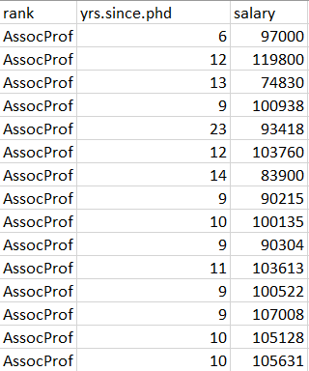
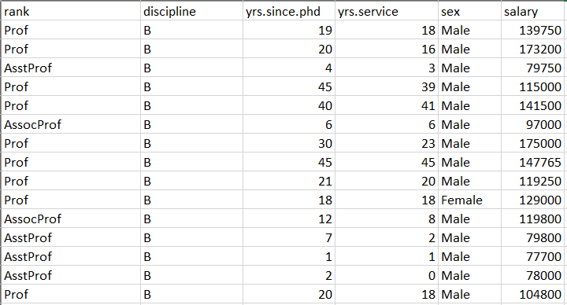

- Data visualisation and Descriptive Statistics
- Data visualisation
After the data collection step, we next perform the visualization of that data. Data visualization plays an important role in helping us in the initial step of visualizing the data to proceed with placing the data. Statistical calculations are reasonable.
To do this visualization step well, we need to choose appropriate chart types to clearly display the objects in the dataset. Corresponding to the group's dataset, we have filtered out the two most important data during the calculation process. math is ysr.since.phd and salar to perform the visualization.
First, use two types of column charts to represent the above two types of data. To get the first general view of the distribution and coverage density of the data.
The first chart helps us have a visual view of the stretch of the data, the min and max points of the data.
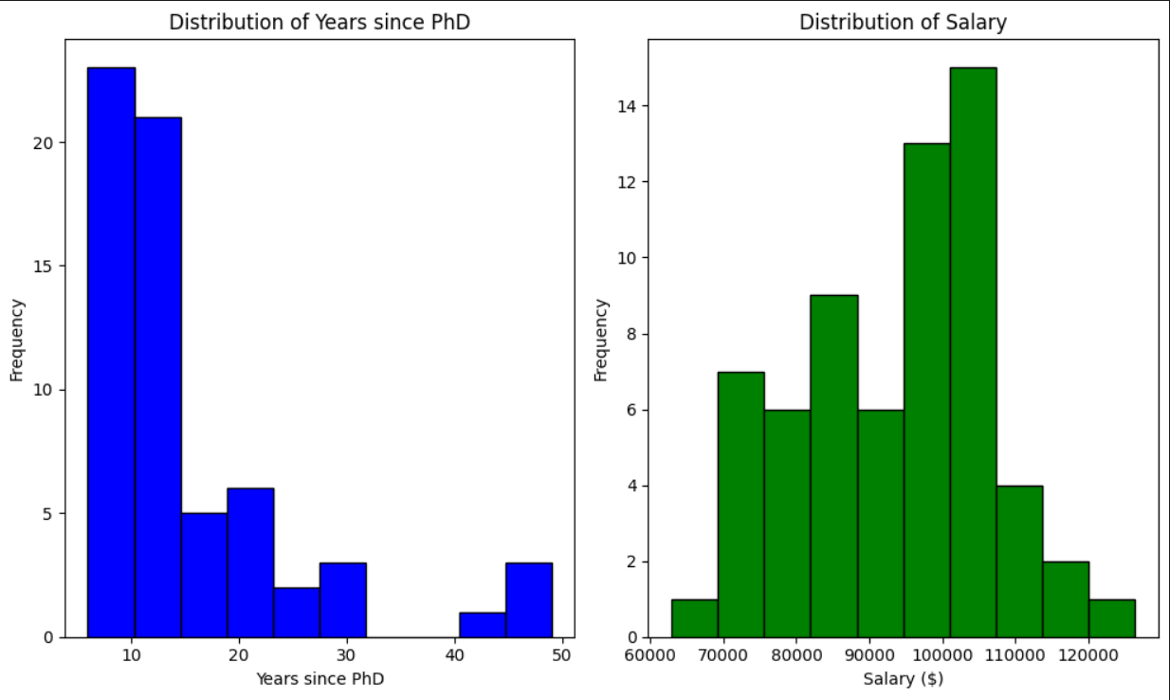

The second chart shows us where the density of data, salary, and number of years after obtaining a degree is concentrated, thereby easily determining the relationship between them.
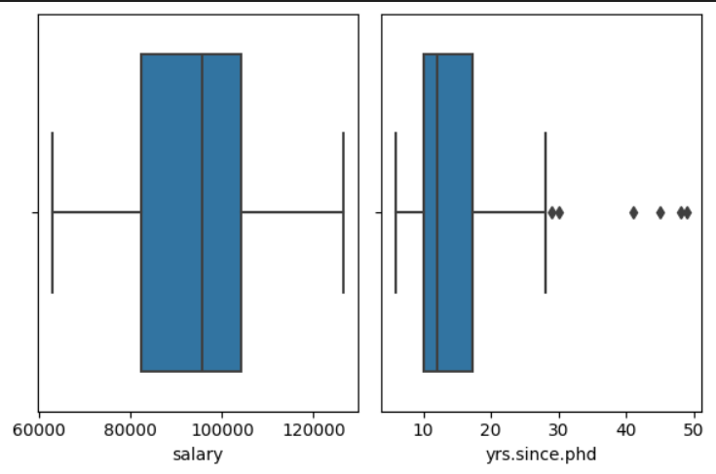
After observing the density and properties of the data, we will proceed to visualize them as a point with coordinates (x,y). Where, x is ysr.since.phd (number of years after degree) and y is salary (corresponding salary).
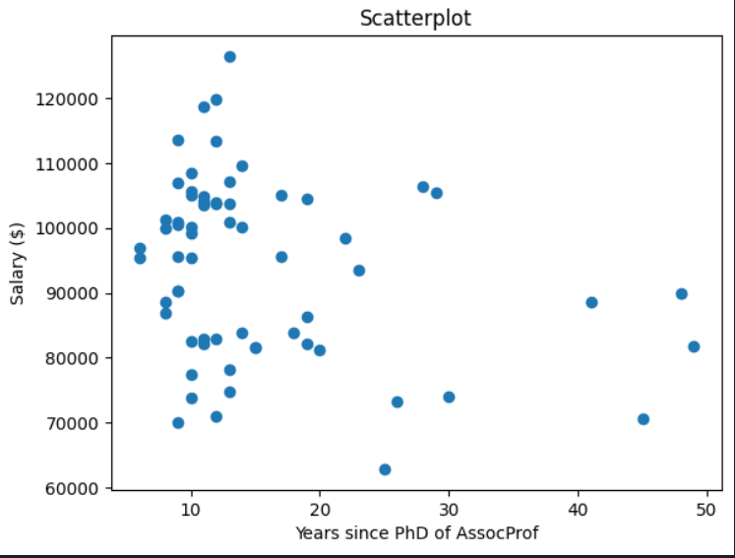
This final visualization serves to calculate linear regression. Use heapmaps and related calculations to draw a linear regression line (we will talk more about it later).

- Descriptive Statistics
- Mean Calculation
*Mean of Salary:

- Let$X_{i}$ represent the salary of the $i$th professor with the 'AssocProf' rank.
- The mean of salary $μ_{salary}$for 'AssocProf' rank is calculated as follows:
$μ_{salary}$=$\frac{\sum_{i-1}^{n}{X_{i}}}{n}$
$μ_{salary}$ = $\frac{139750+173200+79750+…..+95329+81035}{398}= 93876.4375$
Where n is the total number of professors with the 'AssocProf' rank.

*Mean of Years Since PhD:
- Let $Y_{i}$ represent the years since PhD of the $i$th professor with the 'AssocProf' rank.
- The mean of years since PhD $μ_{yrs.since.phd}$ for 'AssocProf' rank is calculated as follows:
$μ_{yrs.since.phd}$=$\frac{\sum_{i-1}^{n}{Y_{i}}}{n}$
$μ_{yrs.since.phd}=\frac{19+20+4+…..+25+8}{398}= 15.453125$

- Variance Calculation
*Variance of Salary:
- The variance of salary $σ_{salary}^{2}$for 'AssocProf' rank is calculated as:
$σ_{salary}^{2}$= $\frac{\sum_{i-1}^{n}{{\left(X_{i-}μ_{salary}\right)}^{2}}}{n}$
$σ_{salary}^{2}$ = $\frac{{(139750-93876.4375)}^{2}+{(173200-93876.4375)}^{2}+…+{\left(95329-93876.4375\right)}^{2}+{(81035-93876.4375)}^{2}}{398}=188326609.30859375$

*Variance of Years Since PhD:
- The variance of years since PhD $σ_{yrs.since.phd}^{2}$ for 'AssocProf' rank is calculated as:
$$σ_{yrs.since.phd}^{2}=\frac{\sum_{i-1}^{n}{{\left(Y_{i-}μ_{yrs.since.phd}\right)}^{2}}}{n}$$
$σ_{yrs.since.phd}^{2}= \frac{{(19-15.453125)}^{2}+{(20-15.453125)}^{2}+…+{\left(25-15.453125\right)}^{2}+{(8-15.453125)}^{2}}{398}$ = 91.716552734375
- Standard Deviation Calculation
*Standard Deviation of Salary:
- The standard deviation of salary($σ_{salary})$for 'AssocProf' rank is the square root of the variance of salary:
$$σ_{salary}= \sqrt{σ_{salary}^{2}}$$
$σ_{salary}= \sqrt{σ_{salary}^{2}}$ = $\sqrt{188326609.30859375}$ = 13723.21424844026
*Standard Deviation of Years Since PhD:
- The standard deviation of years since PhD($σ_{yrs.since.phd})$ for 'AssocProf' rank is the square root of the variance of years since PhD:
$$σ_{yrs.since.phd}= \sqrt{σ_{yrs.since.phd}^{2}}$$
$σ_{yrs.since.phd}= \sqrt{σ_{yrs.since.phd}^{2}}$ = $\sqrt{91.716552734375}$ = 9.576875938132174
In these formulas:
- $X_{i}$represents the salary of the $i$th professor with the 'AssocProf' rank.
- $Y$represents the years since PhD of the $i$th professor with the 'AssocProf' rank.
-$μ_{salary}$and $μ_{yrs.since.phd}$represent the mean salary and mean years since PhD, respectively, for the 'AssocProf' rank.
- $σ_{salary}^{2}$and $σ_{yrs.since.phd}^{2}$ represent the variance of salary and variance of years since PhD, respectively, for the 'AssocProf' rank.
-$σ_{salary}$ and $σ_{yrs.since.phd}$ represent the standard deviation of salary and standard deviation of years since PhD, respectively, for the 'AssocProf' rank.

- Hypothesis testing.
Hypothesis testing involves posing two hypotheses: the null hypothesis (H0) and the alternative hypothesis (H1 or Ha). Test statistics, alpha level, and probability distribution are used to evaluate the null hypothesis's validity. The test results are compared with the alpha level to draw conclusions. Type I and Type II errors can occur, with Type I errors rejecting the null hypothesis and Type II errors accepting it. Statistical tools like z-tests, t-tests, ANOVA tests, and chi-squared tests are used. Sample size is crucial for determining testing results' accuracy.
This is an overview of our team's hypothesis testing.
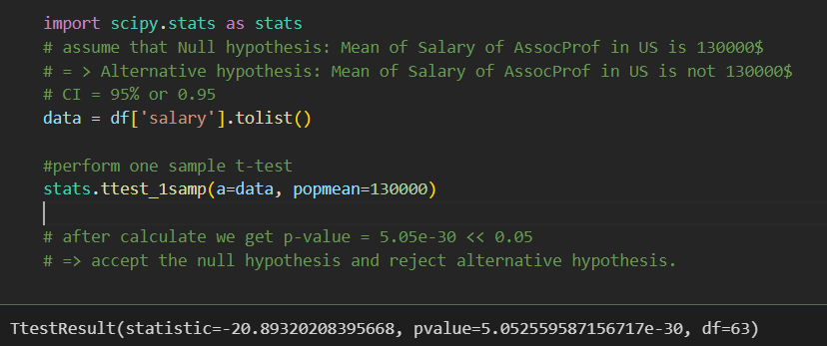
Below is a description of the hypothesis part of this code:
Null Hypothesis: This is the hypothesis whose validity you want to test. In this case, the null hypothesis is: "The average salary of an 'AssocProf' professor in the United States is $130,000."
Alternative Hypothesis: This is the hypothesis you want to test to see if there is evidence to support it. In this case, the alternative hypothesis is: "The average salary of an 'AssocProf' professor in the United States is not $130,000."
CI (Confidence Interval): This is the confidence level you want to apply to the test. In this case, you used a 95% confidence level (0.95), meaning you wanted to test whether the average salary falls within the 95% confidence interval.
Conclusion: The t-test was conducted using the scipy.stats library to analyze salary data for professors in the 'AssocProf' class. The p-value, calculated using the stats.ttest_1samp function, was less than the alpha level of 0.05, indicating the validity of the null hypothesis. The p-value of 5.05e-30, less than the alpha level, suggests that the average salary of an 'AssocProf' professor in the US is not $130,000.

- Simple Linear Regression

- Critical Assessment.
In this part, we will analyze the advantages and disadvantages of the statistical operations that we used throughout the process of proving the hypothesis and drawing the final conclusions of the problem.
- Advantages and Disadvantages:
- Linear Regression
Some advantages and disadvantages of linear regression:
*Advantage:
-Easy to understand and implement
-Quick calculation
-Assume independent data
-Interpretability
*Defect:
-Linear relationship assumption
-Sensitive to noise
-Limitations in describing complex relationships
-Not suitable for non-linear input variables
-Possibility of overfitting and underfitting
- Standard Deviation
Here are some advantages and disadvantages of Standard Deviation:
*Advantage:
-Measuring variability
-Easy to understand
-Used for comparison
-Mathematical properties
*Defect:
-Disadvantages for peripheral data
-Does not reflect data structure
-Not enough for a comprehensive description
- Hypothesis testing.
Here are some advantages and disadvantages of hypothesis testing:
*Advantage:
-The results are scientific
-Quality and precision
-Create classification
-Widely applicable
*Defect:
-Assumed level of error.
-Limits on the level of influence.
-Not enough to understand the relationship
-Depends on sample data
- Final conclusion
From the data we collected, combined with statistical calculations, training and testing and predictions based on linear regression, the first hypothesis (H0) that we made is false. average salary of an 'AssocProf' professor in the US is $130,000".

