Low Level Design

|  |  |
| --- | --- |
| **Written By** | Sairaj Honrao |
| **Document Version** | 0.3 |
| **Last Revised Date** |  |

**DOCUMENT CONTROL**

**Change Record:**

|  |  |  |  |
| --- | --- | --- | --- |
| **VERSION** | **DATE** | **AUTHOR** | **COMMENTS** |
| 0.1 | 18th feb 2024 | Sairaj Honrao | Introduction and architecture defined |
| 0.2 | 18th feb 2024 | Sairaj Honrao | Architecture & Architecture description appended and  updated. |
|  |  |  |  |
|  |  |  |  |

**Reviews:**

|  |  |  |  |
| --- | --- | --- | --- |
| **VERSION** | **DATE** | **REVIEWER** | **COMMENTS** |
| 0.2 | 21- Feb-  2024 | Sairaj Honrao | Unit test cases to be added |

**Approval Status:**

|  |  |  |  |  |  |
| --- | --- | --- | --- | --- | --- |
| **VERSION** | **REVIEW**  **DATE** | **REVIEWED BY** |  | **APPROVED BY** | **COMMENTS** |
|  |  |  |  |  |  |

# Contents

1. **Introduction** **04**
   1. **What is Low-Level Design Document?** **04**

|  |  |  |
| --- | --- | --- |
| **1.2** | | **Scope** **04** |
| **2.** | **Architecture** **05** | |
| **3.** | **Architecture Description** **08** | |
|  | **3.1** | **Data Description** **08** |
|  | **3.2** | **Web Scrapping** **08** |
|  | **3.3** | **Data Transformation** **08** |
|  | **3.4** | **Data insertion into database** **08** |
|  | **3.5** | **Connection with SQL**  **08** |
|  | **3.5** | **Export Data from database** **12** |
|  | **3.6** | **Deployment** **12** |
| **4.** | **Unit** | **test cases** **15** |

# Introduction

## What is Low-Level design document?

The goal of the LDD or Low-level design document (LLDD) is to give the internal logic design of the actual program code for the House Price Prediction dashboard. LDD describes the class diagrams with the methods and relations between classes and programs specs. It describes the modules so that the programmer can directly code the program from the document.

## Scope

Low-level design (LLD) is a component-level design process that follows a step-by-step refinement process. The process can be used for designing data structures, required software architecture, source code and ultimately, performance algorithms. Overall, the data organization may be defined during requirement analysis and then refined during data design work.

# Architecture

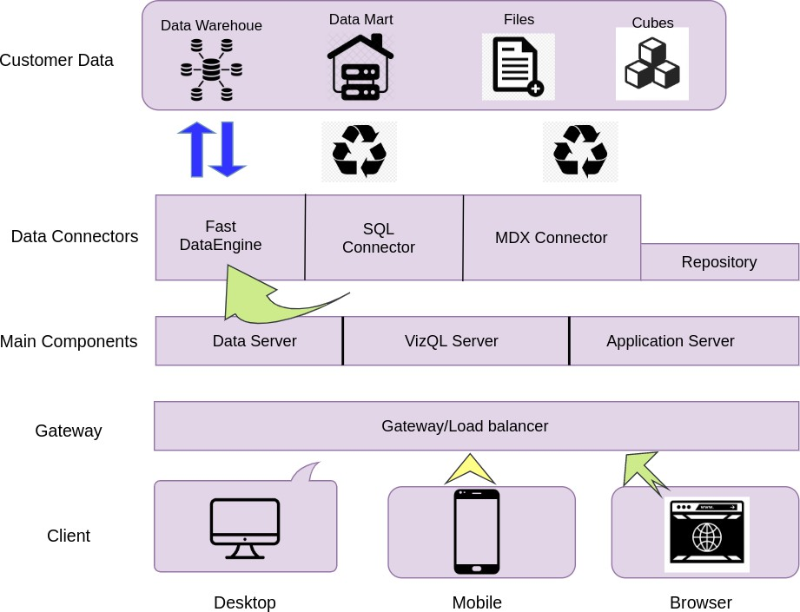

**Power BI Architecture**

Power BI has a highly scalable, n-tier client- architecture that serves mobile clients, web clients and desktop-installed software. Power BI architecture supports fast and flexible deployments.

The following diagram shows Power BI ’s architecture:

**LOW LEVEL DESIGN**

**6**

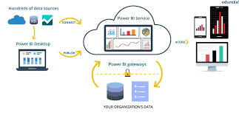

## 1. Gateway/Load Balancer

It acts as an Entry gate to the Power BI and also balances the load to the if multiple Processes are configured.

**2) Application :-**

Application processes (wg.exe) handle browsing and permissions for the Power BI web and mobile interfaces. When a user opens a view in a client device, that user starts a session on Power BI . This means that an Application thread starts and checks the permissions for that user and that view.

1. **Repository:-**

Power BI Repository is a PostgreSQL database that stores data. This data includes information about Power BI users, groups and group assignments, permissions, projects, data sources, and extract metadata and refresh information.

**4Data Engine:-**

It Stores data extracts and answers queries.

1. **Backgrounder:-**

The backgrounder Executes server tasks which includes refreshes scheduled extracts, tasks initiated from tabcmd and manages other background tasks.

# Architecture Description

## Data Description

* User_ID
* Cust_name
* Product_ID
* Gender
* Age Group
* Age
* Marital_Status
* State Zone Occupation
* Product_Category
* Orders Amount
* Status
* User_ID:

Description: A unique identifier assigned to each user. This is usually an alphanumeric code.

* Cust_name:

Description: The name of the customer. This can include first name, last name, or a full name.

* Product_ID:
* Description: A unique identifier assigned to each product. This helps in tracking and managing products.
* Gender:

Description: The gender of the customer. This is usually captured as a categorical value.

* Age Group:

Description: The age range that the customer falls into. This helps in segmenting customers for analysis.

* Age:

Description: The actual age of the customer.

* Marital_Status:

Description: The marital status of the customer.

* State:

Description: The state where the customer resides.

* Zone:

Description: The geographical zone of the customer's location, often divided into regions for analysis.

* Occupation:

Description: The profession or job title of the customer.

* Product_Category:

Description: The category to which a product belongs. This is useful for product management and inventory control.

* Orders:

Description: The number of orders placed by the customer.

* Amount:

Description: The total monetary value of the orders placed by the customer.

* Status:

Description: The current status of the order(s). This can indicate whether an order is pending, completed, shipped, or cancelled.

## Data Transformation

In the Transformation Process, we will convert our original datasets with other necessary attributes format. And will merge it with the Scrapped dataset.

## Data Insertion into Database

1. Database Creation and connection - Create a database with name passed. If the database is already created, open the connection to the database.
2. Table creation in the database.
3. Insertion of files in the table

## 3.5 Make the SQL connection and set up the data source

**Step 1: Configuring Power BI**

Launch Power BI on your workstation and select SQL from the connect column on the left. This will open a dialogue box where you need to provide the connection details for SQL .

To connect with Power BI, you will need to provide information about the which hosts your database. If you want to connect to a contained database, you can also specify the name of the database.

To connect with a port other than the default port, you need to specify the port and as follows:

<server_name><port_number>

Example query: my_ 8051

There are two ways in which you can sign-in to the , either by using Windows authentication or by using the username and password. Using the username and password becomes a must if you’re working with a password-protected in a non-Kerberos environment.

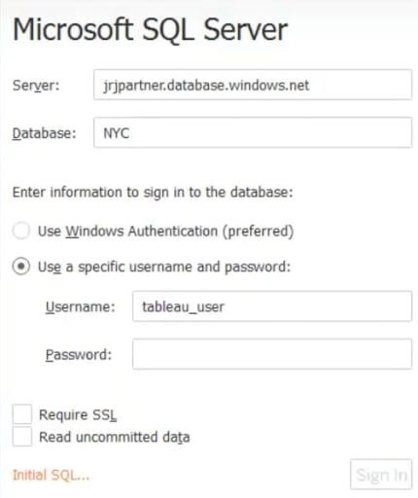

Click on Sign in to establish a connection. This will enable a connection without SSL. To establish an SSL enabled connection, click the Require SSL checkbox before you sign in.

SQL provides an option to let the user queries access the modified rows even before they have been committed. This option is called Read Uncommitted data. It saves time by preventing complex queries such as extract refreshes from locking the database and causing a delay. If this option is unchecked, Power BI makes use of default isolation levels.

If you want to run a specific SQL command every-time a new connection is established, you can use the Initial SQL option. This will open a dialogue box, where you can specify your desired SQL query.

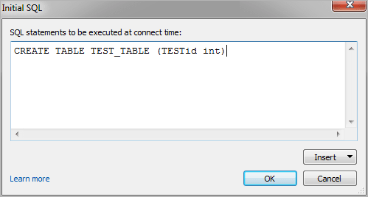

**Step 2: Configuring Data Source**

The data source page loads up after configuring the Power BI connector and successfully signing in. This is how the page looks like:

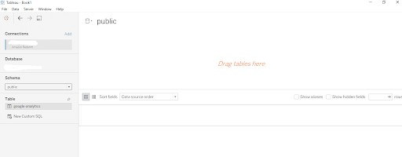

Select the data source name option and give a unique name to the database you are using. It’s considered a good practice to have a unique name as it makes it much easier for users to identify the database from which data is being fetched.

To select the desired schema, you can use the schema drop-down list from the column on the left. You can also perform a text-based search to find the desired option. Now similarly find and select the desired table and drag it onto the canvas.

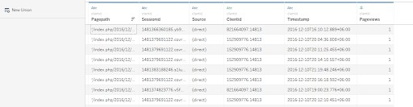

This is how you can connect SQL with Power BI. Now click on the sheets tab to begin the analysis.

Custom SQL features can be used to focus on specific SQL statements, rather than querying the entire database. Click on the Custom SQL option from the panel on the left. A new dialogue box will now open up, where you can provide the query you want to execute.

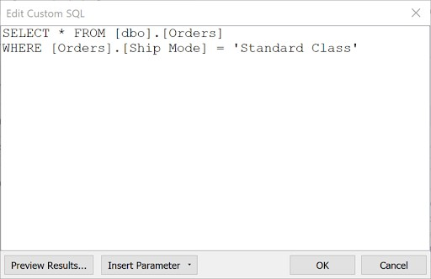

## Export Data from Database

Data Export from Database - The data in a stored database is exported as a CSV file to be used for Data Pre-processing.

## 3.6 Deployment.

Once you’ve completed your dashboard, follow these steps:**- Server, Power BI Public, Save to Power BI Public As**

You may be prompted to log into your Power BI Public profile first if this is your first time publishing.

### LOW LEVEL DESIGN

**12**

Next, fill out the title you want your viz to have and click “save”.

This message means that your connection to the Sample-Superstore data set is a live connection. Power BI Public cannot host live connections, so you’ll need to convert your connection to an extract (like a frozen screenshot of your data).

Here in the below screenshot, we can see that out workbook has been published to Power BI public.

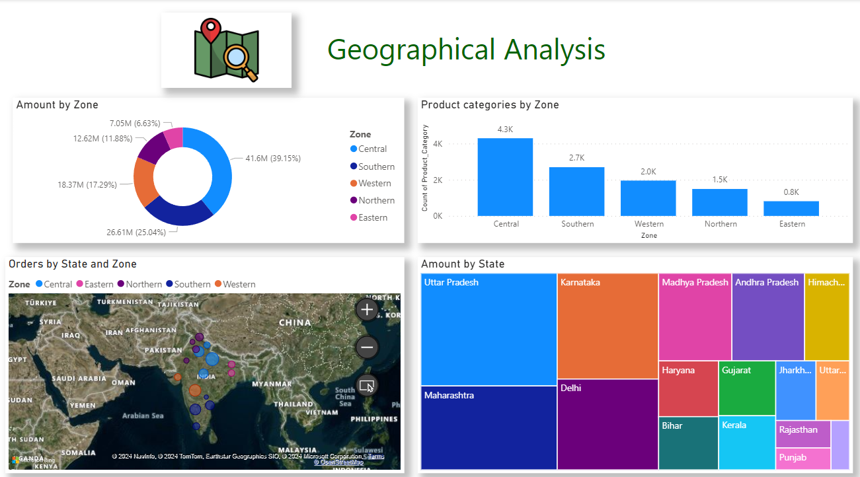

**13 LOW LEVEL DESIGN**