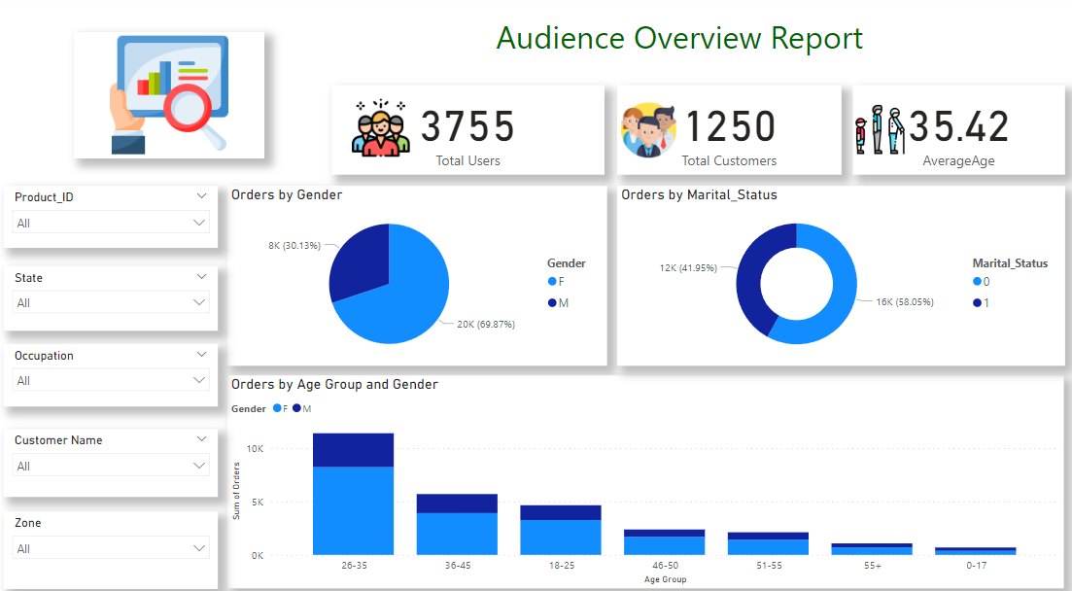**Audience Overview Report :-**

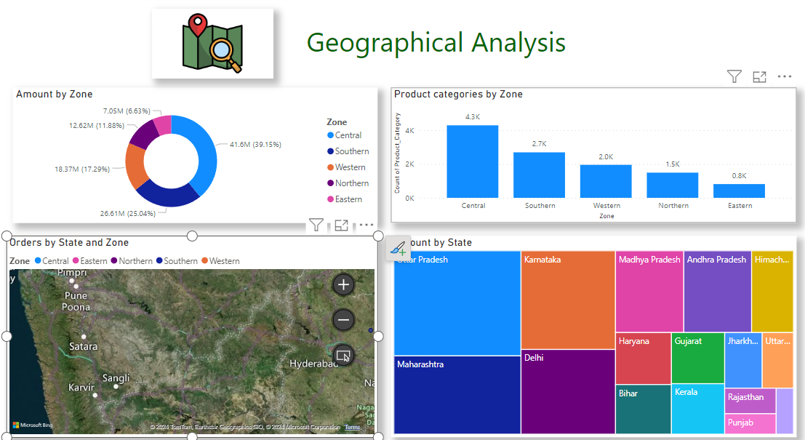**Geographical Analysis Report :-**

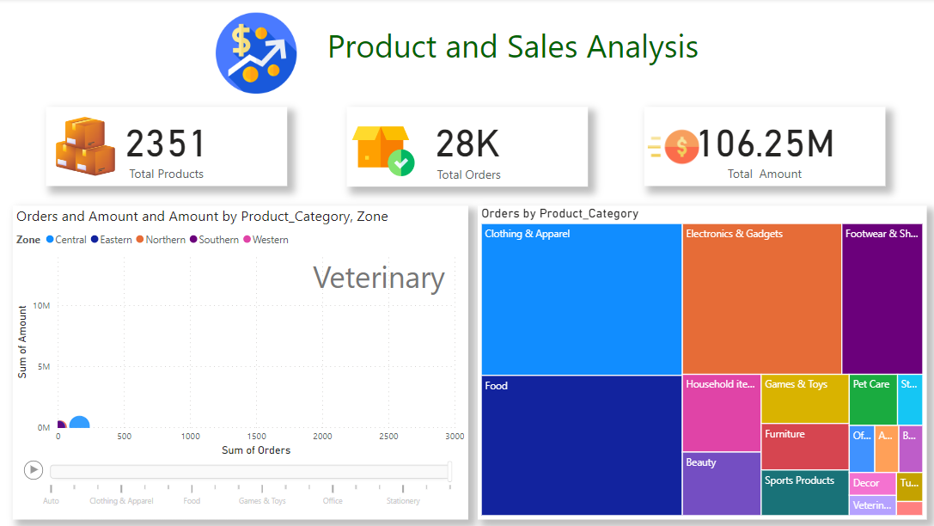**Product And Sales Analysis.**

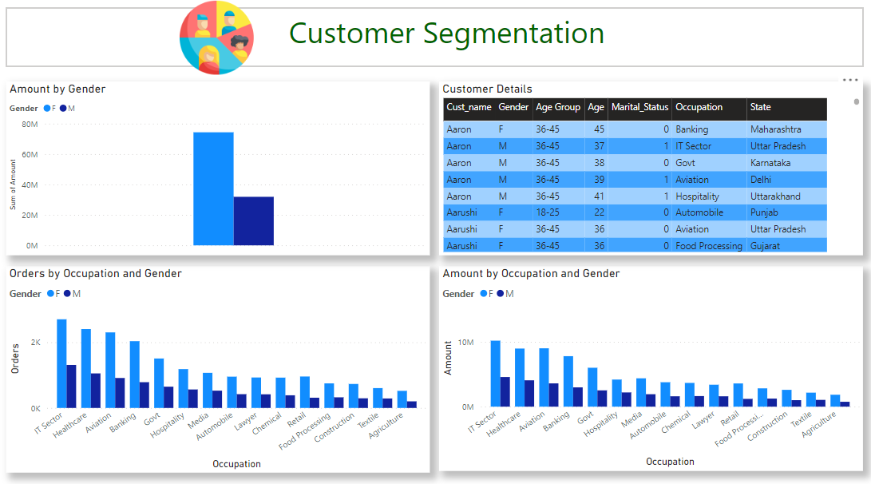**Customer Segmentation**

**Product and Sales Analysis:-**