# Contribute to Authors

# Dear friends and fans of Krkal

Maybe you like the game so much, that you'd like to show appreciation to the authors for their hard work. This is why we prepared several ways to do just that. If you're still hesitating and thinking, don't! The great feeling is worth it ☺. The contribution is of course voluntary, you will not receive any better Krkal or benefits for it.

We do however greatly appreciate your support and we **thank you** for it in advance.

# Email

[support@krkal.org](mailto:support@krkal.org)

Let us know that you liked the game.

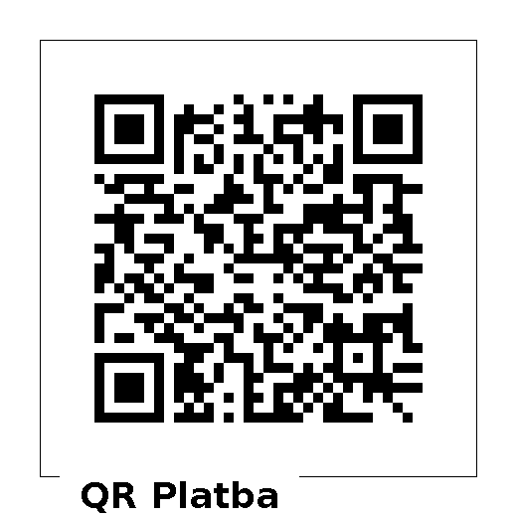

# Payment in favor of a Czech bank account

**670100-2201314697/6210**

Appropriate only within the Czech Republic. The advantage is that the transfer is usually without charges. Select the amount as per your consideration.

# Payment via PayPal, payment via debit/credit card

|  |  |  |
| --- | --- | --- |
| [50 CZK](https://www.paypal.com/cgi-bin/webscr?cmd=_s-xclick&hosted_button_id=R4M9CG27Q953A) | [EUR 2.5](https://www.paypal.com/cgi-bin/webscr?cmd=_s-xclick&hosted_button_id=EHJX4YR7JP84S) | [USD 2.5](https://www.paypal.com/cgi-bin/webscr?cmd=_s-xclick&hosted_button_id=Y64XY8HKJD4YW) |
| [100 CZK](https://www.paypal.com/cgi-bin/webscr?cmd=_s-xclick&hosted_button_id=QVBJX6K7FC7TG) | [EUR 5](https://www.paypal.com/cgi-bin/webscr?cmd=_s-xclick&hosted_button_id=QSAPTY7CW2MHW) | [USD 5](https://www.paypal.com/cgi-bin/webscr?cmd=_s-xclick&hosted_button_id=EY72AXSH23AYA) |
| [200 CZK](https://www.paypal.com/cgi-bin/webscr?cmd=_s-xclick&hosted_button_id=DSCV3W4ZE5LZE) | [10 EUR](https://www.paypal.com/cgi-bin/webscr?cmd=_s-xclick&hosted_button_id=F5QAWAZ554KR8) | [10 USD](https://www.paypal.com/cgi-bin/webscr?cmd=_s-xclick&hosted_button_id=TUWDKUNKCLQVA) |
| [500 CZK](https://www.paypal.com/cgi-bin/webscr?cmd=_s-xclick&hosted_button_id=KDEEMJ4R2GJMS) | [25 EUR](https://www.paypal.com/cgi-bin/webscr?cmd=_s-xclick&hosted_button_id=4PKMMGWM5E864) | [25 USD](https://www.paypal.com/cgi-bin/webscr?cmd=_s-xclick&hosted_button_id=4TNFANB5DFQ36) |



It works internationally.

# Bitcoin transfer

1GCpgpXRvsVdGbsXg2SWdFhpgd5PoRT3wT

Suitable only for fans of BTC