Software Requirements Specification
For
Student Management System
Version: 1.0
Group: Group 11
Date Created: March, 2026

Table of Contents
1. Introduction 3
1.1. Purpose 3
1.2. Document Conventions 3
1.3. Project Scope and Product Features 3
2. Overall Description 3
2.1. Product Perspective 3
2.2. User Classes and Characteristics 4
2.3. Operating Environment 5
2.4. Design and Implementation Constraints 5
2.5. Assumptions and Dependencies 5
3. Specific Requirements 6
3.1. Business Rules 6
3.2. Functional Requirements 7
3.2.1. Auth — Account Authentication 7
3.2.2. User — User Account and Permission Management 7
3.2.3. Student — Student Management 8
3.2.4. Class — Class Management 8
3.2.5. Subject — Course Management 9
3.2.6. Assignment — Teaching Assignment 9
3.2.7. Grade — Grade Management 9
3.2.8. Report — Reports and Statistics 10
3.2.9. Announcement and Schedule — Notifications and Schedule 10
3.3. Non-Functional Requirements 11
4. System Models 12
4.1. Use Case Diagram 12
4.2. Use Case Specifications 13
4.2.1. UC-1 Login 13
4.2.2. UC-2 Admin Manages Students 14
4.2.3. UC-3 Teacher Enters Student Grades 15
4.2.4. UC-4 Student Views Grade Report 16
4.3. Sequence Diagrams 18
4.3.1. Sequence Diagram for UC-1 Login 18
4.3.2. Sequence Diagram for UC-2 Admin Manages Students 19
4.3.3. Sequence Diagram for UC-3 Teacher Enters Student Grades 20
4.3.4. Sequence Diagram for UC-4 Student Views Grade Report 21
4.4. Class Diagram 22
4.5. Activity Diagram 23
4.6. State Diagram 24
4.7 UI Screen Flow 25
5. Data Requirements 25
5.1. Logical Data Model 25
5.2. Data Dictionary 26
5.3. Reports 27
5.3.1. Report Specification 27
5.4. Data Integrity, Retention, and Disposal 27
6. External Interface Requirements 28
6.1. User Interfaces 28
6.2. Software Interfaces 28
6.3. Hardware Interfaces 29
6.4. Communications Interfaces 29
7. Quality Attributes 30
7.1. Usability Requirements 30
7.2. Performance Requirements 30
7.3. Security Requirements 30
7.4. Safety Requirements 31
7.5. Availability Requirements 31
7.6. Robustness Requirements 31

1. Introduction

1.1. Purpose
This document describes the functional and non-functional requirements for Release 1.0 of the Student Management System. It is used by project team members for analysis, design, implementation, testing, and evaluation of the system’s completeness.

1.2. Document Conventions
No special typographic conventions are used in this SRS document.

1.3. Project Scope and Product Features
The Student Management System is a web application that supports centralized management of user accounts, student profiles, classes, courses, teaching assignments, grades, schedules, notifications, and basic statistical reports. The system serves three primary user groups: Admin, Teacher, and Student.
The main functional modules include: account and login management, student management, class management, course management, teaching assignment, grade management, statistical reports, and notification board.
The planned technology stack is ReactJS for the frontend, Spring Boot for the backend, and MySQL for the database.

2. Overall Description

2.1. Product Perspective
The Student Management System is a new software system built to replace manual or fragmented management methods using spreadsheets, paper forms, and scattered data files. The system centralizes academic data in one place and supports user administration, student information management, class and course management, teaching assignments, grading, notifications, and reporting.
The system is designed with a 3-tier architecture consisting of Presentation Layer, Business Logic Layer, and Data Layer.
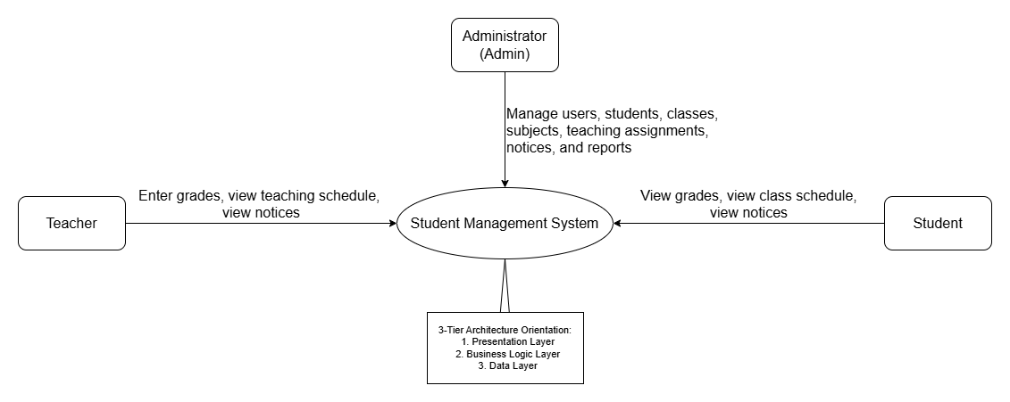
Figure 1. Context Diagram of the Student Management System

2.2. User Classes and Characteristics
User Class | Description | Key Characteristics | Main Permissions
Admin | System administrator | Manages master data and user accounts | Login, user account management, permission assignment, student/class/course management, teaching assignment, notifications, reports
Teacher | User operating within teaching scope | Works only with assigned classes or courses | Login, view student lists, enter/edit grades, view grade reports, view teaching schedule, view notifications
Student | End user querying academic information | Only operates on their own personal data | Login, view personal profile, class information, course list, grade report, academic results, class schedule, notifications

2.3. Operating Environment
Code | Description
OE-1 | Frontend built with ReactJS; Tailwind CSS or Bootstrap may be used for the user interface.
OE-2 | Backend built with Spring Boot.
OE-3 | Database uses MySQL.
OE-4 | The system is accessed via web browser on laptops or desktop computers.
OE-5 | Development tools include GitHub, Postman, Draw.io, PlantUML, and XAMPP.

2.4. Design and Implementation Constraints
Code | Constraint
CO-1 | The system must support the three main roles: Admin, Teacher, and Student.
CO-2 | The scope of the first release focuses on core functions for mid-term review and product demo.
CO-3 | The system architecture must be clear enough to support drawing Use Case Diagram, Sequence Diagram, Class Diagram, Activity Diagram, State Diagram, and Logical Data Model.
CO-4 | Main modules: accounts, students, classes, courses, teaching assignments, grades, reports, notifications.
CO-5 | The system must support clear role-based access control between actors.

2.5. Assumptions and Dependencies
Code | Content
AS-1 | The Admin will pre-create accounts and assign roles to users before they use the system.
AS-2 | Student, class, course, and teaching assignment data must be entered correctly so the system can generate schedules and grade reports.
AS-3 | Teachers only operate on assigned classes or courses; students only view their own data.
DE-1 | The system depends on MySQL database for centralized data storage.
DE-2 | The system depends on the ReactJS + Spring Boot architecture chosen by the team for the first release.

3. Specific Requirements

3.1. Business Rules
BR Code | Content
BR-1 | Each login account must be unique; usernames or email addresses must not be duplicated.
BR-2 | Each account can only be assigned one primary role at a time: Admin, Teacher, or Student.
BR-3 | Only users with valid accounts are allowed to log into the system.
BR-4 | Accounts that are locked or disabled are not permitted to log in.
BR-5 | Only the Admin has the right to create accounts, lock/unlock accounts, and assign user permissions.
BR-6 | Each student must have a unique student ID in the system.
BR-7 | Only the Admin has the right to add, edit, or delete student profiles.
BR-8 | Each student must belong to at least one class in the system at any given time.
BR-9 | Only the Admin has the right to add, edit, or delete classes and courses.
BR-10 | Each teaching assignment must be linked to a specific teacher, course, class, class time, and classroom.
BR-11 | Teachers can only view and operate on classes or courses they have been assigned.
BR-12 | Only assigned teachers are allowed to enter or edit grades for students.
BR-13 | Entered grades must fall within the valid range defined by the system.
BR-14 | Students can only view their own grade reports and academic data.
BR-15 | Only the Admin has the right to create, edit, or delete notifications.
BR-16 | Report and statistical data must be retrieved from actual data stored in the system.

3.2. Functional Requirements

3.2.1. Auth — Account Authentication
FR Code | Function Name | Details
FR_AUTH_001 | Login | The system allows Admin, Teacher, and Student to log in using username/email and password.
FR_AUTH_002 | Logout | The system allows users to log out.
FR_AUTH_003 | Role Identification | After successful login, the system correctly identifies the user’s role and redirects to the appropriate interface.
FR_AUTH_004 | Change Password | The system allows users to change their password.
FR_AUTH_005 | Access Control | The system blocks unauthorized access to functions not permitted for the current role.

3.2.2. User — User Account and Permission Management
FR Code | Function Name | Details
FR_USER_001 | Create User Account | Admin can create new accounts for teachers or students.
FR_USER_002 | Update Account | Admin can update user account information.
FR_USER_003 | Lock/Unlock Account | Admin can lock or unlock accounts.
FR_USER_004 | Assign User Permissions | Admin can assign roles to user accounts.

3.2.3. Student — Student Management
FR Code | Function Name | Details
FR_STU_001 | Add Student | Admin can add a new student profile.
FR_STU_002 | Edit Student | Admin can edit student information.
FR_STU_003 | Delete Student | Admin can delete a student if no data constraints are violated.
FR_STU_004 | View Student List | Admin can view the full list of students.
FR_STU_005 | View Student Details | The system allows viewing detailed student profiles.
FR_STU_006 | Search Student | The system allows searching students by ID, name, class, or related information.

3.2.4. Class — Class Management
FR Code | Function Name | Details
FR_CLASS_001 | Add Class | Admin can create a new class.
FR_CLASS_002 | Edit Class | Admin can update class information.
FR_CLASS_003 | Delete Class | Admin can delete a class when no data constraints are violated.
FR_CLASS_004 | View Class List | The system allows viewing the list of existing classes.
FR_CLASS_005 | Assign Student to Class | Admin can assign students to the corresponding class.

3.2.5. Subject — Course Management
FR Code | Function Name | Details
FR_SUB_001 | Add Course | Admin can add a new course.
FR_SUB_002 | Edit Course | Admin can update course information.
FR_SUB_003 | Delete Course | Admin can delete a course when no data constraints are violated.
FR_SUB_004 | View Course List | The system allows viewing the list of existing courses.

3.2.6. Assignment — Teaching Assignment
FR Code | Function Name | Details
FR_ASSIGN_001 | Create Teaching Assignment | Admin can assign a teacher to teach a specific course for a specific class.
FR_ASSIGN_002 | Set Schedule Time and Classroom | Admin can configure class time and classroom when making the assignment.
FR_ASSIGN_003 | Update Teaching Assignment | Admin can edit teaching assignment information.
FR_ASSIGN_004 | View Teaching Assignments | The system allows viewing the list of current teaching assignments.

3.2.7. Grade — Grade Management
FR Code | Function Name | Details
FR_GRADE_001 | Enter Student Grades | Teachers can enter grades for students in the classes or courses they are responsible for.
FR_GRADE_002 | Edit Student Grades | Teachers can edit previously entered grades within their assigned scope.
FR_GRADE_003 | View Grade Report for Assigned Class/Course | Teachers can view the grade report for the classes or courses they teach.
FR_GRADE_004 | View Personal Grades | Students can view their own grades.
FR_GRADE_005 | View Academic Results | Students can view their overall academic results.
FR_GRADE_006 | Calculate Average Grade | The system automatically calculates the basic average grade based on grade components.

3.2.8. Report — Reports and Statistics
FR Code | Function Name | Details
FR_REPORT_001 | View Comprehensive Reports | Admin can view system-wide comprehensive reports.
FR_REPORT_002 | View Statistical Charts | Admin can view basic statistical charts.
FR_REPORT_003 | Statistics of Students by Class | The system provides statistics on the number of students by class.
FR_REPORT_004 | Average Grade Statistics | The system provides average grade statistics by class or course.
FR_REPORT_005 | Pass/Fail Student List | The system displays the list of students who passed or failed based on the criteria.
FR_REPORT_006 | Export Grade Report | Teachers can export grade reports within the scope of the courses or classes they are responsible for.

3.2.9. Announcement and Schedule — Notifications and Schedule
FR Code | Function Name | Details
FR_ANN_001 | Create and Manage Notifications | Admin can create, edit, or delete notifications.
FR_ANN_002 | View Notification Board | Teachers and Students can view notifications relevant to them.
FR_SCH_001 | View Weekly Teaching Schedule | Teachers can view their weekly teaching schedule.
FR_SCH_002 | View Weekly Class Schedule | Students can view their weekly class schedule.

3.3. Non-Functional Requirements
NFR Code | Category | Description
NFR_001 | Usability | The interface must be user-friendly and easy to use.
NFR_002 | Performance | The system must respond to normal operations quickly.
NFR_003 | Security | Passwords must be encrypted before being stored in the database.
NFR_004 | Security | The system must have a clear role-based access control mechanism.
NFR_005 | Reliability | Data must be stored stably and consistently.
NFR_006 | Compatibility | The system must work on popular web browsers.
NFR_007 | Maintainability | The system must be easy to maintain and extend.
NFR_008 | Security | Only valid users are allowed to access the corresponding functions.

4. System Models

4.1. Use Case Diagram
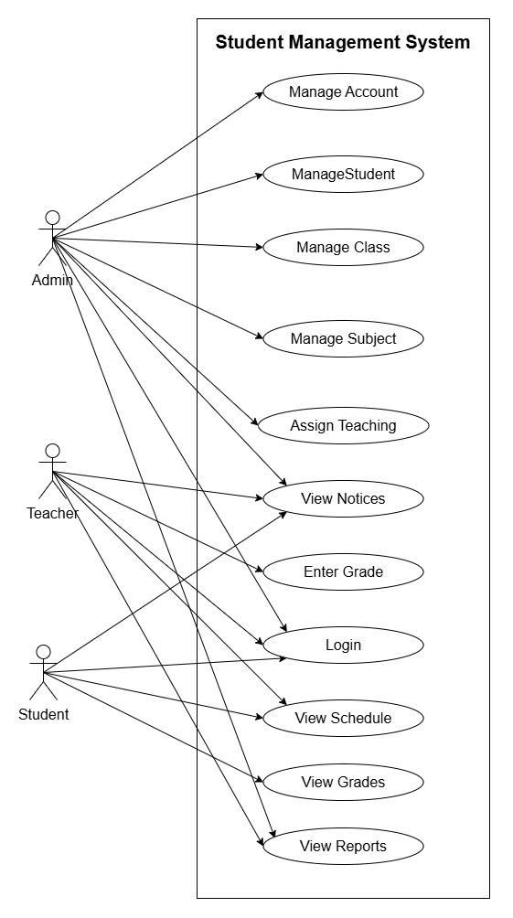
Figure 2. General Use Case Diagram of the Student Management System

4.2. Use Case Specifications

4.2.1. UC-1 Login
Item | Content
ID and Name | UC-1 Login
Created By | Project Team
Date Created | March, 2026
Primary Actor | Admin, Teacher, Student
Secondary Actors | User Database
Description | The user accesses the system with a valid account to use functions corresponding to their assigned role.
Trigger | The user selects the login function on the system interface.
Preconditions | PRE-1. The user has a valid account in the system.  PRE-2. The account is not locked or disabled.
Postconditions | POST-1. The user logs in successfully.  POST-2. The system correctly identifies the role and redirects to the appropriate interface.
Normal Flow | 1. The user accesses the login screen.  2. The system displays the login form.  3. The user enters username or email and password.  4. The user clicks the Login button.  5. The system checks the account in the database.  6. The system authenticates the password.  7. The system determines the user’s role.  8. The system creates a valid login session.  9. The system redirects to the main interface corresponding to the role.
Alternative Flows | 1. The user may edit the login information before submitting the request.
Exceptions | E1. Incorrect username or password.  E2. Account is locked or disabled.
Priority | High
Business Rules | BR-1, BR-2, BR-3, BR-4, BR-5
Other Information | This is the initial use case for most other functions in the system.

4.2.2. UC-2 Admin Manages Students
Item | Content
ID and Name | UC-2 Admin Manages Students
Created By | Project Team
Date Created | March, 2026
Primary Actor | Admin
Secondary Actors | Student Database
Description | The Admin performs operations to add, edit, delete, view list, view details, and search for students.
Trigger | The Admin selects the Student Management function from the administration interface.
Preconditions | PRE-1. The Admin has logged in.  PRE-2. The account has valid administrative privileges.
Postconditions | POST-1. Student data is added, edited, deleted, or displayed correctly according to the operation.  POST-2. The system updates the database if the operation is valid.
Normal Flow | 1. The Admin accesses the Student Management function.  2. The system displays the list of students.  3. The Admin selects add new, edit, delete, view details, or search.  4. If adding or editing, the Admin enters or updates information.  5. The system validates the data.  6. The system saves the changes.  7. The system notifies success.  8. If deleting, the system requires confirmation and checks constraints before deleting.
Alternative Flows | A1. The Admin cancels the add or edit operation.  A2. The Admin does not confirm deletion.
Exceptions | E1. Invalid data.  E2. Duplicate student ID.  E3. Cannot delete due to data constraints.
Priority | High
Business Rules | BR-6, BR-7, BR-8
Other Information | This use case is the foundation for the student management sequence diagram and CRUD functions.

4.2.3. UC-3 Teacher Enters Student Grades
Item | Content
ID and Name | UC-3 Teacher Enters Student Grades
Created By | Project Team
Date Created | March, 2026
Primary Actor | Teacher
Secondary Actors | Teaching Assignment Database, Grade Database
Description | The teacher enters or updates grades for students in the classes or courses they are assigned to teach.
Trigger | The teacher selects the Enter Grades function on the system interface.
Preconditions | PRE-1. The teacher has logged in.  PRE-2. The teacher has been assigned to the relevant course or class.  PRE-3. The student exists in the system.
Postconditions | POST-1. The student’s grades are saved successfully if valid.  POST-2. The grade report is updated with the latest data.
Normal Flow | 1. The teacher accesses the Enter Grades function.  2. The system displays the list of classes or courses the teacher is responsible for.  3. The teacher selects the class or course.  4. The system displays the corresponding list of students.  5. The teacher selects the student to enter grades.  6. The system displays the grade entry form.  7. The teacher enters the grade components.  8. The system validates the grade data.  9. The system saves the grades to the database.  10. The system notifies success.
Alternative Flows | A1. The teacher edits previously entered grades.  A2. The teacher cancels the grade entry operation.
Exceptions | E1. The teacher is not assigned to the class/course.  E2. Invalid grade.  E3. The student does not belong to the selected class or course.
Priority | High
Business Rules | BR-10, BR-11, BR-12, BR-13
Other Information | This is the core use case for the Teacher actor.

4.2.4. UC-4 Student Views Grade Report
Item | Content
ID and Name | UC-4 Student Views Grade Report
Created By | Project Team
Date Created | March, 2026
Primary Actor | Student
Secondary Actors | Grade Database
Description | The student views their own grade report and academic results on the system.
Trigger | The student selects the View Grade Report function.
Preconditions | PRE-1. The student has logged in.  PRE-2. The student account is correctly linked to the student profile in the system.
Postconditions | POST-1. The student can view their own grade report if data exists.  POST-2. The system does not allow viewing another person’s grade report.
Normal Flow | 1. The student accesses the View Grade Report function.  2. The system identifies the student ID from the logged-in account.  3. The system retrieves the student’s grade data.  4. The system displays the list of courses and corresponding grade components.  5. The system displays the overall academic results if available.
Alternative Flows | A1. The student filters the grade report by semester.
Exceptions | E1. No grade data available.  E2. The account is not correctly linked to the student profile.
Priority | High
Business Rules | BR-14
Other Information | This use case reflects the self-service academic result lookup function for students.

4.3. Sequence Diagrams

4.3.1. Sequence Diagram for UC-1 Login
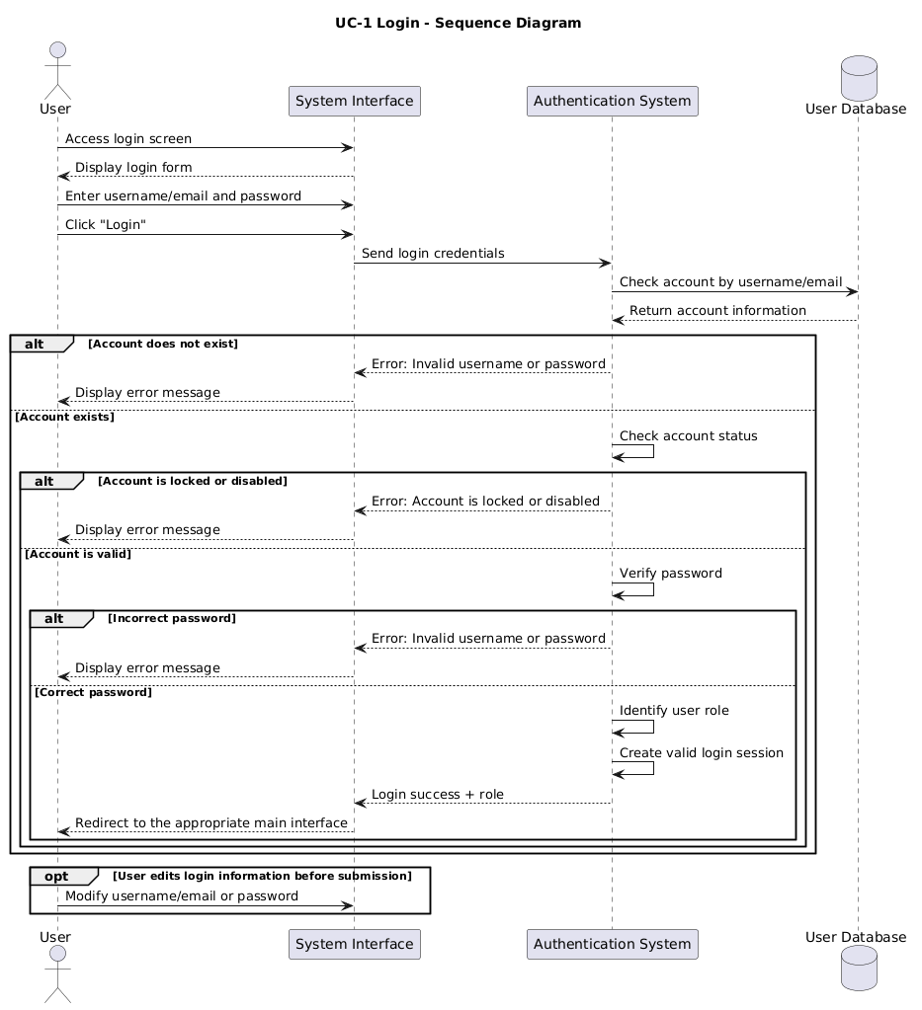

4.3.2. Sequence Diagram for UC-2 Admin Manages Students
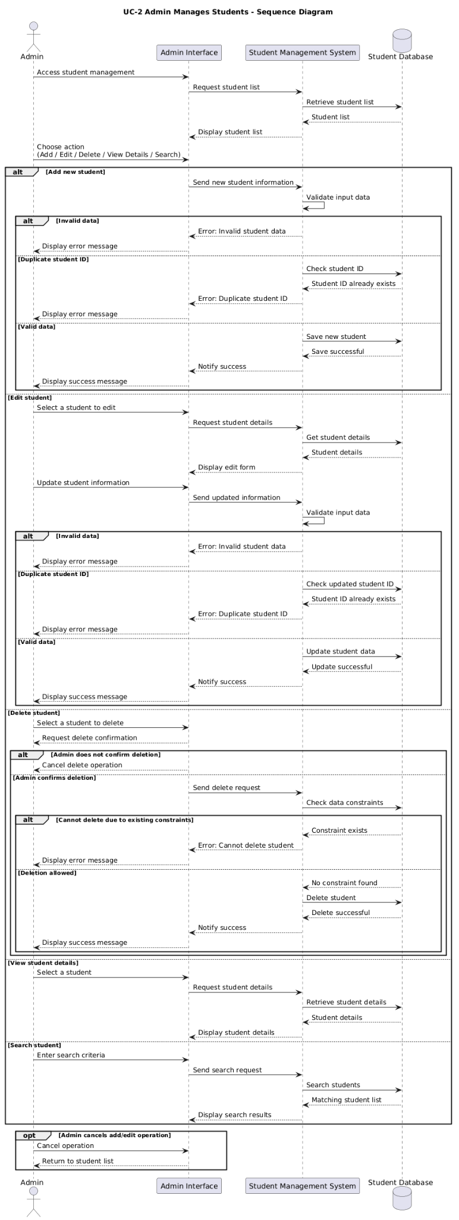

4.3.3. Sequence Diagram for UC-3 Teacher Enters Student Grades
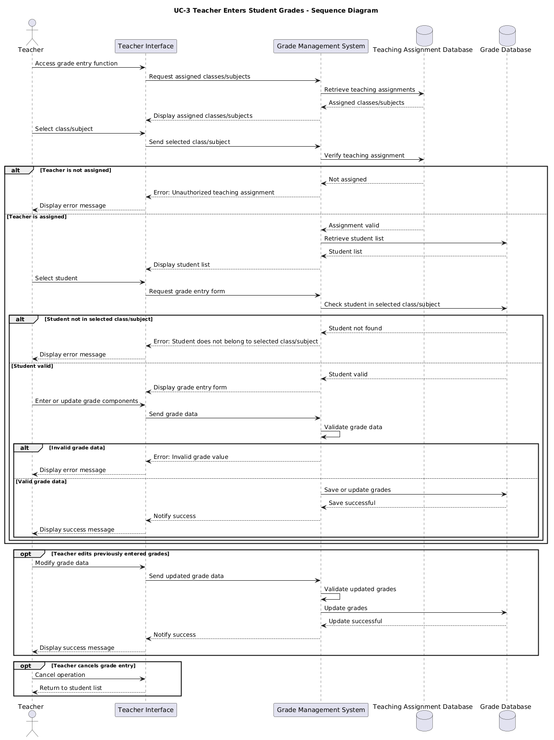

4.3.4. Sequence Diagram for UC-4 Student Views Grade Report
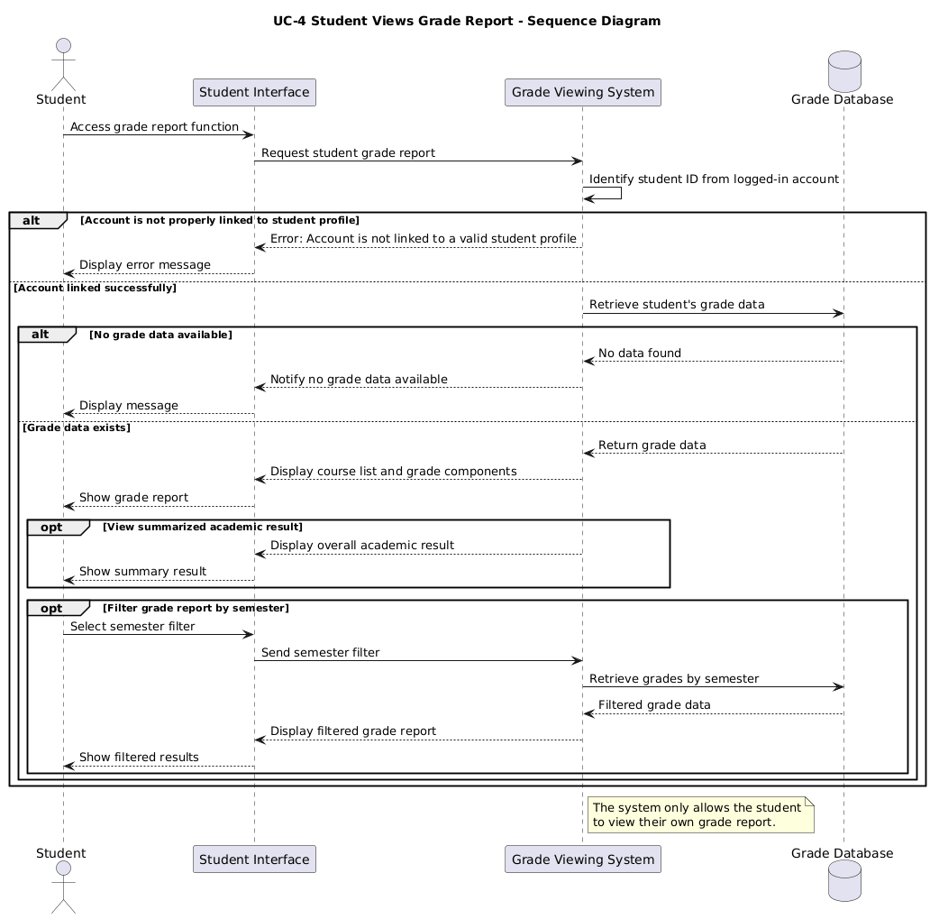

4.4. Class Diagram
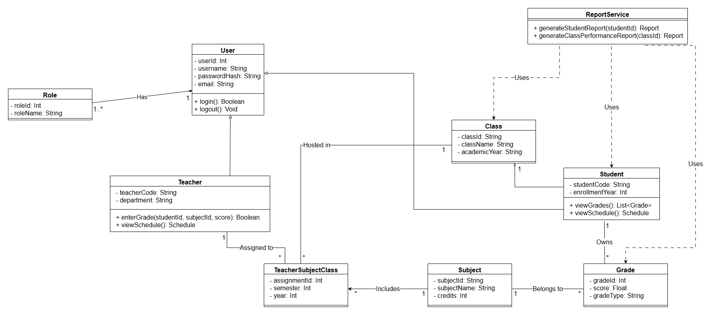
Figure 4. Class Diagram of the Student Management System

4.5. Activity Diagram
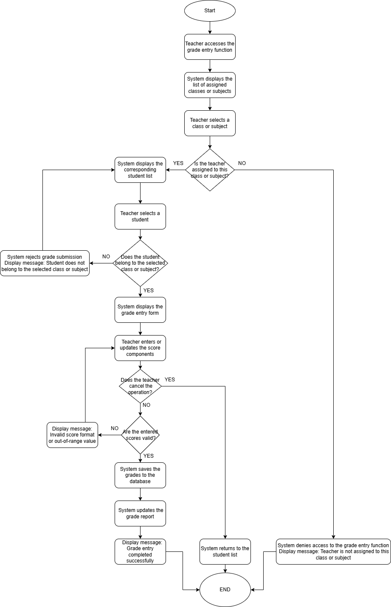
Figure 5. Activity Diagram for the Teacher Enters Student Grades Function

4.6. State Diagram
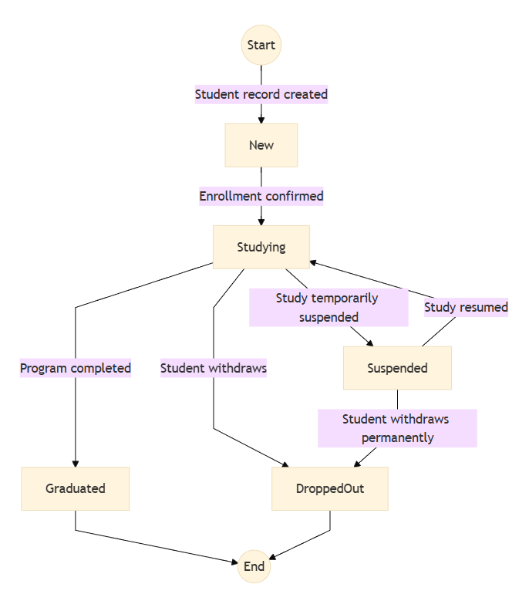
Figure 6. State Diagram of the Student Object

4.7 UI Screen Flow
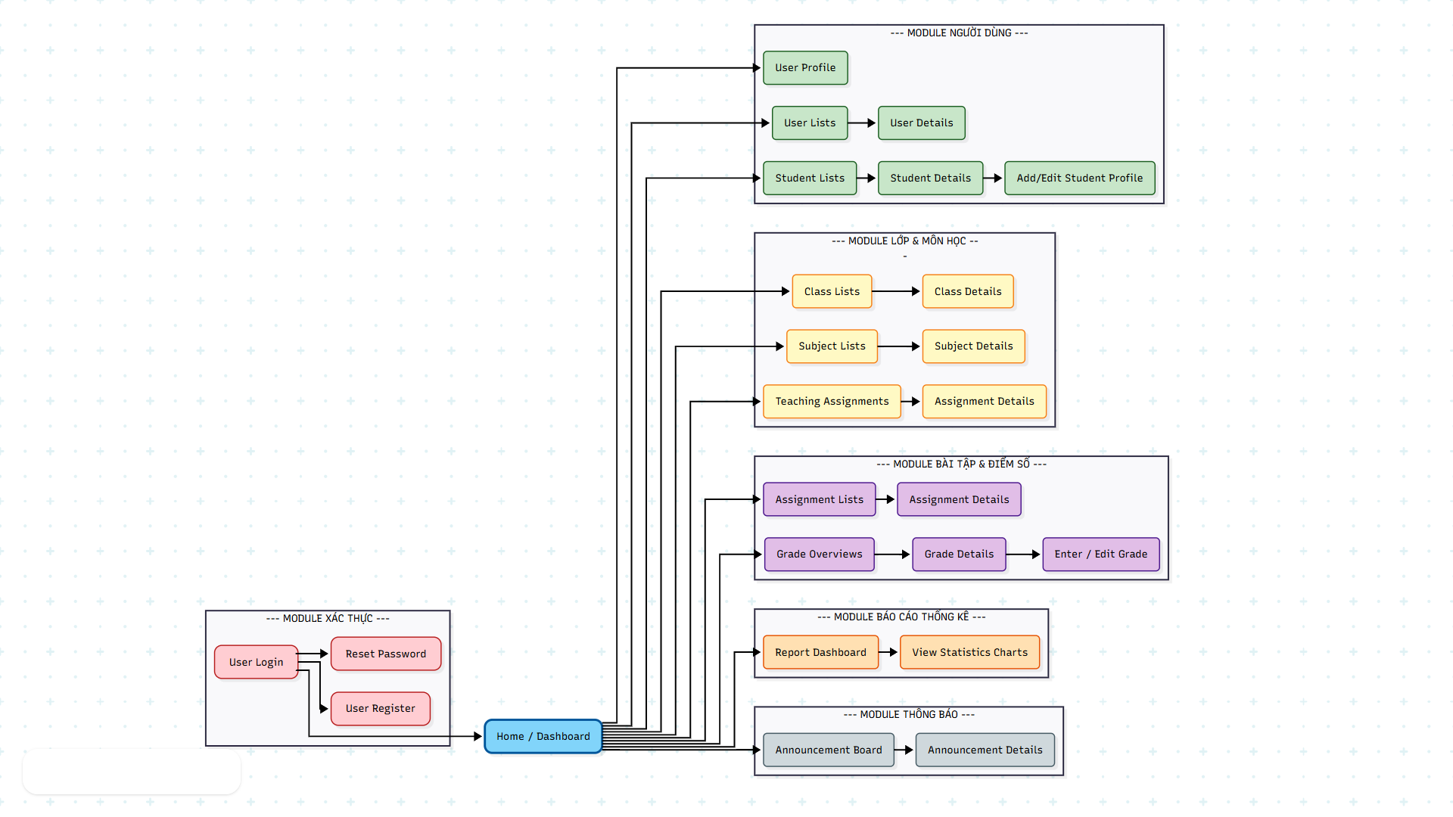
Figure 8. UI Screen Flow for Student Management System

5. Data Requirements

5.1. Logical Data Model
The logical data model of the system includes the following main entities: roles, users, students, teachers, classes, subjects, teacher_subject_class, grades, and announcements.
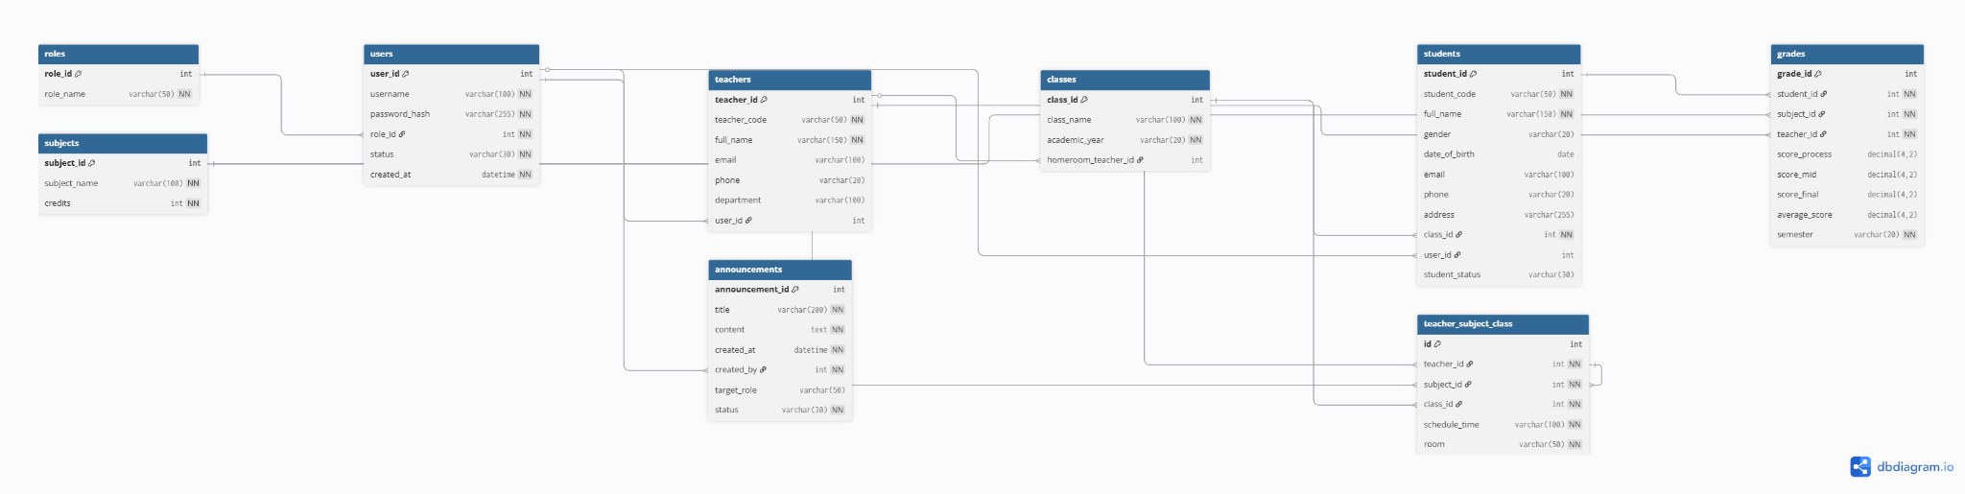
Figure 8. Logical Data Model of the Student Management System

5.2. Data Dictionary
Data Element | Description | Composition / Data Type | Notes
role | User role in the system | role_id, role_name | Main values: admin, teacher, student
user | User login account | user_id, username, password_hash, role_id, status, created_at | Used for authentication and authorization
student | Student profile | student_id, student_code, full_name, gender, date_of_birth, email, phone, address, class_id, user_id | Linked to class and user account
teacher | Teacher profile | teacher_id, teacher_code, full_name, email, phone, department, user_id | Linked to user account
class | Class information | class_id, class_name, academic_year, homeroom_teacher_id | Linked to students
subject | Course information | subject_id, subject_name, credits | Linked to teaching assignments and grades
teacher_subject_class | Teaching assignment | id, teacher_id, subject_id, class_id, schedule_time, room | Defines which teacher teaches which course in which class
grade | Student grade data | grade_id, student_id, subject_id, teacher_id, score_process, score_mid, score_final, average_score, semester | Used to display grade reports and statistics
announcement | System notification | announcement_id, title, content, created_at, created_by, target_role, status | Used for the notification board

5.3. Reports

5.3.1. Report Specification
Attribute | Report 1 | Report 2 | Report 3
Report ID | SMS-RPT-1 | SMS-RPT-2 | SMS-RPT-3
Report Title | Student Statistics by Class | Average Grade Statistics | Pass/Fail Student List
Report Purpose | Helps Admin track the number of students in each class | Helps Admin or Teacher track academic performance by class or course | Helps identify groups of students who passed or failed based on criteria
Priority | High | High | Medium
Report Users | Admin | Admin, Teacher | Admin, Teacher
Data Sources | students, classes | grades, students, classes, subjects | grades, students
Frequency and Disposition | On-demand, displayed on web interface | On-demand, displayed on web interface | On-demand, displayed on web interface
Latency | Under 3 seconds for normal data volume | Under 3 seconds for normal data volume | Under 3 seconds for normal data volume
Security Access Restrictions | Admin only has full access | Admin has full access; Teacher only within assigned scope | Admin has full access; Teacher only within assigned scope

5.4. Data Integrity, Retention, and Disposal
Code | Content
DI-1 | The system must validate input data before saving it to the database.
DI-2 | The system must reject records with duplicate student IDs or invalid data.
DI-3 | When deleting a student or class, the system must check related constraints before performing the deletion.
DI-4 | Grade data must be correctly linked to the corresponding student, course, teacher, and semester.
DI-5 | The system must store data centrally and ensure consistency throughout add, update, and delete operations.

6. External Interface Requirements

6.1. User Interfaces
Code | Requirement
UI-1 | The system must provide a web interface for Admin, Teacher, and Student.
UI-2 | The interface must include basic screens such as login, role-based dashboard, student management, class management, course management, grade entry, grade report viewing, schedule viewing, and notification viewing.
UI-3 | The interface must be clear, user-friendly, and suitable for general users in an educational environment.
UI-4 | Error messages and success notifications must be easy to understand and displayed in Vietnamese.

6.2. Software Interfaces
Code | Requirement
SI-1 | The ReactJS frontend must communicate with the Spring Boot backend through APIs.
SI-2 | The backend must connect to the MySQL database to retrieve and store data.
SI-3 | The system must support APIs for authentication, authorization, student management, class management, course management, grade entry, grade report viewing, reports, and notifications.
SI-4 | The Postman tool may be used to test APIs during the development phase.

6.3. Hardware Interfaces
Code | Requirement
HI-1 | There are no special hardware requirements for the current release.
HI-2 | The system can run in a local development environment on the team’s personal computers.
HI-3 | Users access the system through a web browser on a standard computer.

6.4. Communications Interfaces
Code | Requirement
CI-1 | Users access the system via the HTTP or HTTPS protocol.
CI-2 | The frontend sends requests to the backend over the internal network or localhost environment during development.
CI-3 | Notifications in the current version are primarily displayed on the in-system notification board.

7. Quality Attributes

7.1. Usability Requirements
Code | Requirement
USE-1 | The interface must be user-friendly and easy to use for Admin, Teacher, and Student.
USE-2 | Users must be able to perform basic operations such as login, viewing data, or entering grades without complex training.
USE-3 | Error messages and operation instructions must be clear.

7.2. Performance Requirements
Code | Requirement
PER-1 | The system must respond to normal operations in a short time.
PER-2 | Search functions such as student lists, grade reports, and notifications must display results within an acceptable time.
PER-3 | Basic reports should be generated within a few seconds with the project-scale dataset.

7.3. Security Requirements
Code | Requirement
SEC-1 | User passwords must be encrypted before being stored in the database.
SEC-2 | The system must have a clear role-based access control mechanism between Admin, Teacher, and Student.
SEC-3 | Users must log in to access protected functions.
SEC-4 | Students can only view their own academic data.
SEC-5 | Teachers can only enter or edit grades within the scope of their teaching assignments.

7.4. Safety Requirements
Code | Requirement
SAF-1 | The system must restrict operations that could corrupt academic data, such as entering grades outside the permitted scope or deleting data while constraints still exist.
SAF-2 | The system must display warnings or reject operations when data is invalid.

7.5. Availability Requirements
Code | Requirement
AVL-1 | The system must be available during the time the team uses it for demo, testing, and presentation.
AVL-2 | Within the scope of the project, the goal is for the system to operate stably in the local development environment.

7.6. Robustness Requirements
Code | Requirement
ROB-1 | The system must validate input data before saving.
ROB-2 | When invalid data is detected, the system must display an error message and allow the user to re-enter the data.
ROB-3 | Core functions such as login, student management, grade entry, and grade report viewing must include basic error handling to avoid interrupting the entire user flow.

